S Table 1:
Analysis of equilibrium Cd (II) biosorption capacity of Candida tropicalis XTA1874 by Langmuir Isotherm before optimization
Experiment No. | C_{i} (ppm) | C_{e} (ppm) | 1/C_{e} |  |  | q_{e}(mg/g) | 1/q_{e} |  | Equilibrium Biosorption capacity(%)(C_{i}-C_{e})*100/C_{i} | Mean Equilibrium Biosorption capacity(%)
1 | 15 | 3.2 | 0.3125 |  |  | 7.866667 | 0.127119 |  | 78.66666667
2 | 45 | 10.8 | 0.092593 |  |  | 22.8 | 0.04386 |  | 76
3 | 55 | 11.16 | 0.089606 |  |  | 29.22667 | 0.034215 |  | 79.70909091 | 75.52596537
4 | 100 | 20.32 | 0.049213 |  |  | 53.12 | 0.018825 |  | 79.68
5 | 250 | 62.34 | 0.016041 |  |  | 125.1067 | 0.007993 |  | 75.064
6 | 300 | 109.23 | 0.009155 |  |  | 127.18 | 0.007863 |  | 63.59
7 | 500 | 120.14 | 0.008324 |  |  | 253.24 | 0.003949 |  | 75.972

S Table 2:
Linear plot for Langmuir Isotherm before optimization
1/C_{e} | 1/q_{e} |  | Intercept | Slope | R² | q_{max} (mg/g) | K_{L} | R_{L}
0.3125 | 0.127119 |  | 0.0017 | 0.40165 | 0.995455 | 588.2450556 | 0.004232 | 0.940303
0.092593 | 0.04386 |  |  |  |  |  |  | 0.840011
0.089606 | 0.034215 |  |  |  |  |  |  | 0.811171
0.049213 | 0.018825 |  |  |  |  |  |  | 0.702619
0.016041 | 0.007993 |  |  |  |  |  |  | 0.485881
0.009155 | 0.007863 |  |  |  |  |  |  | 0.440579
0.008324 | 0.003949 |  |  |  |  |  |  | 0.3209

S Table 3:
Statistical analysis for the data obtain from Langmuir Adsorption Isotherm before optimization
No of Observations | Removal (%) | Mean Removal (%) | SD | SEM | q_{max} (mg/g) | Mean Maximum Surface Adsorption (mg/g) | SD | SEM
1 | 75.972 | 75.9671 | 0.070761 | 0.028888 | 588.2353 | 588.4334 | 0.331157 | 0.135194
2 | 76.035 |  |  |  | 588.3251
3 | 75.9248 |  |  |  | 588.285
4 | 75.9236 |  |  |  | 588.3451
5 | 76.0648 |  |  |  | 589.105
6 | 75.8824 |  |  |  | 588.3051

S Table 4:
Analysis of equilibrium Cd(II) biosorption capacity of Candida tropicalis XTA1874 by Langmuir Isotherm after optimization

Experiment No. | C_{i} (ppm) | C_{e} (ppm) | 1/C_{e} |  |  | q_{e}(mg/g) | 1/q_{e} |  | Equilibrium Biosorption capacity(%)(C_{i}-C_{e})*100/C_{i} | Mean Equilibrium Biosorption capacity(%)
1 | 15 | 1.3 | 0.769231 |  |  | 9.133333 | 0.109489 |  | 91.33333
2 | 45 | 2.8 | 0.357143 |  |  | 28.13333 | 0.035545 |  | 93.77778
3 | 55 | 5.16 | 0.193798 |  |  | 33.22667 | 0.030096 |  | 90.61818 | 87.90028
4 | 100 | 10.32 | 0.096899 |  |  | 59.78667 | 0.016726 |  | 89.68
5 | 250 | 43.34 | 0.023073 |  |  | 137.7733 | 0.007258 |  | 82.664
6 | 300 | 86.23 | 0.011597 |  |  | 142.5133 | 0.007017 |  | 71.25667
7 | 500 | 20.14 | 0.049652 |  |  | 319.9067 | 0.003126 |  | 95.972

S Table 5:
Linear plot for Langmuir Isotherm after optimization
1/C_{e} | 1/q_{e} | Intercept | Slope | R² | q_{max} (mg/g) | K_{L} | R_{L}
0.769231 | 0.109489 | 1.18E-03 | 0.13389 | 0.96928 | 847.4576 | 0.008813 | 0.883238
0.357143 | 0.035545 |  |  |  |  |  | 0.716028
0.193798 | 0.030096 |  |  |  |  |  | 0.673525
0.096899 | 0.016726 |  |  |  |  |  | 0.531542
0.023073 | 0.007258 |  |  |  |  |  | 0.312178
0.011597 | 0.007017 |  |  |  |  |  | 0.274427
0.049652 | 0.003126 |  |  |  |  |  | 0.184959

S Table 6:
Statistical analysis for the data obtain from Langmuir Adsorption Isotherm after optimization
No of Observations | Removal (%) | Mean Removal (%) | SD | SEM | q_{max} (mg/g) | Mean Maximum Surface Adsorption (mg/g) | SD | SEM
Observation 1 | 95.972 | 95.96233 | 0.068916 | 0.028135 | 847.4576 | 0.028135 | 0.004698 | 0.008007
Observation 2 | 95.974 |  |  |  | 847.4643
Observation 3 | 95.98 |  |  |  | 847.4772
Observation 4 | 95.976 |  |  |  | 847.4966
Observation 5 | 95.832 |  |  |  | 847.4583
Observation 6 | 96.04 |  |  |  | 847.5026

S Table 7:
Analysis of equilibrium Cd(II) biosorption capacity of Candida tropicalis XTA1874 by Freundlich Isotherm before optimization

Experiment No. | C_{i} (ppm) | C_{e} (ppm) |  | logC_{e} |  | q_{e}(mg/g) |  | logq_{e} | Equilibrium Biosorption capacity(%)(C_{i}-C_{e})*100/Ci | Mean Equilibrium Biosorption capacity(%)
1 | 15 | 3.2 |  | 0.50515 |  | 7.866667 |  | 0.895791 | 78.66667
2 | 45 | 10.8 |  | 1.033424 |  | 22.8 |  | 1.357935 | 76
3 | 55 | 11.16 |  | 1.047664 |  | 29.22667 |  | 1.465779 | 79.70909 | 76.09739
4 | 100 | 20.32 |  | 1.307924 |  | 53.12 |  | 1.725258 | 79.68
5 | 250 | 62.34 |  | 1.794767 |  | 125.1067 |  | 2.09728 | 75.064
6 | 300 | 109.23 |  | 2.038342 |  | 127.18 |  | 2.104419 | 63.59
7 | 500 | 100.14 |  | 2.000608 |  | 266.5733 |  | 2.425817 | 79.972

S Table 8:
Linear plot for Freundlich Isotherm before optimization
logC_{e} | logq_{e} | Intercept | Slope | 1/n | n | K_{F} | R²
0.50515 | 0.895791 | 0.48367 | 0.89296 | 0.89296 | 1.119871 | 3.04558 | 0.95455
1.033424 | 1.357935
1.047664 | 1.465779
1.307924 | 1.725258
1.794767 | 2.09728
2.038342 | 2.104419
2.000608 | 2.425817

S Table 9:
Statistical analysis for the data obtain from Freundlich Adsorption Isotherm before optimization
No of Observation | K_{F} | Mean | SD | SEM | n | Mean | SD | SEM
1 | 3.04558 | 3.09558 | 0.061644 | 0.025166 | 1.119871 | 1.12067 | 0.001245 | 0.000508
2 | 3.20558 |  |  |  | 1.121471
3 | 3.08558 |  |  |  | 1.122871
4 | 3.06558 |  |  |  | 1.119971
5 | 3.12558 |  |  |  | 1.119963
6 | 3.04558 |  |  |  | 1.119871

S Table 10:
Analysis of equilibrium Cd(II) biosorption capacity of Candida tropicalis XTA1874 by Freundlich Isotherm after optimization
Experiment No. | C_{i} (ppm) | C_{e} (ppm) |  | logC_{e} |  | q_{e}(mg/g) |  | logq_{e} | Equilibrium Biosorption capacity(%)(C_{i}-C_{e})*100/Ci | Mean Equilibrium Biosorption capacity(%)
1 | 15 | 1.3 |  | 0.113943 |  | 9.133333 |  | 0.960629 | 91.33333
2 | 45 | 2.8 |  | 0.447158 |  | 28.13333 |  | 1.449221 | 93.77778
3 | 55 | 5.16 |  | 0.71265 |  | 33.22667 |  | 1.521487 | 90.61818 | 87.90028
4 | 100 | 10.32 |  | 1.01368 |  | 59.78667 |  | 1.776604 | 89.68
5 | 250 | 43.34 |  | 1.636889 |  | 137.7733 |  | 2.139165 | 82.664
6 | 300 | 86.23 |  | 1.935658 |  | 142.5133 |  | 2.153855 | 71.25667
7 | 500 | 20.14 |  | 1.304059 |  | 319.9067 |  | 2.505023 | 95.972

S Table 11:
Linear plot for Freundlich Isotherm after optimization
logC_{e} | logq_{e} | Intercept | Slope | 1/n | n | K_{F} | R²
0.113943 | 0.960629 | 1.06984 | 0.70032 | 0.70032 | 1.427919 | 11.74465 | 0.75973
0.447158 | 1.449221
0.71265 | 1.521487
1.01368 | 1.776604
1.636889 | 2.139165
1.935658 | 2.153855
1.304059 | 2.505023

S Table 12:
Statistical analysis for the data obtain from Freundlich Adsorption Isotherm after optimization
No of Observation | K_{F} | Mean | SD | SEM | n | Mean | SD | SEM
1 | 11.74465 | 11.77248 | 0.024967 | 0.010193 | 1.427919 | 1.457797 | 0.036753 | 0.015005
2 | 11.75865 |  |  |  | 1.439919
3 | 11.78265 |  |  |  | 1.432919
4 | 11.74965 |  |  |  | 1.460187
5 | 11.80465 |  |  |  | 1.527919
6 | 11.79465 |  |  |  | 1.457919

S Table 13:
Analysis of Cd(II) biosorption kinetics by Pseudo First Order Kinetic Model before optimization using 100 ppm Cd(II)
Experiment No. | Time (min) | C_{i} (ppm) | C_{e} (ppm) | q_{t} (mg/g) |  | ln (q_{e}-q_{t})
1 | 0 | 0 | 0 | 0 |  | 0
2 | 40 | 100 | 25.26 | 49.82667 |  | 1.1919
3 | 60 | 100 | 24.56 | 50.29333 |  | 1.039098
4 | 80 | 100 | 23.43 | 51.04667 |  | 0.729158
5 | 100 | 100 | 22.37 | 51.75333 |  | 0.312375
6 | 150 | 100 | 21.28 | 52.48 |  | -0.44629
7 | 180 | 100 | 21.28 | 52.48 |  | -0.44629
8 | 200 | 100 | 21.28 | 52.48 |  | -0.44629
9 | 250 | 100 | 21.28 | 52.48 |  | -0.44629
10 | 280 | 100 | 21.28 | 52.48 |  | -0.44629
11 | 300 | 100 | 21.28 | 52.48 |  | -0.44629
12 | 350 | 100 | 21.28 | 52.48 |  | -0.44629
13 | 380 | 100 | 21.28 | 52.48 |  | -0.44629
14 | 400 | 100 | 21.28 | 52.48 |  | -0.44629
15 | 450 | 100 | 21.28 | 52.48 |  | -0.44629
16 | 480 | 100 | 21.28 | 52.48 |  | -0.44629
17 | 500 | 100 | 21.28 | 52.48 |  | -0.44629

S Table 14:
Linear plot of Pseudo First Order Kinetics Before optimization Using 100 ppm Cd(II)
Time (min) | ln (q_{e}-q_{t}) | Intercept | Slope | q_{e}(mg/g) | k₁ | R²
0 | 0 | 1.89883 | -0.01551 | 6.678077 | -0.0001 | 0.98893
40 | 1.1919
60 | 1.039098
80 | 0.729158
100 | 0.312375
150 | -0.44629

S Table 15:
Statistical analysis of Pseudo First Order Kinetics Before optimization Using 100 ppm Cd(II)
Observation no | q_{e} | Mean | SD | SEM | k₁ | Mean | SD | SEM
1 | 6.678077 | 6.991768 | 1.050226 | 0.428753 | -0.0001 | -0.00012 | 2.27E-05 | 9.26E-06
2 | 6.917799 |  |  |  | -0.00012
3 | 6.519999 |  |  |  | -0.00014
4 | 6.917799 |  |  |  | -0.00016
5 | 8.999139 |  |  |  | -0.0001
6 | 5.917793 |  |  |  | -0.0001

S Table 16:
Analysis of Cd(II) biosorption kinetics by Pseudo First Order Kinetic Model before optimization using 250 ppm Cd(II)
Experiment No. | Time (min) | C_{i} (ppm) | C_{e} (ppm) | qt (mg/g) |  | ln (q_{e}-q_{t})
1 | 0 | 0 | 0 | 0 |  | 0
2 | 40 | 250 | 65.35 | 123.1 |  | 0.696475
3 | 60 | 250 | 64.28 | 123.8133 |  | 0.257223
4 | 80 | 250 | 63.34 | 124.44 |  | -0.40547
5 | 100 | 250 | 62.57 | 124.9533 |  | -1.87514
6 | 150 | 250 | 62.42 | 125.0533 |  | -2.93119
7 | 180 | 250 | 62.42 | 125.0533 |  | -2.93119
8 | 200 | 250 | 62.42 | 125.0533 |  | -2.93119
9 | 250 | 250 | 62.42 | 125.0533 |  | -2.93119
10 | 280 | 250 | 62.42 | 125.0533 |  | -2.93119
11 | 300 | 250 | 62.42 | 125.0533 |  | -2.93119
12 | 350 | 250 | 62.42 | 125.0533 |  | -2.93119
13 | 380 | 250 | 62.42 | 125.0533 |  | -2.93119
14 | 400 | 250 | 62.42 | 125.0533 |  | -2.93119
15 | 450 | 250 | 62.42 | 125.0533 |  | -2.93119
16 | 480 | 250 | 62.42 | 125.0533 |  | -2.93119
17 | 500 | 250 | 62.42 | 125.0533 |  | -2.93119

S Table 17:
Linear plot of Pseudo First Order Kinetics Before optimization Using 250 ppm Cd(II)
Time (min) | ln (q_{e}-q_{t}) | Intercept | Slope | q_{e}(mg/g) | k₁ | R²
0 | 0 | 2.16975 | -0.03513 | 8.756095 | -0.00023 | 0.95549
40 | 0.696475
60 | 0.257223
80 | -0.40547
100 | -1.87514
150 | -2.93119

S Table 18:
Statistical analysis of Pseudo First Order Kinetics Before optimization Using 250 ppm Cd(II)
Observation no | q_{e} | Mean | SD | SEM | k₁ | Mean | SD | SEM
1 | 8.756095 | 12.22295 | 4.767139 | 1.946176 | -0.00023 | -0.00028 | 2.82E-05 | 1.15E-05
2 | 5.917799 |  |  |  | -0.00028
3 | 10.7489 |  |  |  | -0.00032
4 | 12.99799 |  |  |  | -0.0003
5 | 15.99914 |  |  |  | -0.00028
6 | 18.91779 |  |  |  | -0.00028

S Table 19:
Analysis of Cd(II) biosorption kinetics by Pseudo First Order Kinetic Model before optimization using 300 ppm Cd(II)
Experiment No. | Time (min) | C_{i} (ppm) | C_{e} (ppm) | q_{t} (mg/g) |  | ln (q_{e}-q_{t})
1 | 0 | 0 | 0 | 0 |  | 0
2 | 40 | 300 | 112.46 | 125.0267 |  | 0.767017
3 | 60 | 300 | 111.27 | 125.82 |  | 0.307485
4 | 80 | 300 | 110.84 | 126.1067 |  | 0.070769
5 | 100 | 300 | 109.57 | 126.9533 |  | -1.48427
6 | 150 | 300 | 109.45 | 127.0333 |  | -1.91959
7 | 180 | 300 | 109.45 | 127.0333 |  | -1.91959
8 | 200 | 300 | 109.45 | 127.0333 |  | -1.91959
9 | 250 | 300 | 109.45 | 127.0333 |  | -1.91959
10 | 280 | 300 | 109.45 | 127.0333 |  | -1.91959
11 | 300 | 300 | 109.45 | 127.0333 |  | -1.91959
12 | 350 | 300 | 109.45 | 127.0333 |  | -1.91959
13 | 380 | 300 | 109.45 | 127.0333 |  | -1.91959
14 | 400 | 300 | 109.45 | 127.0333 |  | -1.91959
15 | 450 | 300 | 109.45 | 127.0333 |  | -1.91959
16 | 480 | 300 | 109.45 | 127.0333 |  | -1.91959
17 | 500 | 300 | 109.45 | 127.0333 |  | -1.91959

S Table 20:
Linear plot of Pseudo First Order Kinetics Before optimization Using 300 ppm Cd(II)
Time (min) | ln (q_{e}-q_{t}) | Intercept | Slope | q_{e}(mg/g) | k₁ | R²
0 | 0 | 1.81104 | -0.02631 | 6.116806 | -0.00018 | 0.88723
40 | 0.767017
60 | 0.307485
80 | 0.070769
100 | -1.48427
150 | -1.91959

S Table 21:
Statistical analysis of Pseudo First Order Kinetics Before optimization Using 300 ppm Cd(II)
Observation no | q_{e} | Mean | SD | SEM | k₁ | Mean | SD | SEM
1 | 6.116806 | 5.1474 | 2.81834 | 1.150583 | -0.00018 | -0.00018 | 2.06E-06 | 8.42E-07
2 | 4.01978 |  |  |  | -0.00018
3 | 4.748899 |  |  |  | -0.00018
4 | 2.998955 |  |  |  | -0.00018
5 | 5.999999 |  |  |  | -0.00018
6 | 6.999961 |  |  |  | -0.00018

S Table 22:
Analysis of Cd(II) biosorption kinetics by Pseudo First Order Kinetic Model before optimization using500 ppm Cd(II)
Experiment No. | Time (min) | C_{i} (ppm) | C_{e} (ppm) | q_{t} (mg/g) |  | ln (q_{e}-q_{t})
1 | 0 | 0 | 0 | 0 |  | 0
2 | 40 | 500 | 123.26 | 251.16 |  | 0.732368
3 | 60 | 500 | 122.48 | 251.68 |  | 0.444686
4 | 80 | 500 | 121.35 | 252.4333 |  | -0.21484
5 | 100 | 500 | 120.53 | 252.98 |  | -1.34707
6 | 150 | 500 | 120.22 | 253.1867 |  | -2.93119
7 | 180 | 500 | 120.22 | 253.1867 |  | -2.93119
8 | 200 | 500 | 120.22 | 253.1867 |  | -2.93119
9 | 250 | 500 | 120.22 | 253.1867 |  | -2.93119
10 | 280 | 500 | 120.22 | 253.1867 |  | -2.93119
11 | 300 | 500 | 120.22 | 253.1867 |  | -2.93119
12 | 350 | 500 | 120.22 | 253.1867 |  | -2.93119
13 | 380 | 500 | 120.22 | 253.1867 |  | -2.93119
14 | 400 | 500 | 120.22 | 253.1867 |  | -2.93119
15 | 450 | 500 | 120.22 | 253.1867 |  | -2.93119
16 | 480 | 500 | 120.22 | 253.1867 |  | -2.93119
17 | 500 | 500 | 120.22 | 253.1867 |  | -2.93119

S Table 23:
Linear plot of Pseudo First Order Kinetics Before optimization Using 500 ppm Cd(II)
Time (min) | ln (q_{e}-q_{t}) | Intercept | Slope | q_{e}(mg/g) | k₁ | R²
0 | 0 | 2.36149 | -0.03517 | 10.60674 | -0.00023 | 0.97996
40 | 0.732368
60 | 0.444686
80 | -0.21484
100 | -1.34707
150 | -2.93119

S Table 24:
Statistical analysis of Pseudo First Order Kinetics Before optimization Using 500 ppm Cd(II)
Observation no | q_{e} | Mean | SD | SEM | k₁ | Mean | SD | SEM
1 | 10.60674 | 14.43672 | 3.530067 | 1.441144 | -0.00023 | -0.00021 | 2.4E-05 | 9.79E-06
2 | 12.01978 |  |  |  | -0.00018
3 | 11.9949 |  |  |  | -0.00022
4 | 15.99895 |  |  |  | -0.00024
5 | 16 |  |  |  | -0.00019
6 | 19.99996 |  |  |  | -0.0002

S Table 25:
Analysis of Cd(II) biosorption kinetics by Pseudo Second Order Kinetic Model before optimization using 100 ppm Cd(II)
Experiment No. | Time (min) | C_{i} (ppm) | C_{e} (ppm) | q_{t} (mg/g) | t/qt
1 | 0 | 0 | 0 | 0 | 0
2 | 40 | 100 | 25.26 | 49.82667 | 0.802783
3 | 60 | 100 | 24.56 | 50.29333 | 1.193001
4 | 80 | 100 | 23.43 | 51.04667 | 1.567193
5 | 100 | 100 | 22.37 | 51.75333 | 1.932243
6 | 150 | 100 | 21.28 | 52.48 | 2.858232
7 | 180 | 100 | 21.28 | 52.48 | 3.429878
8 | 200 | 100 | 21.28 | 52.48 | 3.810976
9 | 250 | 100 | 21.28 | 52.48 | 4.76372
10 | 280 | 100 | 21.28 | 52.48 | 5.335366
11 | 300 | 100 | 21.28 | 52.48 | 5.716463
12 | 350 | 100 | 21.28 | 52.48 | 6.669207
13 | 380 | 100 | 21.28 | 52.48 | 7.240854
14 | 400 | 100 | 21.28 | 52.48 | 7.621951
15 | 450 | 100 | 21.28 | 52.48 | 8.574695
16 | 480 | 100 | 21.28 | 52.48 | 9.146341
17 | 500 | 100 | 21.28 | 52.48 | 9.527439

S Table 26:
Linear plot of Pseudo Second Order Kinetics Before optimization Using 100 ppm Cd(II)
Time (min) | t/q_{t} | Intercept | Slope | q_{e} (mg/g) (cal) | q_{e}² | K₂ | R²
0 | 0 | 0.03312 | 0.01897 | 52.71481 | 2778.851 | 0.010865 | 0.99998
40 | 0.324939
60 | 0.4846
80 | 0.64288
100 | 0.800299
150 | 1.199488
180 | 1.439386
200 | 1.599318
250 | 1.999147
280 | 2.239045
300 | 2.398976
350 | 2.798806
380 | 3.038703
400 | 3.198635
450 | 3.598465
480 | 3.838362
500 | 3.998294

S Table 27 :
Statistical analysis of Pseudo Second Order Kinetics Before optimization Using 100 ppm Cd(II)
Observation no | q_{e} | Mean | SD | SEM | k₂ | Mean | SD | SEM
1 | 52.71481 | 53.06293 | 0.198789 | 0.081155 | 0.021938 | 0.021905 | 0.006998 | 0.002857
2 | 53.11498 |  |  |  | 0.022438
3 | 52.99813 |  |  |  | 0.019638
4 | 53.31481 |  |  |  | 0.026538
5 | 53.11001 |  |  |  | 0.021938
6 | 53.12481 |  |  |  | 0.018938

S Table 28:
Analysis of Cd(II) biosorption kinetics by Pseudo Second Order Kinetic Model before optimization using 250 ppm Cd(II)
Experiment No. | Time (min) | C_{i} (ppm) | C_{e} (ppm) | q_{t} (mg/g) | t/q_{t}
1 | 0 | 0 | 0 | 0 | 0
2 | 40 | 250 | 65.35 | 123.1 | 0.324939
3 | 60 | 250 | 64.28 | 123.8133 | 0.4846
4 | 80 | 250 | 63.34 | 124.44 | 0.64288
5 | 100 | 250 | 62.57 | 124.9533 | 0.800299
6 | 150 | 250 | 62.42 | 125.0533 | 1.199488
7 | 180 | 250 | 62.42 | 125.0533 | 1.439386
8 | 200 | 250 | 62.42 | 125.0533 | 1.599318
9 | 250 | 250 | 62.42 | 125.0533 | 1.999147
10 | 280 | 250 | 62.42 | 125.0533 | 2.239045
11 | 300 | 250 | 62.42 | 125.0533 | 2.398976
12 | 350 | 250 | 62.42 | 125.0533 | 2.798806
13 | 380 | 250 | 62.42 | 125.0533 | 3.038703
14 | 400 | 250 | 62.42 | 125.0533 | 3.198635
15 | 450 | 250 | 62.42 | 125.0533 | 3.598465
16 | 480 | 250 | 62.42 | 125.0533 | 3.838362
17 | 500 | 250 | 62.42 | 125.0533 | 3.998294

S Table 29:
Linear plot of Pseudo Second Order Kinetics Before optimization Using 250 ppm Cd(II)
Time (min) | t/q_{t} | Intercept | Slope | q_{e} (mg/g) (cal) | q_{e}² | K₂ | R²
0 | 0 | 0.00291 | 0.00799 | 125.1564 | 15664.14 | 0.021938 | 1
40 | 0.324939
60 | 0.4846
80 | 0.64288
100 | 0.800299
150 | 1.199488
180 | 1.439386
200 | 1.599318
250 | 1.999147
280 | 2.239045
300 | 2.398976
350 | 2.798806
380 | 3.038703
400 | 3.198635
450 | 3.598465
480 | 3.838362
500 | 3.998294

S Table 30 :
Statistical analysis of Pseudo Second Order Kinetics Before optimization Using 250ppm Cd(II)
Observation no | q_{e} | Mean | SD | SEM | k₂ | Mean | SD | SEM
1 | 125.1564 | 125.1147 | 0.067495 | 0.027555 | 0.021938 | 0.021904859 | 0.002672 | 0.001091
2 | 125.2001 |  |  |  | 0.022438
3 | 125.1274 |  |  |  | 0.019638
4 | 125.1034 |  |  |  | 0.026538
5 | 124.9995 |  |  |  | 0.021938
6 | 125.1012 |  |  |  | 0.018938

S Table 31:
Analysis of Cd(II) biosorption kinetics by Pseudo Second Order Kinetic Model before optimization using 300 ppm Cd(II)
Experiment No. | Time (min) | C_{i} (ppm) | C_{e} (ppm) | q_{t} (mg/g) | t/q_{t}
1 | 0 | 0 | 0 | 0 | 0
2 | 40 | 300 | 112.46 | 125.0267 | 0.319932
3 | 60 | 300 | 111.27 | 125.82 | 0.476872
4 | 80 | 300 | 110.84 | 126.1067 | 0.634384
5 | 100 | 300 | 109.57 | 126.9533 | 0.787691
6 | 150 | 300 | 109.45 | 127.0333 | 1.180792
7 | 180 | 300 | 109.45 | 127.0333 | 1.416951
8 | 200 | 300 | 109.45 | 127.0333 | 1.57439
9 | 250 | 300 | 109.45 | 127.0333 | 1.967987
10 | 280 | 300 | 109.45 | 127.0333 | 2.204146
11 | 300 | 300 | 109.45 | 127.0333 | 2.361585
12 | 350 | 300 | 109.45 | 127.0333 | 2.755182
13 | 380 | 300 | 109.45 | 127.0333 | 2.991341
14 | 400 | 300 | 109.45 | 127.0333 | 3.14878
15 | 450 | 300 | 109.45 | 127.0333 | 3.542377
16 | 480 | 300 | 109.45 | 127.0333 | 3.778536
17 | 500 | 300 | 109.45 | 127.0333 | 3.935975

S Table 32:
Linear plot of Pseudo Second Order Kinetics Before optimization Using 300 ppm Cd(II)
Time (min) | t/q_{t} | Intercept | Slope | q_{e} (mg/g) (cal) | q_{e}² | K₂ | R²
0 | 0 | 0.00312 | 0.00786 | 127.2265 | 16186.57 | 0.019801 | 1
40 | 0.319932
60 | 0.476872
80 | 0.634384
100 | 0.787691
150 | 1.180792
180 | 1.416951
200 | 1.57439
250 | 1.967987
280 | 2.204146
300 | 2.361585
350 | 2.755182
380 | 2.991341
400 | 3.14878
450 | 3.542377
480 | 3.778536
500 | 3.935975

S Table 33 :
Statistical analysis of Pseudo Second Order Kinetics Before optimization Using 300 ppm Cd(II)
Observation no | q_{e} | Mean | SD | SEM | k₂ | Mean | SD | SEM
1 | 127.2265 | 127.0333 | 1.59E-14 | 6.49E-15 | 0.019801 | 0.021467 | 0.002282 | 0.000932
2 | 127.197 |  |  |  | 0.024022
3 | 127.2376 |  |  |  | 0.023912
4 | 127.2265 |  |  |  | 0.019801
5 | 127.2265 |  |  |  | 0.019801
6 | 127.2265

S Table 34:
Analysis of Cd(II) biosorption kinetics by Pseudo Second Order Kinetic Model before optimization using 500 ppm Cd(II)
Experiment No. | Time (min) | C_{i} (ppm) | C_{e} (ppm) | q_{t} (mg/g) | t/q_{t}
1 | 0 | 0 | 0 | 0 | 0
2 | 40 | 500 | 123.26 | 251.16 | 0.159261
3 | 60 | 500 | 122.48 | 251.68 | 0.238398
4 | 80 | 500 | 121.35 | 252.433333 | 0.3169154
5 | 100 | 500 | 120.53 | 252.98 | 0.3952882
6 | 150 | 500 | 120.22 | 253.186667 | 0.5924483
7 | 180 | 500 | 120.22 | 253.186667 | 0.7109379
8 | 200 | 500 | 120.22 | 253.186667 | 0.789931
9 | 250 | 500 | 120.22 | 253.186667 | 0.9874138
10 | 280 | 500 | 120.22 | 253.186667 | 1.1059034
11 | 300 | 500 | 120.22 | 253.186667 | 1.1848965
12 | 350 | 500 | 120.22 | 253.186667 | 1.3823793
13 | 380 | 500 | 120.22 | 253.186667 | 1.5008689
14 | 400 | 500 | 120.22 | 253.186667 | 1.579862
15 | 450 | 500 | 120.22 | 253.186667 | 1.7773448
16 | 480 | 500 | 120.22 | 253.186667 | 1.8958344
17 | 500 | 500 | 120.22 | 253.186667 | 1.9748275

S Table 35 :
Linear plot of Pseudo Second Order Kinetics Before optimization Using 500 ppm Cd(II)
Time (min) | t/q_{t} | Intercept | Slope | q_{e} (mg/g) (cal) | q_{e}² | K₂ | R²
0 | 0 | 8.36E-04 | 0.00395 | 253.1646 | 64092.29 | 0.01866 | 1
40 | 0.159261
60 | 0.238398
80 | 0.316915
100 | 0.395288
150 | 0.592448
180 | 0.710938
200 | 0.789931
250 | 0.987414
280 | 1.105903
300 | 1.184897
350 | 1.382379
380 | 1.500869
400 | 1.579862
450 | 1.777345
480 | 1.895834
500 | 1.974828

S Table 36 :
Statistical analysis of Pseudo Second Order Kinetics Before optimization Using 500 ppm Cd(II)
Observation no | q_{e} | Mean | SD | SEM | k₂ | Mean | SD | SEM
1 | 253.1646 | 253.0809 | 0.129383 | 0.05282 | 0.01866 | 0.019186 | 0.000847 | 0.000346
2 | 252.8669 |  |  |  | 0.018851
3 | 252.9769 |  |  |  | 0.018848
4 | 253.1866 |  |  |  | 0.01923
5 | 253.1634 |  |  |  | 0.020861
6 | 253.1269 |  |  |  | 0.018663

S Table 37:
Analysis of Cd(II) biosorption kinetics by Pseudo First Order Kinetic Model after optimization using 100 ppm Cd(II)
Experiment No. | Time (min) | C_{i} (mg/g) | C_{e} (mg/g) | q_{t} (mg/g) |  | ln (q_{e}-q_{t})
1 | 0 | 0 | 0 | 0 |  | 0
2 | 40 | 100 | 15.63 | 56.24667 |  | 1.264127
3 | 60 | 100 | 14.45 | 57.03333 |  | 1.012812
4 | 80 | 100 | 14.35 | 57.1 |  | 0.988301
5 | 100 | 100 | 14.28 | 57.14667 |  | 0.970779
6 | 150 | 100 | 14.23 | 57.18 |  | 0.958072
7 | 180 | 100 | 14.23 | 57.18 |  | 0.958072
8 | 200 | 100 | 14.23 | 57.18 |  | 0.958072
9 | 250 | 100 | 14.23 | 57.18 |  | 0.958072
10 | 280 | 100 | 14.23 | 57.18 |  | 0.958072
11 | 300 | 100 | 14.23 | 57.18 |  | 0.958072
12 | 350 | 100 | 14.23 | 57.18 |  | 0.958072
13 | 380 | 100 | 14.23 | 57.18 |  | 0.958072
14 | 400 | 100 | 14.23 | 57.18 |  | 0.958072
15 | 450 | 100 | 14.23 | 57.18 |  | 0.958072
16 | 480 | 100 | 14.23 | 57.18 |  | 0.958072
17 | 500 | 100 | 14.23 | 57.18 |  | 0.958072

S Table 38 :
Linear plot of Pseudo First Order Kinetics After optimization Using 100 ppm Cd(II)
Time (min) | ln (q_{e}-q_{t}) | Intercept | Slope | q_{e}(mg/g) | k₁ | R²
0 | 0 | 3.82871 | -0.02247 | 46.00316 | -0.00015 | 0.85282
40 | 3.264127
60 | 2.512812
80 | 1.888301
100 | 0.989879
150 | 0.828072

S Table 39:
Statistical analysis of Pseudo First Order Kinetics After optimization Using 100 ppm Cd(II)
Observation no | q_{e} | Mean | SD | SEM | k₁ | Mean | SD | SEM
1 | 46.00316 | 56.24805 | 5.286257 | 2.158106 | -0.00015 | -0.00018 | 2.12E-05 | 8.64E-06
2 | 55.57329 |  |  |  | -0.00018
3 | 60.46217 |  |  |  | -0.0002
4 | 57.53782 |  |  |  | -0.00019
5 | 59.28898 |  |  |  | -0.00016
6 | 58.62289 |  |  |  | -0.0002

S Table 40:
Analysis of Cd(II) biosorption kinetics by Pseudo First Order Kinetic Model after optimization using 250 ppm Cd(II)
Experiment No. | Time (min) | C_{i} (mg/g) | C_{e} (mg/g) | q_{t} (mg/g) |  | ln (q_{e}-q_{t})
1 | 0 | 0 | 0 | 0 |  | 0
2 | 40 | 250 | 46.67 | 135.5533 |  | 0.797507
3 | 60 | 250 | 45.75 | 136.1667 |  | 0.474162
4 | 80 | 250 | 44.64 | 136.9067 |  | -0.1431
5 | 100 | 250 | 44.57 | 136.9533 |  | -0.19845
6 | 150 | 250 | 43.48 | 137.68 |  | -2.37158
7 | 180 | 250 | 43.48 | 137.68 |  | -2.37158
8 | 200 | 250 | 43.48 | 137.68 |  | -2.37158
9 | 250 | 250 | 43.48 | 137.68 |  | -2.37158
10 | 280 | 250 | 43.48 | 137.68 |  | -2.37158
11 | 300 | 250 | 43.48 | 137.68 |  | -2.37158
12 | 350 | 250 | 43.48 | 137.68 |  | -2.37158
13 | 380 | 250 | 43.48 | 137.68 |  | -2.37158
14 | 400 | 250 | 43.48 | 137.68 |  | -2.37158
15 | 450 | 250 | 43.48 | 137.68 |  | -2.37158
16 | 480 | 250 | 43.48 | 137.68 |  | -2.37158
17 | 500 | 250 | 43.48 | 137.68 |  | -2.37158

S Table 41 :
Linear plot of Pseudo First Order Kinetics After optimization Using 250 ppm Cd(II)
Time (min) | ln (q_{e}-q_{t}) | Intercept | Slope | q_{e}(mg/g) | k₁ | R²
0 | 0 | 2.16022 | -0.02847 | 8.673046 | -0.00019 | 0.94159
40 | 0.797507
60 | 0.474162
80 | -0.1431
100 | -0.19845
150 | -2.37158

S Table 42 :
Statistical analysis of Pseudo First Order Kinetics After optimization Using 250 ppm Cd(II)
Observation no | q_{e} | Mean | SD | SEM | k₁ | Mean | SD | SEM
1 | 8.673046 | 9.290274 | 0.615514 | 0.251283 | -0.00019 | -0.00017 | 3.78E-05 | 1.54E-05
2 | 9.2864 |  |  |  | -0.0001
3 | 8.5621 |  |  |  | -0.00015
4 | 9.2546 |  |  |  | -0.00019
5 | 10.0894 |  |  |  | -0.00016
6 | 9.8761 |  |  |  | -0.0002

S Table 43:
Analysis of Cd(II) biosorption kinetics by Pseudo First Order Kinetic Model after optimization using 300 ppm Cd(II)
Experiment No. | Time (min) | C_{i} (mg/g) | C_{e} (mg/g) | q_{t} (mg/g) |  | ln (q_{e}-q_{t})
1 | 0 | 0 | 0 | 0 |  | 0
2 | 40 | 300 | 88.28 | 141.1467 |  | 0.312375
3 | 60 | 300 | 87.64 | 141.5733 |  | -0.06188
4 | 80 | 300 | 86.68 | 142.2133 |  | -1.20397
5 | 100 | 300 | 86.35 | 142.4333 |  | -2.52573
6 | 150 | 300 | 86.24 | 142.5067 |  | -5.01064
7 | 180 | 300 | 86.24 | 142.5067 |  | -5.01064
8 | 200 | 300 | 86.24 | 142.5067 |  | -5.01064
9 | 250 | 300 | 86.24 | 142.5067 |  | -5.01064
10 | 280 | 300 | 86.24 | 142.5067 |  | -5.01064
11 | 300 | 300 | 86.24 | 142.5067 |  | -5.01064
12 | 350 | 300 | 86.24 | 142.5067 |  | -5.01064
13 | 380 | 300 | 86.24 | 142.5067 |  | -5.01064
14 | 400 | 300 | 86.24 | 142.5067 |  | -5.01064
15 | 450 | 300 | 86.24 | 142.5067 |  | -5.01064
16 | 480 | 300 | 86.24 | 142.5067 |  | -5.01064
17 | 500 | 300 | 86.24 | 142.5067 |  | -5.01064

S Table 44 :
Linear plot of Pseudo First Order Kinetics After optimization Using 300 ppm Cd(II)
Time (min) | ln (q_{e}-q_{t}) | Intercept | Slope | q_{e}(mg/g) | k₁ | R²
0 | 0 | 2.6694 | -0.05078 | 14.43131 | -0.00034 | 0.98608
40 | 0.312375
60 | -0.06188
80 | -1.20397
100 | -2.52573
150 | -5.01064

S Table 45 :
Statistical analysis of Pseudo First Order Kinetics After optimization Using 300 ppm Cd(II)
Observation no | q_{e} | Mean | SD | SEM | k₁ | Mean | SD | SEM
1 | 14.43131 | 15.47383 | 1.574082 | 0.642616 | -0.00034 | -0.00036 | 4.06E-05 | 1.66E-05
2 | 15.2894 |  |  |  | -0.00036
3 | 16.2622 |  |  |  | -0.00038
4 | 14.2846 |  |  |  | -0.00029
5 | 14.2994 |  |  |  | -0.00039
6 | 18.2761 |  |  |  | -0.0004

S Table 46:
Analysis of Cd(II) biosorption kinetics by Pseudo First Order Kinetic Model after optimization using 500 ppm Cd(II)
Experiment No. | Time (min) | C_{i} (mg/g) | C_{e} (mg/g) | q_{t} (mg/g) |  | ln (q_{e}-q_{t})
1 | 0 | 0 | 0 | 0 |  | 0
2 | 40 | 500 | 23.28 | 317.8133 |  | 0.738758
3 | 60 | 500 | 22.68 | 318.2133 |  | 0.526699
4 | 80 | 500 | 21.25 | 319.1667 |  | -0.30111
5 | 100 | 500 | 20.64 | 319.5733 |  | -1.09861
6 | 150 | 500 | 20.28 | 319.8133 |  | -2.37158
7 | 180 | 500 | 20.28 | 319.8133 |  | -2.37158
8 | 200 | 500 | 20.28 | 319.8133 |  | -2.37158
9 | 250 | 500 | 20.28 | 319.8133 |  | -2.37158
10 | 280 | 500 | 20.28 | 319.8133 |  | -2.37158
11 | 300 | 500 | 20.28 | 319.8133 |  | -2.37158
12 | 350 | 500 | 20.28 | 319.8133 |  | -2.37158
13 | 380 | 500 | 20.28 | 319.8133 |  | -2.37158
14 | 400 | 500 | 20.28 | 319.8133 |  | -2.37158
15 | 450 | 500 | 20.28 | 319.8133 |  | -2.37158
16 | 480 | 500 | 20.28 | 319.8133 |  | -2.37158
17 | 500 | 500 | 20.28 | 319.8133 |  | -2.37158

S Table 47 :
Linear plot of Pseudo First Order Kinetics After optimization Using 500 ppm Cd(II)
Time (min) | ln (q_{e}-q_{t}) | Intercept | Slope | q_{e}(mg/g) | k₁ | R²
0 | 0 | 2.07197 | -0.02992 | 7.94045 | -0.0002 | 0.98222
40 | 0.738758
60 | 0.526699
80 | -0.30111
100 | -1.09861
150 | -2.37158

S Table 48 :
Statistical analysis of Pseudo First Order Kinetics After optimization Using 500 ppm Cd(II)
Observation no | q_{e} | Mean | SD | SEM | k₁ | Mean | SD | SEM
1 | 7.98085 | 13.74043 | 3.430697 | 1.400576 | -0.0002 | -0.00023 | 2.81E-05 | 1.15E-05
2 | 15.2894 |  |  |  | -0.00026
3 | 12.2982 |  |  |  | -0.00024
4 | 14.2986 |  |  |  | -0.00025
5 | 14.2994 |  |  |  | -0.00019
6 | 18.2761 |  |  |  | -0.00022

S Table 49:
Analysis of Cd(II) biosorption kinetics by Pseudo Second Order Kinetic Model after optimization using 100 ppm Cd(II)
Experiment No. | Time (min) | C_{i} (mg/g) | C_{e} (mg/g) | q_{t} (mg/g) | t/q_{t}
1 | 0 | 0 | 0 | 0 | 0
2 | 40 | 100 | 15.63 | 56.24667 | 0.711153
3 | 60 | 100 | 14.45 | 57.03333 | 1.052016
4 | 80 | 100 | 14.35 | 57.1 | 1.401051
5 | 100 | 100 | 14.28 | 57.14667 | 1.749883
6 | 150 | 100 | 14.23 | 57.18 | 2.623295
7 | 180 | 100 | 14.23 | 57.18 | 3.147954
8 | 200 | 100 | 14.23 | 57.18 | 3.497726
9 | 250 | 100 | 14.23 | 57.18 | 4.372158
10 | 280 | 100 | 14.23 | 57.18 | 4.896817
11 | 300 | 100 | 14.23 | 57.18 | 5.24659
12 | 350 | 100 | 14.23 | 57.18 | 6.121021
13 | 380 | 100 | 14.23 | 57.18 | 6.64568
14 | 400 | 100 | 14.23 | 57.18 | 6.995453
15 | 450 | 100 | 14.23 | 57.18 | 7.869885
16 | 480 | 100 | 14.23 | 57.18 | 8.394544
17 | 500 | 100 | 14.23 | 57.18 | 8.744316

S Table 50 :
Linear plot of Pseudo Second Order Kinetics After optimization Using 100 ppm Cd(II)
Time (min) | t/q_{t} | Intercept | Slope | q_{e} (mg/g) (cal) | q_{e}² | K₂ | R²
0 | 0 | 0.00378 | 0.01748 | 57.20824 | 3272.782 | 0.080833 | 1
40 | 0.711153
60 | 1.052016
80 | 1.401051
100 | 1.749883
150 | 2.623295
180 | 3.147954
200 | 3.497726
250 | 4.372158
280 | 4.896817
300 | 5.24659
350 | 6.121021
380 | 6.64568
400 | 6.995453
450 | 7.869885
480 | 8.394544

S Table 51 :
Statistical analysis of Pseudo Second Order Kinetics After optimization Using 100 ppm Cd(II)
Observation no | q_{e} | Mean | S.D. | SEM | k₂ | Mean | S.D. | SEM
1 | 57.20824 | 59.44014 | 1.106602 | 0.451768 | 0.080833 | 0.083153 | 0.002533 | 0.001034
2 | 60.02468 |  |  |  | 0.0825
3 | 59.6968 |  |  |  | 0.082
4 | 59.77725 |  |  |  | 0.08574
5 | 59.78634 |  |  |  | 0.081
6 | 60.14753 |  |  |  | 0.086842

S Table 52:
Analysis of Cd(II) biosorption kinetics by Pseudo Second Order Kinetic Model after optimization using 250 ppm Cd(II)
Experiment No. | Time (min) | C_{i} (mg/g) | C_{e} (mg/g) | q_{t} (mg/g) | t/q_{t}
1 | 0 | 0 | 0 | 0 | 0
2 | 40 | 250 | 46.67 | 135.5533 | 0.295087
3 | 60 | 250 | 45.75 | 136.1667 | 0.440636
4 | 80 | 250 | 44.64 | 136.9067 | 0.58434
5 | 100 | 250 | 44.57 | 136.9533 | 0.730176
6 | 150 | 250 | 43.48 | 137.68 | 1.089483
7 | 180 | 250 | 43.48 | 137.68 | 1.307379
8 | 200 | 250 | 43.48 | 137.68 | 1.452644
9 | 250 | 250 | 43.48 | 137.68 | 1.815805
10 | 280 | 250 | 43.48 | 137.68 | 2.033701
11 | 300 | 250 | 43.48 | 137.68 | 2.178966
12 | 350 | 250 | 43.48 | 137.68 | 2.542127
13 | 380 | 250 | 43.48 | 137.68 | 2.760023
14 | 400 | 250 | 43.48 | 137.68 | 2.905288
15 | 450 | 250 | 43.48 | 137.68 | 3.268449
16 | 480 | 250 | 43.48 | 137.68 | 3.486345
17 | 500 | 250 | 43.48 | 137.68 | 3.63161

S Table 53 :
Linear plot of Pseudo Second Order Kinetics After optimization Using 250 ppm Cd(II)
Time (min) | t/q_{t} | Intercept | Slope | q_{e} (mg/g) (cal) | q_{e}² | K₂ | R2
0 | 0 | 0.00342 | 0.00725 | 137.931 | 19024.97 | 0.015369 | 1
40 | 0.295087
60 | 0.440636
80 | 0.58434
100 | 0.730176
150 | 1.089483
180 | 1.307379
200 | 1.452644
250 | 1.815805
280 | 2.033701
300 | 2.178966
350 | 2.542127
380 | 2.760023
400 | 2.905288
450 | 3.268449
480 | 3.486345
500 | 3.63161

S Table 54 :
Statistical analysis of Pseudo Second Order Kinetics After optimization Using 250 ppm Cd(II)
Observation no | q_{e} | Mean | SD | SEM | k₂ | Mean | SD | SEM
1 | 137.931 | 137.8865 | 0.242782 | 0.099115 | 0.015369 | 0.037909 | 0.046398 | 0.018942
2 | 137.9674 |  |  |  | 0.0226
3 | 138.2943 |  |  |  | 0.018831
4 | 137.5793 |  |  |  | 0.132406
5 | 137.7738 |  |  |  | 0.022453
6 | 137.7732 |  |  |  | 0.015794

S Table 55:
Analysis of Cd(II) biosorption kinetics by Pseudo Second Order Kinetic Model after optimization using 300 ppm Cd(II)
Experiment No. | Time (min) | C_{i} (mg/g) | C_{e} (mg/g) | q_{t} (mg/g) | t/q_{t}
1 | 0 | 0 | 0 | 0 | 0
2 | 40 | 300 | 88.28 | 141.1467 | 0.283393
3 | 60 | 300 | 87.64 | 141.5733 | 0.423809
4 | 80 | 300 | 86.68 | 142.2133 | 0.562535
5 | 100 | 300 | 86.35 | 142.4333 | 0.702083
6 | 150 | 300 | 86.24 | 142.5067 | 1.052582
7 | 180 | 300 | 86.24 | 142.5067 | 1.263099
8 | 200 | 300 | 86.24 | 142.5067 | 1.403443
9 | 250 | 300 | 86.24 | 142.5067 | 1.754304
10 | 280 | 300 | 86.24 | 142.5067 | 1.96482
11 | 300 | 300 | 86.24 | 142.5067 | 2.105165
12 | 350 | 300 | 86.24 | 142.5067 | 2.456025
13 | 380 | 300 | 86.24 | 142.5067 | 2.666542
14 | 400 | 300 | 86.24 | 142.5067 | 2.806886
15 | 450 | 300 | 86.24 | 142.5067 | 3.157747
16 | 480 | 300 | 86.24 | 142.5067 | 3.368263
17 | 500 | 300 | 86.24 | 142.5067 | 3.508608

S Table 56 :
Linear plot of Pseudo Second Order Kinetics After optimization Using 300 ppm Cd(II)
Time (min) | t/q_{t} | Intercept | Slope | q_{e} (mg/g) (cal) | q_{e}² | k₂ | R²
0 | 0 | 1.50E-03 | 0.00701 | 142.6534 | 20349.98 | 0.03276 | 1
40 | 0.283393
60 | 0.423809
80 | 0.562535
100 | 0.702083
150 | 1.052582
180 | 1.263099
200 | 1.403443
250 | 1.754304
280 | 1.96482
300 | 2.105165
350 | 2.456025
380 | 2.666542
400 | 2.806886
450 | 3.157747
480 | 3.368263
500 | 3.508608

S Table 57 :
Statistical analysis of Pseudo Second Order Kinetics After optimization Using 300 ppm Cd(II)
Observation no | q_{e} | Mean | SD | SEM | k₂ | Mean | SD | SEM
1 | 142.6534 | 142.5395 | 0.055934 | 0.022835 | 0.03276 | 0.036641 | 0.002974 | 0.001214
2 | 142.5183 |  |  |  | 0.0376
3 | 142.5246 |  |  |  | 0.034631
4 | 142.5133 |  |  |  | 0.035206
5 | 142.5139 |  |  |  | 0.038853
6 | 142.5136 |  |  |  | 0.040794

S Table 58:
Analysis of Cd(II) biosorption kinetics by Pseudo Second Order Kinetic Model after optimization using 500 ppm Cd(II)
Experiment No. | Time (min) | C_{i} (ppm) | C_{e} (ppm) | q_{t} (mg/g) | t/q_{t}
1 | 0 | 0 | 0 | 0 | 0
2 | 40 | 500 | 23.28 | 317.8133 | 0.12586
3 | 60 | 500 | 22.68 | 318.2133 | 0.188553
4 | 80 | 500 | 21.25 | 319.1667 | 0.250653
5 | 100 | 500 | 20.64 | 319.5733 | 0.312917
6 | 150 | 500 | 20.28 | 319.8133 | 0.469024
7 | 180 | 500 | 20.28 | 319.8133 | 0.562828
8 | 200 | 500 | 20.28 | 319.8133 | 0.625365
9 | 250 | 500 | 20.28 | 319.8133 | 0.781706
10 | 280 | 500 | 20.28 | 319.8133 | 0.875511
11 | 300 | 500 | 20.28 | 319.8133 | 0.938047
12 | 350 | 500 | 20.28 | 319.8133 | 1.094388
13 | 380 | 500 | 20.28 | 319.8133 | 1.188193
14 | 400 | 500 | 20.28 | 319.8133 | 1.25073
15 | 450 | 500 | 20.28 | 319.8133 | 1.407071
16 | 480 | 500 | 20.28 | 319.8133 | 1.500876
17 | 500 | 500 | 20.28 | 319.8133 | 1.563412

S Table 59 :
Linear plot of Pseudo Second Order Kinetics After optimization Using 500 ppm Cd(II)
Time (min) | t/q_{t} | Intercept | Slope | q_{e} (mg/g) (cal) | q_{e}² | k₂ | R²
0 | 0 | 5.22E-04 | 0.00313 | 319.4888 | 102073.1 | 0.018762 | 1
40 | 0.12586
60 | 0.188553
80 | 0.250653
100 | 0.312917
150 | 0.469024
180 | 0.562828
200 | 0.625365
250 | 0.781706
280 | 0.875511
300 | 0.938047
350 | 1.094388
380 | 1.188193
400 | 1.25073
450 | 1.407071
480 | 1.500876
500 | 1.563412

S Table 60 :
Statistical analysis of Pseudo Second Order Kinetics After optimization Using 500 ppm Cd(II)
Observation no | q_{e} | Mean | SD | SEM | k₂ | Mean | SD | SEM
1 | 319.4888 | 319.8361 | 0.170161 | 0.069468 | 0.018762 | 0.074993 | 0.087399 | 0.035681
2 | 319.8996 |  |  |  | 0.018147
3 | 319.9065 |  |  |  | 0.018463
4 | 319.9105 |  |  |  | 0.018965
5 | 319.9065 |  |  |  | 0.189925
6 | 319.9046 |  |  |  | 0.185697

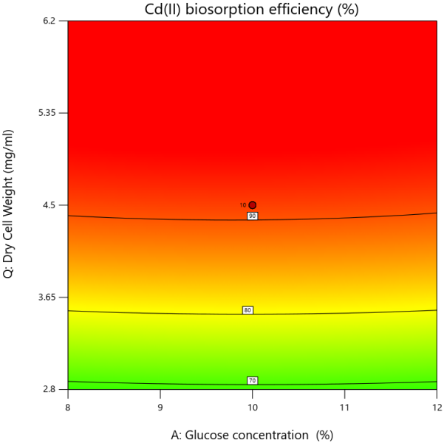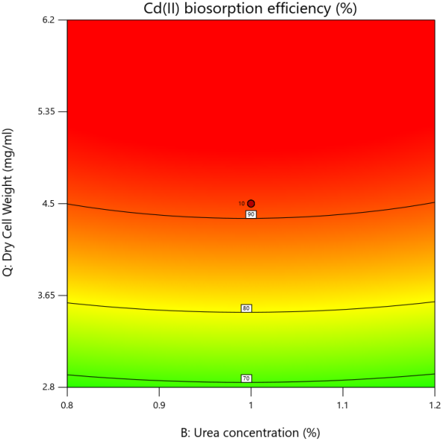
B
A

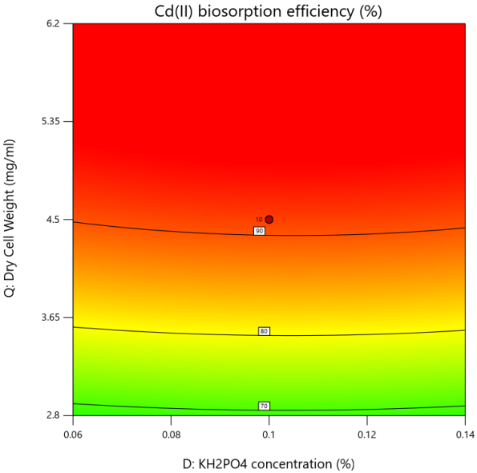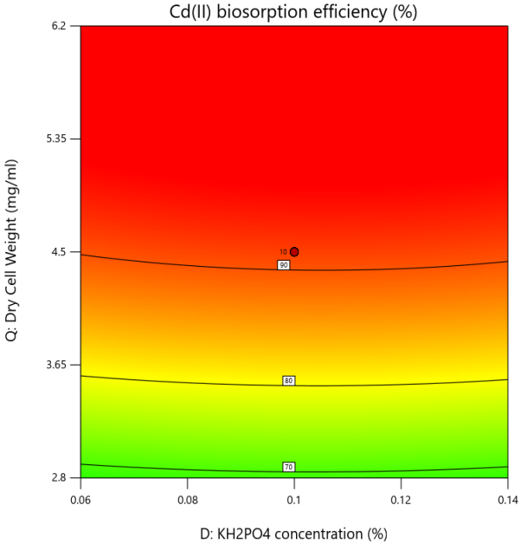
D
C

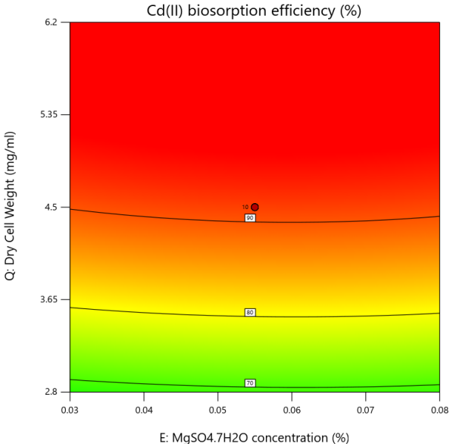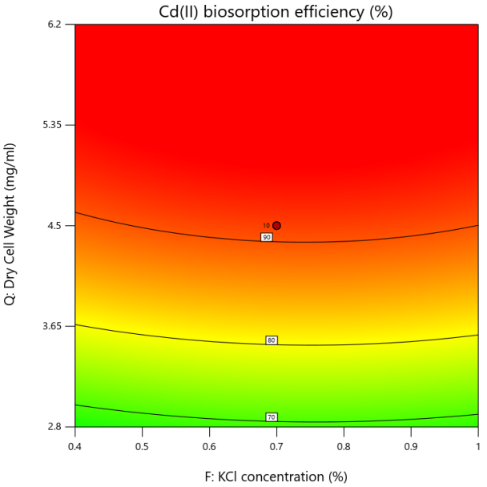
E
F

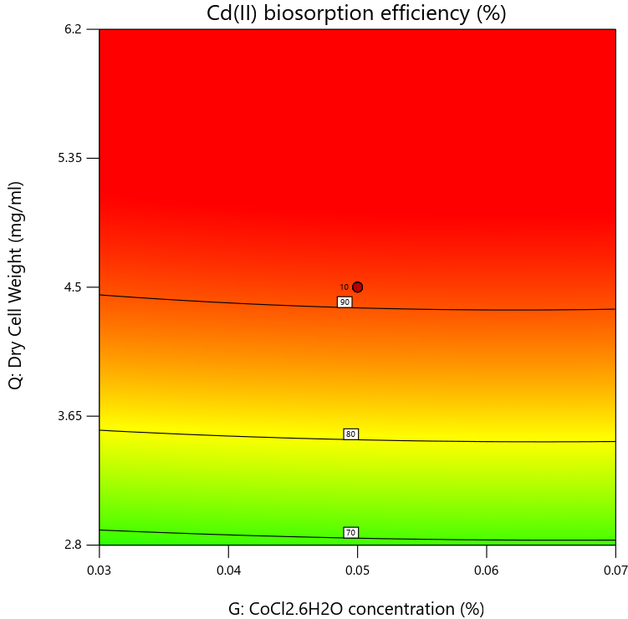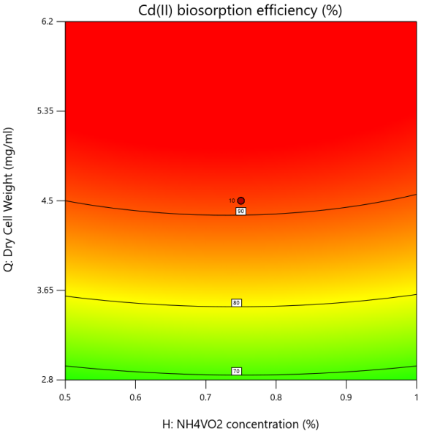
H
G

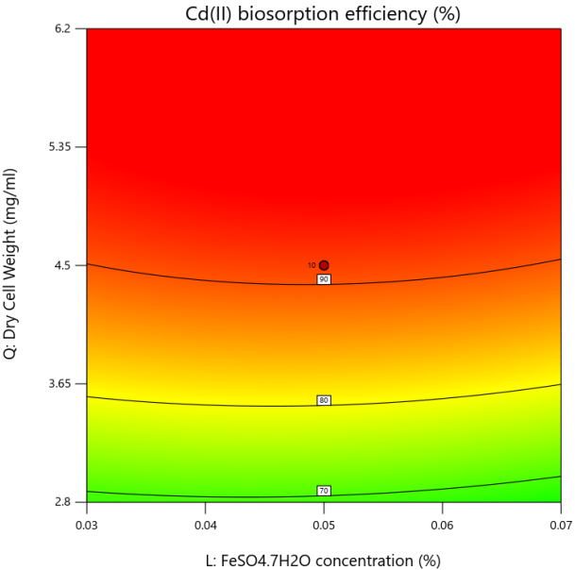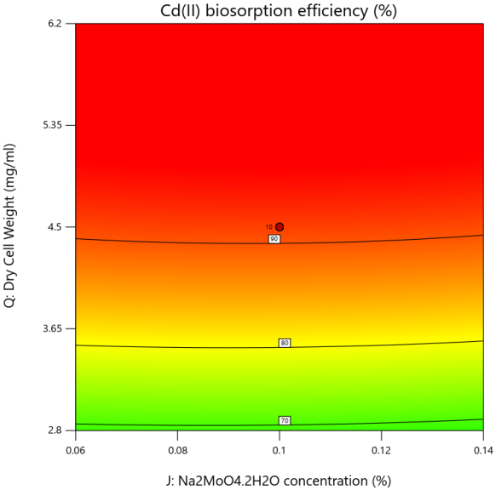
I
J

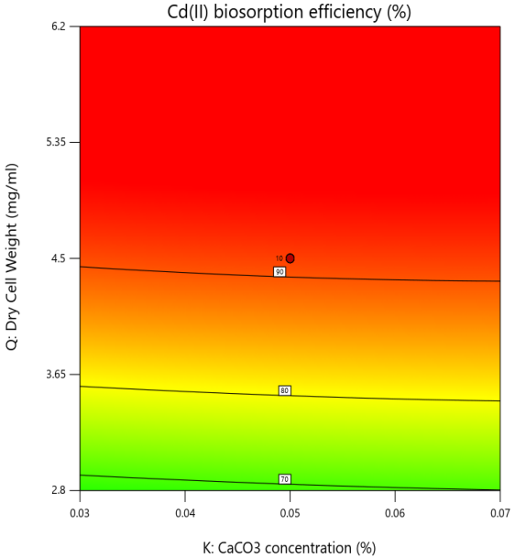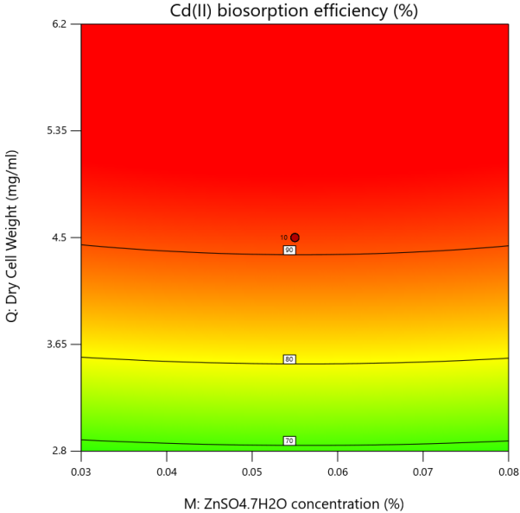
L
K

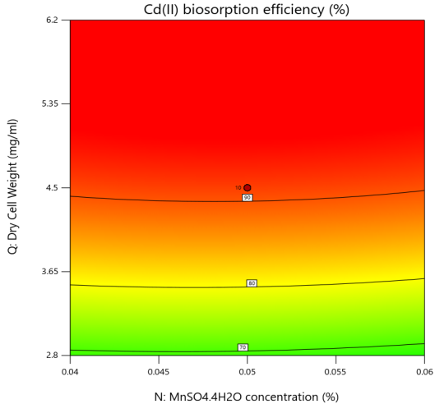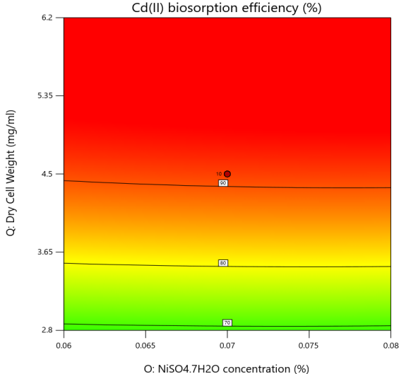
N
M

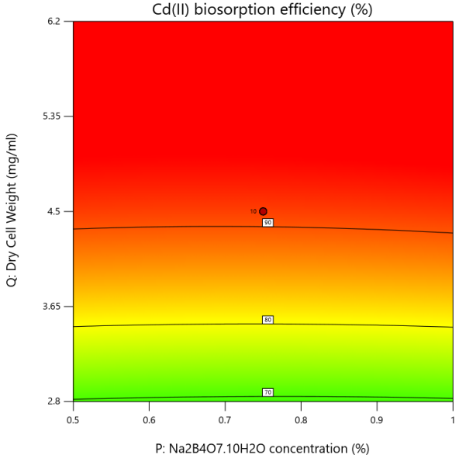
O

S Fig 1. Contour Plots For Surface Optimization of (A) Glucose concentration (%) (B) Urea concentration (%) (C) K₂HPO₄ concentration (%) (D) KH₂PO₄ concentration (%) (E) MgSO₄.7H₂O concentration (%) (F) KCl concentration (%) (G) CoCl₂.6H₂O concentration (%) (H) NH₄VO₂ concentration (%) (I) FeSO₄.7H₂O concentration (%) (J) Na₂MoO₄ concentration (%) (K) CaCO₃ concentration (%) (L) ZnSO₄.7H₂O concentration (%) (M) MnSO₄.7H₂O concentration (%) (N) NiSO₄.7H₂O concentration (%) (O) Na₂B₄O₇concentration (%)

