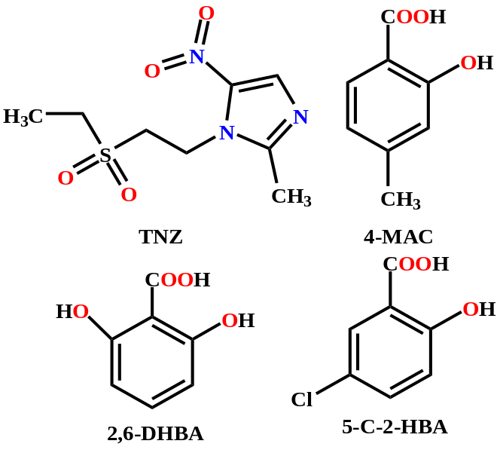

Scheme 1 Molecular Structures in This work.

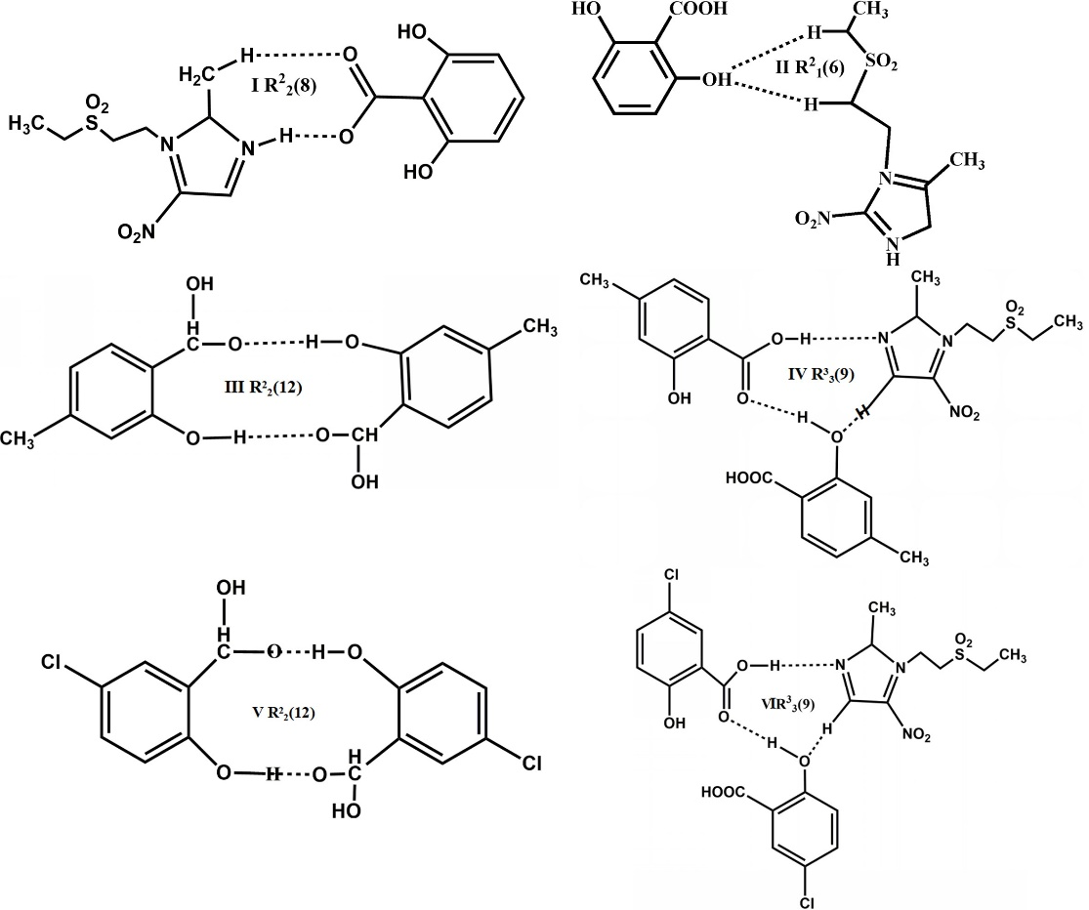
Scheme 2 The supramolecular synthons of 1-3

