Supporting information for this article：
Fig. S1: The IR spectras of 1-3
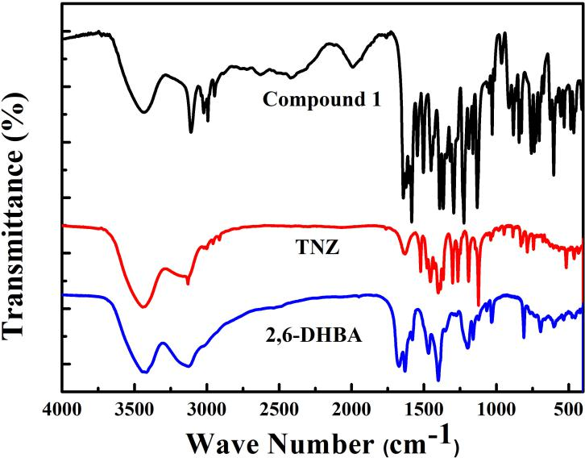
The IR cspectra of 1

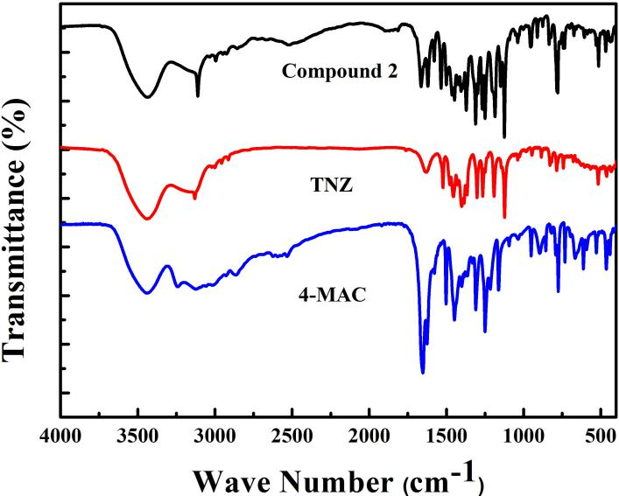
The IR spectra of 2
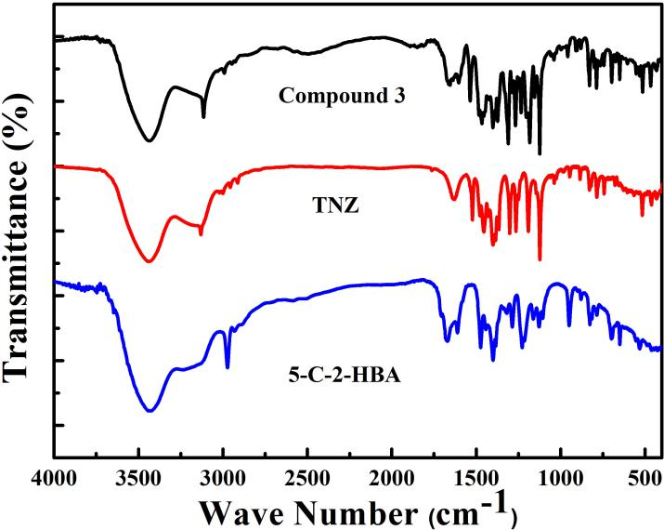
The IR spectra of 3
Fig. S2: Thermogravimetric analysis (TGA) curves of compounds
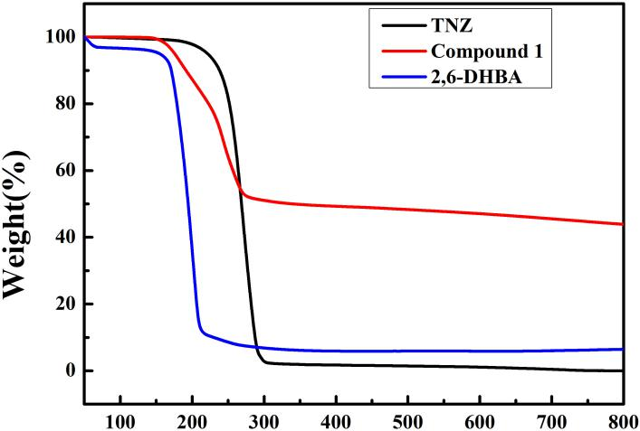
Fig. 4(a) The TGA curve of 1
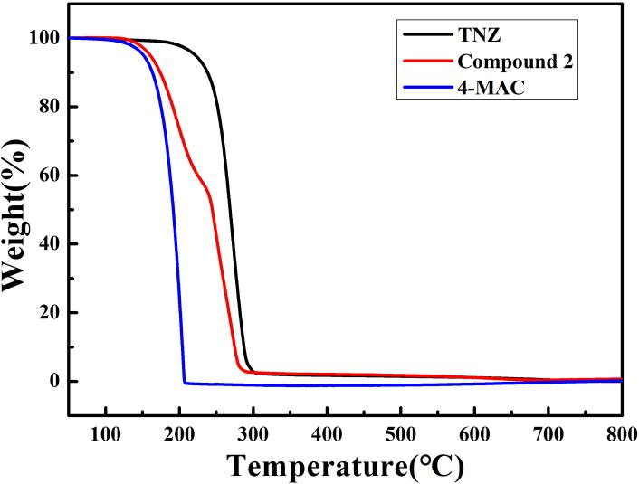
Fig. 4(b) The TGA curve of 2
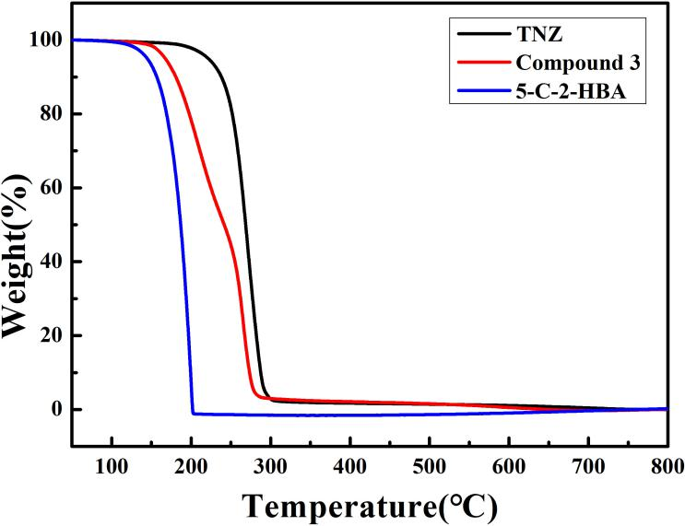
Fig. 4(c) The TGA curve of 3

