Temperature and pH responsive behavior of wormlike micelles formed by a long chain Gemini-like surfactant
Xiaomei Pei · Ting Pan¹ · Xu Han² · Yiqun Yan² · Junhui Wu¹· Binglei Song¹ · Zhao Chen¹ · Yao Gu¹

Fig. S1 Variations of surface tension with 2C18N3N/SA concentrations at 25°C.
Fig. S2 Variations of surface tension with 2C18N3N/AA concentrations at 25°C.

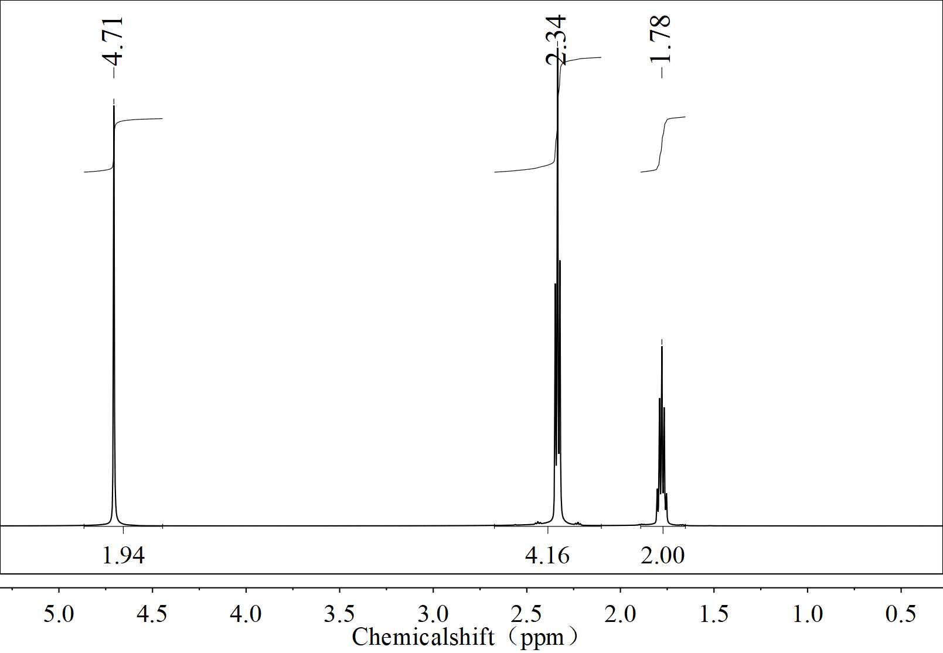
Fig. S3 ¹H NMR of GA in D₂O.

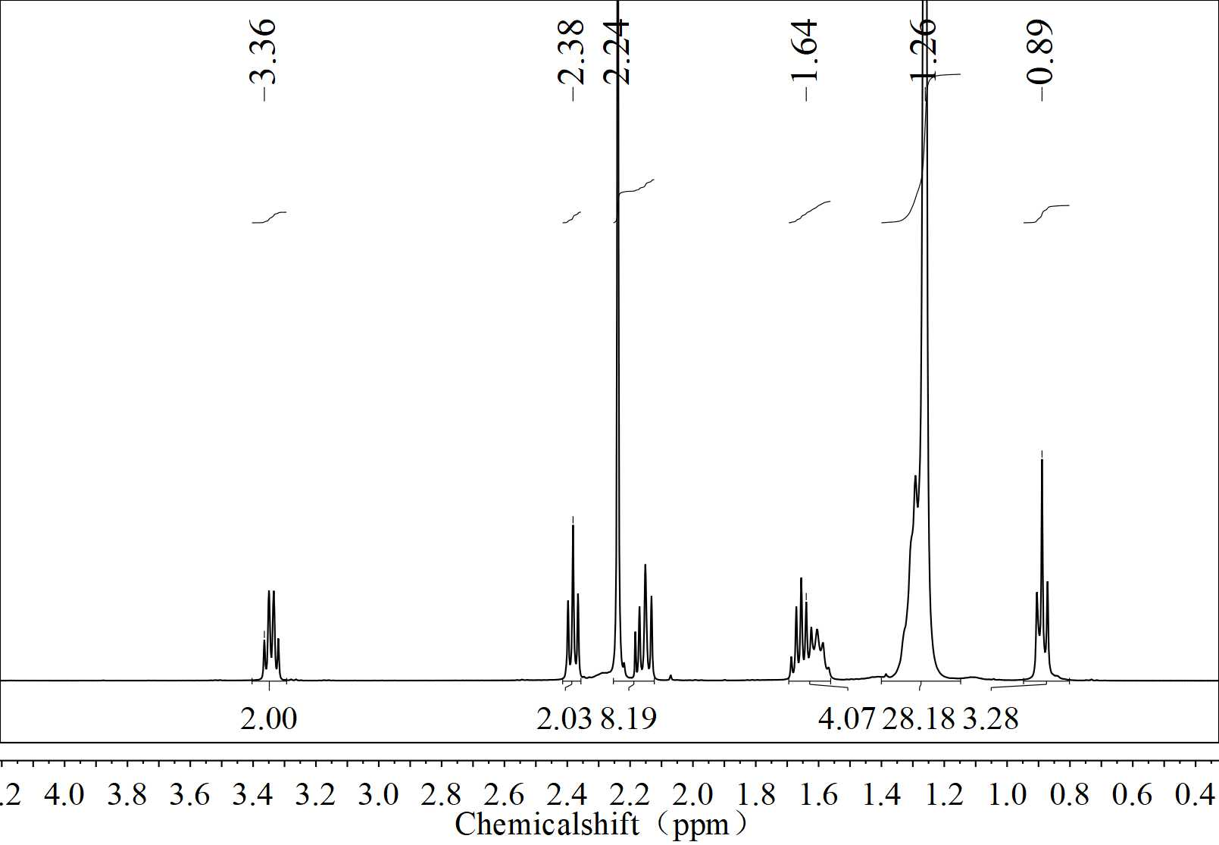
Fig. S4 ¹H NMR of C18N3N in CDCl₃.
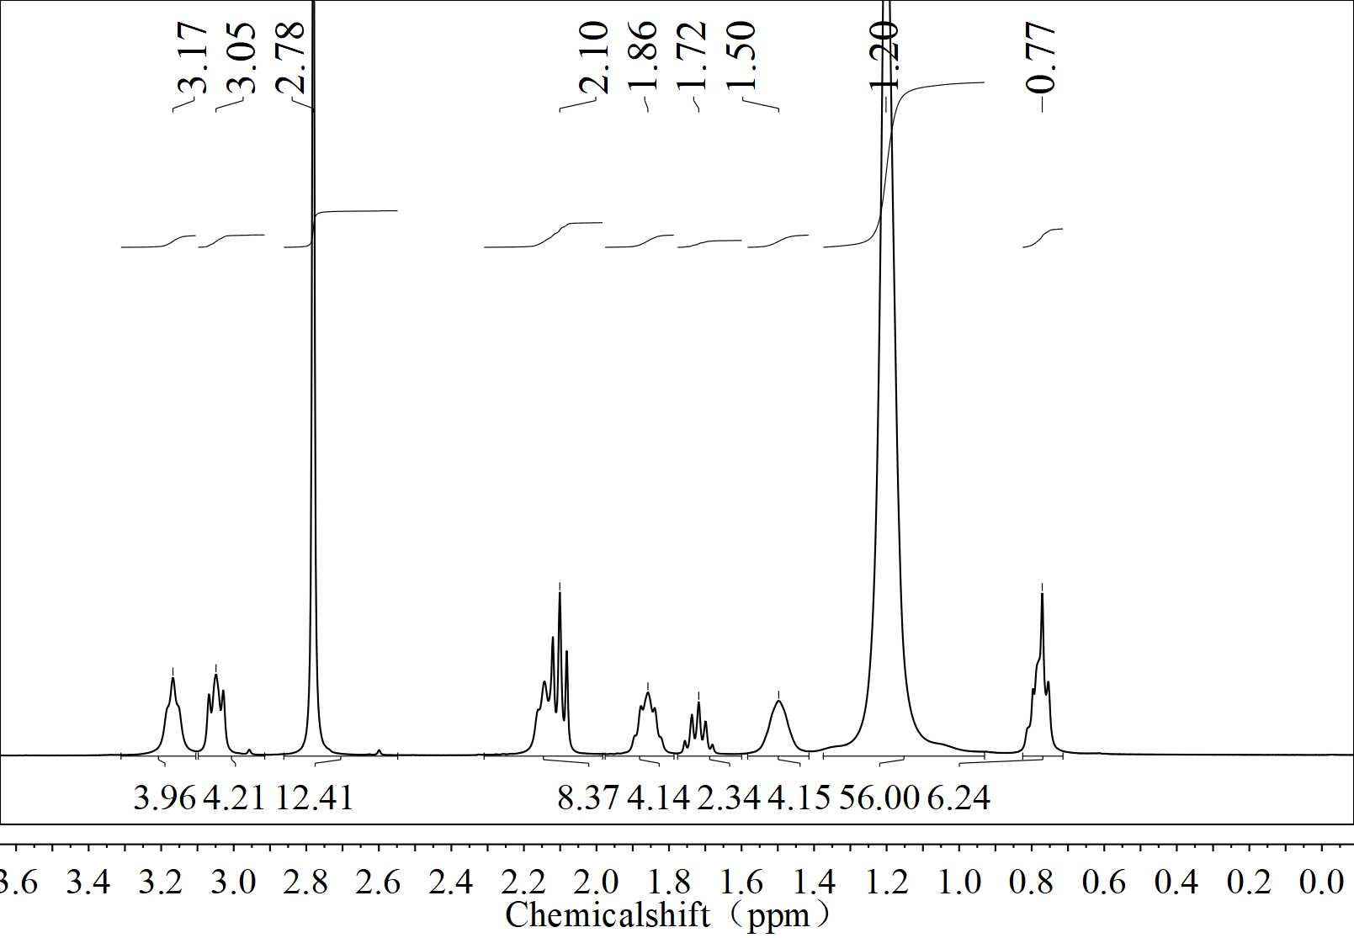
Fig. S5 ¹H NMR of 2C18N3N/GA in D₂O.
Fig. S6 Steady-state rheological behavior of 2C18N3N/SA solutions with different concentrations, T=60 °C.
Fig. S7 Steady-state rheological behavior of 2C18N3N/AA solutions with different concentrations, T=60 °C.
Fig. S8 Steady shear viscosity as a function of 2C18N3N/SA (300/150 mM) at different temperatures.
Fig. S9 Steady shear viscosity as a function of 2C18N3N/AA (300/150 mM) at different temperatures.

Corresponding author: Xiaomei Pei, pxmxiaomei@163.com ¹ The Key Laboratory of Synthetic and Biological Colloids, Ministry of Education, School of Chemical and Material Engineering, Jiangnan University, Wuxi, Jiangsu 214122, China. ² PetroChina Research Institute of Petroleum Exploration & Development, Beijing 100083, China.

