Supplementary Materials for

Entropy Removal of Medical Diagnostics

Shuhan He* et al.

*Corresponding author. Email: she@mgh.harvard.edu

This PDF file includes:

Supplementary Text
Fig. S1

Supplementary Text
Detailed walkthrough of patient dataset generation via bootstrapping
Synthetic patient datasets were generated according to data provided by validation/original papers (23, 24). The data generated was binary data with “0” denoting lack of disease and “1” denoting presence of disease. Data was then run through a machine learning model (sklearn DecisionTreeClassifier, 70% training/30% testing split, max depth = 5, criterion = entropy). This yielded information gain (entropy removal) and feature importance metrics for each step in the respective algorithms (see Fig. S1).

Fig. S1.
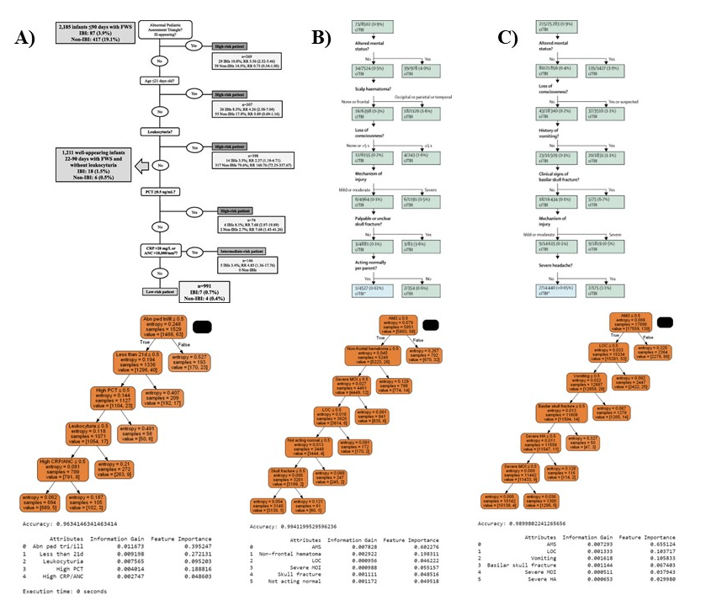
A) Figure taken from reference 23; breakdown of clinical algorithm was used to generate the corresponding patient dataset which yielded the following decision tree below it with information gain (entropy removal) and feature importance metrics listed directly below. B, C) Figures taken from reference 24 and analysis performed as in A.

