Mammal Research

Supplementary Information

Size does not matter: natural history and sexual dimorphism of the striped hog-nosed skunk (Carnivora, Mephitidae) in protected and anthropised landscapes of a Neotropical ecosystem

Giulianny A. Machado¹, Fernanda C. Azevedo^{1,2}, Mozart C. Freitas-Junior^{1,2}, Caio F. M. Lima^{2,3}, Gitana N. Cavalcanti⁴, André A. Cunha⁵, Kátia G. Facure⁶, Frederico G. Lemos^{1,2}

¹Laboratório da Biologia Integrativa e Conservação (LABIC), Departamento de Ciências Biológicas, Universidade Federal de Catalão, Catalão, Goiás, Brazil
²Programa de Conservação Mamíferos do Cerrado (PCMC), Fazenda Limoeiro, Cumari, Goiás, Brazil
³Fundação Parque Zoológico de São Paulo (FPZSP), São Paulo, São Paulo, Brazil
⁴Universidade Federal de Minas Gerais (UFMG), Belo Horizonte, Minas Gerais, Brazil
⁵Universidade de Brasília (UnB), Campus Universitário Darcy Ribeiro, Brasília, Distrito Federal, Brazil
⁶Universidade Federal de Uberlândia (UFU), Faculdade de Ciências Integradas do Pontal, Ituiutaba, Minas Gerais, Brazil

Correspondence: Giulianny A. Machado. E-mail: giulianny.alves@gmail.com

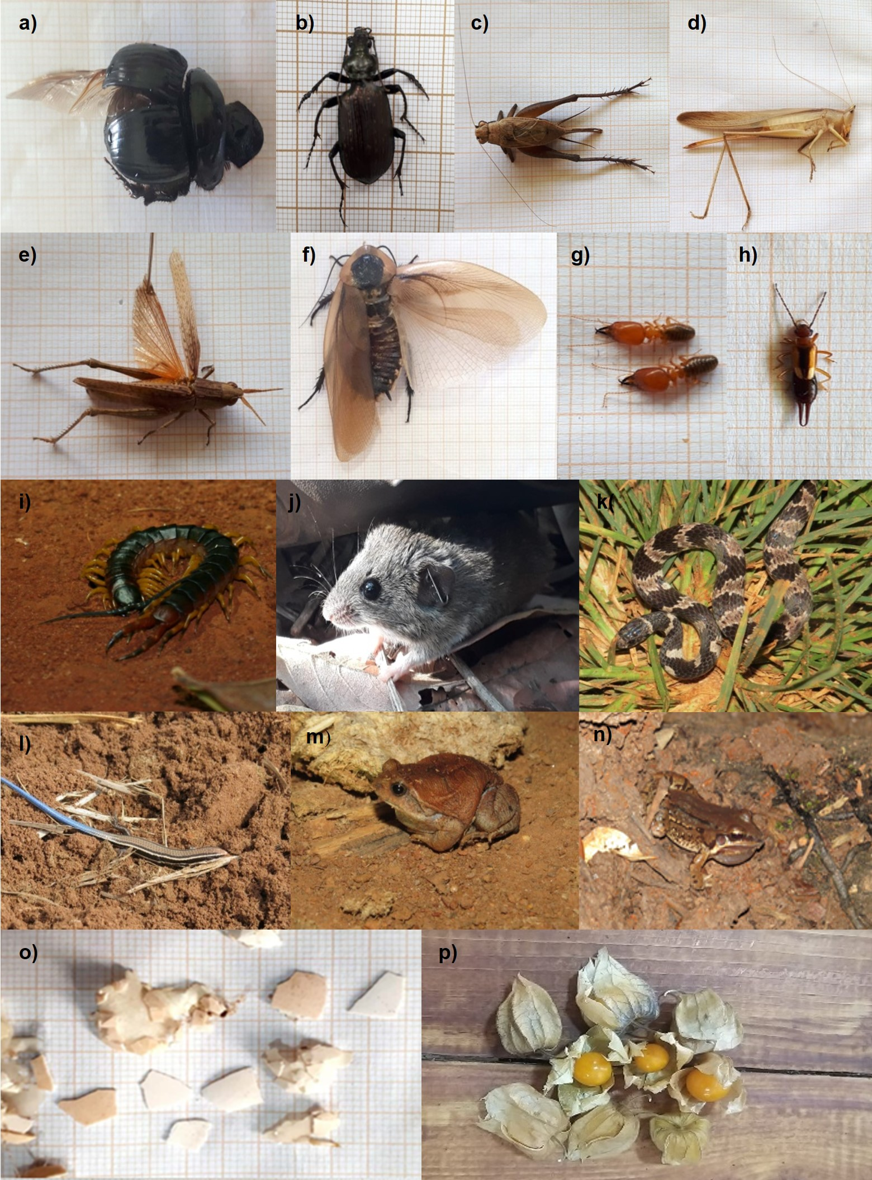
Fig. S1 Food items consumed by the striped hog-nosed skunk (Conepatus amazonicus) in anthropised landscapes and protected areas in Central Brazil between 2009 and 2020. a) Scarabaeidae, dung beetle; b) Carabidae, ground beetle; c) Gryllidae, cricket; d) Tettigoniidae, bush cricket; e) Acrididae, grasshopper; f) Blaberidae, native cockroach; g) Termitidae, termite; h); Forficulidae, earwig. Photograph credits: a–h Giulianny Alves; i) Scolopendromorpha, centipede (Mozart Freitas); j) Calomys tener, delicate vesper mouse (Ingrid de Mattos); k) Dipsas mikanii, Brazilian white-collared slug-eater; l) Micrablepharus atticolus, blue-tailed spectacled lizard; m) Physalaemus nattereri, four-eyed foam-nesting frog; n) Leptodactylus mystacinus, moustached frog (k–n Michelle Guastalla); o) eggshells (Aves); p) Physalis sp., husk tomato (o-p Giulianny Alves)
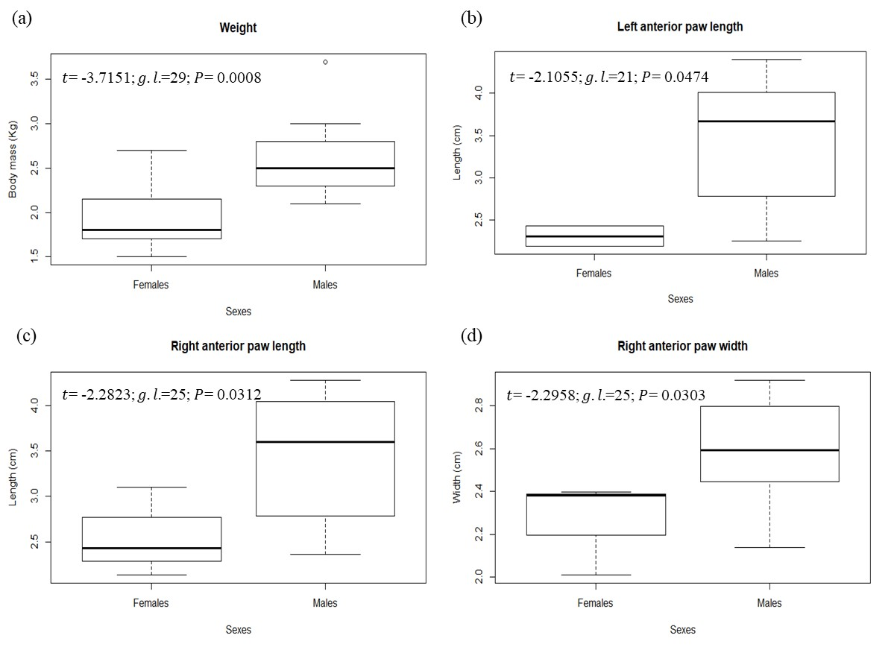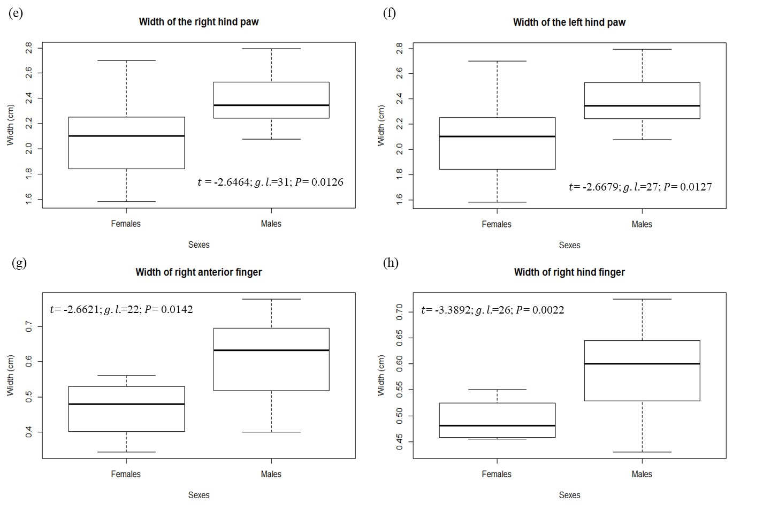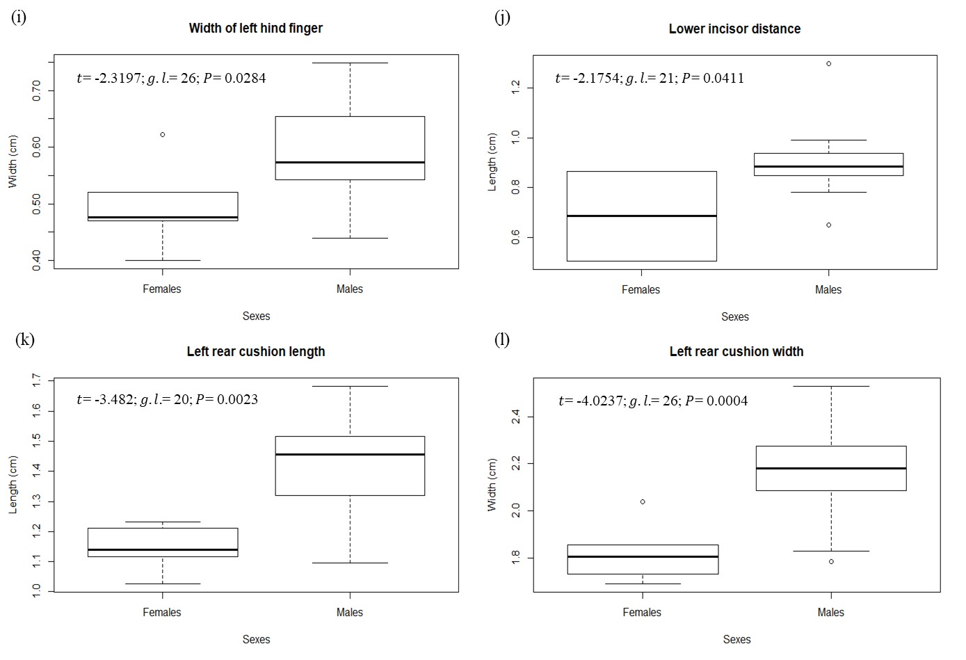
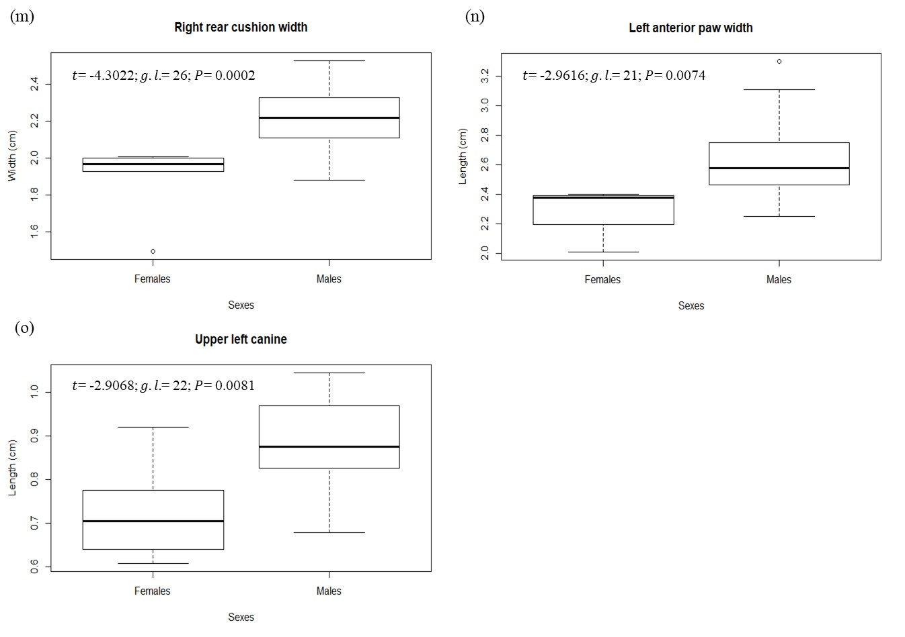
Fig. S2 Morphometric measurements of the striped hog-nosed skunk (Conepatus amazonicus) that showed sexual dimorphism in anthropised landscapes and protected areas in Central Brazil between 2009 and 2020

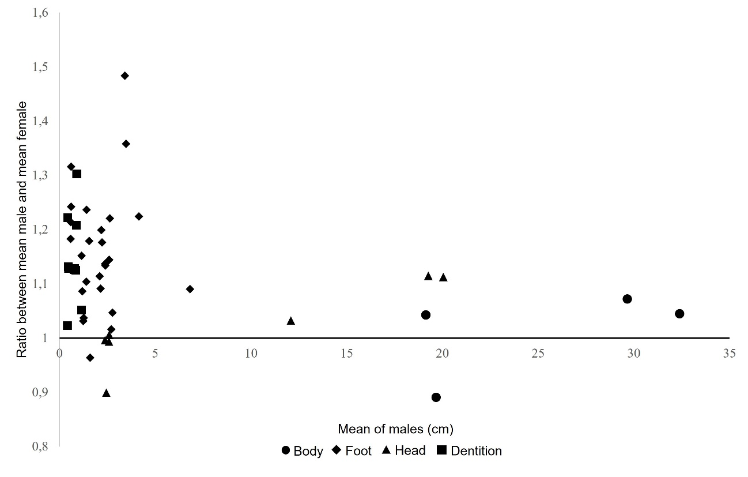
Fig. S3 Ratio between morphometric measurements of the body, foot, head, and dentition of males and females of the striped hog-nosed skunk (Conepatus amazonicus) in anthropised landscapes and protected areas in Central Brazil between 2009 and 2020

Table S1. Food items ingested by striped hog-nosed skunk (Conepatus amazonicus) in an agroecosystem in Central Brazil. Abbreviations: Absolute Frequency (AF), Relative Frequency (RF), Frequency of Occurrence (FO), and Percentage of Occurrence (PO). n = 22 individuals; *Accidental ingestion.
Food items | AF (count) | RF (%) | FO (%) | PO (%)
Invertebrata (sum) | 414 | 90.79 |  | 81.65
Insecta (sum) | 404 | 88.6 |  | 72.48
Coleoptera
Scarabaeidae
Scarabaeinae | 138 | 30.26 | 94.44 | 15.6
Carabidae | 23 | 5.04 | 16.67 | 2.75
Larva n.i. | 2 | 0.44 | 11.11 | 1.83
Orthoptera
Gryllidae | 72 | 15.79 | 94.44 | 15.6
Tettigoniidae | 2 | 0.44 | 11.11 | 1.83
Acrididae | 1 | 0.22 | 5.56 | 0.92
Lepidoptera
Saturniidae | 4 | 0.88 | 5.56 | 0.92
Larva n.i. | 17 | 3.73 | 27.78 | 4.59
Pupa n.i. | 5 | 1.1 | 22.22 | 3.67
n.i. | 1 | 0.22 | 5.56 | 0.92
Blattodea
Blaberidae | 10 | 2.19 | 44.44 | 7.34
Termitidae | 12 | 2.63 | 22.22 | 3.67
Hymenoptera
Fomicidae
Atta sp. | 1 | 0.22 | 5.56 | 0.92
n.i. | 2 | 0.44 | 5.56 | 0.92
Apidae
Bombus sp. | 1 | 0.22 | 5.56 | 0.92
Tetragonisca angustula | 73 | 16.01 | 5.56 | 0.92
n.i. | 1 | 0.22 | 5.56 | 0.92
Dermaptera
Forficulidae | 27 | 5.92 | 16.67 | 2.75
Diptera
Larva n.i.* | 3 | 0.66 | 5.56 | 0.92
Oestridae
Metacuterebra* | 5 | 1.1 | 11.11 | 1.83
Hemiptera
Cicadoidea | 3 | 0.66 | 11.11 | 1.83
n.i. | 1 | 0.22 | 5.56 | 0.92
Arachnida (sum) | 6 | 1.32 |  | 5.5
Araneae n.i. | 6 | 1.32 | 33.33 | 5.5
Chilopoda (sum) | 3 | 0.66 |  | 2.75
Scolopendromorpha n.i. | 3 | 0.66 | 16.67 | 2.75
Malacostraca (sum) | 1 | 0.22 |  | 0.92
Isopoda n.i | 1 | 0.22 | 5.56 | 0.92
Vertebrata (sum) | 19 | 4.17 |  | 14.68
Mammalia (sum) | 7 | 1.54 | 33.33 | 5.5
Rodentia
Cricetidae
Calomys tener | 3 | 0.66 | 11.11 | 1.83
n.i. | 4 | 0.88 | 22.22 | 3.67
Reptilia (sum) | 7 | 1.54 |  | 4.59
Squamata
Colubroidea
Dipsas mikanii | 1 | 0.22 | 5.56 | 0.92
Teiidae
Ameiva ameiva | 3 | 0.66 | 5.56 | 0.92
Gymnophthalmidae
Micrablepharus sp. | 1 | 0.22 | 5.56 | 0.92
Tropiduridae
Tropidurus sp. | 1 | 0.22 | 5.56 | 0.92
Lizard n.i. | 1 | 0.22 | 5.56 | 0.92
Amphibia (sum) | 3 | 0.66 |  | 2.75
Anura
Leptodactylidae
Leptodactylus mystacinus | 1 | 0.22 | 5.56 | 0.92
Physalaemus nattereri | 2 | 0.44 | 11.11 | 1.83
Aves (sum) | 1 | 0.22 |  | 0.92
Egg n.i. | 1 | 0.22 | 5.56 | 0.92
Vertebrates n.i (sum) | 1 | 0.22 |  | 0.92
Bones | 1 | 0.22 | 5.56 | 0.92
Plants (sum) | 23 | 5.04 |  | 3.67
Solanales (sum) | 21 | 4.61 |  | 1.83
Solanaceae
Physalis angulata | 14 | 3.07 | 5.56 | 0.92
Capsicum baccatum var. praetermissum | 7 | 1.54 | 5.56 | 0.92
n.i. (sum) | 2 | 0.44 |  | 1.83
Fruits n.i. | 2 | 0.44 | 11.11 | 1.83
Total | 456 | 100 |  | 100

Table S2. Food items ingested by striped hog-nosed skunk (Conepatus amazonicus) at the Emas National Park, Brazil. Abbreviations: Frequency of Occurrence (FO), and Percentage of Occurrence (PO). n = 8 stools; *Accidental ingestion.
Food items | FO (%) | PO (%)
Invertebrata (sum) |  | 82.76
Insecta (sum) |  | 68.97
Coleoptera
Scarabaeidae | 25 | 6.9
Scolytidae | 12.5 | 3.45
n.i. | 50 | 13.79
Larva | 37.5 | 10.34
Orthoptera
Gryllotalpidae | 87.5 | 24.14
n.i. | 12.5 | 3.45
Lepidoptera
n.i. | 12.5 | 3.45
Blattodea
Blaberidae | 12.5 | 3.45
Hymenoptera
Fomicidae | 37.5 | 10.34
Arachnida (sum) |  | 3.45
Araneae n.i. | 12.5 | 3.45
Vertebrata (sum) |  | 3.45
Bones n.i. | 12.5 | 3.45
Plants (sum) |  | 13.79
Leaves n.i.* | 12.5 | 3.45
Seeds n.i.* | 37.5 | 10.34
Total |  | 100

Table S3. Amount of food items consumed by females (n = 11) and males (n = 9) of the striped hog-nosed skunk (Conepatus amazonicus), and individuals of unidentified sex (n = 2) in anthropised landscapes in Central Brazil between 2009 and 2020.
Food items |  | Females | Males | Unidentified
Coleoptera | Scarabaeidae | 94 | 43 | 1
Coleoptera | Carabidae | 2 | 0 | 21
Coleoptera | larva n.i. | 1 | 0 | 1
Orthoptera | Gryllidae | 53 | 18 | 1
Orthoptera | Tettigoniidae | 1 | 1 | 0
Orthoptera | Acrididae | 0 | 1 | 0
Lepidoptera | n.i. | 0 | 0 | 1
Lepidoptera | larva n.i. | 14 | 2 | 1
Lepidoptera | pupa n.i. | 3 | 2 | 0
Lepidoptera | Saturniidae | 0 | 4 | 0
Araneae | n.i. | 2 | 4 | 0
Blattodea | Termitidae | 4 | 4 | 4
Blattodea | Blaberidae | 4 | 5 | 1
Fomicidae | Atta sp. | 0 | 1 | 0
Fomicidae | n.i | 2 | 0 | 0
Apidae | Bombus sp. | 0 | 0 | 1
Apidae | Tetragonisca angustula | 0 | 73 | 0
Apidae | n.i. | 0 | 0 | 1
Diptera | larva n.i. | 0 | 3 | 0
Diptera | Cuterebra sp. | 2 | 0 | 3
Isecta | n.i | 0 | 1 | 0
Hemiptera | Cicadoidea | 2 | 1 | 0
Dermaptera | Forficulidae | 22 | 5 | 0
Chilopoda | n.i | 1 | 2 | 0
Isopoda | n.i | 1 | 0 | 0
Squamata | Dipsas mikanii | 1 | 0 | 0
Squamata | Ameiva ameiva | 0 | 3 | 0
Squamata | Micrablepharus sp. | 0 | 1 | 0
Squamata | Tropidurus sp. | 1 | 0 | 0
Squamata | Lizard n.i | 0 | 1 | 0
Anura | Leptodactylus mystacinus | 0 | 1 | 0
Anura | Physalaemus nattereri | 0 | 2 | 0
Rodentia | Calomys tener | 1 | 0 | 2
Rodentia | n.i. | 2 | 2 | 0
Ossos | n.i. | 1 | 0 | 0
Aves | ovo n.i | 0 | 1 | 0
Plantae | Physalis angulata | 0 | 14 | 0
Plantae | Capsicum baccatum var. praetermissum | 0 | 7 | 0
Plantae | n.i | 1 | 1 | 0
Total | 39 types of food items | 215 | 203 | 38

Table S4. Morphometric measurements of males (M) and females (F) of the striped hog-nosed skunk (Conepatus amazonicus) in anthropised landscapes and protected areas in Central Brazil between 2009 and 2020.
Measurement | Sex | Minimum | 1st Quartile | Median | 3rd Quartile | Maximum | Average | Standard deviation | n | Missing  data | Shapiro-Wilk (P) | Levene
Weight (g) | F | 1.500 | 1.700 | 2.000 | 2.150 | 2.700 | 1.955 | 0.362 | 11 | 1 | 0.428
Weight (g) | M | 1.400 | 2.275 | 2.500 | 2.800 | 3.700 | 2.507 | 0.439 | 28 | 0 | 0.179
Body length (cm) | F | 28.000 | 30.000 | 32.000 | 32.000 | 33.000 | 31.000 | 2.000 | 5 | 7 | 0.440
Body length (cm) | M | 27.000 | 30.625 | 33.000 | 34.000 | 41.000 | 32.392 | 3.456 | 26 | 2 | 0.307
Tail length (cm) | F | 18.500 | 21.000 | 22.500 | 23.250 | 25.000 | 22.071 | 2.188 | 7 | 5 | 0.824
Tail length (cm) | M | 10.000 | 19.000 | 20.250 | 21.875 | 25.000 | 19.665 | 3.231 | 26 | 2 | 0.008
Head length (cm) | F | 10.000 | 11.125 | 11.500 | 11.500 | 14.700 | 11.700 | 15.811 | 6 | 6 | 0.059
Head length (cm) | M | 10.500 | 11.125 | 11.750 | 13.000 | 16.000 | 12.081 | 12.722 | 26 | 2 | 0.008
Total length (cm) | F | 62.500 | 63.500 | 66.000 | 67.000 | 67.500 | 65.300 | 2.197 | 5 | 7 | 0.410
Total length (cm) | M | 54.000 | 60.250 | 64.500 | 68.000 | 74.500 | 64.067 | 5.617 | 24 | 4 | 0.533
Height (cm) | F | 16.000 | 16.375 | 18.250 | 20.225 | 20.900 | 18.350 | 2.461 | 4 | 8 | 0.255
Height (cm) | M | 16.000 | 18.525 | 19.000 | 20.000 | 22.000 | 19.132 | 1.478 | 22 | 6 | 0.607
Metatarsus (cm) | F | 2.000 | 3.000 | 3.290 | 4.150 | 4.500 | 3.388 | 0.988 | 5 | 7 | 0.830
Metatarsus (cm) | M | 2.000 | 3.888 | 4.190 | 4.500 | 6.000 | 4.148 | 0.967 | 20 | 8 | 0.083
Foot length (cm) | F | 4.500 | 6.103 | 6.605 | 6.800 | 7.000 | 6.252 | 0.929 | 6 | 6 | 0.068
Foot length (cm) | M | 4.500 | 6.633 | 6.965 | 7.500 | 8.200 | 6.817 | 0.921 | 26 | 2 | 0.056
Head  circumference (cm) | F | 16.000 | 16.050 | 17.100 | 18.375 | 19.000 | 17.283 | 1.372 | 6 | 6 | 0.102
Head  circumference (cm) | M | 16.000 | 18.075 | 19.500 | 20.500 | 22.000 | 19.269 | 1.624 | 26 | 2 | 0.462
Neck circumference (cm) | F | 15.500 | 16.200 | 17.900 | 19.750 | 20.800 | 18.017 | 2.215 | 6 | 6 | 0.437
Neck circumference (cm) | M | 15.100 | 19.200 | 20.000 | 21.375 | 23.000 | 20.046 | 1.616 | 26 | 2 | 0.075
Thorax circumference (cm) | F | 22.000 | 25.625 | 28.250 | 29.375 | 33.000 | 27.667 | 3.817 | 6 | 6 | 0.972
Thorax circumference (cm) | M | 22.100 | 28.625 | 29.000 | 30.000 | 41.000 | 29.662 | 3.225 | 26 | 2 | 0.001
Right ear (cm) | F | 2.000 | 2.023 | 2.425 | 2.980 | 3.460 | 2.578 | 0.700 | 4 | 8 | 0.320
Right ear (cm) | M | 1.248 | 2.250 | 2.740 | 2.894 | 3.523 | 2.593 | 0.570 | 15 | 13 | 0.236
Upper right  canine (cm) | F | 0.610 | 0.633 | 0.750 | 0.868 | 0.890 | 0.750 | 0.145 | 4 | 8 | 0.161
Upper right  canine (cm) | M | 0.579 | 0.793 | 0.840 | 0.916 | 1.000 | 0.844 | 0.105 | 19 | 9 | 0.580
Lower right  canine (cm) | F | 0.500 | 0.563 | 0.620 | 0.820 | 0.960 | 0.693 | 0.192 | 5 | 7 | 0.535 | 0.036
Lower right  canine (cm) | M | 0.595 | 0.732 | 0.773 | 0.864 | 0.960 | 0.782 | 0.107 | 19 | 9 | 0.399
Right anterior  paw (cm) | F | 2.135 | 2.285 | 2.434 | 2.767 | 3.100 | 2.556 | 0.494 | 3 | 9 | 0.587
Right anterior  paw (cm) | M | 2.364 | 2.796 | 3.602 | 4.038 | 4.280 | 3.472 | 0.667 | 24 | 4 | 0.008
Right anterior  pad (cm) | F | 0.915 | 0.997 | 1.052 | 1.368 | 2.230 | 1.312 | 0.616 | 4 | 8 | 0.027
Right anterior  pad (cm) | M | 0.910 | 1.019 | 1.286 | 2.178 | 2.541 | 1.547 | 0.604 | 20 | 8 | 0.003
Right anterior  finger (cm) | F | 1.160 | 1.165 | 1.204 | 1.244 | 1.254 | 1.205 | 0.049 | 4 | 8 | 0.168 | 0.016
Right anterior  finger (cm) | M | 0.987 | 1.097 | 1.201 | 1.374 | 1.600 | 1.243 | 0.183 | 20 | 8 | 0.259
Right  hindlimb (cm) | F | 2.260 | 2.277 | 2.280 | 2.553 | 3.836 | 2.641 | 0.679 | 5 | 7 | 0.005
Right  hindlimb (cm) | M | 2.394 | 2.550 | 2.694 | 2.835 | 4.060 | 2.764 | 0.387 | 17 | 11 | 0.000
Right posterior  pad (cm) | F | 1.042 | 1.070 | 1.190 | 1.319 | 1.800 | 1.269 | 0.285 | 6 | 6 | 0.102 | 0.037
Right posterior  pad (cm) | M | 1.220 | 1.319 | 1.400 | 1.448 | 1.600 | 1.401 | 0.112 | 16 | 12 | 0.690
Right posterior finger (cm) | F | 0.954 | 1.011 | 1.098 | 1.195 | 1.247 | 1.101 | 0.119 | 6 | 6 | 0.607
Right posterior finger (cm) | M | 0.780 | 1.117 | 1.228 | 1.363 | 1.508 | 1.196 | 0.214 | 22 | 6 | 0.059
Right testicle (cm) | F | NA | NA | NA | NA | NA | NA | NA | 0 | 12
Right testicle (cm) | M | 1.606 | 1.797 | 1.870 | 2.084 | 2.540 | 1.950 | 0.274 | 14 | 14
Left ear (cm) | F | 2.290 | 2.505 | 2.720 | 2.760 | 2.800 | 2.603 | 0.274 | 3 | 9 | 0.280
Left ear (cm) | M | 1.015 | 2.289 | 2.800 | 3.000 | 3.200 | 2.587 | 0.579 | 17 | 11 | 0.019
Upper left  canine (cm) | F | 0.607 | 0.655 | 0.705 | 0.759 | 0.920 | 0.725 | 0.112 | 6 | 6 | 0.513
Upper left  canine (cm) | M | 0.678 | 0.830 | 0.891 | 0.968 | 1.046 | 0.877 | 0.110 | 18 | 10 | 0.367
Lower left  canine (cm) | F | 0.547 | 0.569 | 0.590 | 0.730 | 0.870 | 0.669 | 0.175 | 3 | 9 | 0.235
Lower left  canine (cm) | M | 0.522 | 0.693 | 0.749 | 0.844 | 0.935 | 0.754 | 0.118 | 21 | 7 | 0.562
Left anterior  paw (cm) | F | 2.190 | 2.251 | 2.311 | 2.372 | 2.432 | 2.311 | 0.171 | 2 | 10 |  | 0.006
Left anterior  paw (cm) | M | 2.250 | 2.785 | 3.668 | 4.007 | 4.400 | 3.428 | 0.734 | 21 | 7
Left anterior  pad (cm) | F | 0.958 | 1.020 | 1.570 | 2.208 | 2.530 | 1.657 | 0.781 | 4 | 8 | 0.275
Left anterior  pad (cm) | M | 0.965 | 1.075 | 1.380 | 2.222 | 2.740 | 1.597 | 0.621 | 19 | 9 | 0.005
Left anterior  finger (cm) | F | 1.084 | 1.152 | 1.220 | 1.285 | 1.350 | 1.218 | 0.133 | 3 | 9 | 0.975
Left anterior  finger (cm) | M | 0.944 | 1.144 | 1.268 | 1.411 | 1.516 | 1.263 | 0.173 | 19 | 9 | 0.385
Left posterior  paw (cm) | F | 2.210 | 2.240 | 2.432 | 2.447 | 4.012 | 2.668 | 0.759 | 5 | 7 | 0.005 | 0.004
Left posterior  paw (cm) | M | 2.422 | 2.551 | 2.704 | 2.831 | 3.086 | 2.711 | 0.190 | 16 | 12 | 0.899
Left posterior  pad (cm) | F | 1.026 | 1.117 | 1.140 | 1.210 | 1.232 | 1.145 | 0.082 | 5 | 7 | 0.729
Left posterior  pad (cm) | M | 1.095 | 1.320 | 1.457 | 1.515 | 1.683 | 1.416 | 0.166 | 17 | 11 | 0.402
Left posterior  finger (cm) | F | 0.808 | 0.928 | 0.984 | 1.100 | 1.200 | 1.004 | 0.152 | 5 | 7 | 0.977
Left posterior  finger (cm) | M | 0.842 | 0.996 | 1.113 | 1.267 | 1.550 | 1.156 | 0.203 | 23 | 5 | 0.255
Left testicle (cm) | F | NA | NA | NA | NA | NA | NA | NA | 0 | 12
Left testicle (cm) | M | 1.634 | 1.738 | 1.955 | 2.034 | 2.447 | 1.952 | 0.269 | 14 | 14
Right ear  width (cm) | F | 2.280 | 2.280 | 2.300 | 2.415 | 2.700 | 2.395 | 0.204 | 4 | 8 | 0.011
Right ear  width (cm) | M | 1.491 | 1.930 | 2.400 | 2.647 | 3.500 | 2.386 | 0.592 | 16 | 12 | 0.306
Upper right canine width (cm) | F | 0.310 | 0.380 | 0.400 | 0.490 | 0.520 | 0.420 | 0.085 | 5 | 7 | 0.749
Upper right canine width (cm) | M | 0.360 | 0.453 | 0.494 | 0.506 | 0.530 | 0.474 | 0.050 | 20 | 8 | 0.005
Right lower canine width (cm) | F | 0.280 | 0.300 | 0.326 | 0.510 | 0.610 | 0.405 | 0.147 | 5 | 7 | 0.189 | 0.000
Right lower canine width (cm) | M | 0.310 | 0.372 | 0.419 | 0.459 | 0.530 | 0.415 | 0.059 | 20 | 8 | 0.915
Right forelimb width (cm) | F | 2.010 | 2.195 | 2.380 | 2.390 | 2.399 | 2.263 | 0.219 | 3 | 9 | 0.083
Right forelimb width (cm) | M | 2.140 | 2.448 | 2.593 | 2.794 | 2.920 | 2.590 | 0.234 | 24 | 4 | 0.166
Right anterior pad width (cm) | F | 1.710 | 1.770 | 1.800 | 1.855 | 2.300 | 1.887 | 0.237 | 5 | 7 | 0.036
Right anterior pad width (cm) | M | 1.760 | 1.943 | 2.089 | 2.231 | 2.568 | 2.102 | 0.216 | 19 | 9 | 0.804
Right anterior finger width (cm) | F | 0.344 | 0.431 | 0.480 | 0.515 | 0.561 | 0.466 | 0.091 | 4 | 8 | 0.822
Right anterior finger width (cm) | M | 0.400 | 0.519 | 0.633 | 0.693 | 0.778 | 0.614 | 0.103 | 20 | 8 | 0.596
Right hindlimb width (cm) | F | 1.580 | 1.904 | 2.104 | 2.216 | 2.700 | 2.096 | 0.380 | 6 | 6 | 0.905
Right hindlimb width (cm) | M | 2.076 | 2.245 | 2.344 | 2.530 | 2.796 | 2.383 | 0.203 | 27 | 1 | 0.281
Right posterior pad width (cm) | F | 1.495 | 1.934 | 1.968 | 2.000 | 2.010 | 1.896 | 0.199 | 6 | 6 | 0.001
Right posterior pad width (cm) | M | 1.880 | 2.126 | 2.220 | 2.318 | 2.530 | 2.229 | 0.160 | 22 | 6 | 0.872
Right posterior finger width (cm) | F | 0.455 | 0.463 | 0.485 | 0.523 | 0.550 | 0.494 | 0.039 | 6 | 6 | 0.388
Right posterior finger width (cm) | M | 0.430 | 0.545 | 0.603 | 0.648 | 0.725 | 0.600 | 0.073 | 22 | 6 | 0.657
Right testicle  width (cm) | F |  |  |  |  |  |  |  | 0 | 12
Right testicle  width (cm) | M | 1.114 | 1.474 | 1.582 | 1.625 | 1.700 | 1.510 | 0.191 | 14 | 14
Left ear width (cm) | F | 2.570 | 2.600 | 2.630 | 2.815 | 3.000 | 2.733 | 0.233 | 3 | 9 | 0.247
Left ear width (cm) | M | 1.085 | 2.045 | 2.350 | 2.912 | 3.500 | 2.457 | 0.639 | 18 | 10 | 0.627
Upper left canine width (cm) | F | 0.350 | 0.368 | 0.385 | 0.438 | 0.490 | 0.408 | 0.073 | 3 | 9 | 0.463
Upper left canine width (cm) | M | 0.330 | 0.431 | 0.461 | 0.511 | 0.550 | 0.462 | 0.058 | 20 | 8 | 0.330
Lower left canine width (cm) | F | 0.230 | 0.252 | 0.329 | 0.424 | 0.500 | 0.347 | 0.126 | 4 | 8 | 0.525
Lower left canine width (cm) | M | 0.278 | 0.373 | 0.398 | 0.459 | 0.588 | 0.424 | 0.077 | 22 | 6 | 0.369
Left front paw width (cm) | F | 2.030 | 2.113 | 2.196 | 2.223 | 2.250 | 2.159 | 0.115 | 3 | 9 | 0.454
Left front paw width (cm) | M | 2.250 | 2.468 | 2.580 | 2.750 | 3.300 | 2.635 | 0.271 | 20 | 8 | 0.082
Left anterior pad width (cm) | F | 1.700 | 1.735 | 1.798 | 2.038 | 2.600 | 1.974 | 0.422 | 4 | 8 | 0.044
Left anterior pad width (cm) | M | 1.737 | 1.935 | 2.127 | 2.274 | 2.825 | 2.154 | 0.284 | 19 | 9 | 0.485
Left anterior finger width (cm) | F | 0.430 | 0.470 | 0.510 | 0.517 | 0.524 | 0.488 | 0.051 | 3 | 9 | 0.265
Left anterior finger width (cm) | M | 0.430 | 0.530 | 0.600 | 0.669 | 0.800 | 0.606 | 0.099 | 19 | 9 | 0.632
Left posterior paw width (cm) | F | 1.870 | 1.916 | 2.060 | 2.191 | 2.600 | 2.115 | 0.277 | 6 | 6 | 0.164
Left posterior paw width (cm) | M | 2.045 | 2.240 | 2.400 | 2.508 | 2.877 | 2.399 | 0.220 | 23 | 5 | 0.781
Left posterior pad width (cm) | F | 1.690 | 1.732 | 1.807 | 1.855 | 2.040 | 1.825 | 0.136 | 5 | 7 | 0.568
Left posterior pad width (cm) | M | 1.784 | 2.085 | 2.180 | 2.275 | 2.530 | 2.189 | 0.191 | 23 | 5 | 0.755
Left posterior finger width (cm) | F | 0.400 | 0.470 | 0.476 | 0.520 | 0.622 | 0.498 | 0.082 | 5 | 7 | 0.759
Left posterior finger width (cm) | M | 0.440 | 0.543 | 0.573 | 0.654 | 0.749 | 0.589 | 0.079 | 23 | 5 | 0.447
Left testicle  width (cm) | F |  |  |  |  |  |  |  | 0 | 12
Left testicle  width (cm) | M | 1.113 | 1.408 | 1.570 | 1.618 | 1.850 | 1.509 | 0.207 | 14 | 14
Upper incisor distance (cm) | F | 1.001 | 1.030 | 1.075 | 1.127 | 1.178 | 1.082 | 0.078 | 4 | 8 | 0.838
Upper incisor distance (cm) | M | 0.950 | 1.078 | 1.105 | 1.187 | 1.400 | 1.138 | 0.098 | 20 | 8 | 0.082
Lower incisor distance (cm) | F | 0.503 | 0.594 | 0.685 | 0.775 | 0.866 | 0.685 | 0.257 | 2 | 10
Lower incisor distance (cm) | M | 0.649 | 0.847 | 0.885 | 0.937 | 1.300 | 0.892 | 0.119 | 21 | 7

