Table 3. Subgroup analysis of study groups.
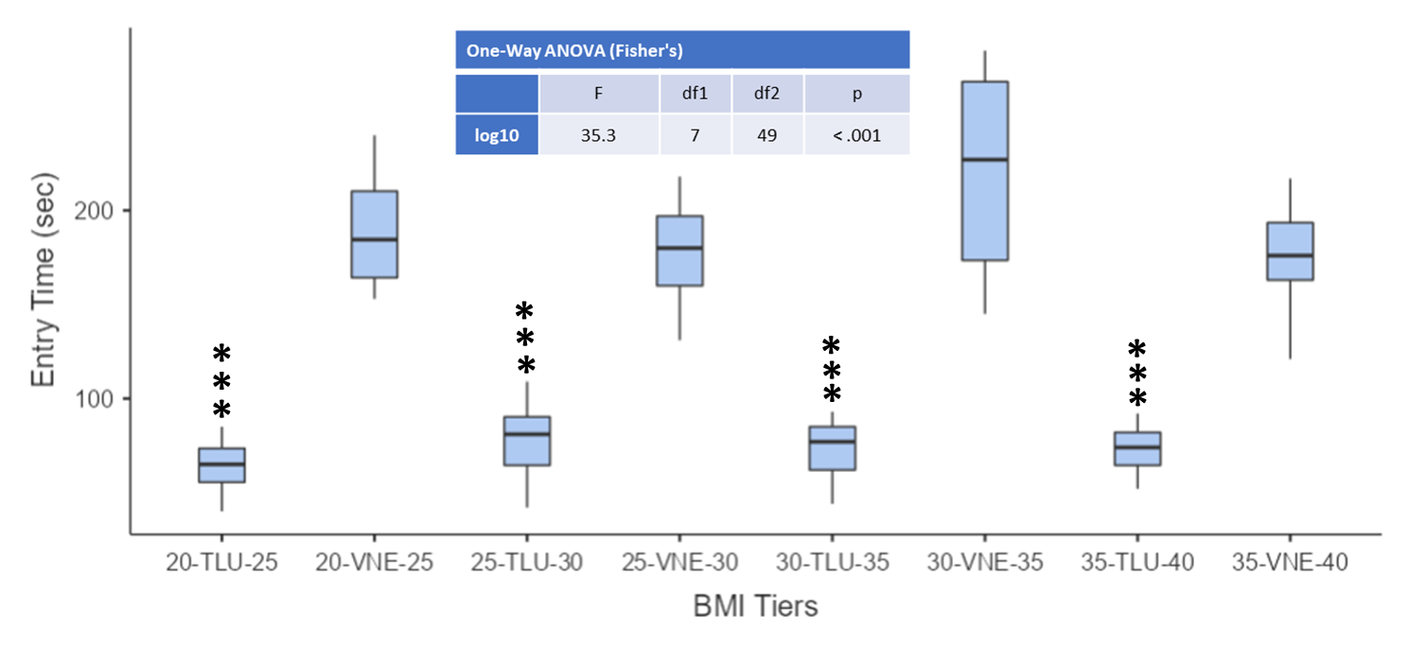

BMI, body mass index; VNE, Veress needle-entry; TLU, teres lift-up. Note. * p < .05, ** p < .01, *** p < .001 and log10 represents the conversion of the variances.

