Supporting Information

Fish-bone like Cd(II)- 1D coordination polymer: Structural elucidation and theoretical Study
Soumyajyoti Ghosh, ª Suprava Bhunia, ª Koushik Saha,ª Manik Shit, ª Pradip Kumar Mahapatra,ª Basudeb Dutta, *^{a,Ұ} Chittaranjan Sinha*ª
ªDepartment of Chemistry, Jadavpur University, Kolkata 700032, West Bengal, India.
^{Ұ}Present Address: Institute for Integrated Cell-Material Sciences (WPI-iCeMS) , Kyoto University, Institute for Advanced Study,Kyoto University, Yoshida, Ushinomiya-cho, Sakyo-ku, Kyoto 606-8501, Japan.
To whom it may correspondence: dutta.basu11@gmail.com and crsjuchem@gmail.com
Sl.NO. | Contents | Pages
1.  2.  3.  4.  5.  3.  4.  5. | IR spectroscopy of Compound 1. (Fig. S1)  TGA plot of Compound 1. (Fig. S2)  PXRD plot of Compound 1. (Fig. S3)  The SEM image of Compound 1 (Fig. S4)  The EDX of Compound 1 (Fig. S5)  Hirshfeld surfaces mapped over (a) dnorm (b) shape index and (c) curvedness for 1.  Selected bond lengths and bond angles in 1 (Table S1)  Reference | S2  S3  S3  S4  S4  S5  S5  S6

Materials and general method
All the chemicals used during this work were purchased in reagent grade and were used without further purification. Infrared (IR) spectrum was recorded using a Perkin Elmer SPECTRUM II LITA FT-IR spectrometer. On the compound 1, a PerkinElmer 240C elemental analyser was used to conduct an elemental analysis (carbon, hydrogen, and nitrogen). Thermogravimetric analysis (TGA) was carried out using a Perkin Elmer Pyris Diamond TG/DTA thermal analyser in a nitrogen atmosphere (flow rate: 50 cm³ min⁻¹) at a temperature range of 30-800 °C with a heating rate of 10 °C/min. We recorded UV/vis spectra using a PerkinElmer Lambda 25 spectrophotometer.

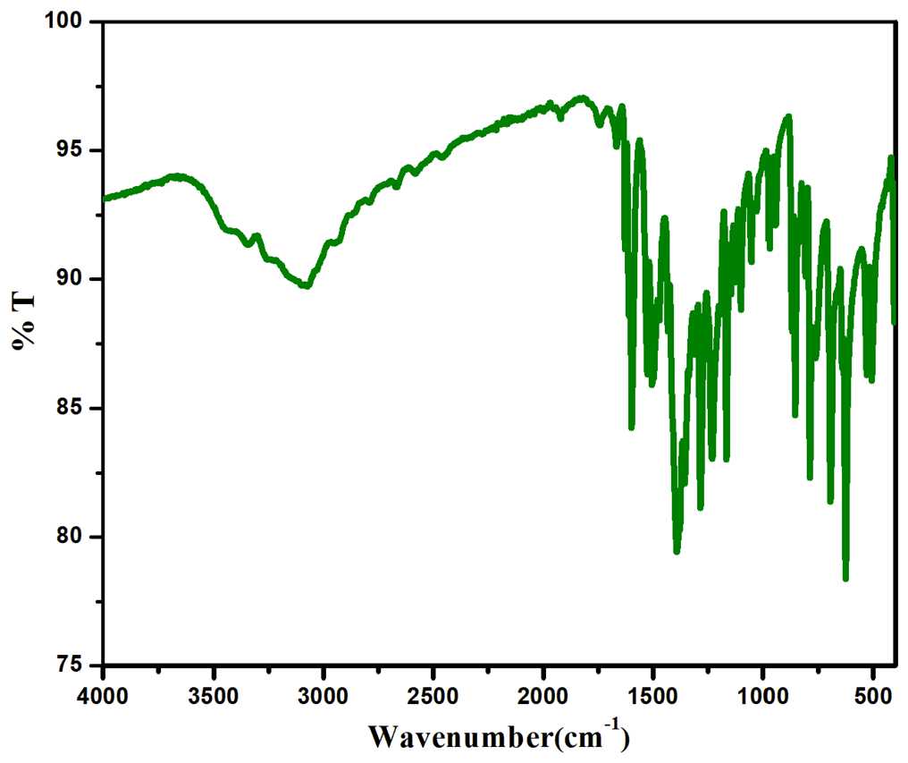
. Fig. S1. IR spectrum of 1
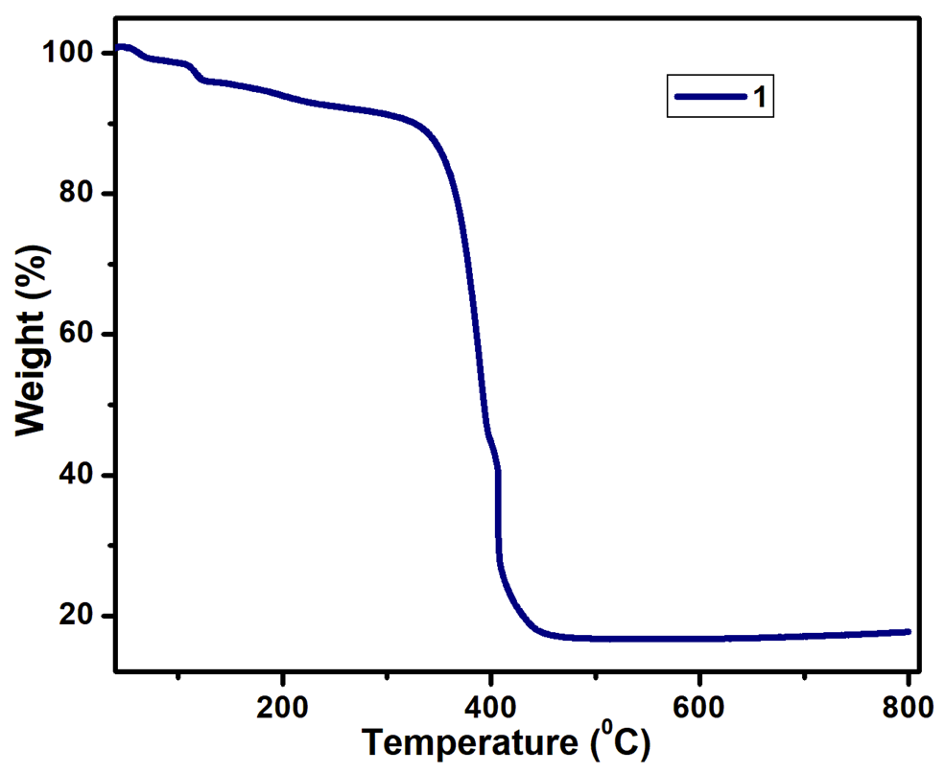
Fig. S2. TGA plot of Compound 1.

Fig. S3 PXRD plot of Compound 1.
Fig. S4. The SEM images of compound 1

Fig. S5. The EDX of compound 1

Hirschfeld surface analysis
Crystal Explorer was used to estimate Hirschfeld surfaces and the related two-dimensional (2D) fingerprint plots.¹⁻⁵ Each point on the Hirschfeld surface has two defined distances: d_{e} (the distance from the point to the nearest nucleus external to the surface) and d_{i} (the distance to the nearest nucleus internal to the surface). The d_{norm} displays a surface with the colour scheme red, white, and blue, where prominent red patches emphasise shorter interactions,⁶⁻⁷ white portions represent contacts near the van der Waals separation, and blue sections are free of close contacts. The normalised contact distance (d_{norm}) based on d_{e} and d^{i} is defined as
d_{norm} = (d_{i} − r_{i}^{vdw}) / r_{i}^{vdw} + (d_{e} − r_{e}^{vdw}) / r_{e}^{vdw}
Where r_{i}^{vdw} and r_{e}^{vdw} are the atoms van der Waals radii, depending on the intermolecular interactions, the value of d_{norm} might be either negative or positive.
The nature of strong and weak interactions between atoms or residues in a crystal is determined with the aid of Hirshfeld Surface analysis. To research the Hirshfeld surfaces, which comprise dnorm, shape index, and curvedness, the asymmetric unit has been examined (Fig. S6). The representations are made in transparent mode to aid the spectator in understanding the calculations by taking the surrounding structural atmosphere into account. For compound 1 the most significant contact was found between the H and O atoms.
Fig. S6. Hirshfeld surfaces mapped over (a) d_{norm} (b) shape index and (c) curvedness for compound 1.
Red, white, and blue patches are used in the dnorm colour scheme to distinguish between variable interatomic distances that are closer, equal, or longer with respect to Van der Waals radii, respectively. To provide more chemical insight into crystal structure, special characteristics of crystal surfaces, specifically curvature, have been proposed in terms of shape index and curvedness parameters. When two molecule surfaces come into contact, there are corresponding hollows (red) and bumps (blue), which are identified by a change in colour in the shape index. Large green areas that are relatively flat and divided by dark blue margins are characteristic features of curvedness maps. Both in form index and curvedness, a noticeable curvedness is distinguished as dark-blue edges.
DFT computation
Optimization of the gas phase geometry of the compound 1 was carried out using Density Functional Theory (DFT) calculation of Gaussian Program Package 09⁸⁻⁹. All calculations were performed using SCXRD coordinates and B3LYP method. LanL2DZ basis set were employed for all elements including Zn. Different electronic transitions were theoretically determined using the time-dependent density functional theory (TDDFT) formalism calculation⁹. Vibrational frequency calculations were performed to ensure that the DFT-optimized geometries represent the local minima and only positive eigenvalues.
Table S1. Bond lengths and bond angles of 1.
Bond lengths
Cd(1) - O(1) | 2.247(3) |  | Cd(1) - O(5) | 2.359(3)
Cd(1) - N(8) | 2.313(4) |  | Cd(1) - O(6) | 2.363(3)
Cd(1) - N(9) | 2.342(4) |  | Cd(1) - O(2) | 2.305(3)
Bond Angles
O(1) - Cd(1) - N(8) |  | 89.63(13) | O(6) - Cd(1) - C(66) |  | 27.18(13)
O(2) - Cd(1) - N(8) |  | 88.79(14) | O(1) - Cd(1) - O(2) |  | 125.50(12)
O(2) - Cd(1) - O(9) |  | 87.51(14) | N(8) - Cd(1) - N(9) |  | 171.95(13)
O(1) - Cd(1) - O(5) |  | 93.39(12) | N(8) - Cd(1) - O(5) |  | 96.20(14)
N(8) - Cd(1) - O(6) |  | 92.72(15) | N(9) - Cd(1) - O(5) |  | 91.17(14)
N(8) - Cd(1) - C(66) |  | 95.20(13) | N(9) - Cd(1) - O(6) |  | 94.18(15)
C(59) - O(2) - Cd(1) |  | 166.8(3) | O(5) - Cd(1) - O(6) |  | 54.74(12)
O(1)c- Cd(1) - N(9) |  | 86.70(13) | O(2) - Cd(1) - O(5) |  | 140.89(12)
O(2) - Cd(1) - C(66) |  | 113.44(13) | O(1) - Cd(1) - O(6) |  | 148.11(13)
O(1) - Cd(1) - C(66) |  | 120.95(13) | O(2) - Cd(1) - O(6) |  | 86.36(13)
O(5)- Cd(1) - C(66) |  | 27.56(13) | N(9) - Cd(1) - C(66) |  | 92.83(14)

Reference
[1] Rohl AL, Moret M, Kaminsky W, Claborn K, McKinnon JJ, Kahr B (2008) Hirshfeld surfaces identify inadequacies in computations of intermolecular interactions in crystals: pentamorphic 1, 8-dihydroxyanthraquinone. Cryst. Growth Des 8:4517-4525
[2] Wolff SK, Grimwood DJ, McKinnon JJ, Turner MJ, Jayatilaka D, Spackman MA Crystal Explorer 3.1 (2013), University of Western Australia, Crawley, Western Australia, 2005–2013.
[3] Hirshfeld, FL (1977) Bonded-atom fragments for describing molecular charge densities. Theoretica chimica acta, 44:129-138.
[4] Wolff SK, Grimwood DJ, McKinnon JJ, Jayatilaka D Spackman MA Crystal Explorer, 2007, 2.
[5] McKinnon JJ, Jayatilaka D, Spackman MA (2007), Chem Comm 37:3814-3816.
[6] Seth SK, Sarkar D, Roy A, Kar T (2011) CrystEngComm 13: 6728-6741.
[7] Gaussian09 RA (2009) 1, mj frisch, gw trucks, hb schlegel, ge scuseria, ma robb, jr cheeseman, g. Scalmani, v. Barone, b. Mennucci, ga petersson et al., gaussian. Inc., Wallingford CT, 121:150-166.
[8] Ji M, Lan X, Han Z, Hao C, Qiu J (2012) Luminescent properties of metal–organic framework MOF-5: relativistic time-dependent density functional theory investigations. Inorg chem 51:12389-12394.
[9] Hidalgo-Rosa Y, Mena-Ulecia K, Treto-Suárez MA, Schott E, Páez-Hernández D and Zarate X (2021) Insights into the selective sensing mechanism of a luminescent Cd (II)-based MOF chemosensor toward NACs: roles of the host–guest interactions and PET processes. J Mater Sci 56:13684-13704.

