SUPPLEMENTAL MATERIALS

Section 1.1
Larval Nest Distributions

Supplemental Table 1. Larval Nest Surveys Spatial Analyses

Maryland
Site | Year | Host Plant | Nests | Area (m²) | CE-R* | p-value**
Alesia | 2018 | Turtlehead | 10 | 1190 | 0.16 | NA⁺
Alesia | 2019 | Turtlehead | 26 | 1190 | 0.09 | < .001
Norrisville | 2018 | Turtlehead | 25 | 5198 | 0.06 | < .001
Norrisville | 2019 | Turtlehead | 24 | 5198 | 0.09 | < .001
White Hall | 2018 | Turtlehead | 24 | 5028 | 0.13 | < .001
White Hall | 2019 | Turtlehead | 12 | 5028 | 0.15 | NA
Massachusetts
Appleton | 2018 | Turtlehead | 35 | 13906 | 0.28 | < .001
Appleton | 2019 | Turtlehead | 61 | 13906 | 0.32 | < .001
Harvard East | 2013 | Both | 46 | 7817 | 0.45 | < .001
Harvard East | 2014 | Both | 106 | 7817 | 0.34 | < .001
Harvard East | 2015 | Both | 129 | 7817 | 0.41 | < .001
Harvard East | 2016 | Both | 32 | 7817 | 0.07 | < .001
Harvard East | 2018 | Both | 7 | 7817 | 0.27 | NA
Harvard East | 2019 | Both | 4 | 7817 | 0.33 | NA
Harvard West | 2013 | Both | 19 | 21821 | 0.19 | NA
Harvard West | 2014 | Both | 84 | 21821 | 0.26 | < .001
Harvard West | 2015 | Both | 112 | 21821 | 0.26 | < .001
Harvard West | 2016 | Both | 7 | 21821 | 0.01 | NA
Upton | 2018 | Plantain | 44 | 10854 | 0.32 | < .001
Upton | 2019 | Plantain | 309 | 10854 | 0.58 | < .001
*Clark-Evans R metric; smaller numbers indicate more clustering
** p-value for test that CE-R was significantly different from 1.0
⁺ NAs indicate that the number of nests was too small to conduct a significance test on CE-R

Section 1.2
Movement Path Parameters

Supplemental Table 2. Mean movement parameters estimated from movement path data

Parameter* | Mean | Lower CL | Upper CL | SE | Degrees of Freedom (df)
Sine of Turning Angle | 0.01 | -0.05 | 0.06 | 0.03 | 15.9
Cosine of Turning Angle | 0.32 | 0.19 | 0.45 | 0.06 | 18.4
Step Time (sec) | 102 | 92 | 113 | 4.90 | 15.2
Step Length (cm)
Instar 4 Upton | 6.69 | 0.00 | 14.9 | 4.00 | 26.08
Instar 5 Upton | 12.03 | 6.83 | 17.2 | 2.17 | 6.51
Instar 6 Upton | 12.01 | 7.91 | 16.10 | 1.72 | 6.76
Instar 4 Tufts | 4.03 | 3.03 | 5.02 | 0.45 | 10.50
Instar 5 Tufts | 4.24 | 3.35 | 5.13 | 0.42 | 16.60
Instar 6 Tufts | 7.62 | 5.96 | 9.28 | 0.79 | 21.50
Step Length² (cm)
Instar 4 Length² Upton | 113 | 0.00 | 391 | 135.40 | 27.20
Instar 5 Length² Upton | 267 | 86.60 | 447 | 67.30 | 4.40
Instar 6 Length² Upton | 201 | 74.00 | 327 | 52.10 | 6.19
Instar 4 Length² Tufts | 22.50 | 4.59 | 40.50 | 8.06 | 10.00
Instar 5 Length² Tufts | 25.30 | 8.96 | 41.70 | 7.81 | 18.20
Instar 6 Length² Tufts | 103.30 | 71.25 | 135.30 | 15.90 | 15.90
Diffusion Coefficient (D)**
Instar 4 D Upton | 0.38 | 0.14 | 1.11
Instar 5 D Upton | 0.99 | 0.45 | 1.43
Instar 6 D Upton | 0.82 | 0.49 | 1.35
Instar 4 D Tufts | 0.09 | 0.07 | 0.15
Instar 5 D Tufts | 0.10 | 0.08 | 0.16
Instar 6 D Tufts | 0.39 | 0.19 | 0.46
* lmer models described in main text
** estimated using equation 5.3 from Turchin (1998): $D= {(m}_{2}+\left(2m_{1}^{2}\right)*\left(\frac{Ψ}{1-Ψ}\right))/(4t)$ (S. Eq. 1).

Section 1.3
Assessment of Correlated Random Walk

Methods
We assessed whether larval movement was directionally biased by testing the null hypothesis that the sine of the turning angle was 0 (i.e. there were equal right and left turns). We used linear mixed effects models in R (lme package; Bates et al., 2015) with date and individual larvae ID as random factors to investigate whether the sine of movement path turning angles was influenced by larval instar or data collection site (as described in main text). We assessed significance with marginal likelihood ratio tests, implemented with the car;;Anova() function in R. To test whether a CRW is an appropriate model for larval movement, we compared the net squared displacement (NSD) from field observations to CRW model predictions. We first calculated the NSD between each possible step interval for each observed movement path and used mixed effects models to estimate the mean observed NSD for each larval instar. We then used mean movement parameters to estimate the expected NSD (Turchin 1998; his Eq. 5.2):
$NSD={n*m}_{2}+\left(2m_{1}^{2}\right)*\left(\frac{Ψ}{1-Ψ}\right)*\left(n-\left(1-\frac{Ψ^{n}}{1-Ψ}\right)\right)$ (S. Eq. 2)
Finally we plotted the NSDs from CRW model predictions and observed NSDs together to assess whether 95% confidence intervals overlapped.

Results
The scaled sine of larval turning angles had a mean distributed around 0 (95% CI -0.05—0.06; S. Table 2), and was not influenced by movement path observation site (χ² =0.01, df = 1 P=0.92) or larval instar (χ² =0.22, df = 1 P=0.64). The predicted and observed NSDs had overlapping confidence intervals (Supplemental Figure 1), supporting the use of a Correlated Random Walk as a movement model for Euphydras phaeton larvae.

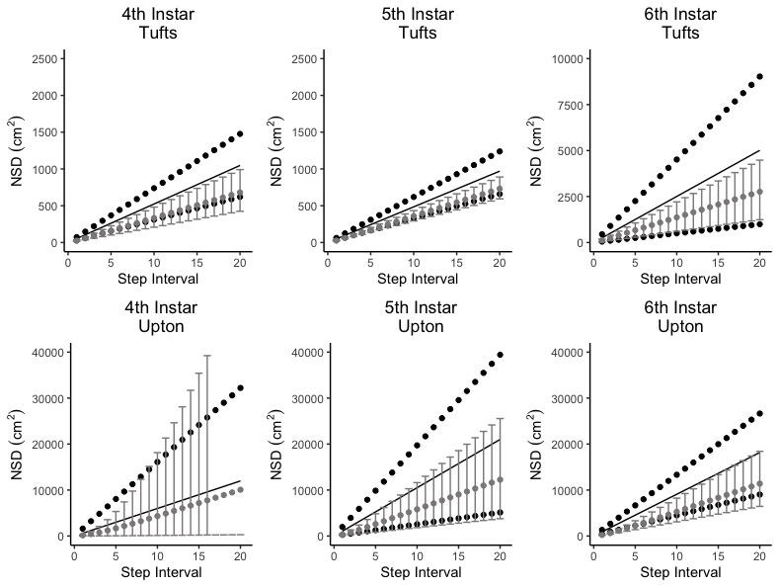

Supplemental Figure 1. The Net Squared Displacements (NSD) from observed larval movement paths (black) and Correlated Random Walk (CRW) model predictions (grey). Ranges are 95% confidence intervals, and movement parameters are calculated for 4th-6th larval instars at Tufts and Upton observation sites.

Section 1.4

Probability Distribution Functions

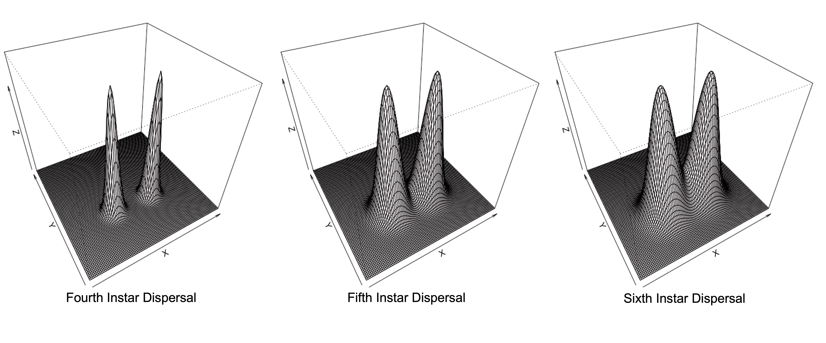
Supplemental Figure 2. The Probability Distribution Functions (PDFs) for two larval nests located 20 m apart after each instar’s dispersal period. These PDFs were created using movement parameters from Upton larval movement paths. This figure is given as a visual example of the PDFs used to calculate pairwise Schoener’s overlap in the main text.

Section 1.5

Population-level behavioral time budget

Methods:
To model larval movement, we need to know how much time they spend actively moving. From May 10 through June 4, 2020, we collected population-level movement behavior data from the Upton MA checkerspot population. These observations consisted of observing larval behavior at eight fixed observation points at the Upton population. Each observation was centered on a patch of Plantago lanceolata host plant and was conducted for 5 minutes, during which we scanned for larvae within 4m using binoculars. Larval behavior was classified as either moving, feeding, resting on a food plant, or resting on a non-food plant. These recurring observations took place on eight different sampling days, during which we observed a total of 2,783 larval behaviors. We examined whether behavioral budgets changed throughout larval development using linear models with observation date as a predictor and proportion of larva exhibiting a given behavior as the dependent variable.

Results:
Larvae spent an average of 23% (95% CI 20-26) of their time actively moving, 18% (95% CI 15-21) of their time actively feeding, 3% (95% CI 2-4) of their time sitting on plantain, and 55% (95% CI 51-59) of their time sitting on non-host plants adjacent to plantain. There were no significant differences in behavioral patterns as the growing season progressed (moving F_{(1, 135)} = 0.16, P= 0.69; feeding F_{(1, 135)} = 0.45, P = 0.51; sitting on plantain F_{(1, 135)} = 0.78, P = 0.38; sitting on other plants F_{(1, 135)} = 2.77, P = 0.38), indicating that these time budgets do not differ significantly between instars.
Section 1.6
Time spent in each instar

Methods:
To estimate the amount of time a larva spends in each post-diapause instar, we monitored larvae that had been overwintered on Tufts campus. When 4th instar larvae emerged from overwintering, we placed 10 larvae in each of six 15 cm plastic dishes kept them at room temperature. Each group of larvae was fed Plantago leaves daily, and we regularly measured their head capsule width and recorded signs of molting. When larvae pupated they were removed from the dish. We analyzed these data using a binomial glm describing the probability of each instar transition as a function of days since emergence from overwintering. To determine the average amount of time spent in each larval instar, we used the binomial model coefficients (b) and solved for the number of days that lead to a 50% transition probability: log(p/(1-p) = b₀ + b₁*Days.

Results:
The mean time in the 4th, 5th and 6th instars were 15.2, 12.6, and 14.2 days respectively. The binomial glm model results for days to transition between the 4th and 5th instars, 5th and 6th instars, and 6th instar to pupa are shown in Supplemental Table 3 and Supplemental Figure 3.
Supplemental Table 3. Results for instar transition binomial glm models.
Transition Probability Model | Factor | Coefficient | Std. Error
4th to 5th Instar | Intercept | -7.14 | 0.85
4th to 5th Instar | Days Since Emergence | 0.47 | 0.06
5th to 6th Instar | Intercept | -8.77 | 0.98
5th to 6th Instar | Days Since Emergence | 0.32 | 0.04
6th Instar to Pupa | Intercept | -18.15 | 2.64
6th Instar to Pupa | Days Since Emergence | 0.43 | 0.06

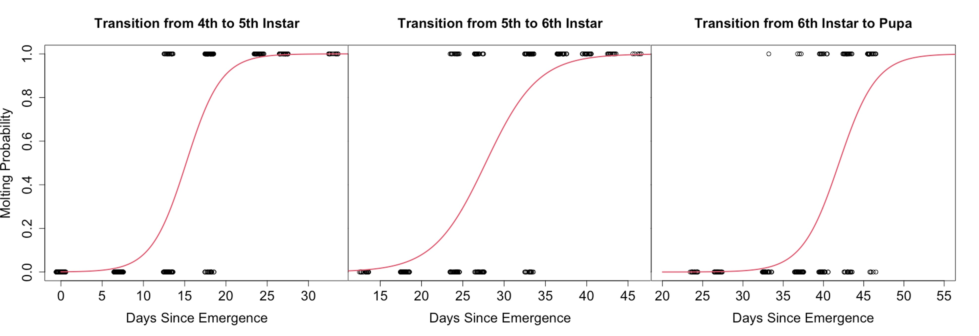
Supplemental Figure 3. The probability of larvae transitioning from 4th to 5th instar, 5th to 6th instar, and 6th instar to pupae as a function of days since overwintering emergence. We solved for the number of days since emergence that the transition probability was 0.5 (dashed lines), and used these values to determine the mean time spent in each post-diapause larval instar. The mean time in the 4th, 5th and 6th instars were 15.2, 12.6, and 14.2 days respectively.

