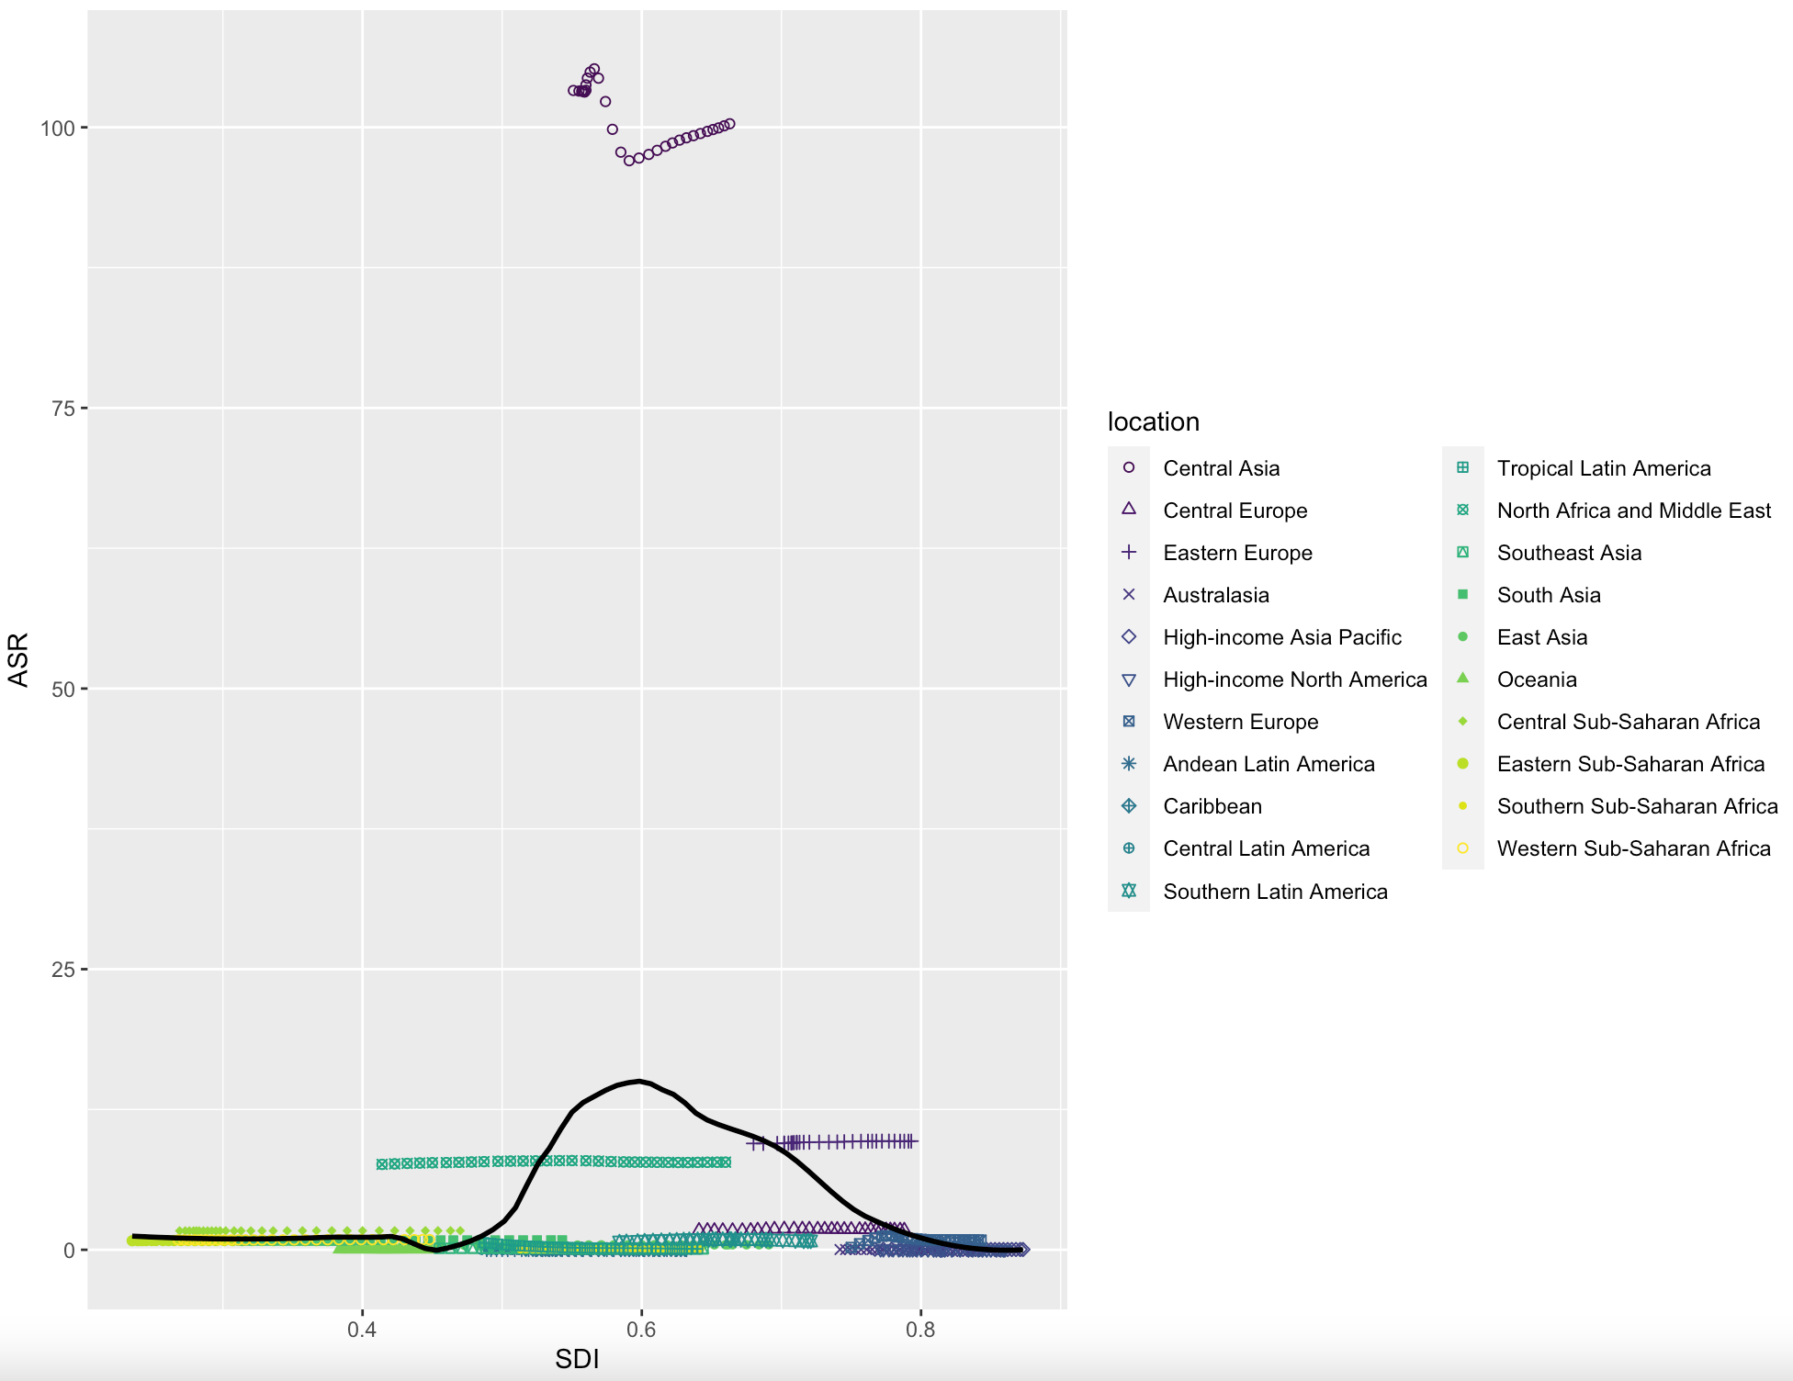
Figure S1 Association between age-standardized incidence of cystic echinococcosis and SDI in 21 GBD regions from 1990 to 2019

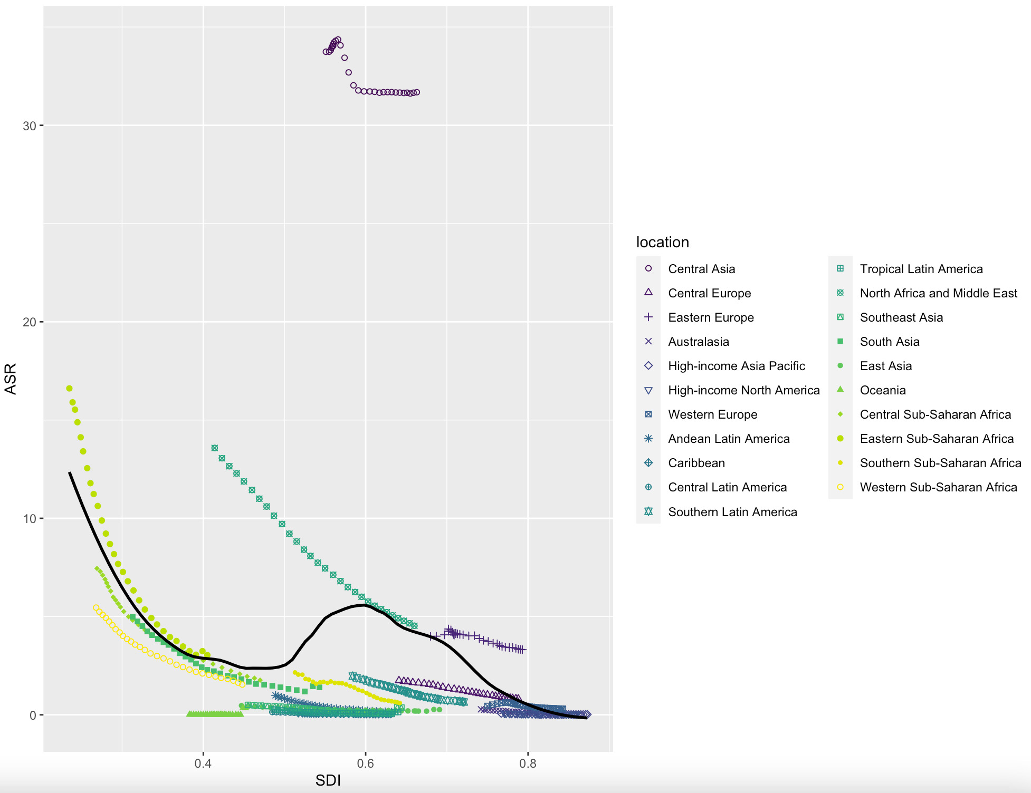
Figure S2 Association between age-standardized DALY rate of cystic echinococcosis and SDI in 21 GBD regions from 1990 to 2019

