Table 1. Total Accuracy by Technique [4].
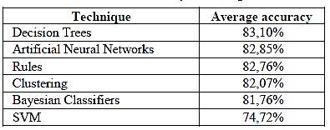

Table 3: Results of CNN implementation.
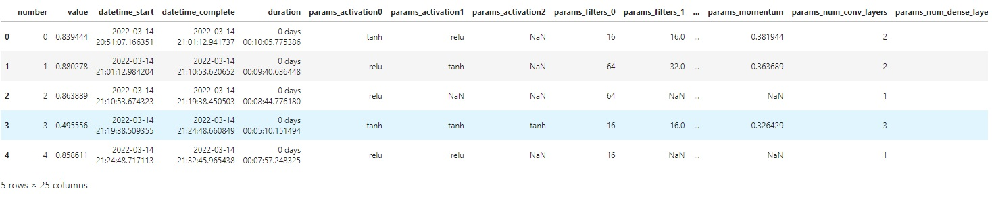
Table 4: Classification report of the positive & negative data sets attributes.

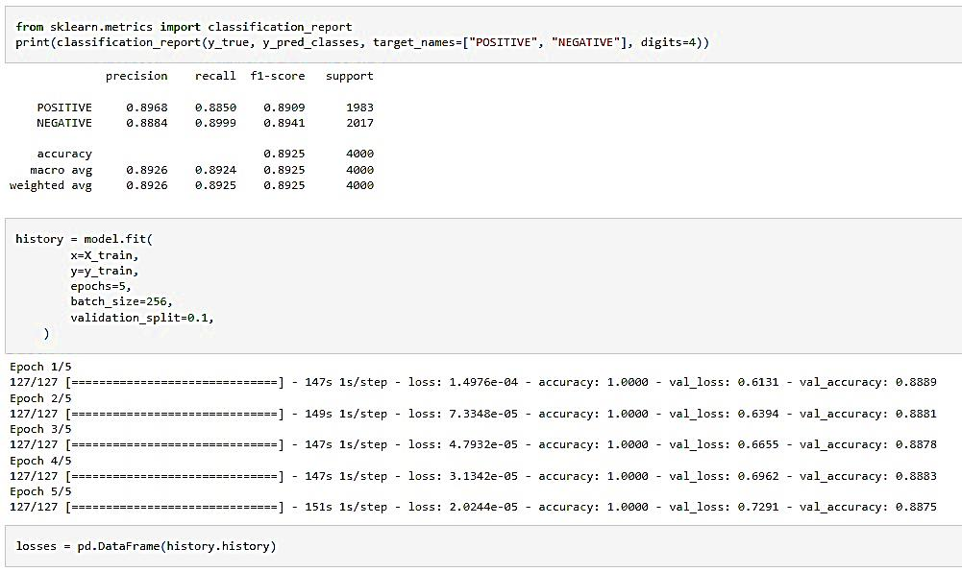

Table 5: Accuracy report of the hyper parameters optimized Tree –Structured Parzen EstimatorDefine_by_Run algorithm test.

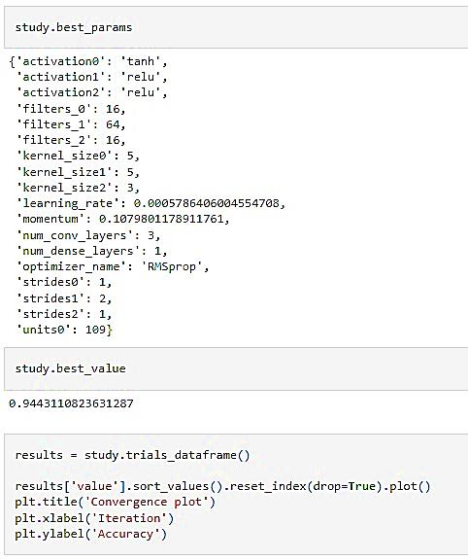

Table 6: Results of Tree Structured Parzen estimator (TPE) Define_by_Run implementation.
