Supplementary Material for
Multichannel and super-flexible SiZrOC ultrafine fibers for high temperature thermal insulation
Xiaoshan ZHANG¹, Qiong TIAN^{1,2}, Bing WANG^{1,}*, Nan WU³, Cheng HAN¹, Xin LONG¹, Yingde WANG^{1,}*
¹Science and Technology on Advanced Ceramic Fiber and Composites Laboratory, ²Jiuquan Satellite Launch Center, Jiuquan 735400, China, ³Department of Material Science and Engineering, College of Aerospace Science and Engineering, National University of Defense Technology, Changsha 410073, China
Fig. S1 Preparation process of MSUF membranes, which includes four procedures: preparation of ES with various PS contents, electrospinning of the ES, thermal curing of the as-spun PFs and pyrolysis of the thermal cured fibers.
Fig. S2 TG curves of the PS and cured PF-10 fibers.
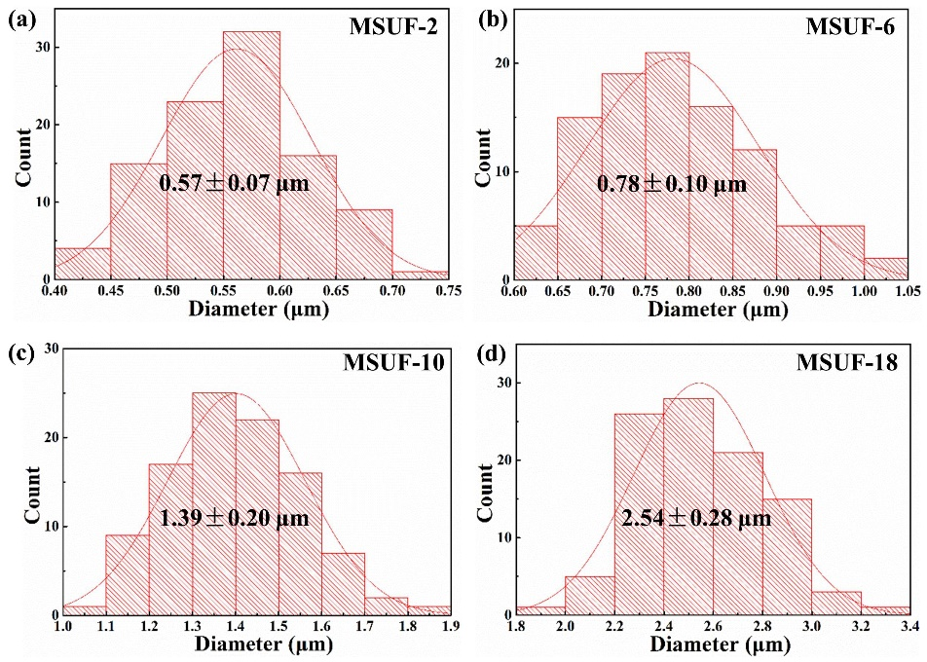
Fig. S3 Diameter of the (a) MSiUF-2, (b) MSiUF-6,(c) MSiUF-10, (d) MSiUF-18.
Fig. S4 Viscosity and electrical conductivity of the various ES.
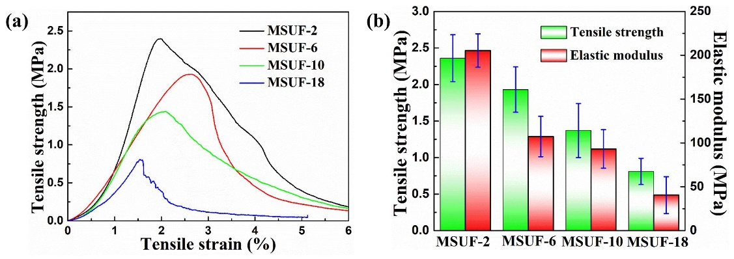
Fig. S5 (a) Stress-strain curves and (b) tensile strength and elastic modulus of the various MSUFs membranes.
Fig. S6 Optical paragraph of MSUF-10 membrane showing high tensile strength.
Fig. S7 Real-time images from high-speed camera showing that a piece of MSUF-10 can recovery at fast speed.
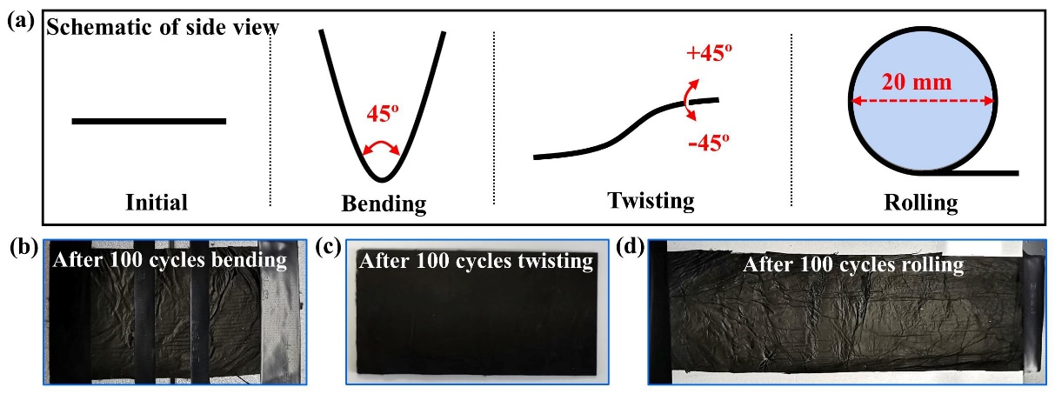
Fig. S8 (a) The schematic of side view of bending, twisting and rolling test; Optical paragraphs of MSUF membranes after 100 cycles (b) bending, (c) twisting and (d) rolling tested.
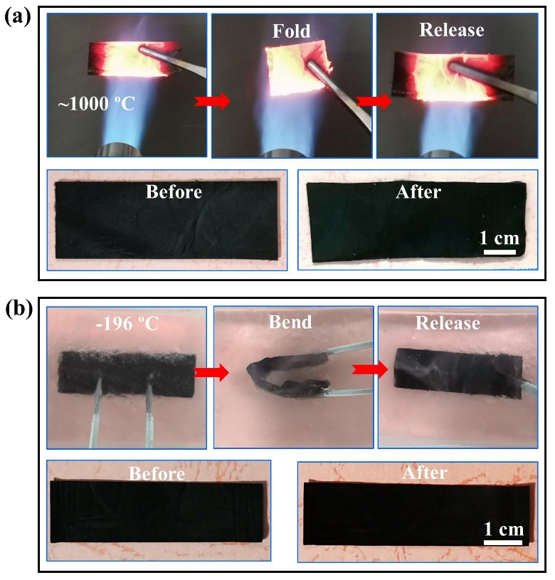
Fig. S9 (a) Optical photographs showing the flexibility and fire resistance of the MSUF membranes burned with a butane blowlamp; (b) Optical photographs showing the flexibility of the MSUF membranes immersed in liquid N₂.
Fig. S10 Optical photographs and corresponding IR images of the MSUF membrane heating by an alcohol lamp.

Table S1 The detail composition of the various ES
Sample | DMF (g) | PR (g) | PVP (g) | Zr(acac)₄ (g) | PS (g)
ES-2 | 2.5-3.5 | 0.5-1.5 | 0.1-0.3 | 0.1-0.2 | 0.1
ES-6 | 2.5-3.5 | 0.5-1.5 | 0.1-0.3 | 0.1-0.2 | 0.3
ES-10 | 2.5-3.5 | 0.5-1.5 | 0.1-0.3 | 0.1-0.2 | 0.5
ES-18 | 2.5-3.5 | 0.5-1.5 | 0.1-0.3 | 0.1-0.2 | 1

Table S2 The detailed specific surface area, density and porosity parameters of the MSUF membranes
Sample | Specific surface area (m²·g⁻¹) | Density  (g·cm⁻³) | Porosity  (%)
MSUF-2 | 10.892 | 0.091±0.003 | 95.1±0.20
MSUF-6 | 13.342 | 0.068±0.002 | 96.1±0.24
MSUF-10 | 27.205 | 0.044±0.003 | 97.7±0.19
MSUF-18 | 22.824 | 0.045±0.003 | 97.2±0.20

