Scheme 1: Layout of a vertical flow constructed wetland system for a single household, source: (Hans Brix , Carlos A. Arias, 2005)

Shema 2, Cross section through CW

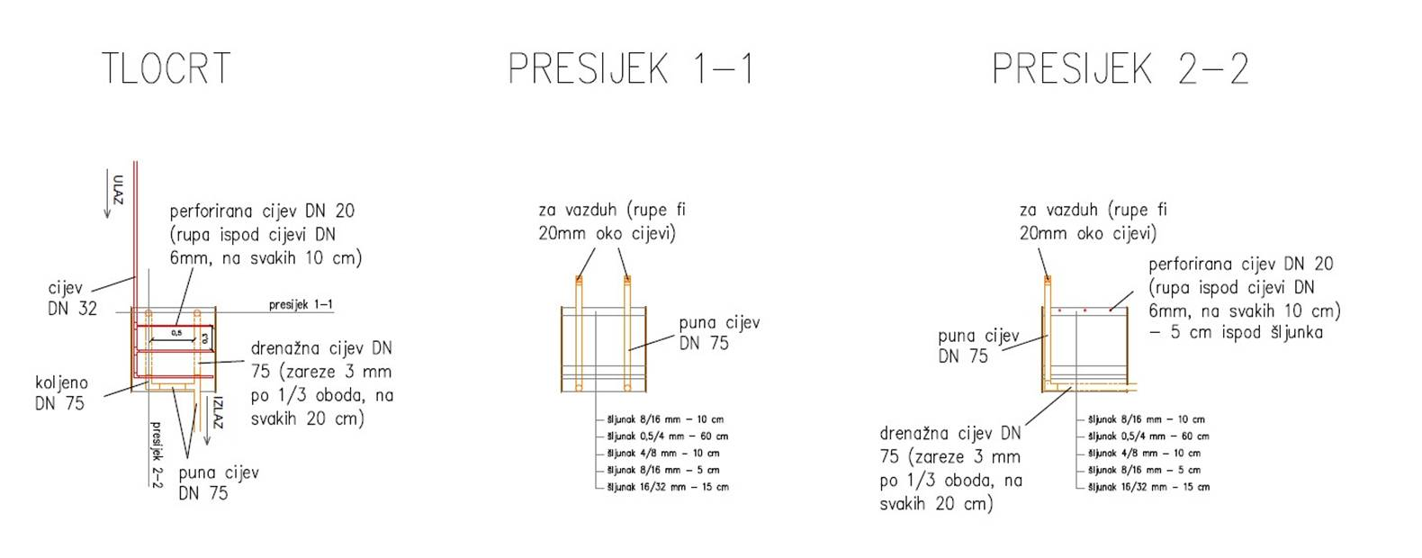

Grafikon 1, Percentage of elimination TSS in efluent

Grafikon 2, Percentage of elimination COD in efluent

Grafikon 3, Percentage of elimination BOD₅ in efluent

