Supporting Information
Exploration for cobalt/nitrogen-doped catalyst to creatinine degradation via peroxymonosulfate activation: Toxicity evaluation, statistical modeling and mechanisms study
Jiadi Liu^{a,b}, Yawen Dongª, Yu Kangª, Qian Kongª, Kuaibing Wangª, Feifei Maoª, Yuanqing Bu^{c,}*, Rong Zhou ^{c}, Chunyong Zhang^{a,}*, Hua Wu^{a,b,}*

ª Jiangsu Key Laboratory of Pesticide Sciences, Department of Chemistry, College of Sciences, Nanjing Agricultural University, Nanjing 210095, P. R. China
^{b} College of Resources and Environmental Sciences, Nanjing Agricultural University, Nanjing 210095, P. R. China
^{c} Research Center of Solid Waste Pollution Prevention, Nanjing Institute of Environmental Science，Ministry of Ecology and Environment, Nanjing 210042, P. R. China
^{d} Jiangsu Collaborative Innovation Center of Atmospheric Environment and Equipment Technology, Nanjing University of Information Science & Technology, Nanjing 210044, P. R. China
E-mail addresses: wuhua@njau.edu.cn

Test. S1. HPLC and LC/MS analyses conditions
The residual creatinine concentrations were then measured using an Agilent 1200 HPLC, which was installed with a Krosmasil C₁₈ column (18 mm, 4.6 mm×250 mm) and coupled with a photodiode array detector (set at 210 nm). Analysis was conducted by using methanol/water (65:35, v:v) as mobile phase, at 0.50 mL min⁻¹ flow rate.
The degradation intermediates was investigated by Waters Acquity UPLC/SQD analyzer (LC/MS). In this analysis procedure, the reaction solution was enriched and 50 µL sample was injected into the apparatus, and the mobile phase was a mixture of methanol and phosphate buffer (pH= 3.5) (65:35 v/v) with a flow rate of 0.45 mL min⁻¹. The MS operated with electrospray source ionization by applying an interface voltage of - 4.0 V and 40 V Q-array RF voltage (in negative mode). The carrier and nebulizing gas was pure nitrogen, and the DL temperature was 300 ºC. Mass spectra were obtained over an m/z range of 80 – 300.

Fig. S1. XRD pattern of the synthesized CoC/N.
Fig. S2. Raman spectra of the synthesized CoC/N.
Fig. S3. (a) M-H curves of the CoC/N measured at room temperature and (b) nitrogen adsorption-desorption isotherm curve of the CoC/N.
Fig. S4. The physical appearance of zebrafish in different cultured solution (photographed at 168 h).

Fig. S5. (a) Predicted-observed and (b) residual-predicted plots for the response of CA degradation efficiency.
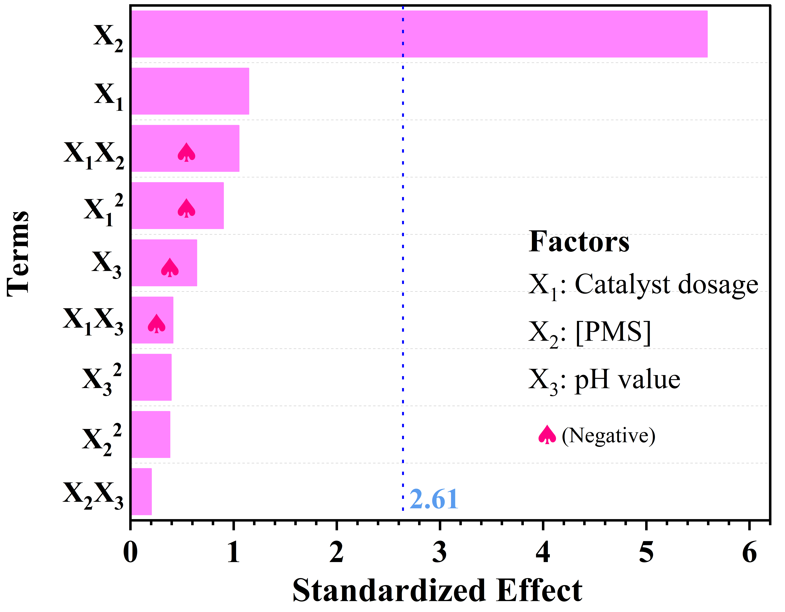
Fig. S6. The Pareto graphic of standardized effects on degradation percentage of creatinine.
Fig. S7. (a) Main and (b) interaction effect plots for CA degradation in PMS-CoC/N system in terms of coupled factors: (X₁) CoC/N dosage; (X₂) [PMS]; (X₃) pH.
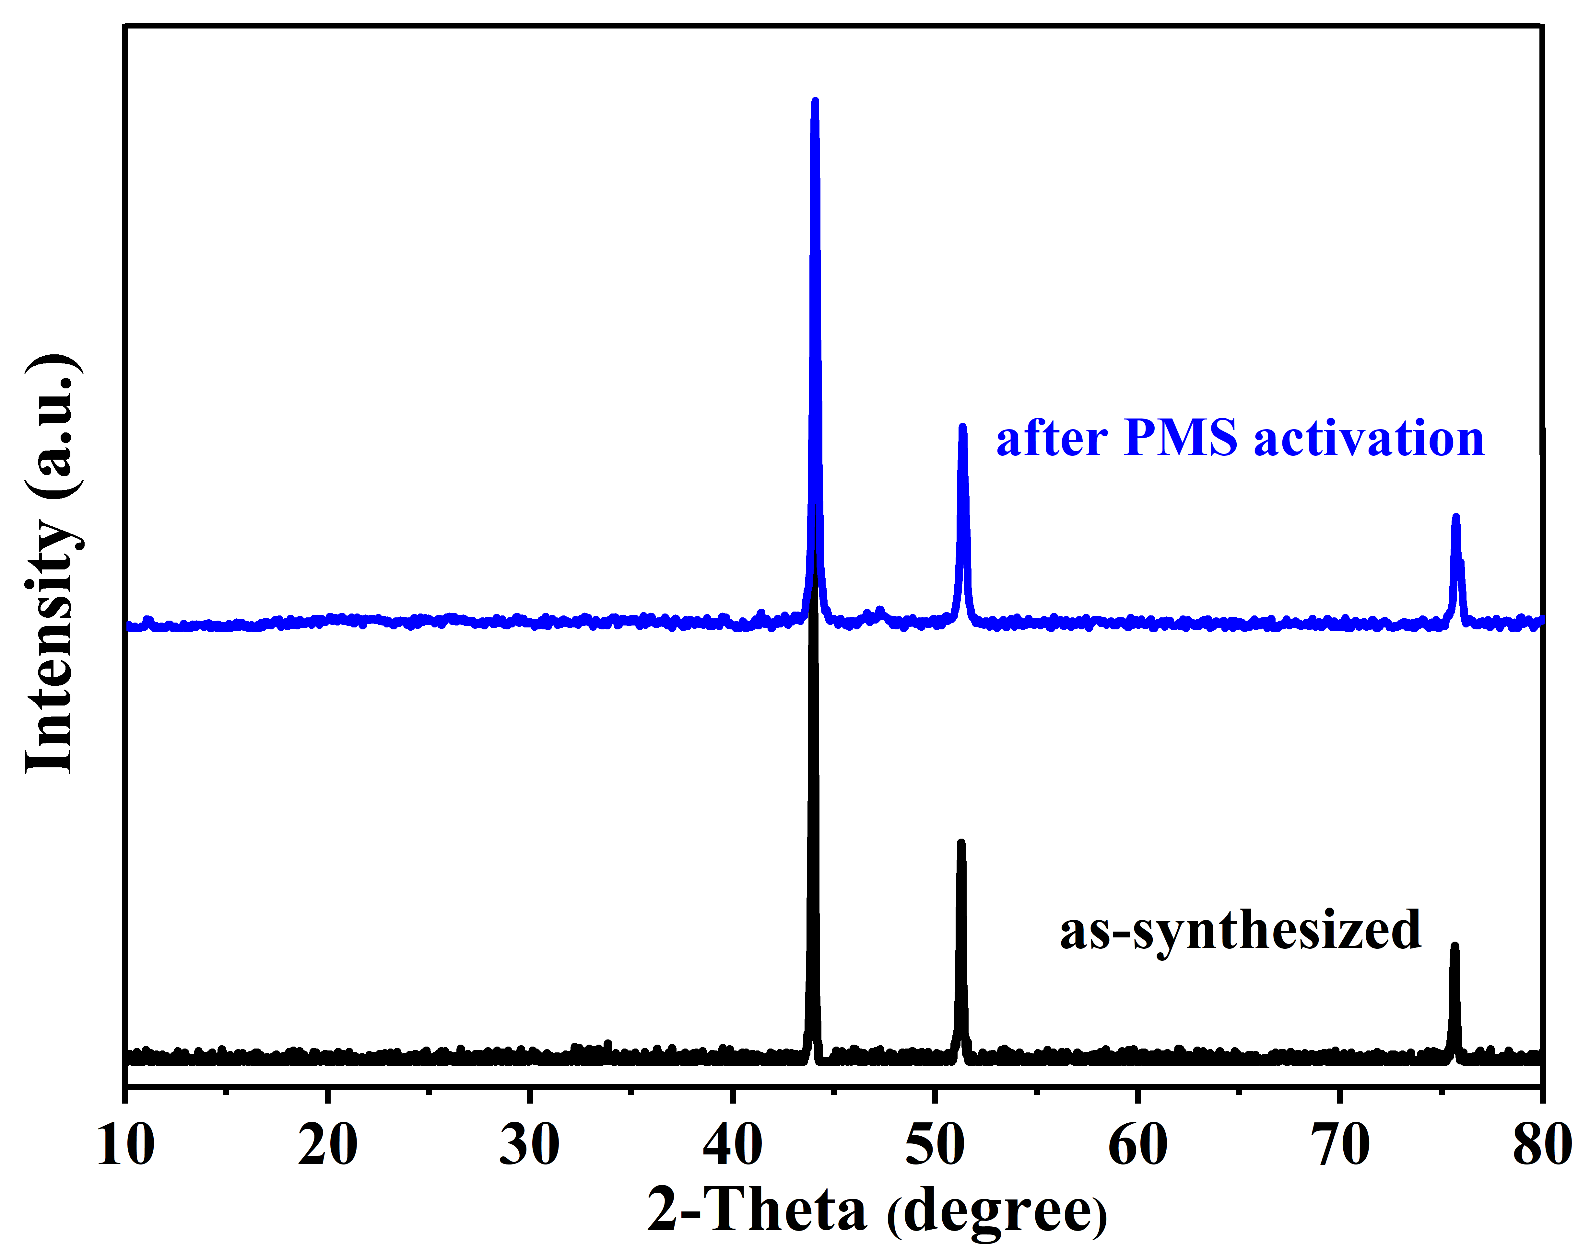
Fig. S8. XRD patterns of CoC/N before and after PMS activation.
Fig. S9. (a-c) EPR spectra of CoC/N for activating PMS, (d) quenching experiment results of CA degradation in CoC/N-PMS system.

