Table S1: Rate of biomass formation in presence of furfural. Cultures were grown in shake flasks containing AM1 media with 1% glucose as sole carbon source. Values are normalized to unit hour per sampling interval. The upper bold values represent SSK101 while lower values represent SSK42.

Time interval | Furfural Concentration
Time interval | 0 g/L | 1.0 g/L | 1.5g/L | 2.0 g/L | 2.5 g/L | 3.0 g/L
0-3h | 0.014±0.005  0.070±0.010 | 0.025±0.004  0.013±0.004 | 0.016±0.003  0.008±0.004 | 0.009±0.003  0.005±0.003 | 0.005±0.001  0.002±0.002 | 0.002±0.001  0.001±0.002
3-6h | 0.029±0.003  0.201±0.011 | 0.054±0.003  0.044±0.005 | 0.028±0.002  0.022±0.006 | 0.010±0.004  0.011±0.005 | 0.003±0.003  0.004±0.002 | 0.000±0.001  0.004±0.006
6-9h | 0.047±0.009  0.164±0.020 | 0.071±0.007  0.107±0.024 | 0.062±0.015  0.042±0.009 | 0.016±0.009  0.010±0.008 | 0.005±0.002  -0.001±0.003 | -0.002±0.002  -0.003±0.006
9-12h | 0.063±0.006  0.007±0.013 | -0.001±0.027 0.167±0.009 | 0.074±0.009  0.099±0.012 | 0.043±0.010  0.038±0.011 | 0.008±0.009  0.012±0.003 | 0.003±0.007  0.002±0.003

Table S2: Rate of biomass formation in presence of 5-HMF. Cultures were grown in shake flasks containing AM1 media with 1% glucose as sole carbon source. Values are normalized to unit hour per sampling interval. The upper bold values represent SSK101 while lower values represent SSK42.

Time duration | HMF Concentration
Time duration | 0 g/L | 1.0 g/L | 1.5 g/L | 2.0 g/L | 2.5 g/L | 3.0 g/L
0-3h | 0.011±0.005  0.078±0.000 | 0.033±0.006  0.041±0.001 | 0.030±0.005  0.028±0.000 | 0.024±0.004  0.020±0.000 | 0.018±0.003  0.018±0.001 | 0.013±0.002  0.014±0.001
3-6h | 0.027±0.002  0.218±0.005 | 0.091±0.005  0.146±0.005 | 0.096±0.004  0.117±0.001 | 0.079±0.011  0.090±0.001 | 0.052±0.013  0.056±0.004 | 0.027±0.007  0.033±0.002
6-9h | 0.044±0.006  0.140±0.009 | 0.038±0.024  0.158±0.012 | 0.091±0.039  0.175±0.014 | 0.126±0.018  0.124±0.011 | 0.131±0.010  0.113±0.008 | 0.097±0.025  0.076±0.001
9-12h | 0.067±0.012  0.042±0.015 | 0.036±0.033  0.063±0.037 | -0.043±0.040  0.079±0.013 | 0.002±0.023  0.137±0.007 | 0.064±0.003  0.138±0.011 | 0.095±0.015  0.107±0.005

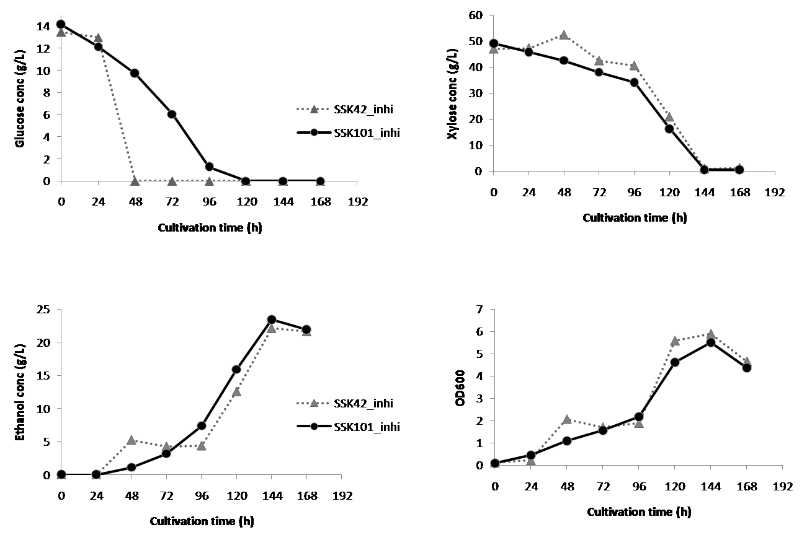
Figure S1: Influence of reduced inhibitor load on fermentation at 12 g/L glucose concentration in media containing glucose-xylose mixture. Strains were cultured in a bioreactor in presence of both furfural and 5-HMF with concentration of each at 0.5 g/L. Total sugar load was ~ 5.5%.

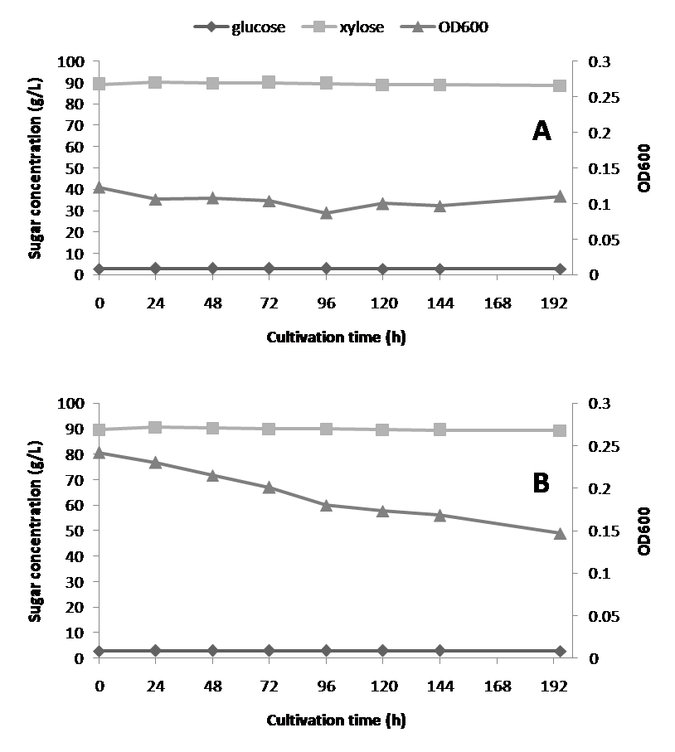
Figure S2: Fermentation profile of SSK101 at high sugar mixture load (0.3% glucose + 9% xylose) and (A) 1.0 g/L each of both furfural and 5-HMF; (B) 1.5 g/L each of both furfural and 5-HMF. Primary culture of SSK101 was performed in presence of 0.2% glucose + 0.8% xylose + 1 g/L furfural in the AM1 media.

