Supplemental Data
Table S1. Bacterial strains and plasmids used in this study.
Strains or plasmids | Relevant genotype description | References
Strains
Corynebacterium glutamicum
RES167 | Restriction-deficient mutant of ATCC13032, Δ(cglIM-cglIR-cglIIR) | Tauch et al., 2002
Δcgahp | cgahp deleted in RES167 | This study
Δcgahp(pXMJ19) | Δcgahp containing pXMJ19 vector | This study
Δcgahp(pXMJ19-cgahp) | Complementation of cgahp in Δcgahp | This study
WT(pXMJ19) | RES167 containing pXMJ19 vector | This study
ΔoasR(pXMJ19) |  | Si et al., 2020
ΔoasR(pXMJ19-oasR) |  | Si et al., 2020
E. coli
BL21(DE3) | E. coli expression host, hsdS gal (λcIts857 ind-l Sam7 nin-5 lac UV5-T7 gene 1) | Novagen
JM109 | recA1 supE44 endA1 hsdR17 gyrA96 relA1 thi Δ(lac-proAB)F′(traD36 proABlacI^{q} lacΔZM15) | Stratagene
Plasmids
pK18mobsacB | Suicide plasmid carrying sacB for selecting double crossover in C. glutamicum, Km^{r} | Schäfer et al.,1994
pK18mobsacB-Δcgahp | Construct used for in-frame deletion of cgahp | This study
pK18mobsacB-P_{cgahp}::lacZY | P_{cgahp}::lacZY fusion in pK18mobsacB | This study
pXMJ19 | Shuttle vector (P_{tac} lacI^{q} pBL1 oriV_{C. glutamicum} pK18 oriV_{E. coli}) | Jakoby et al.,1999
pXMJ19-cgahp | cgahp cloned into pXMJ19 for complementation | This study
pET28a | Expression vector with N-terminal hexahistidine affinity tag | Novagen
pET28a-cgahp | cgahp in pET28a | This study
pET28a-cgahp:C42S | cgahp:C42S in pET28a | This study
pET28a-cgahp:C45S | cgahp:C45S in pET28a | This study
pET28a-mrx1 |  | Si et al., 2014
pET28a-mtr |  | Si et al., 2014
pET28a-sucB |  | Si et al., 2015
pET28a-trx |  | Si et al., 2014
pET28a-trxR |  | Si et al., 2014
References
Tauch A, Kirchner O, Loffler B, Gotker S, Pühler A, Kalinowski J (2002) Efficient electro transformation of Corynebacterium diphtheriae with a mini-replicon derived from the plasmid pGA1. Curr Microbiol 45: 362-367.
Si M, Chen C, Che CC, Liu Y, Li XN, Su T (2020) The thiol oxidation-based sensing and regulation mechanism for the OasR-mediated organic peroxide and antibiotic resistance in C. glutamicum. Biochem J 477:3709-3727.
Si MR, Zhang L, Yang ZF, Xu YX, Liu YB, Jiang CY (2014) NrdH Redoxin enhances resistance to multiple oxidative stresses by acting as a peroxidase cofactor in Corynebacterium glutamicum. Appl Environ Microbiol 80(5):1750-1762.
Si M, Wang J, Xiao X, Guan J, Zhang Y, Ding W (2015) Ohr Protects Corynebacterium glutamicum against Organic Hydroperoxide Induced Oxidative Stress. PLoS One 10(6): e0131634.
Schäfer A, Tauch A, Jager W, Kalinowshi J, Thierbach G, Pühler A (1994) Small mobilizable multi-purpose cloning vectors derived from the Escherichia coli plasmids pK18 and pK19: selection of defined deletions in the chromosome of Corynebacterium glutamicum. Gene 145:69-73.
Jakoby M, Ngouoto-Nkili CE, Burkovski A (1999) Construction and application of new Corynebacterium glutamicum vectors. Biotechnol. Techniques 13:437-441.

Table S2. Primers used in this study.
Primers | 5’-3’ sequence
Ccgahp-F | AGCGGTCGACATGAGTTCGCTCGACAATGCCC (SalI) | For cloning cgahp into pXMJ19
Ccgahp-R | CGCGGATCCTTAGGTTTCGTCCGTCTCTGAC (BamHI) | For cloning cgahp into pXMJ19
Ocgahp-F | CGCGGATCCATGAGTTCGCTCGACAATGCCC (EcoRI) | For cloning cgahp wild type and mutants into pET28a
Ocgahp-R | CCGCTCGAGTTAGGTTTCGTCCGTCTCTGAC (XhoI) | For cloning cgahp wild type and mutants into pET28a
Dcgahp-F1 | CAAGAATTCCTTGAGCTCGCAAGAAGTGCTCGCTC (EcoRI) | To generate pK18mobsacB-Δcgahp
Dcgahp-R1 | CCTGAACATCCAATTCCAGCAGC | To generate pK18mobsacB-Δcgahp
Dcgahp-F2 | GCTGCTGGAATTGGATGTTCAGGATTGCTGCTCGGCAGTTTGCTGTC | To generate pK18mobsacB-Δcgahp
Dcgahp-R2 | GGAAGATCTAGTGCTGCCATTCCGGTGATGCAC (BglII) | To generate pK18mobsacB-Δcgahp
Ocgahp-C42S-F | GTGTTTCAGATGCTAAGCCCTGGATGCGTG | To generate cgahp:C42S DNA fragment
Ocgahp-C42S-R | CACGCATCCAGGGCTTAGCATCTGAAACACC | To generate cgahp:C42S DNA fragment
Ocgahp-C45S-F | GCTATGCCCTGGAAGCGTGAATCACG | To generate cgahp:C45S DNA fragment
Ocgahp-C45S-R | CGTGATTCACGCTTCCAGGGCATAGC
P_{cgahp}-F | TCCCCCGGGATAATCATTGGAGTTTGTTGCAGC (SmaI) | To generate pK18mobsacB-P_{cgahp}::lacZY
P_{cgahp}-R | ACTAGTGAGTTAAACCATGAGTTCGCTC (SpeI) | To generate pK18mobsacB-P_{cgahp}::lacZY
lacZY-F1 | GAGTTAAACCATGAGTTCGCTCACTAGT ATGACCATGATTACGGATTC(SpeI) | To generate pK18mobsacB-P_{cgahp}::lacZY
lacZY-R | AAAACTGCAGTTAAGCGACTTCATTCACCTG(PstI) | To generate pK18mobsacB-P_{cgahp}::lacZY
Qcgahp-F | CCTGCGCGGCAAGGTTGTGGTGG | RT-PCR
Qcgahp-R | ACTTTCAAAGCCTCAGGTGTCATC | RT-PCR
Ecgahp-F | GGTGTTAATTGACCAATCGAAG | To produce the 220-bp EMSA promoter DNA
Ecgahp-R | GGTTTAACTCCCTTCATGAAATG | To produce the 220-bp EMSA promoter DNA
Control-F | CCTGCGCGGCAAGGTTGTGGTG | To produce the 220-bp EMSA control DNA
Control-R | CACTGCCACGGGGAACTTGATC | To produce the 220-bp EMSA control DNA
16 S rRNA-F | ACCCTTGTCTTATGTTGCCAG | RT-PCR
16 S rRNA-R | TGTACCGACCATTGTAGCATG
Underlined sites indicated restriction enzyme cutting sites added for cloning. Letters in italic denoted the mutation sites in overlap PCR for site-directed mutation.

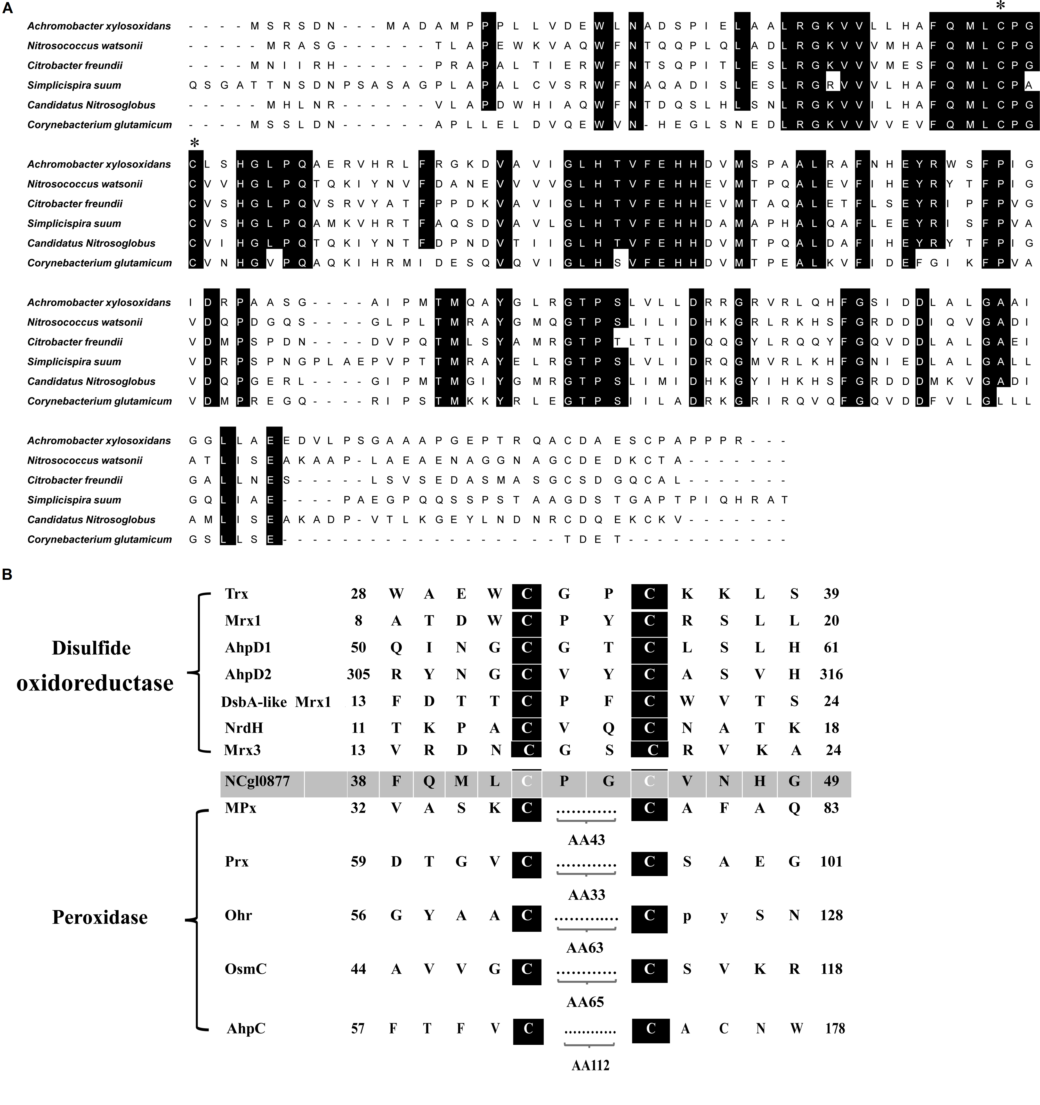
Fig. S1 Multiple sequence alignment of CgAhp with Ahp in other organisms. (A) Active site Cys were pointed out by a black star. Residues that were identical in in all or at least 5 of the 6 sequences were depicted on the black background. Reference sequences were retrieved from the NCBI Database, including Achromobacter xylosoxidans (ADP19073), Nitrosococcus watsonii (ADJ28176); Citrobacter freundii (AUV27934); Simplicispira suum (AVO42213); Candidatus nitrosoglobus (BAW80394); Corynebacterium glutamicum (NP_600142). (B) Sequence characterization of disulfide oxidoreductases and peroxidases of Corynebacterium glutamicum, and alkyl hydroperoxide reductase (AhpC) of Mycobacterium tuberculosis. Sequence alignment between active-site cysteines. Magenta highlights the dicysteine motif. C. glutamicum Trx (NP_602283); C. glutamicum Mrx1 (NP_600071); C. glutamicum AhpD1 (NP_601570); C. glutamicum AhpD2 (NP_601633); C. glutamicum DsbA-like Mrx1 (NP_601623); C. glutamicum NrdH (NP_601732); C. glutamicum Mrx3 (NP_599663); C. glutamicum NCgl0877 (NP_600142); C. glutamicum MPx (NP_601789); C. glutamicum Prx (NP_600314); C. glutamicum Ohr (NP_599276); C. glutamicum OsmC (NP_600290); M. tuberculosis AhpC (NP_216944). AA43, AA33, AA63, AA65, and AA112 expressed 43, 33, 63, 65, and 112 amino acids between two cysteines, respectively.
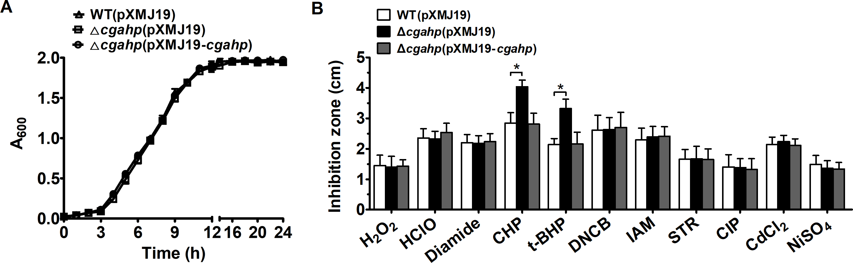
Fig. S2 The Δcgahp strains of C. glutamicum were more sensitive to organic peroxide stress. (A) Growth curves of the Corynebacterium glutamicum RES167 parental strain (WT) containing pXMJ19 [WT(pXMJ19)], Δcgahp(pXMJ19) mutant (the mutant lacking cgahp with the empty plasmid pXMJ19), Δcgahp(pXMJ19-cgahp) strain (the mutant lacking cgahp with the plasmid pXMJ19 containing the wild-type C. glutamicum cgahp gene) under normal condition. The growth of the indicated strains in LB was monitored by measuring A₆₀₀ at indicated time points. (B) The inhibition zone diameter (cm) of WT(pXMJ19), Δcgahp(pXMJ19) mutant and Δcgahp(pXMJ19-cgahp) caused by the paper disks (Ø = 5 mm) with oxidative stress-inducing reagents. Data showed the mean and standard error of the 3 samples sets for each reagent. The asterisk indicated a significant correlation between the WT(pXMJ19) and Δcgahp(pXMJ19) mutants at *P ≤ 0.05.

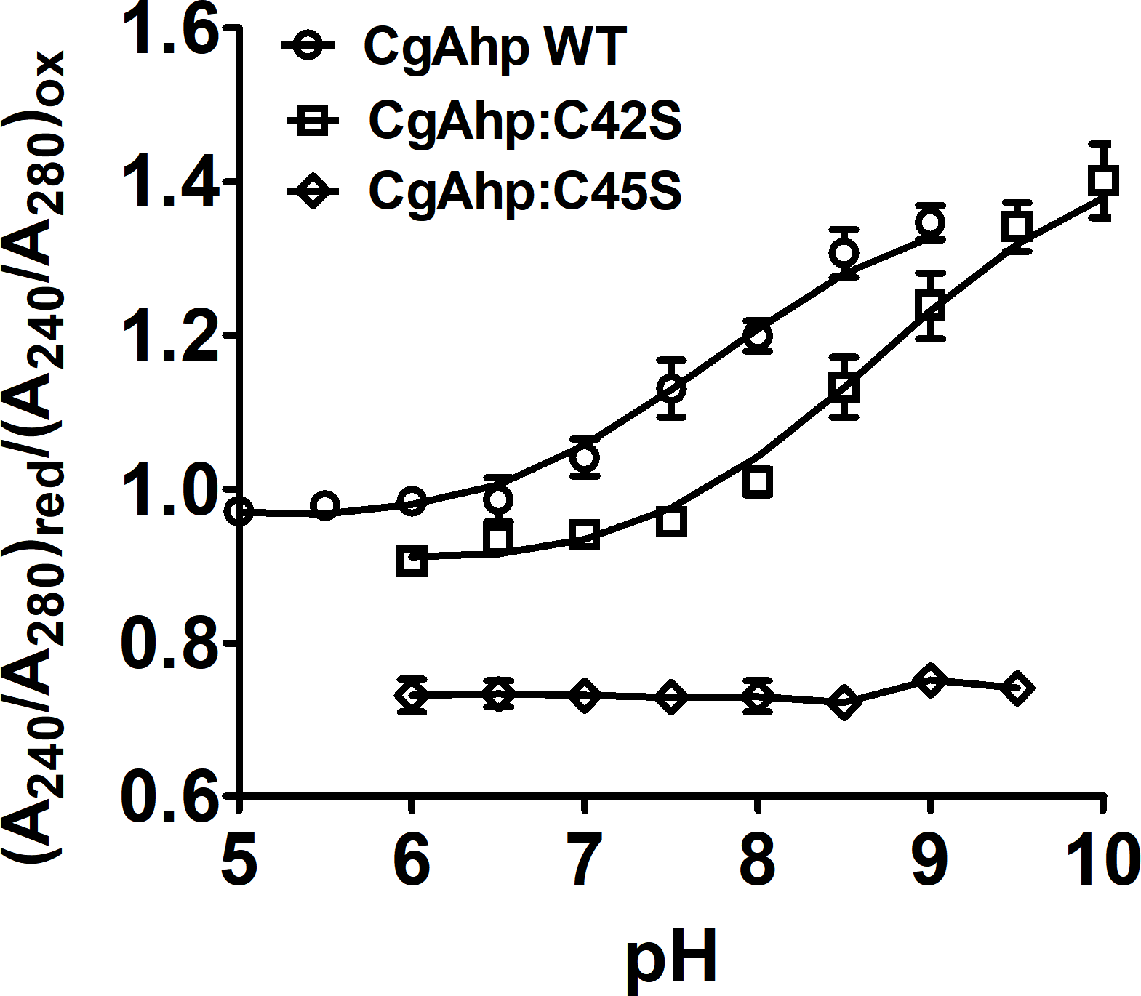
Fig. S3 Cys42 was the nucleophilic cysteine of CgAhp. The pKa measurement of the active site cysteines indicates that Cys42 has an unusual pKa value lower than 6 and that Cys45 was the resolving cysteine with a pKa of 8.39. Ionized thiol groups (R-SH) extinction coefficient at 240 nm was utilized to measure pKa values of cysteines of CgAhp WT (○) and the CgAhp:C42S (□) and CgAhp:C45S (◊). The ratio composed by 240/280_{red} and 240/280_{ox} in a pH range of 5.0 to 12 as fitted with the Henderson-Hasselbalch equation.

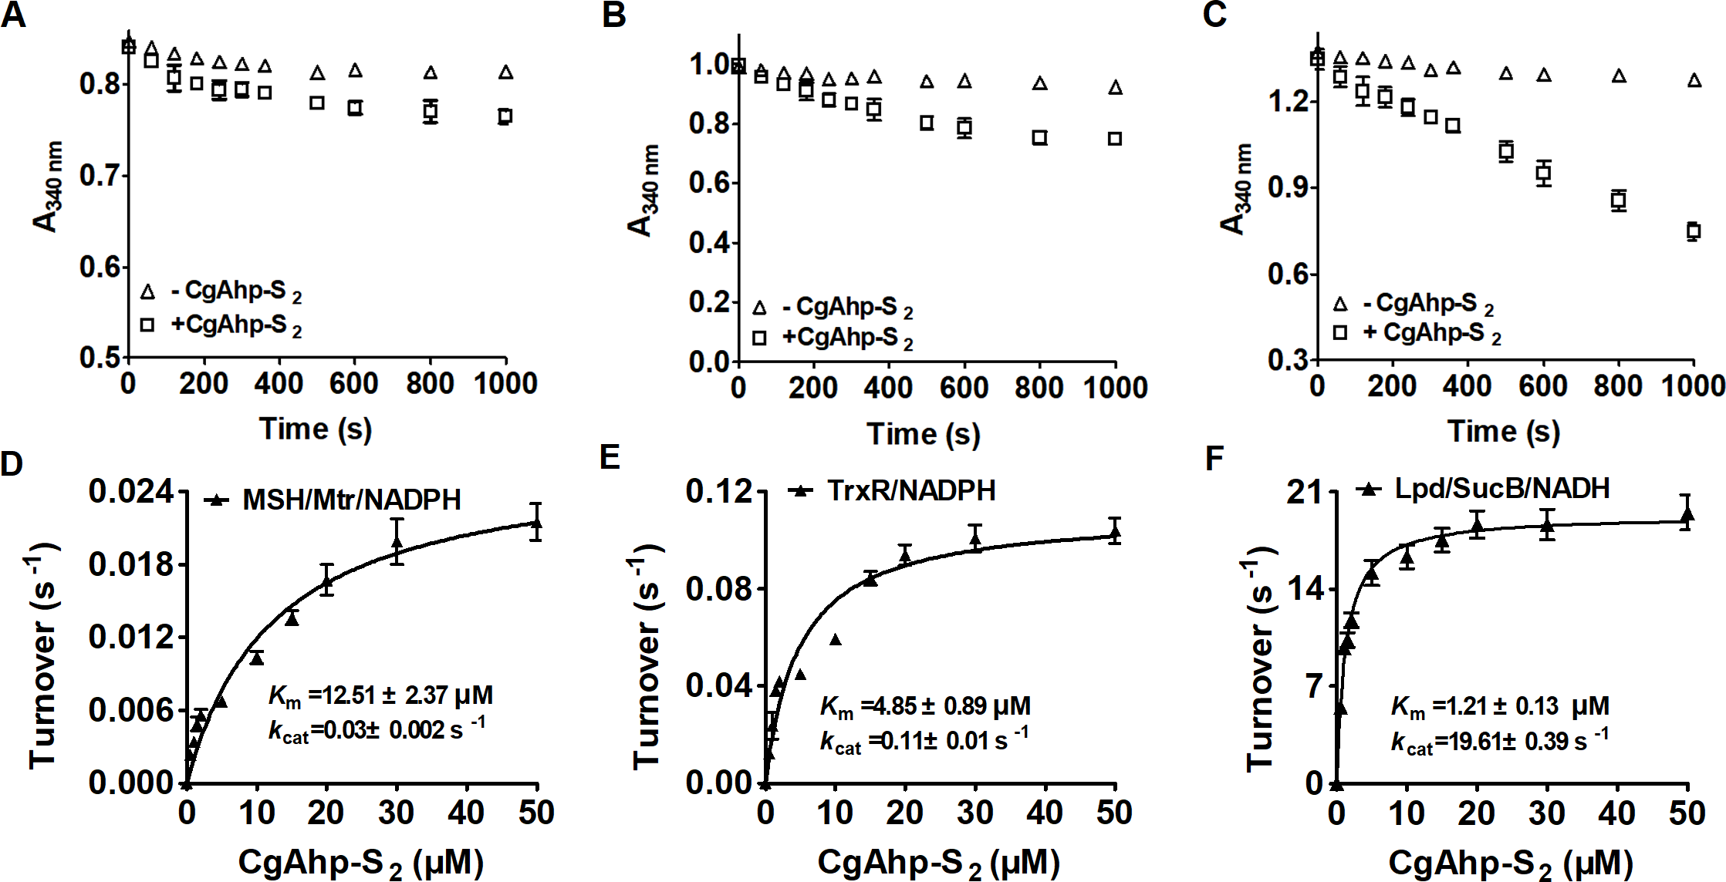
Fig. S4 Oxidized CgAhp (CgAhp-S₂) was preferably reduced by the Lpd/SucB/NADH pathway. (A-C) CgAhp-S₂ was added as substrate to the MSH/Mtr/NADPH(A), theTrxR/NADPH (B) and the Lpd/SucB/NADH (C) pathway. A control reaction in the absence of CgAhp-S₂ was included. The consumption of NADPH or NADH at 340 nm was shown. (D-F) The reduction of CgAhp-S₂ by the MSH/Mtr/NADPH, the TrxR/NADPH, or Lpd/SucB/NADH pathway was evaluated via Michaelis-Menten steady-state kinetics using the program GraphPad Prism 5. The data were represented as mean ± SD of three independent experiments. Different concentrations of CgDsbA-S₂ were mixed with a pre-incubated reaction mixture.

