ASAP Web results

JC69 Jukes-Cantor
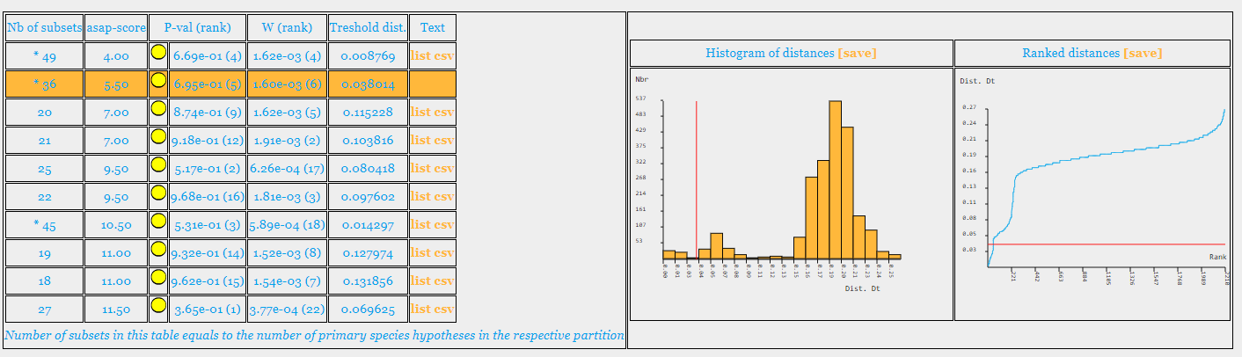
K80 Kimura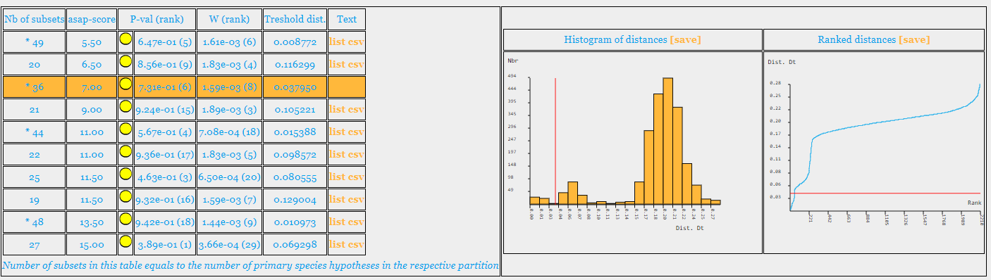
Simple Distance
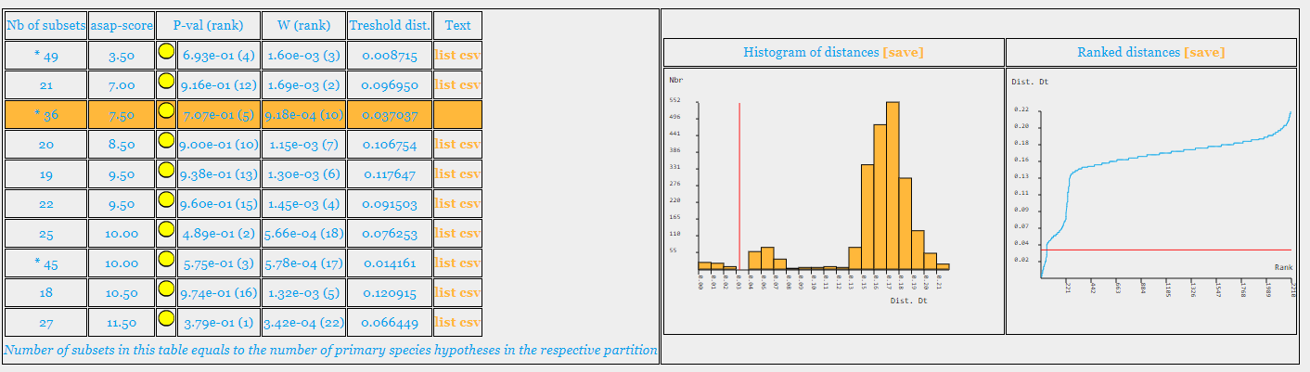

ABGD Web results
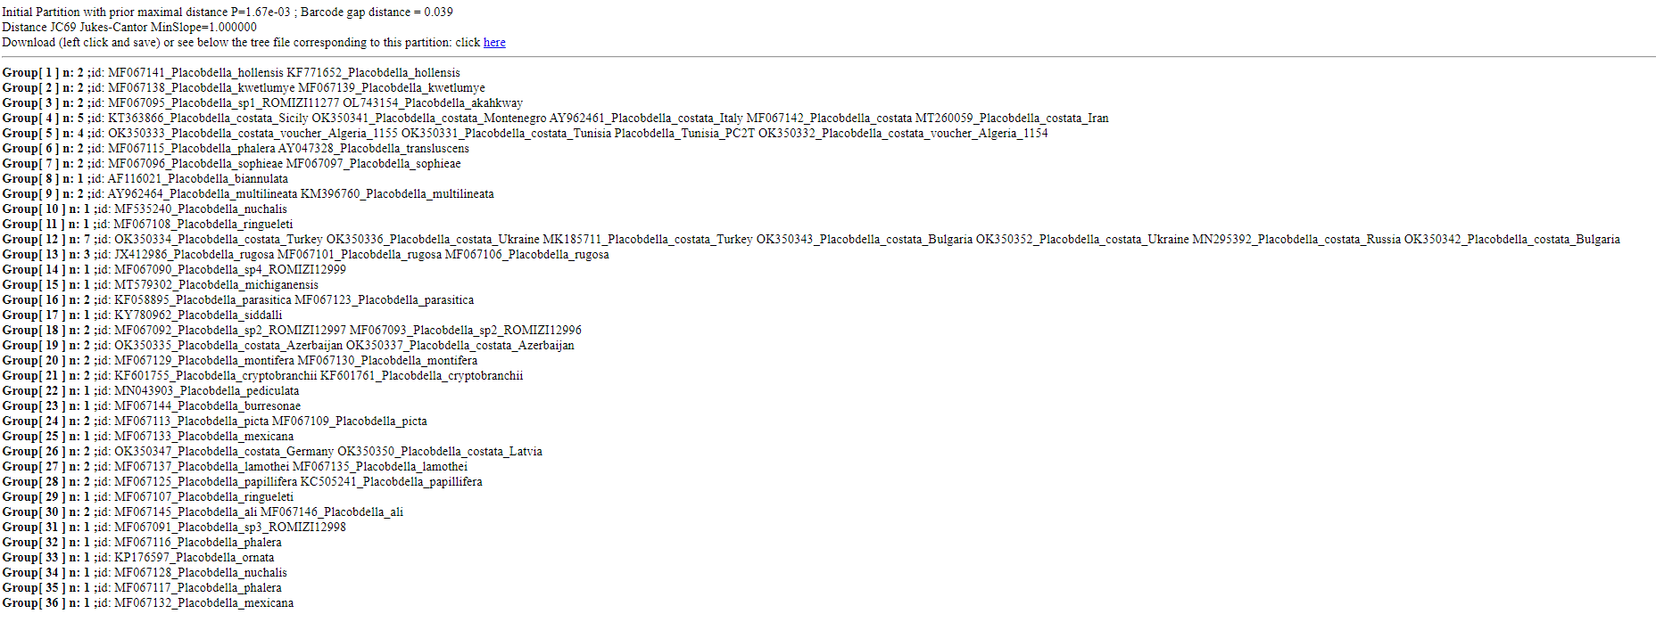

JC69 Jukes-Cantor, X = 1.0
Partition 1 : found 37 groups (prior maximal distance P= 0.001000)
Partition 2 : found 37 groups (prior maximal distance P= 0.001274)
Partition 3 : found 37 groups (prior maximal distance P= 0.001624)
Partition 4 : found 37 groups (prior maximal distance P= 0.002069)
Partition 5 : found 37 groups (prior maximal distance P= 0.002637)
Partition 6 : found 37 groups (prior maximal distance P= 0.003360)
Partition 7 : found 37 groups (prior maximal distance P= 0.004281)
Partition 8 : found 37 groups (prior maximal distance P= 0.005456)
Partition 9 : found 36 groups (prior maximal distance P= 0.006952)
Partition 10 : found 36 groups (prior maximal distance P= 0.008859)
Partition 11 : found 36 groups (prior maximal distance P= 0.011288)
Partition 12 : found 36 groups (prior maximal distance P= 0.014384)

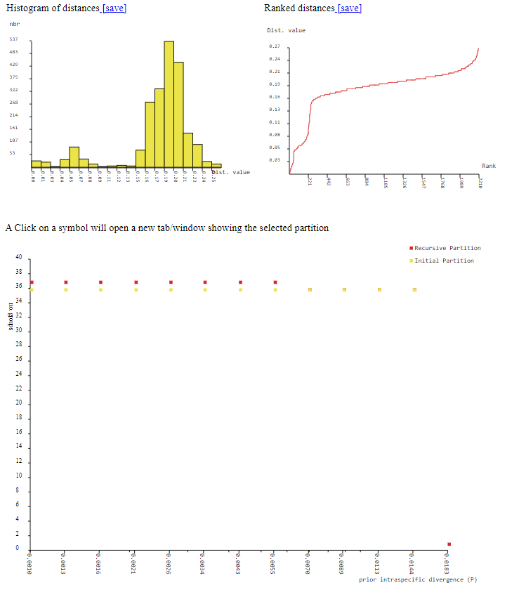

JC69 Jukes-Cantor, X = 0.75
Partition 1 : found 37 groups (prior maximal distance P= 0.001000)
Partition 2 : found 37 groups (prior maximal distance P= 0.001274)
Partition 3 : found 37 groups (prior maximal distance P= 0.001624)
Partition 4 : found 37 groups (prior maximal distance P= 0.002069)
Partition 5 : found 37 groups (prior maximal distance P= 0.002637)
Partition 6 : found 37 groups (prior maximal distance P= 0.003360)
Partition 7 : found 37 groups (prior maximal distance P= 0.004281)
Partition 8 : found 37 groups (prior maximal distance P= 0.005456)
Partition 9 : found 36 groups (prior maximal distance P= 0.006952)
Partition 10 : found 36 groups (prior maximal distance P= 0.008859)
Partition 11 : found 36 groups (prior maximal distance P= 0.011288)
Partition 12 : found 36 groups (prior maximal distance P= 0.014384)
Partition 13 : found 23 groups (prior maximal distance P= 0.018330)
Partition 14 : found 22 groups (prior maximal distance P= 0.023357)
Partition 15 : found 22 groups (prior maximal distance P= 0.029764)
Partition 16 : found 22 groups (prior maximal distance P= 0.037927)
Partition 17 : found 22 groups (prior maximal distance P= 0.048329)
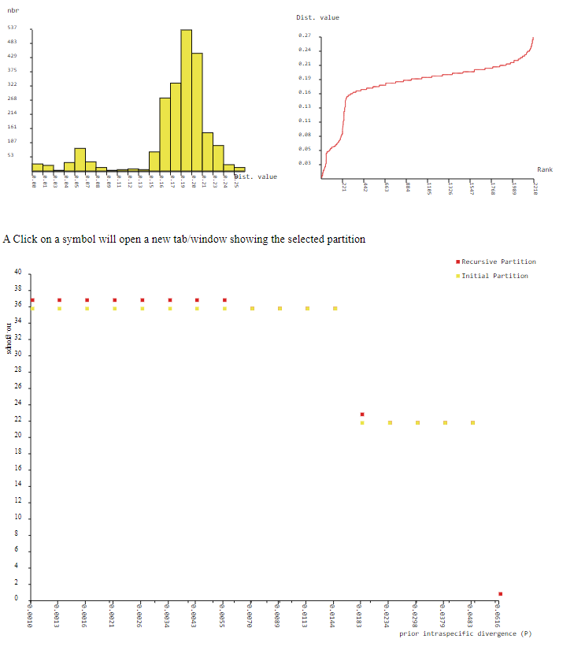
JC69 Jukes-Cantor, X = 0.5
Partition 1 : found 37 groups (prior maximal distance P= 0.001000)
Partition 2 : found 37 groups (prior maximal distance P= 0.001274)
Partition 3 : found 37 groups (prior maximal distance P= 0.001624)
Partition 4 : found 37 groups (prior maximal distance P= 0.002069)
Partition 5 : found 37 groups (prior maximal distance P= 0.002637)
Partition 6 : found 37 groups (prior maximal distance P= 0.003360)
Partition 7 : found 37 groups (prior maximal distance P= 0.004281)
Partition 8 : found 37 groups (prior maximal distance P= 0.005456)
Partition 9 : found 36 groups (prior maximal distance P= 0.006952)
Partition 10 : found 36 groups (prior maximal distance P= 0.008859)
Partition 11 : found 36 groups (prior maximal distance P= 0.011288)
Partition 12 : found 36 groups (prior maximal distance P= 0.014384)
Partition 13 : found 23 groups (prior maximal distance P= 0.018330)
Partition 14 : found 22 groups (prior maximal distance P= 0.023357)
Partition 15 : found 22 groups (prior maximal distance P= 0.029764)
Partition 16 : found 22 groups (prior maximal distance P= 0.037927)
Partition 17 : found 22 groups (prior maximal distance P= 0.048329)
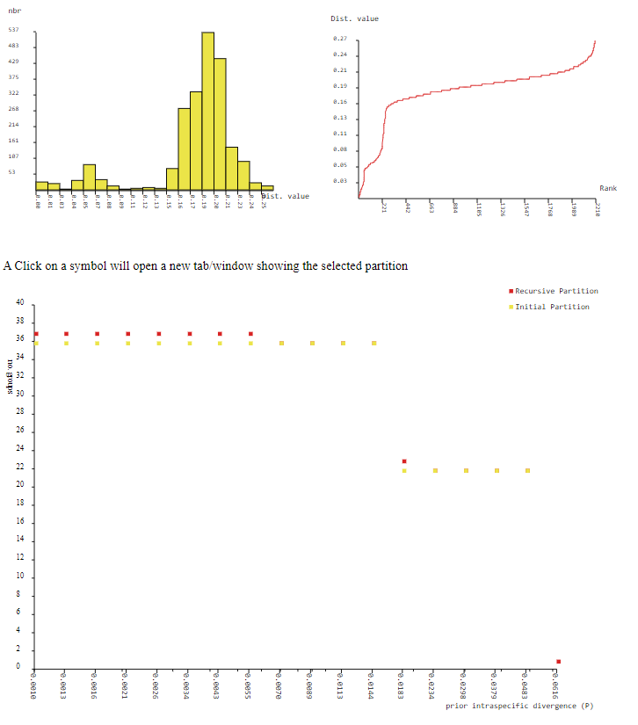

Kimura (K80) = 1.0
Partition 1 : found 37 groups (prior maximal distance P= 0.001000)
Partition 2 : found 37 groups (prior maximal distance P= 0.001274)
Partition 3 : found 37 groups (prior maximal distance P= 0.001624)
Partition 4 : found 37 groups (prior maximal distance P= 0.002069)
Partition 5 : found 37 groups (prior maximal distance P= 0.002637)
Partition 6 : found 37 groups (prior maximal distance P= 0.003360)
Partition 7 : found 37 groups (prior maximal distance P= 0.004281)
Partition 8 : found 37 groups (prior maximal distance P= 0.005456)
Partition 9 : found 36 groups (prior maximal distance P= 0.006952)
Partition 10 : found 36 groups (prior maximal distance P= 0.008859)
Partition 11 : found 36 groups (prior maximal distance P= 0.011288)
Partition 12 : found 36 groups (prior maximal distance P= 0.014384)

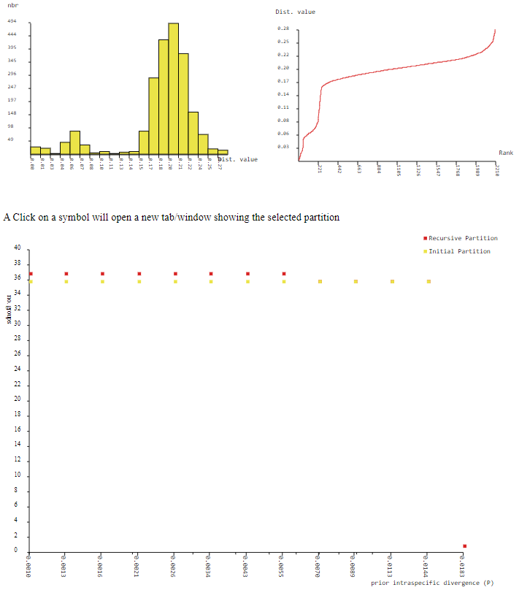

Kimura (K80) = 0.75
Partition 1 : found 37 groups (prior maximal distance P= 0.001000)
Partition 2 : found 37 groups (prior maximal distance P= 0.001274)
Partition 3 : found 37 groups (prior maximal distance P= 0.001624)
Partition 4 : found 37 groups (prior maximal distance P= 0.002069)
Partition 5 : found 37 groups (prior maximal distance P= 0.002637)
Partition 6 : found 37 groups (prior maximal distance P= 0.003360)
Partition 7 : found 37 groups (prior maximal distance P= 0.004281)
Partition 8 : found 37 groups (prior maximal distance P= 0.005456)
Partition 9 : found 36 groups (prior maximal distance P= 0.006952)
Partition 10 : found 36 groups (prior maximal distance P= 0.008859)
Partition 11 : found 36 groups (prior maximal distance P= 0.011288)
Partition 12 : found 36 groups (prior maximal distance P= 0.014384)
Partition 13 : found 23 groups (prior maximal distance P= 0.018330)
Partition 14 : found 22 groups (prior maximal distance P= 0.023357)
Partition 15 : found 22 groups (prior maximal distance P= 0.029764)
Partition 16 : found 22 groups (prior maximal distance P= 0.037927)
Partition 17 : found 22 groups (prior maximal distance P= 0.048329)
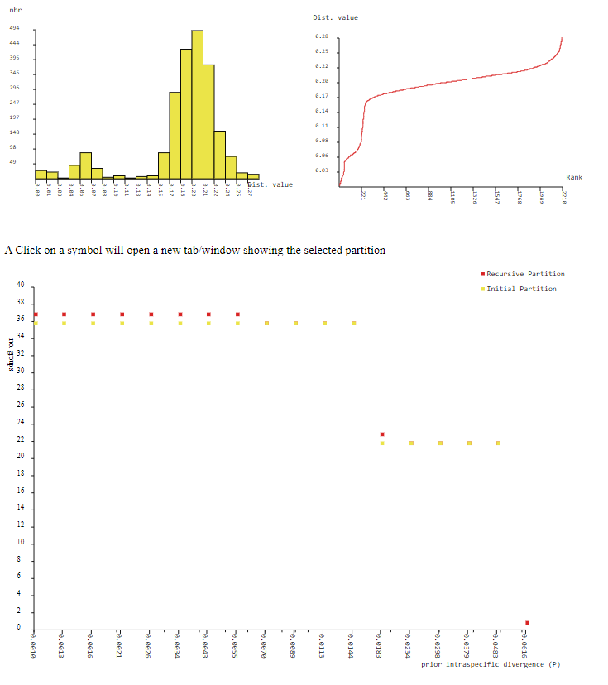

Kimura (K80) = 0.5
Partition 1 : found 37 groups (prior maximal distance P= 0.001000)
Partition 2 : found 37 groups (prior maximal distance P= 0.001274)
Partition 3 : found 37 groups (prior maximal distance P= 0.001624)
Partition 4 : found 37 groups (prior maximal distance P= 0.002069)
Partition 5 : found 37 groups (prior maximal distance P= 0.002637)
Partition 6 : found 37 groups (prior maximal distance P= 0.003360)
Partition 7 : found 37 groups (prior maximal distance P= 0.004281)
Partition 8 : found 37 groups (prior maximal distance P= 0.005456)
Partition 9 : found 36 groups (prior maximal distance P= 0.006952)
Partition 10 : found 36 groups (prior maximal distance P= 0.008859)
Partition 11 : found 36 groups (prior maximal distance P= 0.011288)
Partition 12 : found 36 groups (prior maximal distance P= 0.014384)
Partition 13 : found 23 groups (prior maximal distance P= 0.018330)
Partition 14 : found 22 groups (prior maximal distance P= 0.023357)
Partition 15 : found 22 groups (prior maximal distance P= 0.029764)
Partition 16 : found 22 groups (prior maximal distance P= 0.037927)
Partition 17 : found 22 groups (prior maximal distance P= 0.048329)
Partition 18 : found 1 groups (prior maximal distance P= 0.061585)
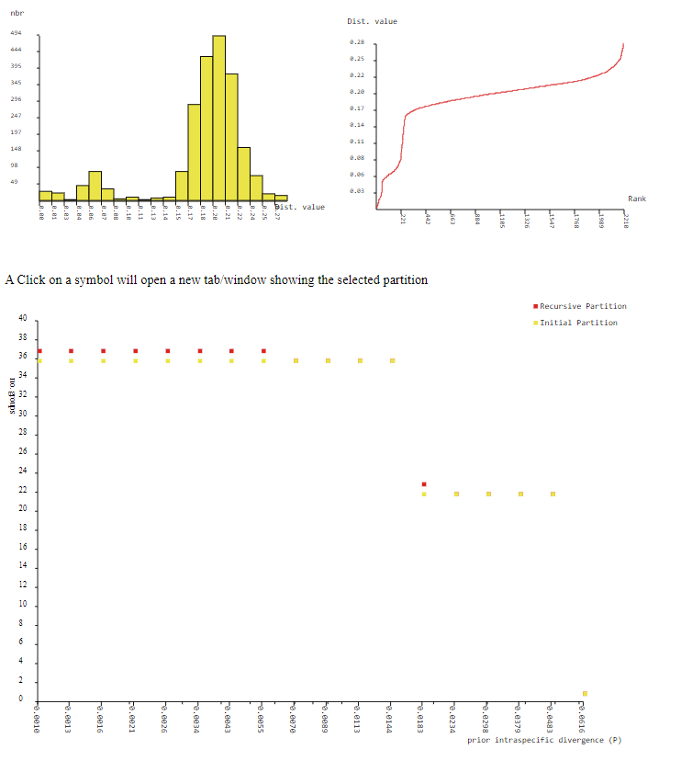

Simple Distance X = 1.0
Partition 1 : found 36 groups (prior maximal distance P= 0.001000)
Partition 2 : found 36 groups (prior maximal distance P= 0.001274)
Partition 3 : found 36 groups (prior maximal distance P= 0.001624)
Partition 4 : found 36 groups (prior maximal distance P= 0.002069)
Partition 5 : found 36 groups (prior maximal distance P= 0.002637)
Partition 6 : found 36 groups (prior maximal distance P= 0.003360)
Partition 7 : found 36 groups (prior maximal distance P= 0.004281)
Partition 8 : found 36 groups (prior maximal distance P= 0.005456)
Partition 9 : found 36 groups (prior maximal distance P= 0.006952)
Partition 10 : found 36 groups (prior maximal distance P= 0.008859)
Partition 11 : found 36 groups (prior maximal distance P= 0.011288)
Partition 12 : found 36 groups (prior maximal distance P= 0.014384)
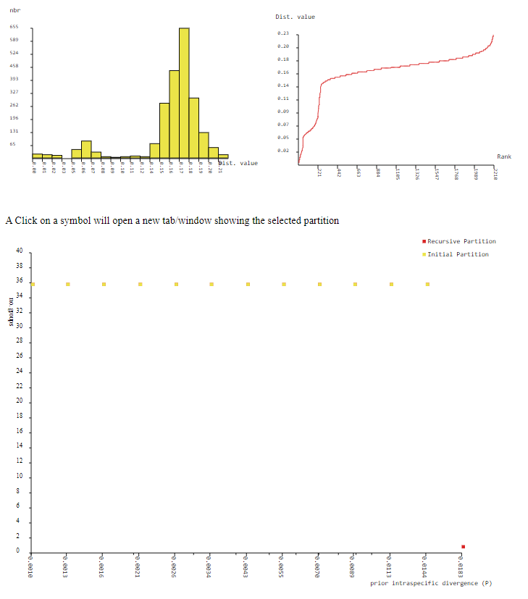

Simple Distance X = 0.75
Partition 1 : found 36 groups (prior maximal distance P= 0.001000)
Partition 2 : found 36 groups (prior maximal distance P= 0.001274)
Partition 3 : found 36 groups (prior maximal distance P= 0.001624)
Partition 4 : found 36 groups (prior maximal distance P= 0.002069)
Partition 5 : found 36 groups (prior maximal distance P= 0.002637)
Partition 6 : found 36 groups (prior maximal distance P= 0.003360)
Partition 7 : found 36 groups (prior maximal distance P= 0.004281)
Partition 8 : found 36 groups (prior maximal distance P= 0.005456)
Partition 9 : found 36 groups (prior maximal distance P= 0.006952)
Partition 10 : found 36 groups (prior maximal distance P= 0.008859)
Partition 11 : found 36 groups (prior maximal distance P= 0.011288)
Partition 12 : found 36 groups (prior maximal distance P= 0.014384)
Partition 13 : found 23 groups (prior maximal distance P= 0.018330)
Partition 14 : found 23 groups (prior maximal distance P= 0.023357)
Partition 15 : found 22 groups (prior maximal distance P= 0.029764)
Partition 16 : found 22 groups (prior maximal distance P= 0.037927)
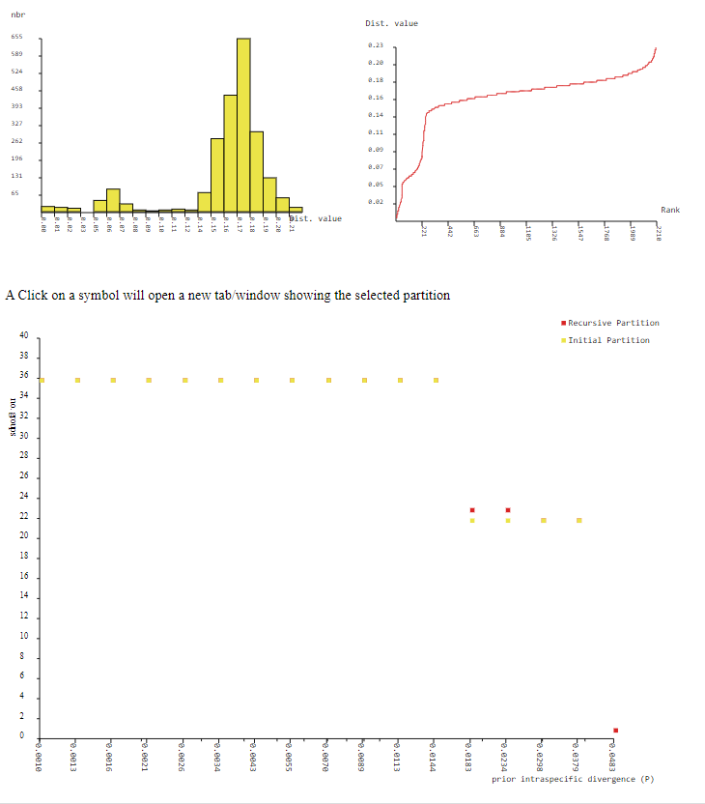

Simple Distance X = 0.5
Partition 1 : found 36 groups (prior maximal distance P= 0.001000)
Partition 2 : found 36 groups (prior maximal distance P= 0.001274)
Partition 3 : found 36 groups (prior maximal distance P= 0.001624)
Partition 4 : found 36 groups (prior maximal distance P= 0.002069)
Partition 5 : found 36 groups (prior maximal distance P= 0.002637)
Partition 6 : found 36 groups (prior maximal distance P= 0.003360)
Partition 7 : found 36 groups (prior maximal distance P= 0.004281)
Partition 8 : found 36 groups (prior maximal distance P= 0.005456)
Partition 9 : found 36 groups (prior maximal distance P= 0.006952)
Partition 10 : found 36 groups (prior maximal distance P= 0.008859)
Partition 11 : found 36 groups (prior maximal distance P= 0.011288)
Partition 12 : found 36 groups (prior maximal distance P= 0.014384)
Partition 13 : found 23 groups (prior maximal distance P= 0.018330)
Partition 14 : found 23 groups (prior maximal distance P= 0.023357)
Partition 15 : found 22 groups (prior maximal distance P= 0.029764)
Partition 16 : found 22 groups (prior maximal distance P= 0.037927)
