Supporting Information
Regulating local molecular polarization of triazine-PDI based polymer for high-efficient photocatalytic coupling of benzylamine

Rong Yan^{a,#}, Meiyang Song^{a,#},Peng Chen^{a,*}, Henghui Songª, Chengbing Fu^{a,*}, Haiyang Pengª, Shuang-Feng Yin^{b,*}

ª Provincial Guizhou Key Laboratory of Green Chemical and Clean Energy Technology, School of Chemistry and Chemical Engineering, Guizhou University, Guiyang 550025, Guizhou, China
^{b} College of Chemistry and Chemical Engineering, Advanced Catalytic Engineering Research Center of the Ministry of Education, State Key Laboratory of Chemo/Biosensing and Chemometrics, Hunan University, Changsha 410082, PR China
Email: pchen3@gzu.edu.cn (P. Chen), gs.songmy21@gzu.edu.cn (M. Song) sf_yin@hnu.edu.cn (S. F. Yin)

Table S1. Apparent quantum yield (AQY) of N-benzylidenebenzylamine formation over PDIMB-2.
Wavelength (nm) | 420 | 450 | 500 | 550 | 600 | 700 | 750
N-benzylidenebenzylamine formation rate (mmol g⁻¹h⁻¹) | 13.67 | 11.07 | 8.61 | 8.20 | 6.84 | 2.42 | 0.40
Light intensity (mW cm⁻²) | 21.04 | 17.02 | 19.92 | 20.08 | 25.22 | 8.51 | 3.05
Irradiation area (cm²) | 8.04 | 8.04 | 8.04 | 8.04 | 8.04 | 8.04 | 8.04
Irradiation time (h) | 2.00 | 2.00 | 2.00 | 2.00 | 2.00 | 2.00 | 2.00
AQY (%) | 6.40 | 5.98 | 3.57 | 3.07 | 1.87 | 1.68 | 0.73

Table S2. Detailed comparison of PDIMB-2 with other photocatalysts.
Catalysts | Reaction  conditions | Sel.  (%) | Generation rate  (mmol g⁻¹ h⁻¹) | Ref
PCN/Ag₃PO₄ | O₂ (1 atm)  298 K | >99 | 2.48 | 1
HUN-64 | O₂ (1 atm)  298 K | >99 | 1.99 | 2
BMO-NP | O₂ (1 atm)  298 K | >99 | 0.30 | 3
mpg-C₃N₄ | O₂ (5 atm)  353 K | 99 | 3.00 | 4
NST | O₂ (1 atm)  298 K | 96.9 | 1.09 | 5
Zn-PDI | O₂ (1atm)  298K | >99 | 9.9 | 6
PDIMB-2 | O₂ (1atm)  298K | >99 | 24.5 | This  work

Table S3. Zeta potentials of as-prepared photocatalysts.
Samples | 1 | 2 | 3 | 4 | 5 | 6 | Average
PDIM | -40.5 | -41.2 | -42.3 | -41.5 | -41.2 | -41.8 | -41.4
PDIMB-1 | -49.5 | -49.2 | -49.0 | -49.9 | -50.2 | -49.5 | -49.6
PDIMB-2 | -51.4 | -52.5 | -52.6 | -52.8 | -52.9 | -52.0 | -52.4
PDIMB-3 | -46.7 | -46.8 | -46.9 | -46.5 | -46.2 | -46.3 | -46.6
PDIMB-4 | -45.3 | -45.2 | -45.9 | -46.0 | -44.9 | -44.8 | -45.4
PDIMB-5 | -42.3 | -42.5 | -43.5 | -42.9 | -43.0 | -43.2 | -42.9

Table S4. Fitting results of time-resolved photoluminescence spectra.
Samples | A₁ (%) | τ₁ (ns) | A₂ (%) | τ₂ (ns) | A₃ (%) | τ₃ (ns) | τ_{ave} (ns)
PDIMB-2 | 47.62 | 0.20 | 30.38 | 1.59 | 22.00 | 5.32 | 4.01
PDIM | 54.37 | 0.25 | 29.48 | 1.87 | 16.15 | 6.24 | 4.34

The τ_{ave} can be calculated by the following equation:
τ_{ave}=(A₁τ₁²+A₂τ₂²+A₃τ₃²)/(A₁τ₁+A₂τ₂+A₃τ₃)

Table S5. Total Mulliken charge populations of PDIM and PDIMB.
 | C (e) | N (e) | O (e) | H (e) | SUM
PDIM | 1.370 | -0.482 | -1.942 | 0.864 | -0.190
PDIMB | 1.364 | -0.474 | -1.961 | 0.862 | -0.209

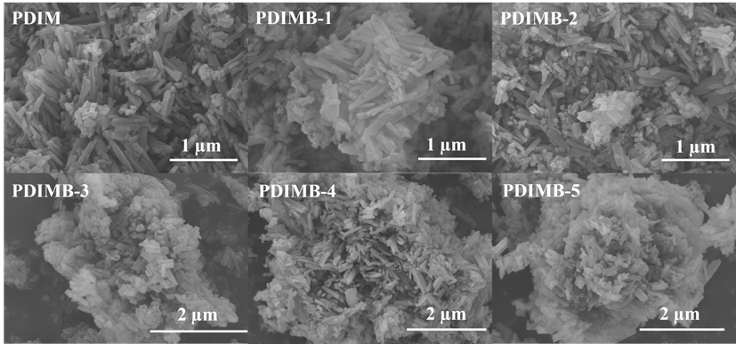
Fig. S1. SEM images of as-prepared samples.
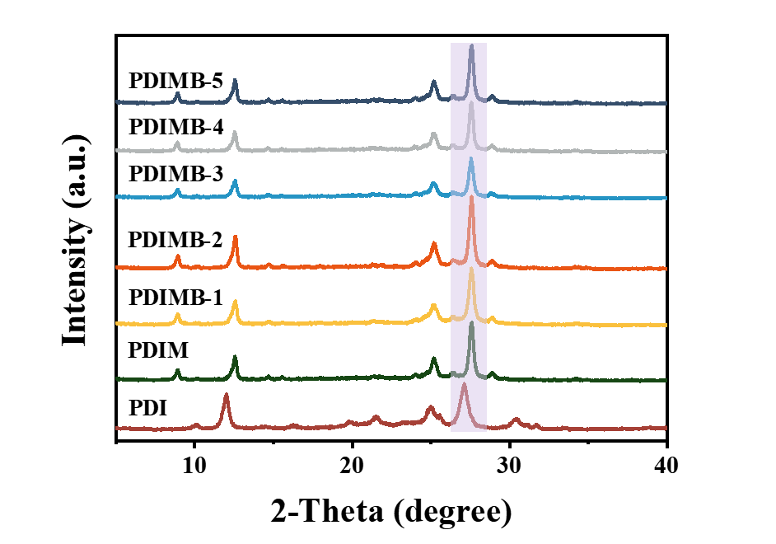
Fig. S2. XRD pattern of as-prepared samples.
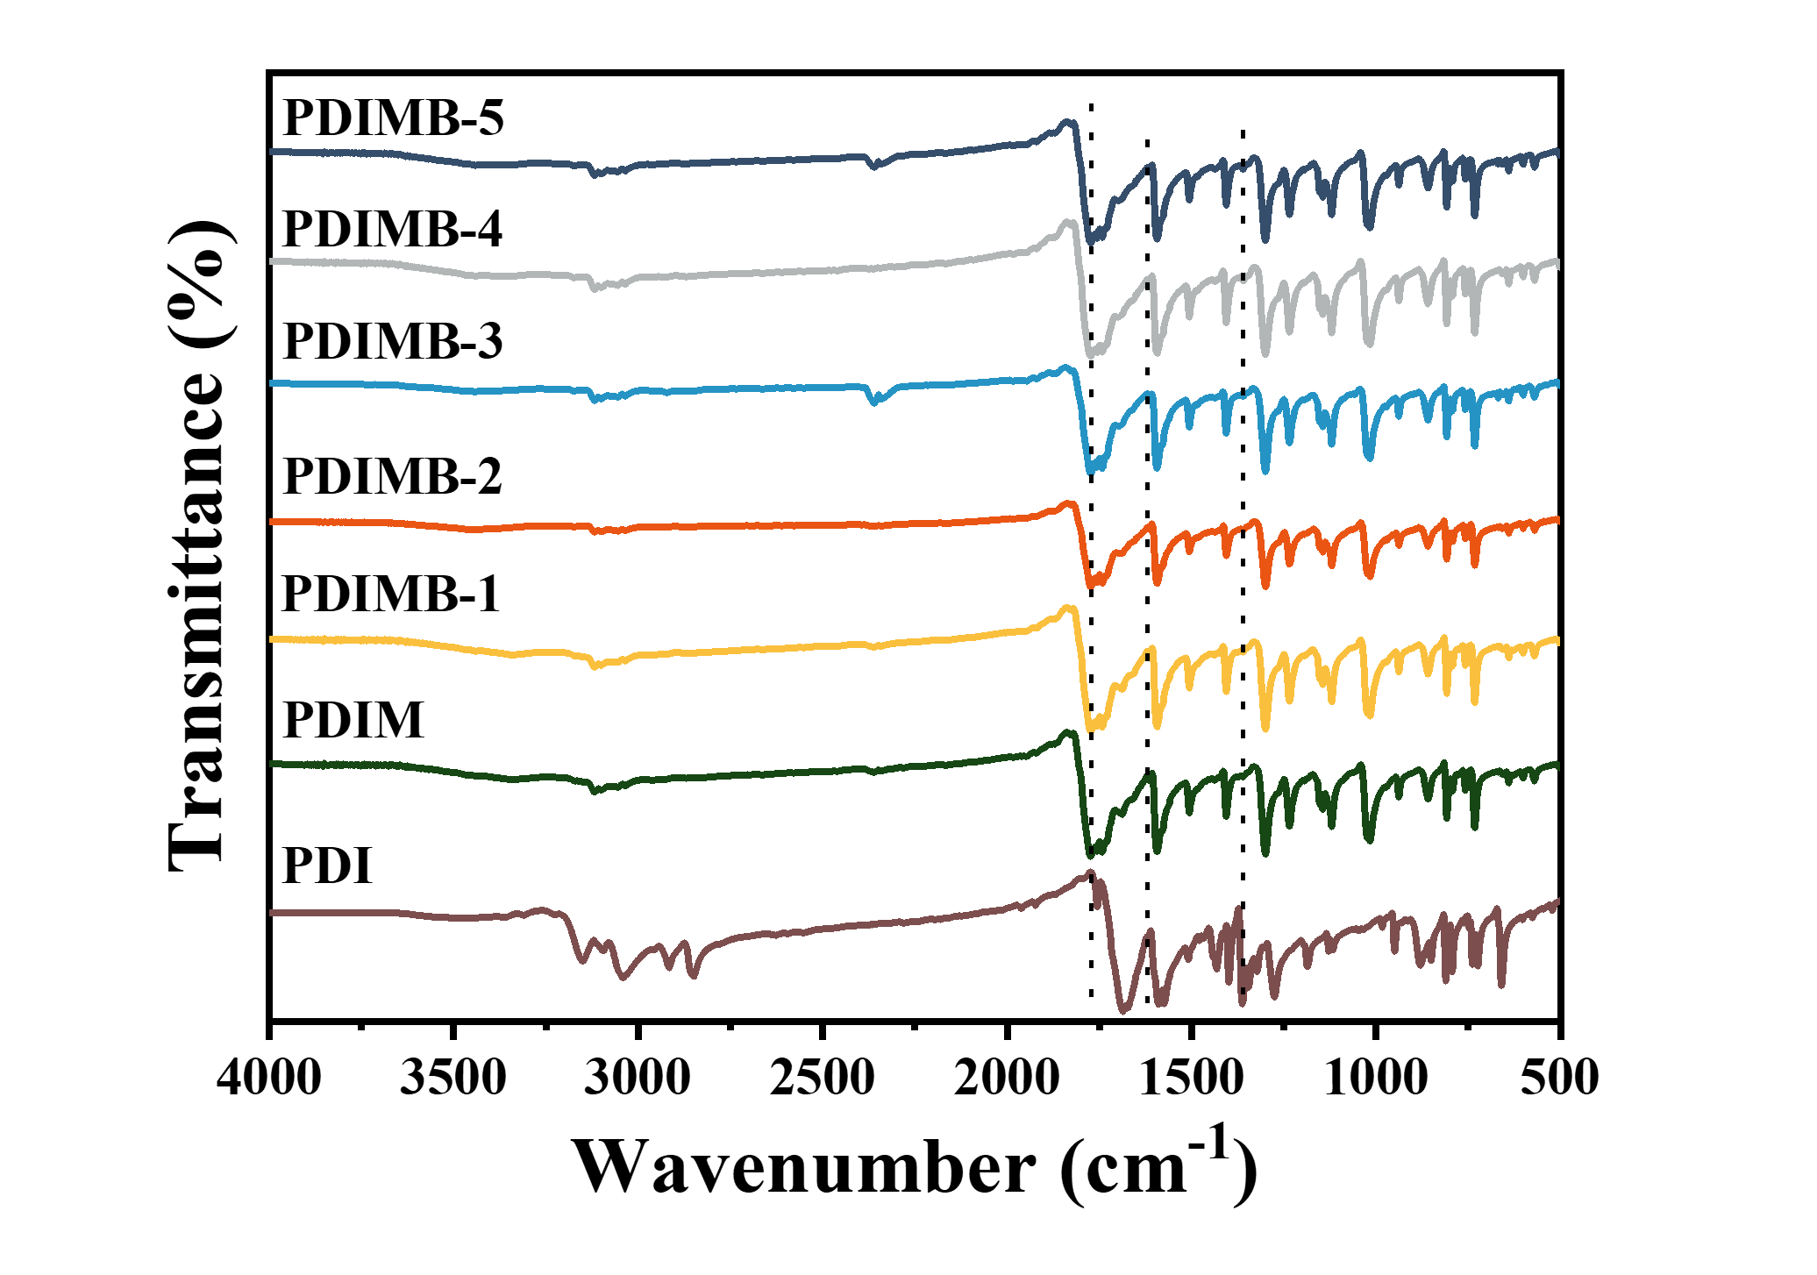
Fig. S3. FTIR spectra of as-prepared samples.
As shown in Fig. S3, the FT-IR spectrum of the synthesized polymers of PDIMB and PDIM are almost the same as that of PDI. Additionally, a peak of PDIM at 1618 cm⁻¹ is the stretching of C=N, suggesting the triazine was successfully embedded in the PDIM.

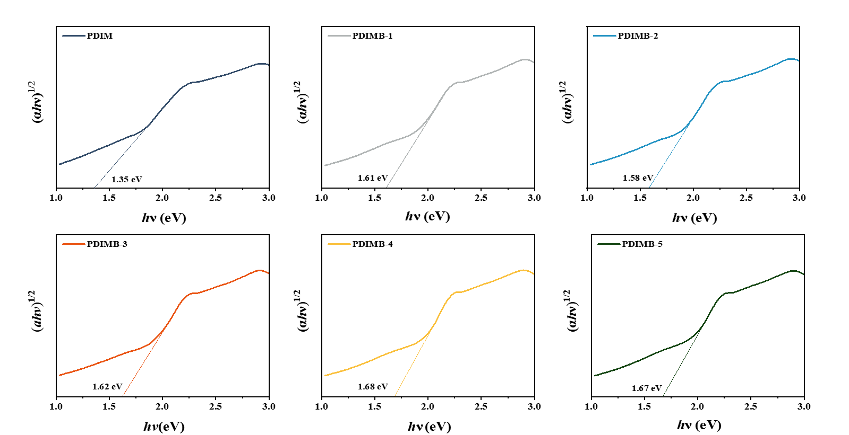
Fig. S4. The corresponding Tauc plots of fabricated samples.

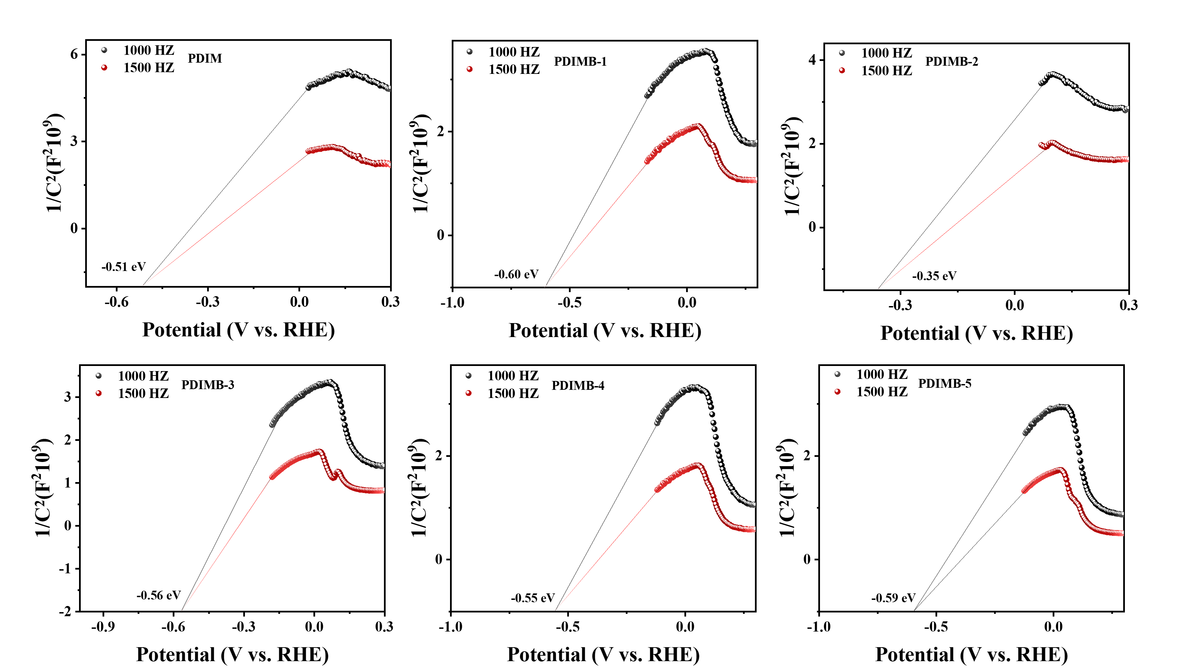
Fig. S5. Mott-Schottky curves of fabricated samples.
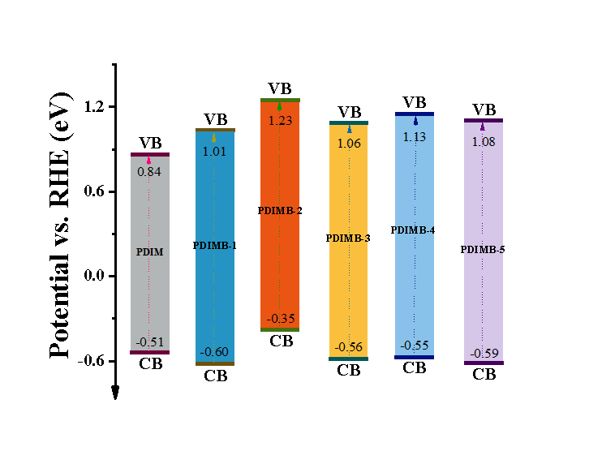
Fig. S6. Energy band structure of PDIM and PDIMB-X.

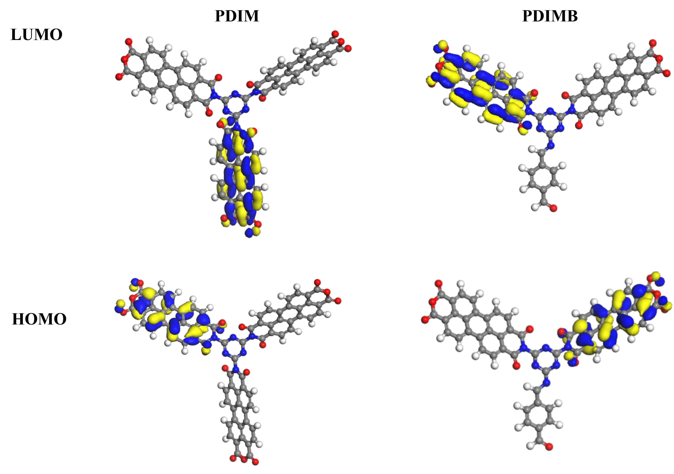
Fig. S7. The HOMO and LUMO orbitals of PDIM and PDIMB
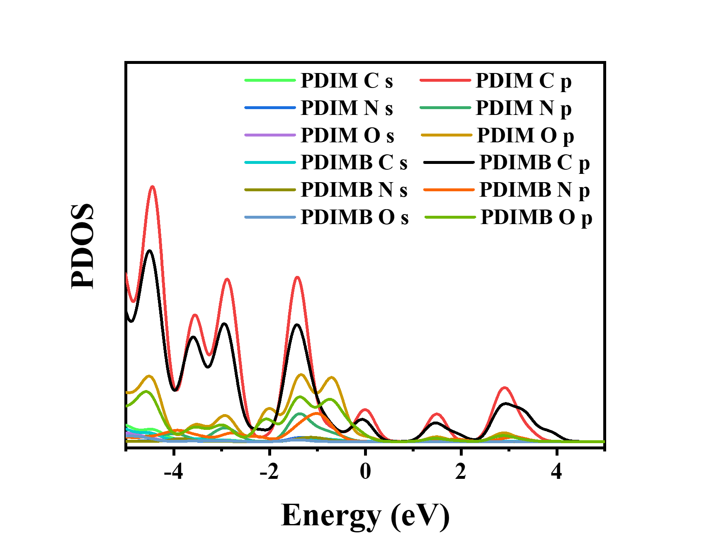
Fig. S8. Projected density of states of PDIM and PDIMB.

Fig. S9. ¹H NMR spectrum of benzylamine oxidation products.

Fig. S10. Photocatalytic selective oxidation of 4-chlorobenzylamine, 4-bromobenzylamine, 4-methylbenzylamine and 4-methoxybenzylamine over PDIMB-2.

Fig. S11. XRD pattern of PDIMB-2 before and after five cycles for photocatalytic selective oxidation of benzylamine.
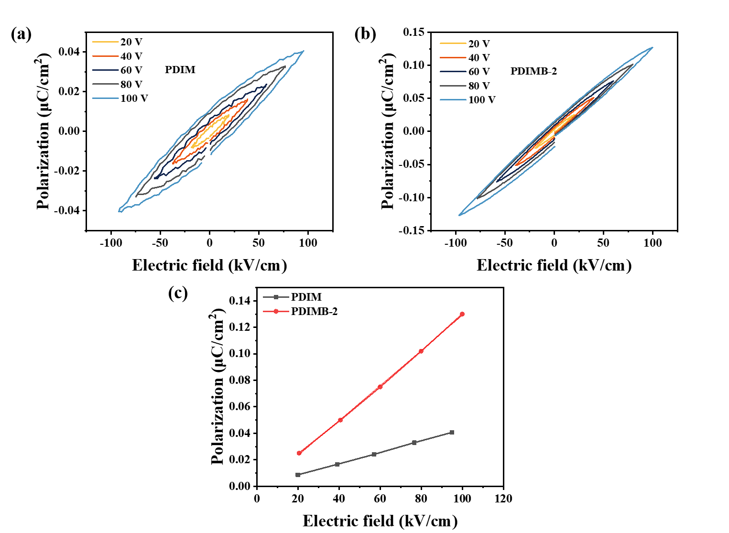

Fig. S12. Room temperature hysteresis loops of (a) PDIM, (b) PDIMB-2, (c) P–E loops of PDIM and PDIMB-2.

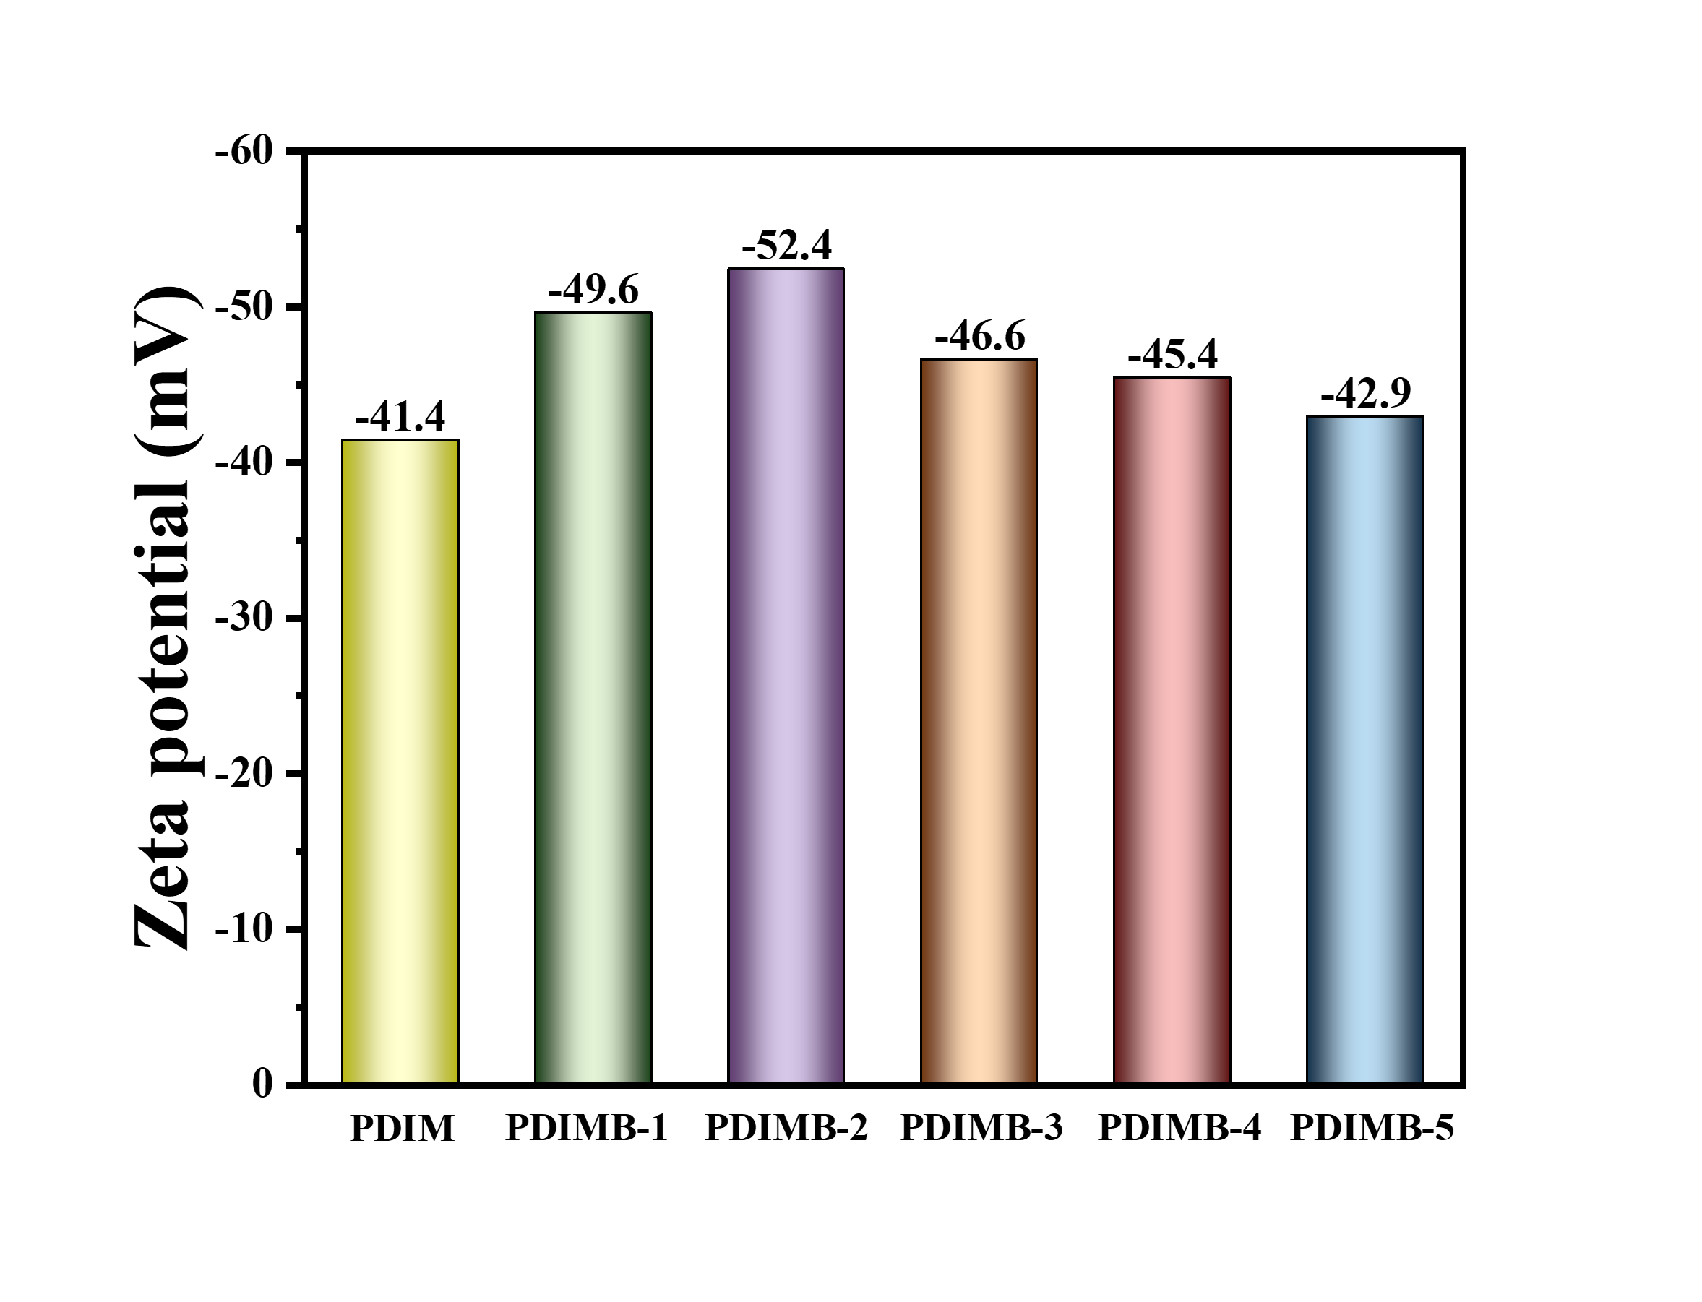
Fig. S13. Zeta potential of PDIM and PDIMB-X.
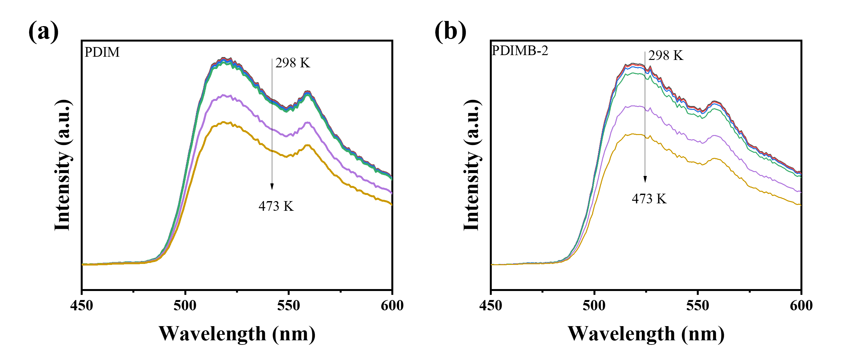
Fig. S14. TD-PL spectrum of (a) PDIM and (b) PDIMB-2.

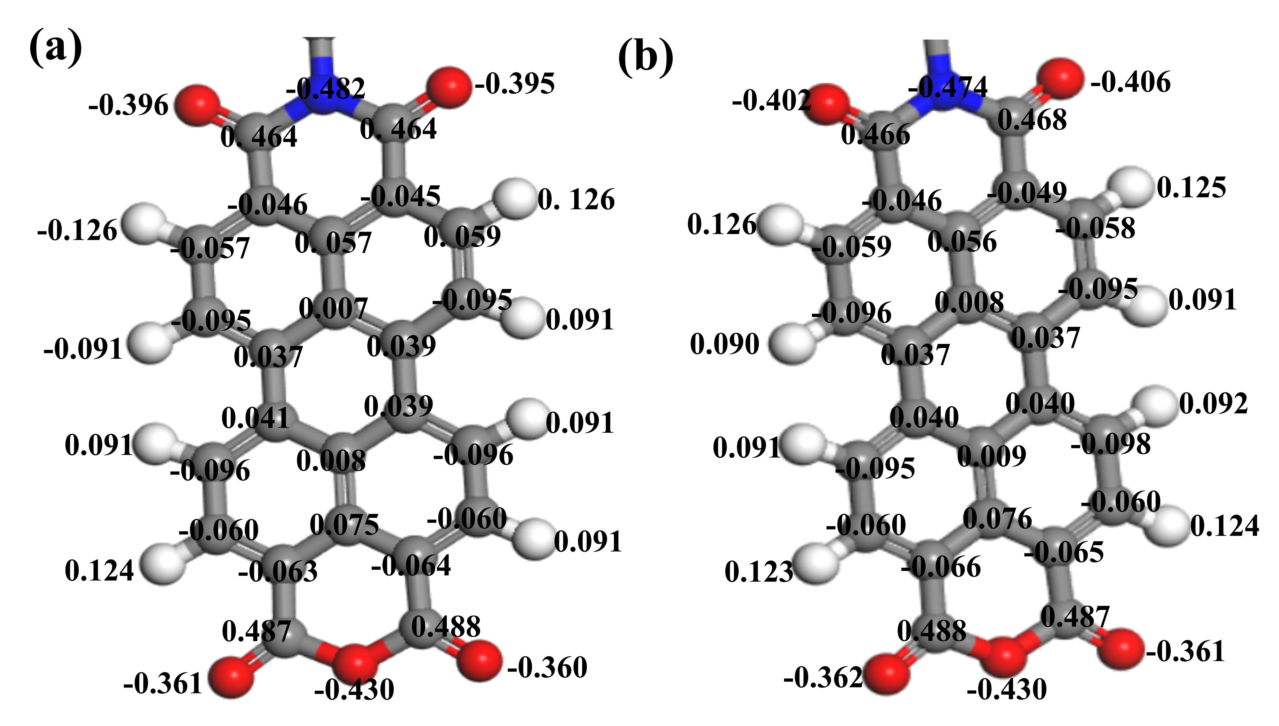
Fig. S15. Mulliken charges of (a) PDIM and (b) PDIMB.

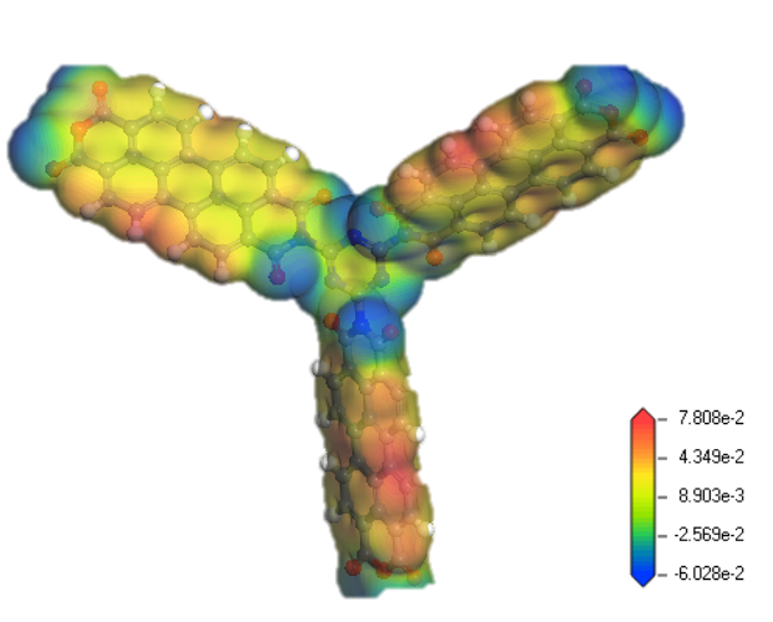
Fig. S16. Differential charge density of PDIM.

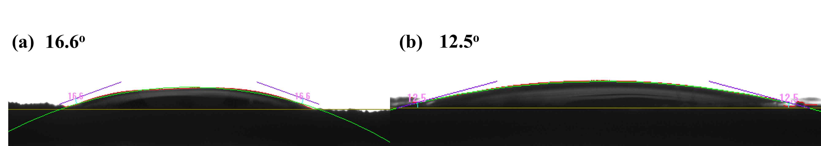
Fig. S17. Contact-angle of benzylamine on the surface of (a) PDIM and (b) PDIMB-2.
Fig. S18. O₂-temperature programmed desorption spectra of PDIM and PDIMB-2.
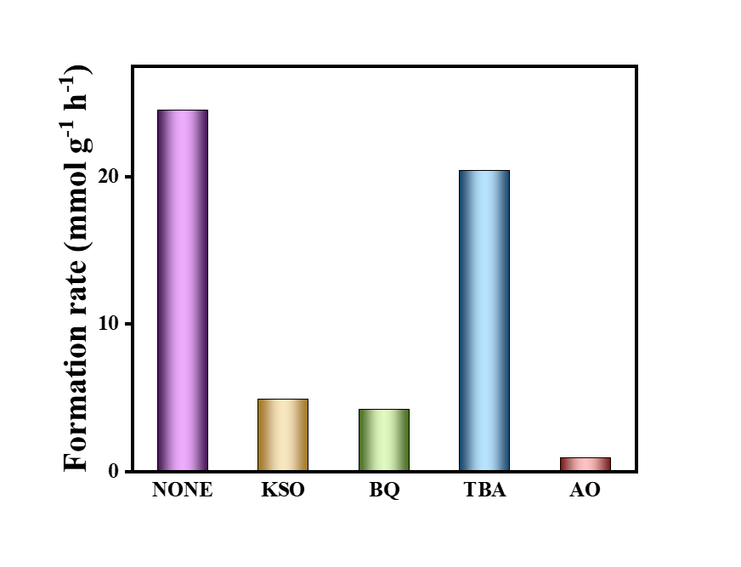
Fig. S19. Photocatalytic selective oxidation of benzylamine over PDIMB-2 with or without a scavenger. (Ammonium oxalate (AO), potassium persulfate (KSO), p-benzoquinone (BQ) and tert-butanol (TBA) acted as scavengers for hole (h⁺), electron (e⁻), superoxide radical (O₂^{•−}) and hydroxyl radical (·OH) trapping, respectively.)

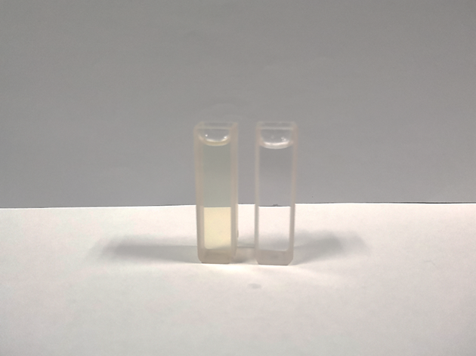
Fig. S20. Detection of H₂O₂ in reaction liquid.

(1)
(2)
(3)
Fig. S21. Proposed reaction progress of the photocatalytic oxidative coupling of benzylamine.

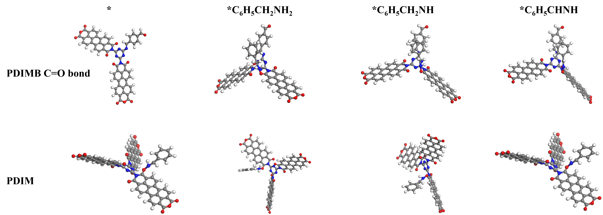
Fig. S22. DFT-calculated Gibbs free energy of selective amines oxidation.

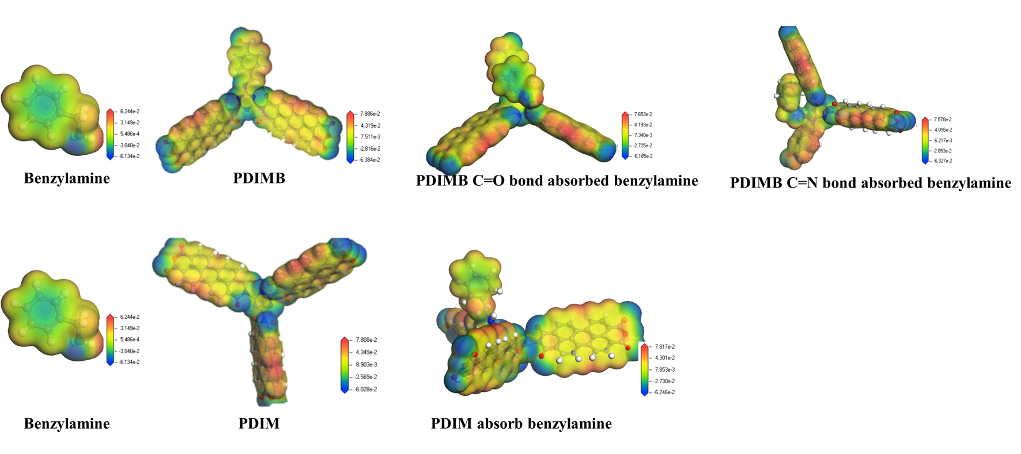
Fig. S23. Differential charge diagram before and after adsorption of benzylamine of PDIMB and PDIM.

References
- W. Li, L. Qin, Z.-H. Wang, G.-C. Xu, H.-C. Zheng, L.-M. Zhou, Z.-Q. Chen, Efficient porous carbon nitride/Ag₃PO₄ photocatalyst for selective oxidation of amines to imines: Z-scheme heterojunction and interfacial adsorption. Colloids Surf A Physicochem Eng Asp 2022; 652: 129806.
- G. Che, W.-T. Yang, C. Wang, M.-L. Li, X.-Y. Li, Q.-H. Pan, Efficient photocatalytic oxidative coupling of benzylamine over uranyl–organic frameworks. Inorg Chem 2022; 61: 12301–12307.
- W. Phasayavan, M. Japa, S. Pornsuwan, D. Tantraviwat, F. Kielar, V.-B. Golovko, S. Jungsuttiwong, B. Inceesungvorn, Oxygen-deficient bismuth molybdate nanocatalysts: Synergistic effects in boosting photocatalytic oxidative coupling of benzylamine and mechanistic insight. J Colloid Interface Sci 2021; 581: 719–728.
- F.-Z. Su, S.-C. Mathew, L. Möhlmann, M. Antonietti, X.-C. Wang, S. Blechert, Aerobic oxidative coupling of amines by carbon nitride photocatalysis with visible light. Angew Chem Int Ed 2011; 50: 657–660.
- Y.-h. Ren, J.-H. Zou, K.-Q. Jing, Y.-Y. Liu, B.-B. Guo, Y.-J. Song, Y. Yu, L. Wu, Photocatalytic synthesis of N-benzyleneamine from benzylamine on ultrathin BiOCl nanosheets under visible light. J Catal 2019; 380: 123–131.
- L. Zeng, T. Liu, C. He, D.-Y. Shi, F.-L. Zhang, C.-Y. Duan, Organized aggregation makes insoluble perylene diimide efficient for the reduction of aryl halides via consecutive visible light-induced electron-transfer processes. J Am Chem Soc 2016; 138: 3958–3961.

