SUPPLEMENTARY ONLINE MATERIALS FOR:

Temporal and spatial patterns of seed dispersal of four shrubs in a Cistus-Erica shrubland from Central Spain

José M. Moreno^{1,2*}, Eva Zuazua^{1,3}, Iván Torres¹, Antonio Parra¹ and Clara Moreno-Fenoll^{1,4}

1: Universidad de Castilla-La Mancha, Departamento de Ciencias Ambientales, Avda. Carlos III, s/n, Toledo, Spain.
2: Current address: Academia de Ciencias Sociales y Humanidades de Castilla-La Mancha, Altagracia, 2; Ciudad Real, Spain.
3: Current address: Fundación "la Caixa", Avenida Diagonal 621-629, Barcelona, Spain.
4: Current address: Laboratory of Biophysics and Evolution, CBI, ESPCI Paris, Université PSL, CNRS, 75005 Paris, France.

Table SOM1. Results of the repeated measures ANOVA for the seed crop of each of the three years studied and for each of the four species. When sphericity could not be assumed (significant Mauchly’s test) the Huynh-Feldt correction was applied. Letters (A, B, C) denote the results of the post hoc pair-wise comparison, corrected by Bonferroni for multiple comparisons. Years sharing the same letter were not significantly different.

Table SOM2. Year, model, range (A₀, m), spatial dependence (SD, %) and weighted sum of squared errors (SSErr) of the variograms fitted to plant cover measured on 0.5 x 0.5 quadrats of a 10 x 15 m plot (n=600) of total plant cover, Cistus ladanifer, Salvia rosmarinus, Erica umbellata and Erica arborea growing in an old Cistus-Erica shrubland in Quintos de Mora Range Station (To, Spain).
Species | Model | A₀ (m) | SD (%) | SSErr
Total plant cover | Spherical | 1.4 | 42 | 1.6E+06
Cistus ladanifer | Spherical | 1.5 | 64 | 5.7E+06
Salvia rosmarinus | Spherical | 2.5 | 40 | 8.1E+05
Erica umbellata | Spherical | 1.5 | 53 | 1.1E+07
Erica arborea | Spherical | 1.9 | 56 | 2.0E+06
Phillyrea angustifolia | Spherical | 1.5 | 70 | 2.1E+07

Table SOM3. Model, range (A₀, m), spatial dependence (SD, %) and weighted sum of squared errors (SSErr) of the variograms fitted to the total seed rain fell during the three years of study on 0.5 x 0.5 quadrats (n=106) of a 10 x 15 m plot of Cistus ladanifer, Salvia rosmarinus, Erica umbellata and Erica arborea growing in an old Cistus-Erica shrubland in Quintos de Mora Range Station (To, Spain).
Species | Model | A₀ (m) | SD (%) | SSErr
Cistus ladanifer | Spherical | 3.5 | 98 | 1.2E+18
Salvia rosmarinus | Spherical | 13.1 | 66 | 1.6E+15
Erica umbellata | Spherical | 2.9 | 55 | 1.4E+21
Erica arborea | Spherical | 4.4 | 36 | 5.3E+21

Table SOM4. Year, model, range (A₀, m), spatial dependence (SD, %) and weighted sum of squared errors (SSErr) of the variograms fitted to seed rain that fell on 0.5 x 0.5 quadrats (n=106) of a 10 x 15 m plot of Cistus ladanifer, Salvia rosmarinus, Erica umbellata and Erica arborea growing in an old Cistus-Erica shrubland in Quintos de Mora Range Station (To, Spain).
Species | Year | Model | A₀ (m) | SD (%) | SSErr
Cistus ladanifer | Year 1 | Spherical | 4.0 | 100 | 2.7E+16
 | Year 2 | Spherical | 3.7 | 87 | 2.2E+15
 | Year 3 | Spherical | 3.4 | 79 | 7.0E+16
Salvia rosmarinus | Year 1 | Spherical | 9.7 | 79 | 3.4E+13
 | Year 2 | Spherical | 11.7 | 34 | 1.3E+14
 | Year 3 | Spherical | 10.7 | 76 | 2.8E+13
Erica umbellata | Year 1 | Linear | 4.0 | 35 | 1.2E+19
 | Year 2 | Nugget | 0.0 | 0 | 1.0E+20
 | Year 3 | Spherical | 2.7 | 100 | 5.3E+19
Erica arborea | Year 1 | Spherical | 6.7 | 26 | 2.6E+35
 | Year 2 | Nugget | 0.0 | 0 | 5.5E+17
 | Year 3 | Spherical | 4.0 | 65 | 1.6E+19

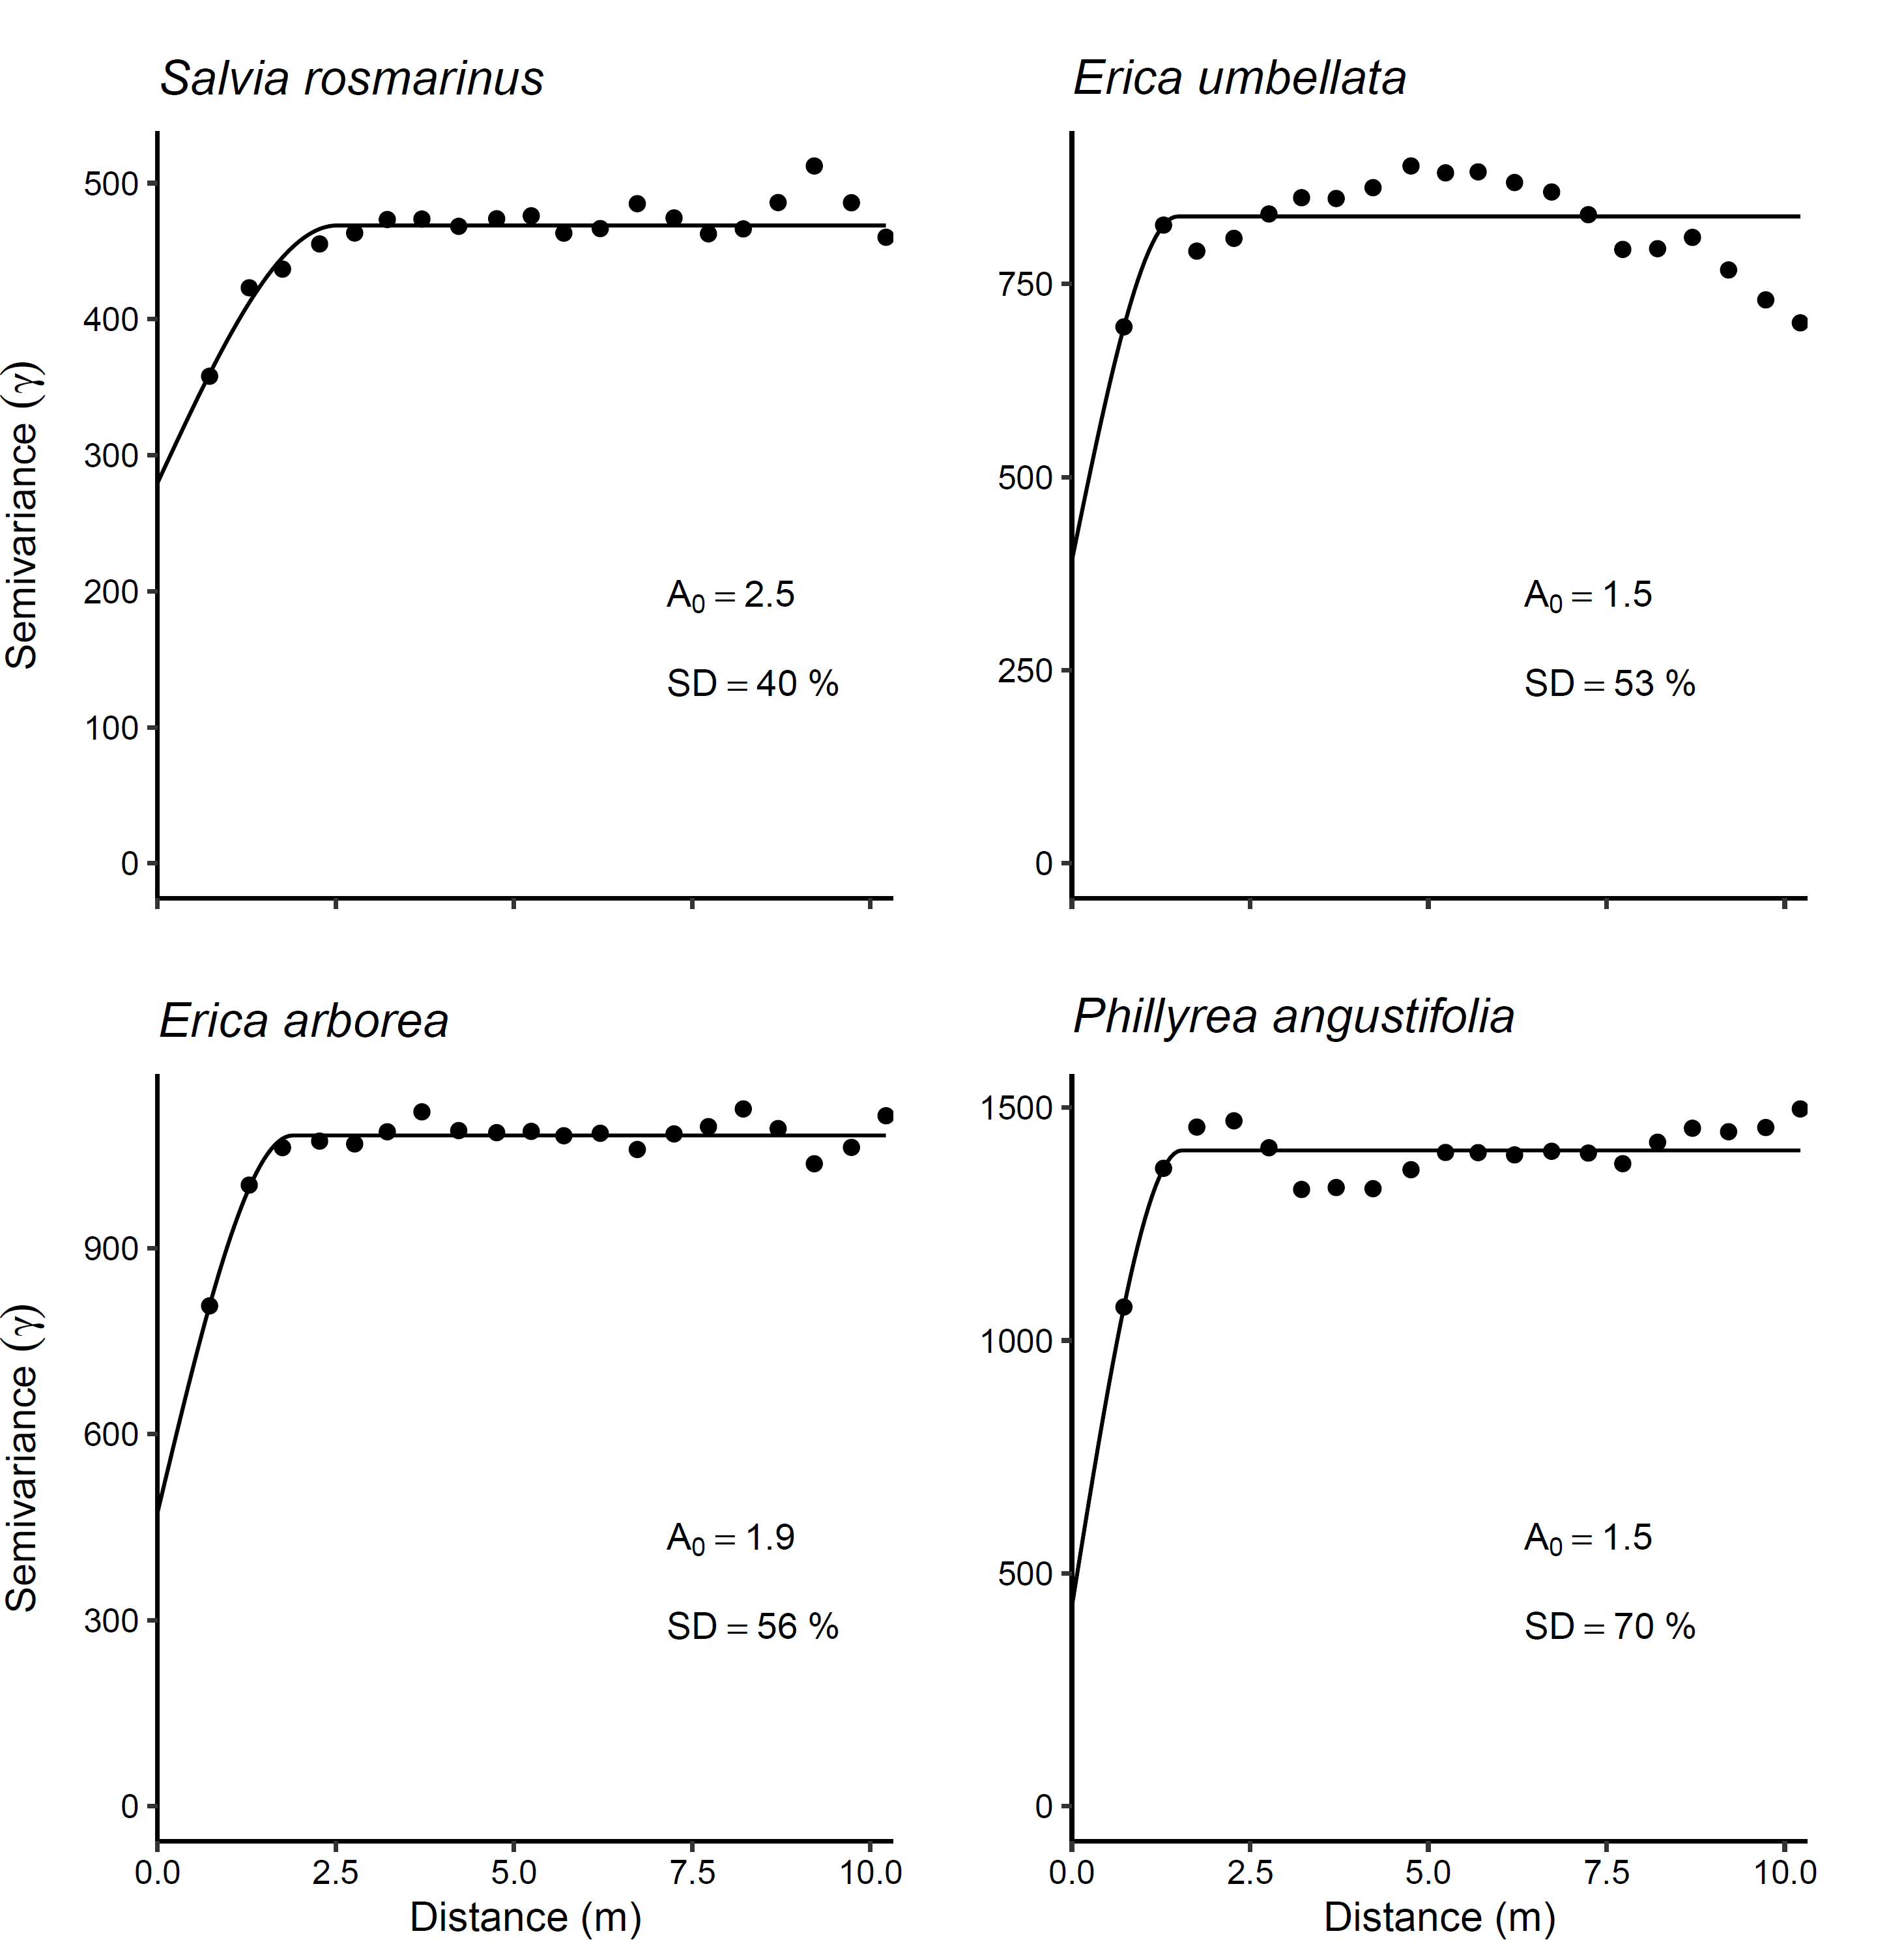
Figure SOM1. Semivariograms (semivariance as a function of distance) fitted to the plant cover (%) measured at the 0.5 x0.5 m quadrats of the 15x10 m plot in a Cistus-Erica shrubland at Quintos de Mora Range Station (Central Spain). Top row: Total plant cover (left), Cistus ladanifer (right); Middle row: Salvia rosmarinus (left), Erica umbellata (right); Bottom row: Erica arborea (left), Phillyrea angustifolia (right).

Figure SOM2. Semivariograms (semivariance as a function of distance) fitted to the seeds fallen at 0.5 x 0.5 m quadrats (n=106) during each of the three years of study (Year 1: Ap. 1997- Mar. 1998; Year 2: Ap.1998-Mar. 1999; Year 3: Ap. 1999- Mar. 2000) in a Cistus-Erica shrubland at Quintos de Mora Range Station (Central Spain) for Cistus ladanifer (top row), Salvia rosmarinus (middle-upper row), Erica umbellata (middle lower row), and Erica arborea (bottom row).

