Appendix
Figure A
Top 10 Languages of Tweets
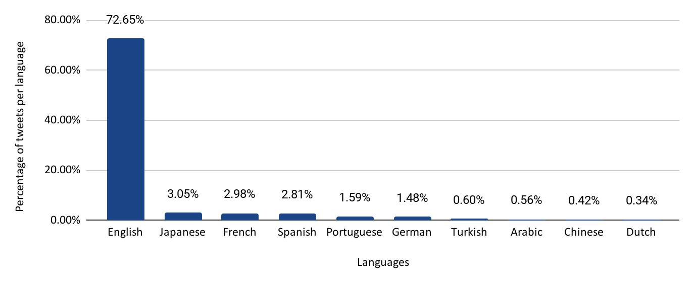

Figure B
Sentiments of Tweets per day Dealing With ChatGPT
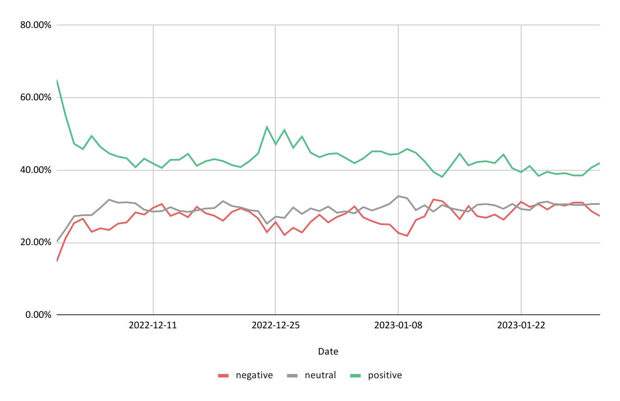
Note. We used 11,401,389 tweets (i.e., all tweets in English, including conversations).

Figure C
Sentiments of Tweets per day Dealing With ChatGPT
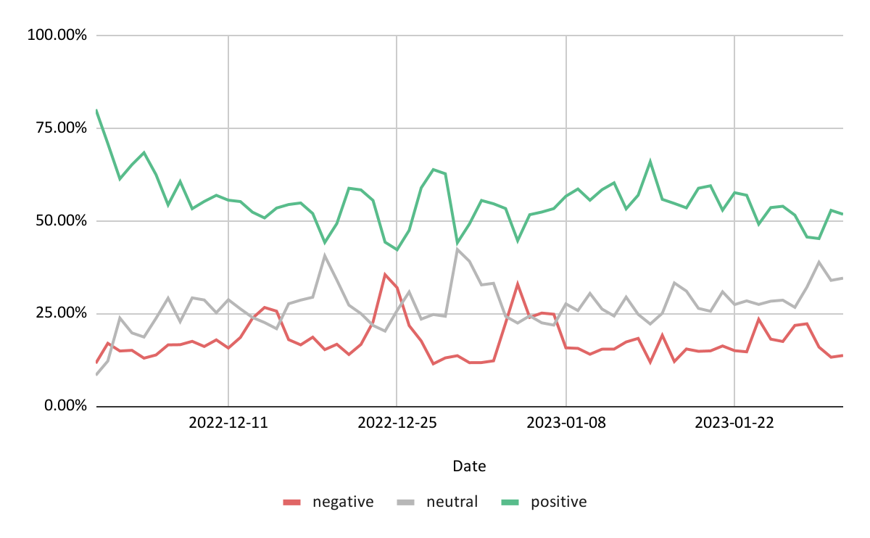
Note. 1,041,127 tweets used (i.e., all tweets in English, not including conversations).

