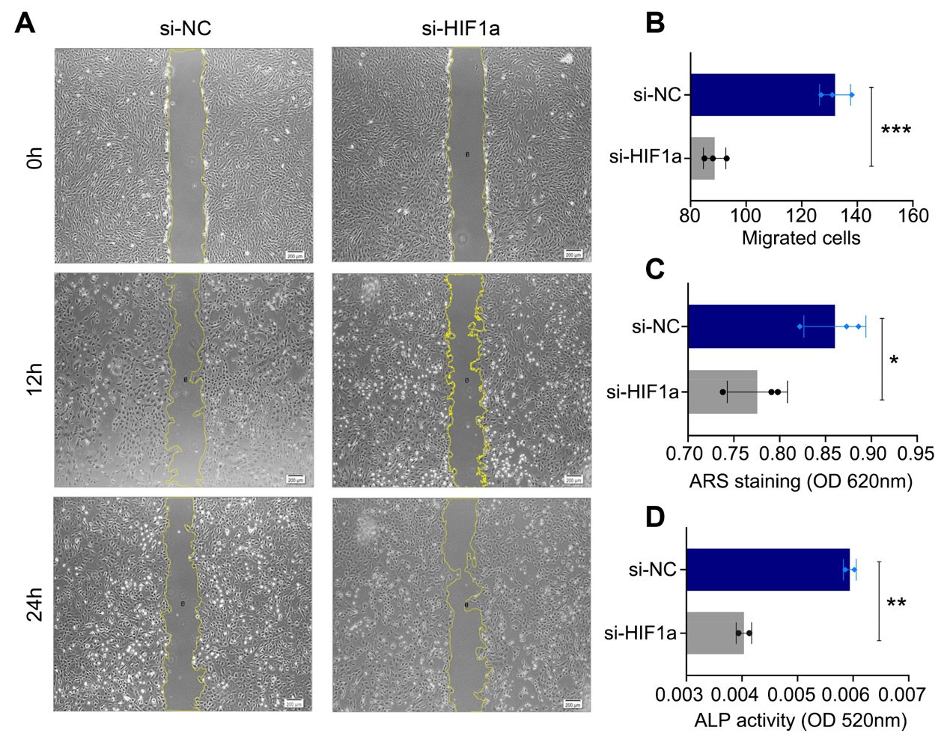
Fig. S1. Silencing HIF-1α under hypoxic condition inhibits migration, invasion, and osteogenic capacity of ADSCs. (A) the migration of ADSCs transfected with si-NC and si-HIF1α was detected by scratch wound assays at 0, 12, and 24h (scale bar=200 μm). Quantitation comparison of (B) Transwell test analysis (n=3); (C) alizarin red staining; and (D) ALP activity. *p<0.05; **p<0.01; ***p<0.001.

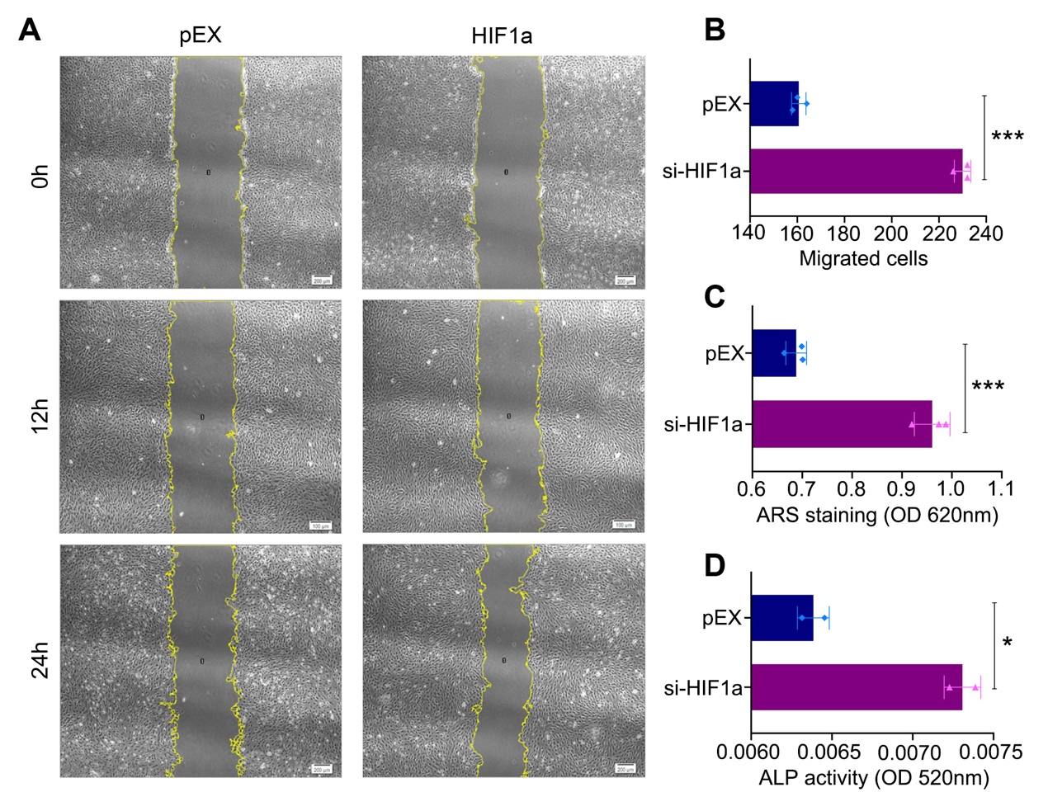
Fig. S2. HIF-1α overexpression in ADSCs significantly increases cell migration and the osteogenic capacity. (A) the migration ability measured by scratch assays at 0, 12, and 24h (scale bar = 200 μm). (B) Analysis of the Transwell test assays by counting the number of migrated cells (n=3); (C) ARS and (D) BCIP/NBT staining after osteogenic induction.

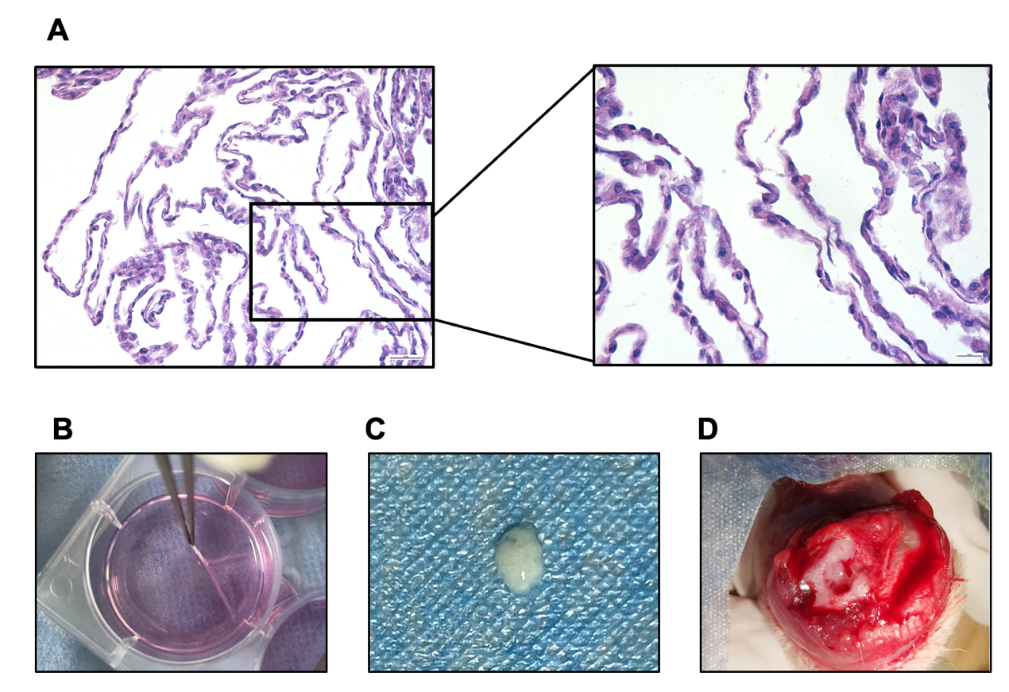
Fig. S3. Hematoxylin eosin staining of ADSCs sheets treated in surgical procedure. (A-C) HE staining and photograph of ADSCs sheet peeled off after 10 days cultured in sheet-forming inducing medium. (D) Transfected ADSCs sheet were placed and subsequent implant placement.

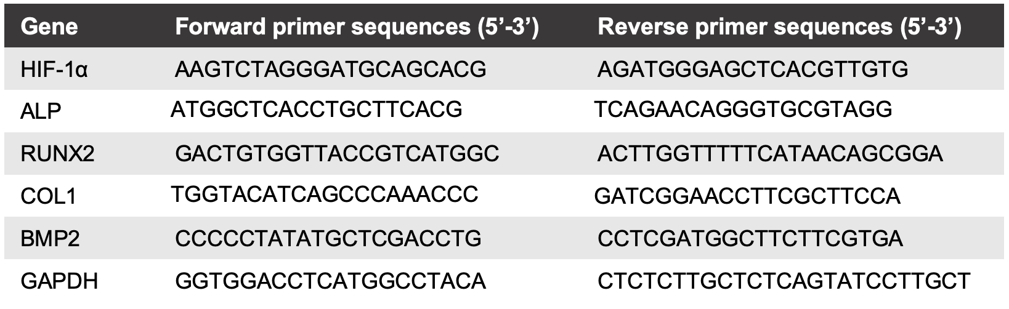
Table S1. Primer sequences used in real-time PCR

