Supplementary Information

Spin-Dependent Graph Neural Network Potential for Magnetic Materials

Hongyu Yu,^{a,b}, Yang Zhong^{a,b}, Liangliang Hong^{a,b}, Changsong Xu^{a,b}, Wei Ren,^{c} Xingao Gong,^{a,b} Hongjun Xiang^{a,b,*}

ªKey Laboratory of Computational Physical Sciences (Ministry of Education), Institute of Computational Physical Sciences, State Key Laboratory of Surface Physics, and Department of Physics, Fudan University, Shanghai 200433, China
^{b}Shanghai Qi Zhi Institute, Shanghai 200030, China
^{c}Department of Physics, International Center of Quantum and Molecular Structures and Materials Genome Institute, Shanghai University 200444, Shanghai, China

*E-mail: hxiang@fudan.edu.cn

Supplementary Discussion 1: The fitting and energy coefficient of magnetic potential
Though magnetic PES is much harder to be described than non-magnetic PES due to the explosion of the dimension from both the positions and magnetic moments, Spin-Allegro learns the complex atomic behavior and fine spin-lattice couplings well due to the equivariant neural network with affordable first-principle data. Also, we find that the influence of the atomic positions is dominant to the magnetic PES, and the couplings between the atomic positions and magnetic configurations are relatively small according to our previous experience of building the effective spin-lattice Hamiltonian¹ and the performance of the original Allegro and Spin-Allegro model. While Allegro performs well enough to describe the structurally related PES, the Spin-Allegro furthermore captures the fine and subtle spin-lattice interaction energy and force influenced by the magnetic moment configuration. Spin-Allegro is first built with the original Allegro with the learned Heisenberg edge for building the Heisenberg-type spin-lattice potential and then involves the spin-distance edge to describe the complex spin-lattice interactions of any form. As a result, the total magnetic potential is divided into three parts, $E_{r}$ for only atomic position-related terms, $E_{HB}$ for dominant Heisenberg spin-lattice term and $E_{rs}$ for high-order spin-lattice term and the coefficients $λ_{r}$, $λ_{HB}$, and $λ_{rs}$ in Eq. 1-3 in main text is important as a preknowledge of the energy contributions to achieve high accuracy. For the simple magnetic material that the Heisenberg-type spin-lattice interaction dominates and high-order terms can be neglected, Spin-Allegro only with the original Allegro with the learned Heisenberg edge is enough to build the magnetic potential for efficiency. It would be of great value to the community to conduct a detailed analysis of the contributions of different energy terms for building a better magnetic potential based on physical knowledge and understanding a specific magnetic material.
Supplementary Discussion 2: Calculation and optimization of the domain wall structure
To obtain the structure of DW configurations, we employed the CG and annealing algorithms for optimization. First, we optimized the initial random spin configuration with the CG algorithm, using 1000 steps. Then, we optimized the atomic positions with the CG algorithm, using 1000 steps and a fixed cell. Next, we ran the NPT-SIB simulation with the annealing algorithm, utilizing a time step of 0.25 fs, and allowed the system to equilibrate at 0.01 K for 2.5 ps. We subsequently heated the system to 300 K in 15 ps and let it equilibrate for 2.5 ps, bringing it near room temperature. Finally, we cooled the system down to 0.01 K in 15 ps and allowed it to equilibrate for 2.5 ps. Lastly, we optimized the atomic positions with the CG algorithm to arrive at the final optimized structure. The energy of the final domain wall structure, reference ferroelectric structure, and calculated domain wall energy for small and large systems is shown in Table S1 and Table S2. Structures of large domain walls are shown in Fig. S1.

Small system | 109 (160 atoms) | 180 (80 atoms) | 71 (80 atoms)
Final energy (eV) | -1010.2 | -504.50 | -504.42
Ferro energy (eV) | -1010.9 | -505.45 | -505.45
Domain wall energy (J/m²) | 65.986 | 166.40 | 181.99
Table S1. Energy landscape of domain wall structures of small systems.

Large system | 109 (1280 atoms) | 180 (640 atoms) | 71 (640 atoms)
Final energy (eV) | -8085.1 | -4039.7 | -4039.5
Ferro energy (eV) | -8087.2 | -4043.6 | -4043.6
Domain wall energy (J/m²) | 65.274 | 170.49 | 184.56
Table S2. Energy landscape of domain wall structures of large systems.
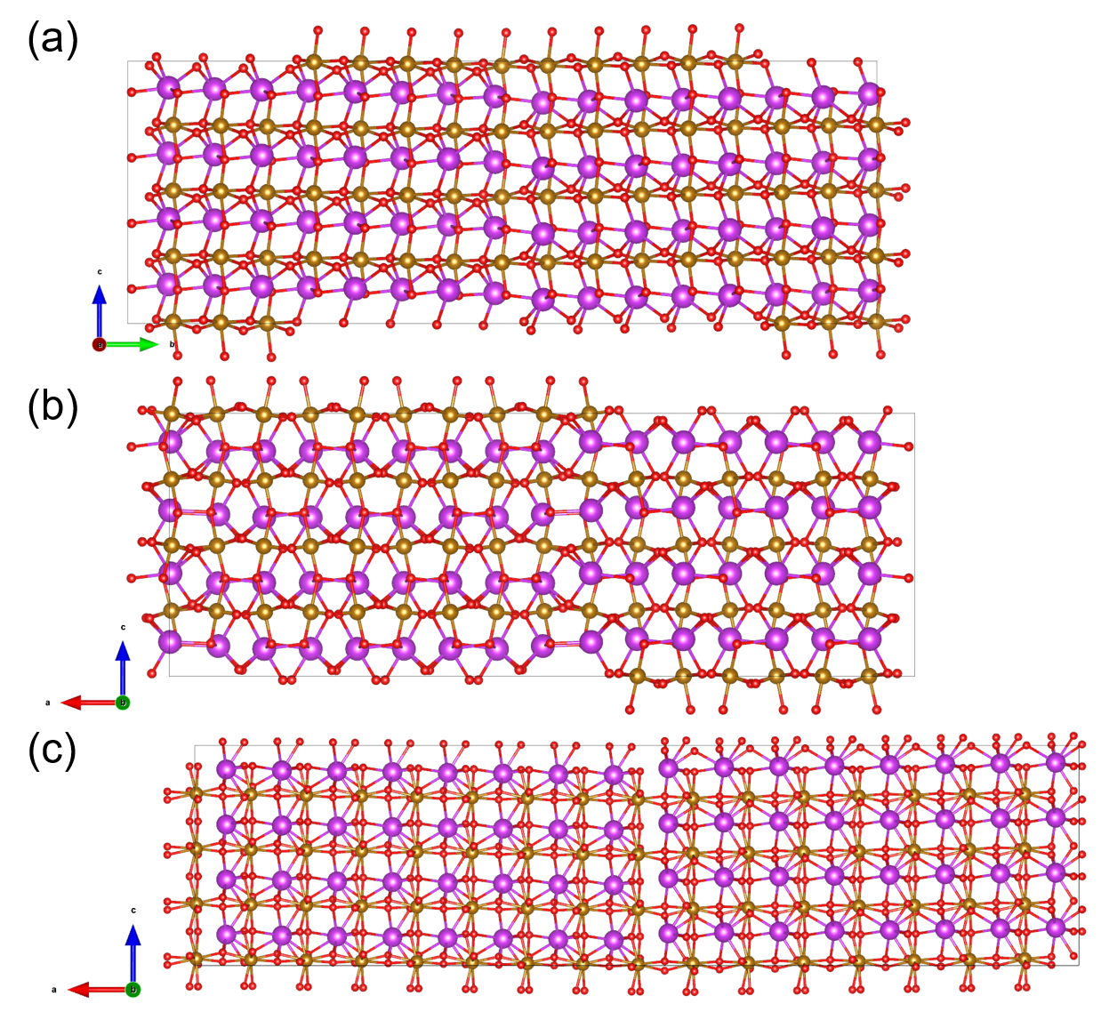
Figure S1 The optimized large domain wall (DW) structures of BiFeO₃ (a) DW71, (b) DW180, and (c) DW190.

Supplementary references
1. Lou, F. et al. PASP: Property analysis and simulation package for materials. J. Chem. Phys. 154, 114103 (2021).

