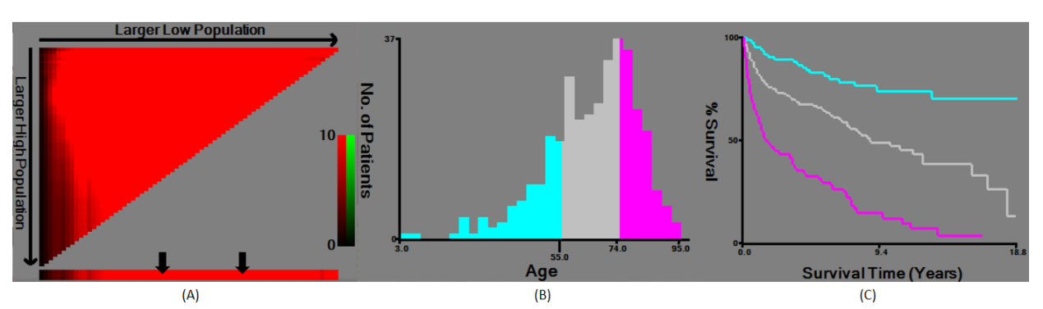
Supplement Fig 1. Through x-tile analysis, the graphs show the best age value. (A) Arrows indicate the best cutoff for the determined age. (B) Histogram constructed according to the best truncation value. (C) Kaplan Meier showed that the best age cutoff values were 55 and 74 years, respectively.

