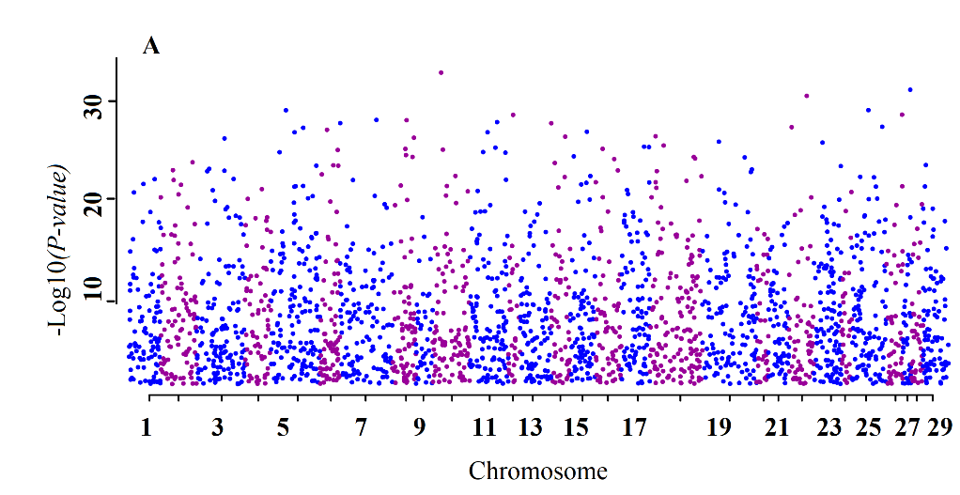
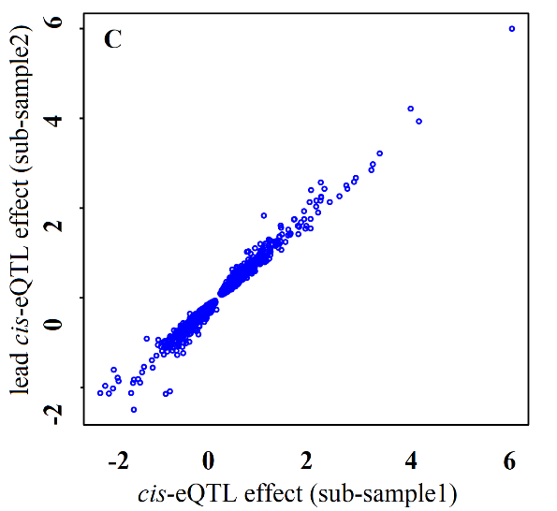
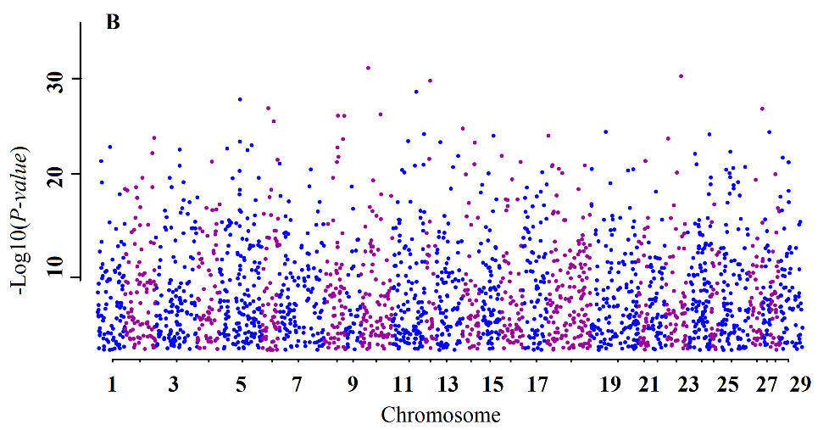
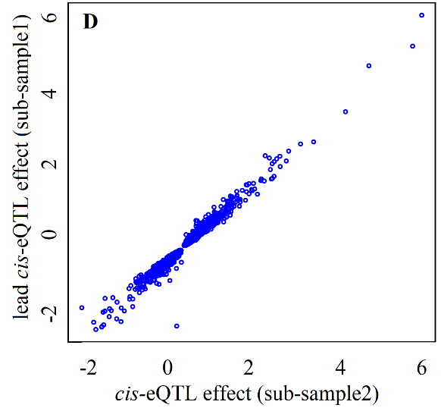
Supplementary Figure 1. Inter-validation of cis-eQTLs; Manhattan plot of lead cis-eQTL for eGenes (FDR<0.01) in half-sample2 (A) and half-sample1 (B), Consistency of effect estimates between pairs across half-sample2 (C), and half-sample1 (D)

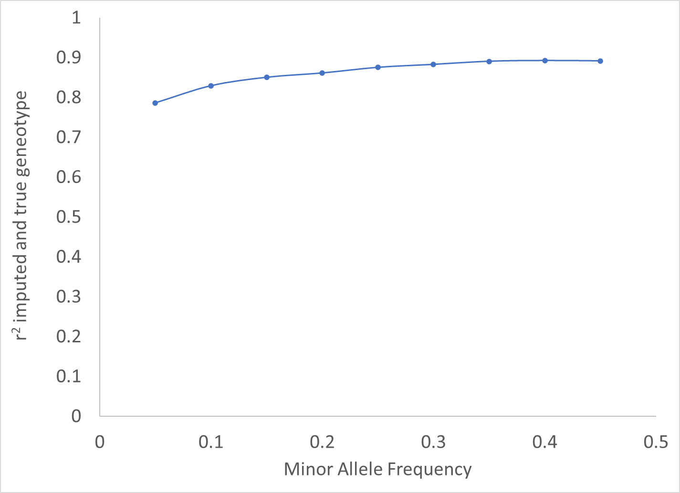
Supplementary Figure 2. Accuracy of imputation (correlation squared of true and imputed genotypes) to whole genome sequence data for the Brahman animals the 1000 bull genomes reference panel.

