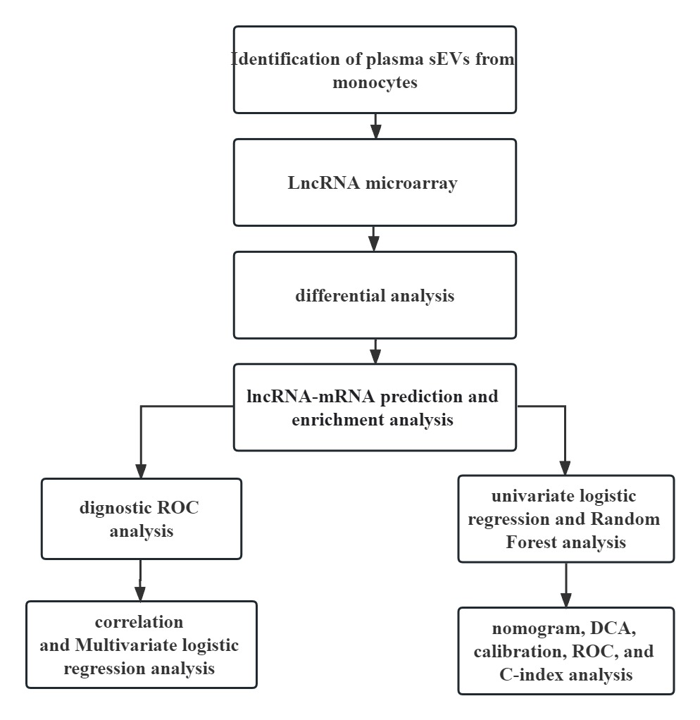

Figure S1. The analytical workflow of the entire study.

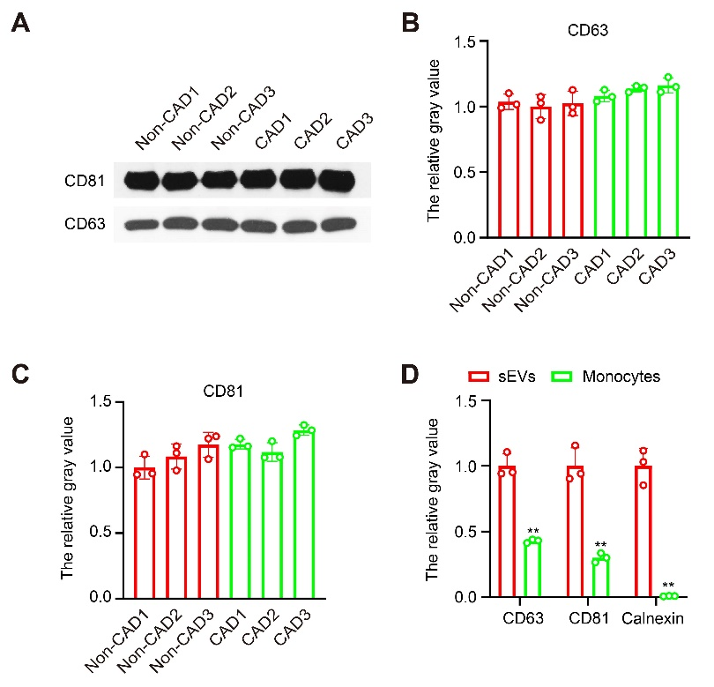

Figure S2, Protein expression in small extracellular vesicles (sEVs) was validated by western blotting. (A) Expression of CD81 and CD63 proteins in sEVs derived from CAD patients and Non-CAD patients. (B-C) The relative gray analysis of CD63 and CD81 in Figure S2A using Image. (D) The relative gray analysis of CD63 and CD81 in Figure 1B using Image.

Original image of western blotting (Figure 1B CD81（original）)
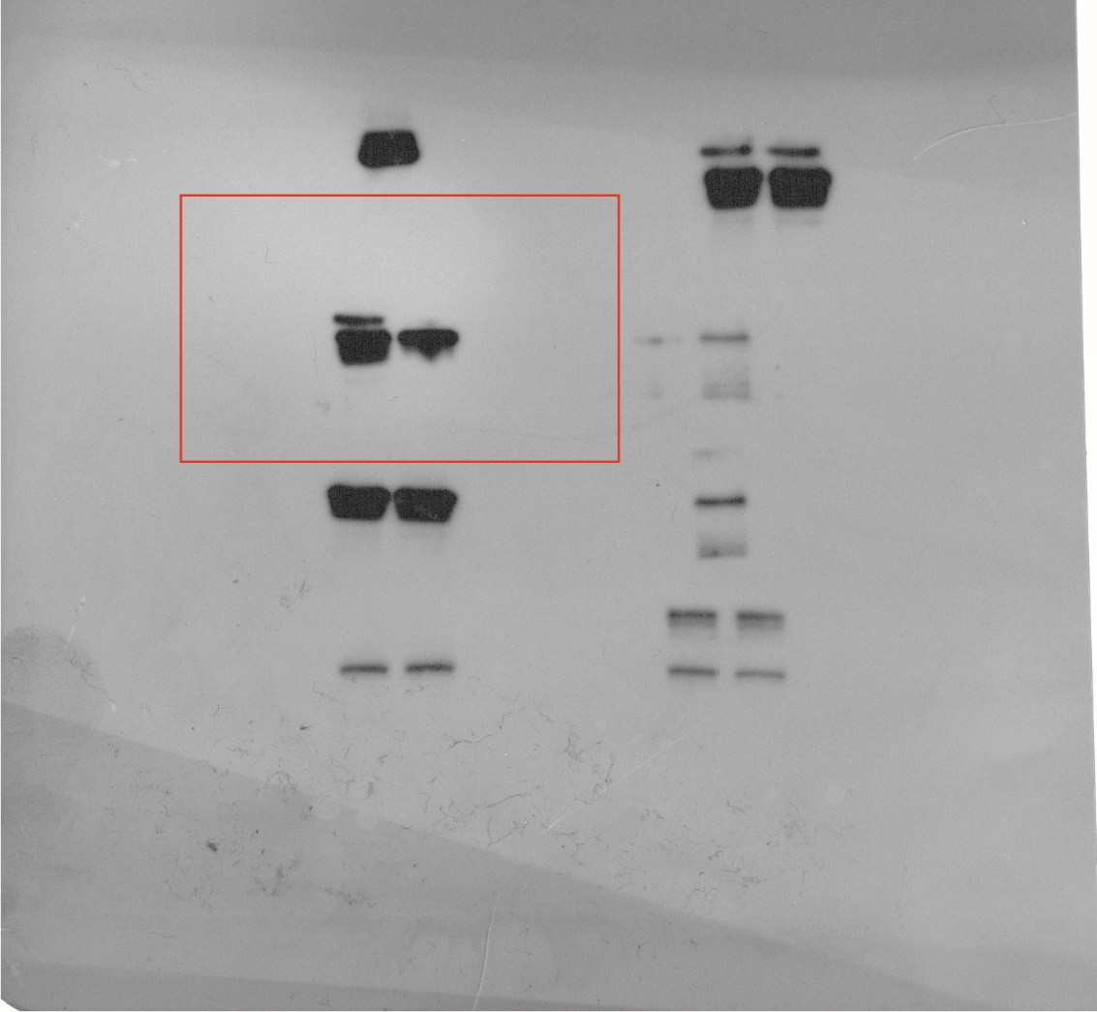
Figure 1B CD81（original）

Original image of western blotting (Figure S1A CD63（original）)
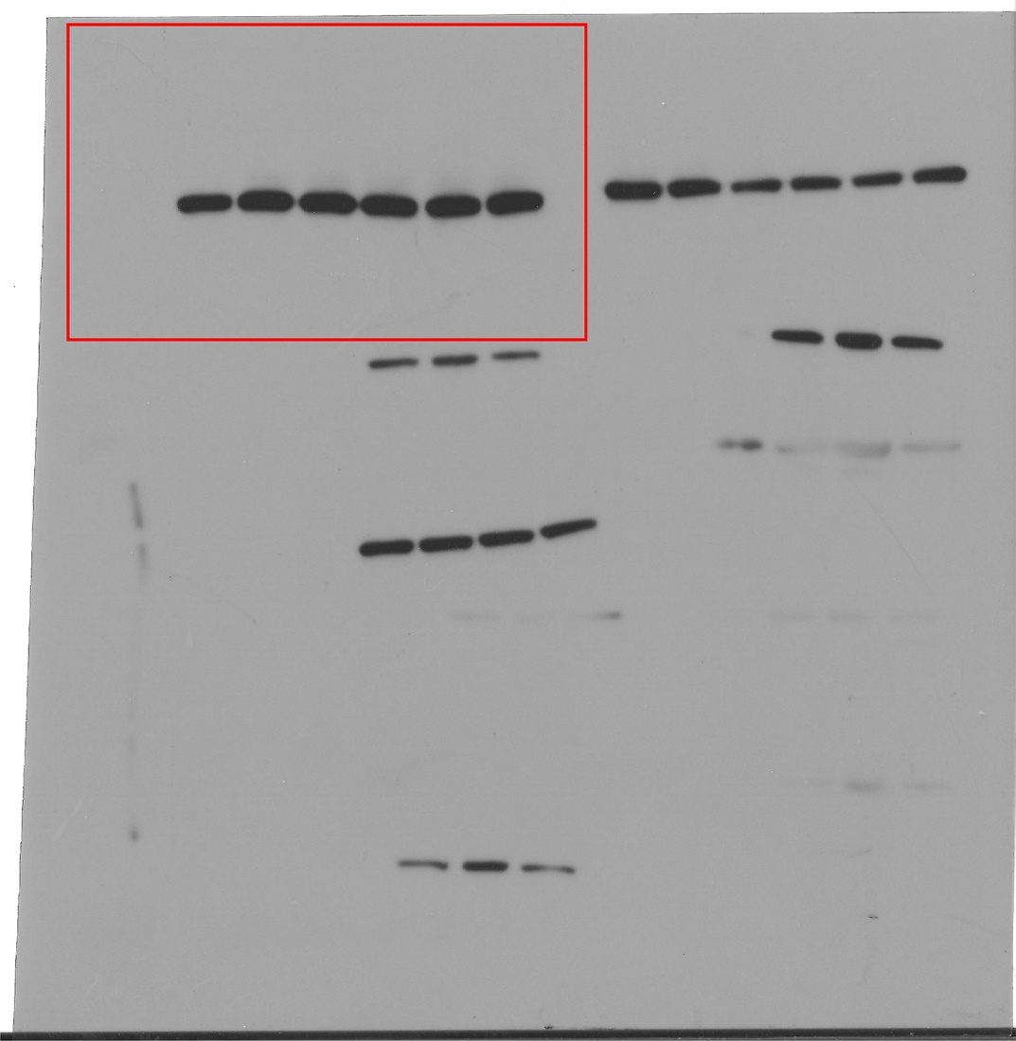
Figure S1A CD63（original）

Original image of western blotting (Figure S1A CD81（original）)

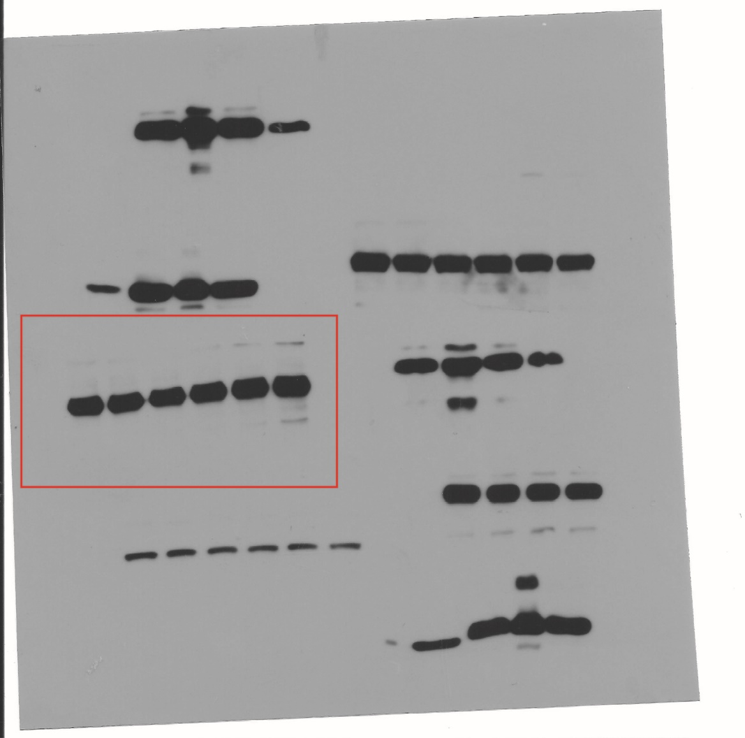
Figure S1A CD81（original）

