Supplementary material
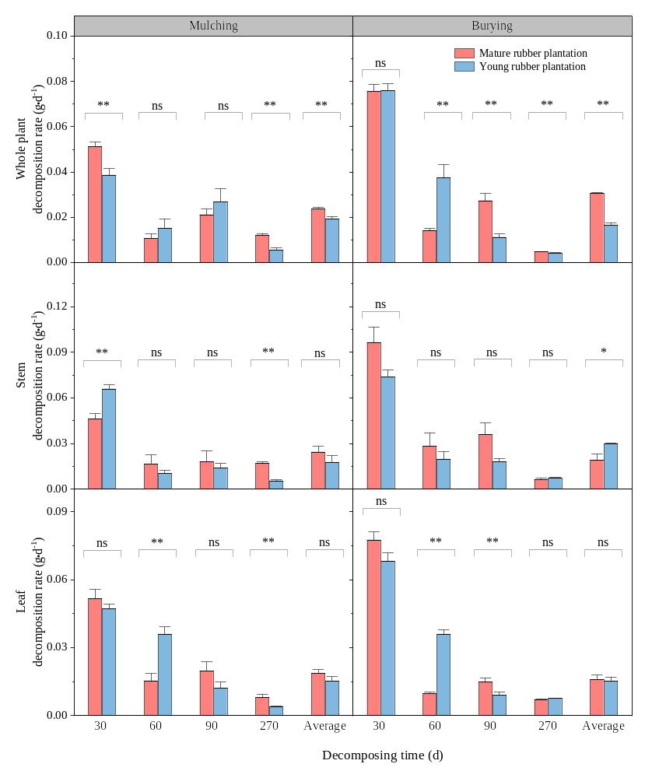Fig. S1 The decomposition rates of three kudzu components in two rubber plantation sites under different returning methods. Values are shown as mean ± standard errors (n=3). Burying, nylon bags placed under mode burying in two rubber plantation sites; Mulching, nylon bags placed under mode mulching in two rubber plantation sites; *, P < 0.05; **, P < 0.01; ns, no significance, P > 0.05.

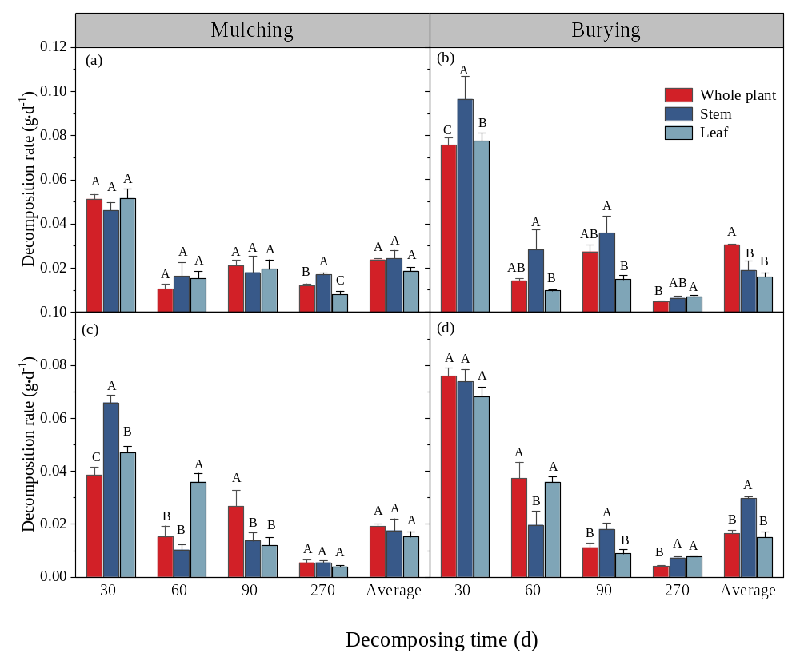Fig. S2 The decomposition rates of three kudzu components in two rubber plantation sites under different returning methods. Values are shown as mean ± standard errors (n=3). （a-b）, Mature rubber plantation; (c-d), Young rubber plantation. Burying, nylon bags placed under mode burying in two rubber plantation sites; Mulching, nylon bags placed under mode mulching in two rubber plantation sites. Different uppercase letters indicate significant differences in decomposition proportion for the three kudzu components at the same decomposition time (P < 0.05); *, P < 0.05; **, P < 0.01; ns, no significance, P > 0.05.
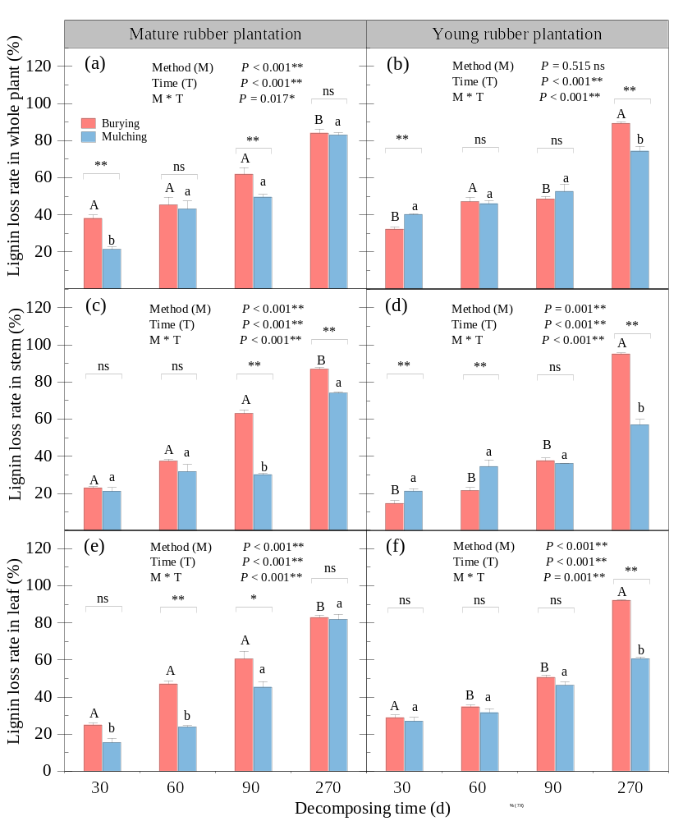Fig. S3 The lignin decomposition proportion of three kudzu components in two rubber plantation sites under two returning methods. Values are shown as mean ± standard errors (n=3). Different lowercase letters indicate significant differences in decomposition proportion for the same kudzu component at the same decomposition time under the burying method between two rubber plantation sites (P < 0.05). Different uppercase letters indicate significant differences in decomposition proportion for the same kudzu component at the same decomposition time under the mulching method between two rubber plantation sites (P < 0.05); ** indicate significant differences in decomposition proportion between the mulching and burying method (P < 0.05).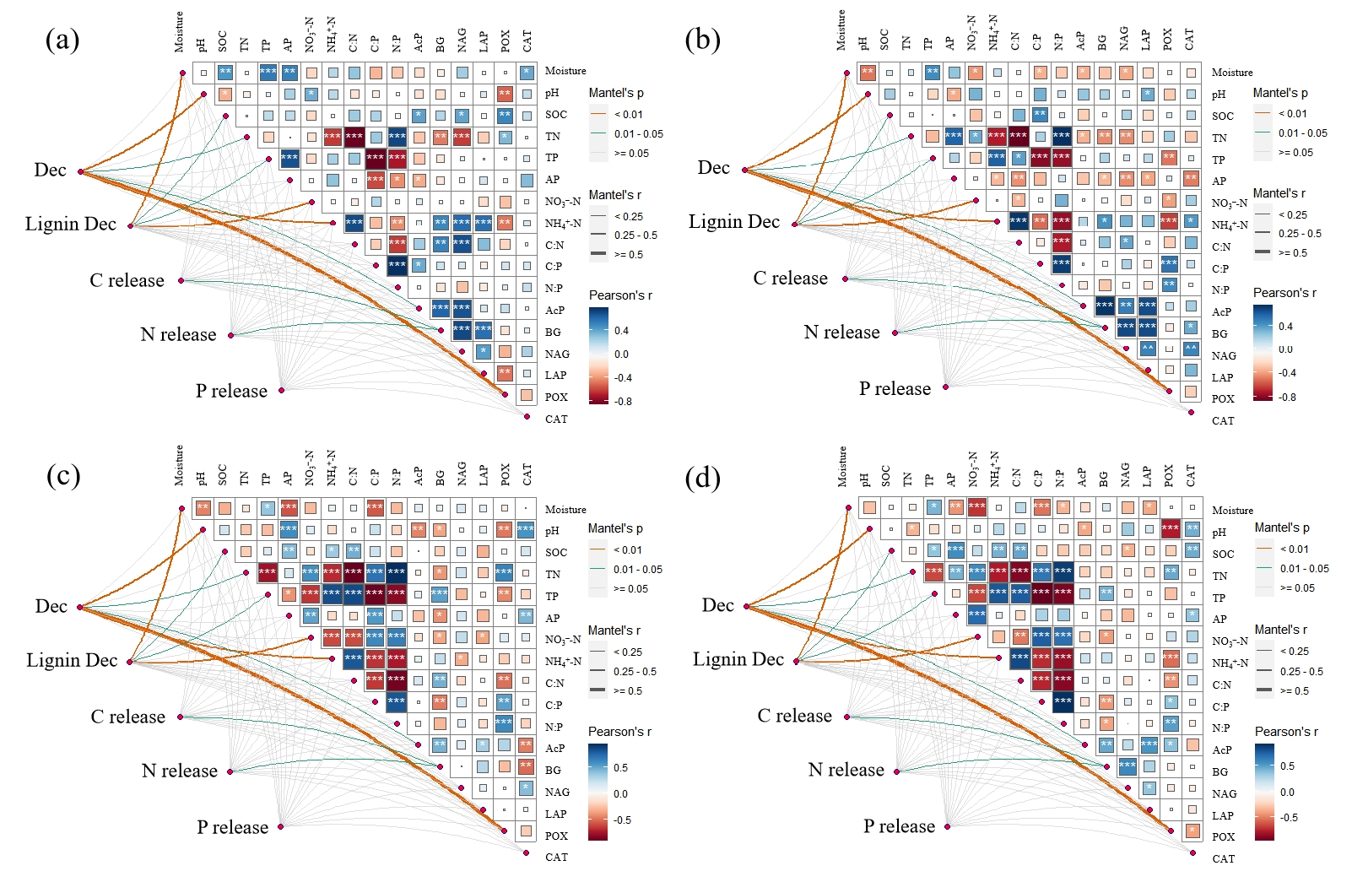
Fig. S4 Pearson's correlations analysis between kudzu decomposition and soil factors (soil chemical properties and enzyme activities) in different returning methods. (a) Young-burying, nylon bags placed under mode burying in the young rubber plantation sites; (b) Young-mulching, nylon bags placed under mode mulching in the young rubber plantation sites; (c) Mature-burying, nylon bags placed under mode burying in the mature rubber plantation sites; (d) Mature-mulching, nylon bags placed under mode mulching in the mature rubber plantation sites. Dec, Decomposition rate; Lignin Dec, Lignin decomposition proportions; C release, C release proportions; N release, N release proportions; P release, P release proportions; SOC, soil organic carbon; TN, soil total nitrogen; TP, soil total phosphorus; AP, soil available phosphorus; AK, Available potassium; NH₄⁺-N, soil ammonium nitrogen; NO₃⁻-N, soil nitrate-nitrogen; AcP, Soil acid phosphatase activity; BG, Soil β-1, 4-glucosidase activity; LAP, Soil L-Leucine aminopeptidase activity; NAG, Soilβ-1,4-N-acetyl-Glycosaminidase; POX, Soil polyphenol oxidase activity; CAT, Soil catalase activity.
Table S1 Statistical results from ANOVA showing the effects of components, returning methods, sampling times, sites, and their interactions on decomposition rate, lignin decomposition, and nutrient release proportion during the decomposition of three kudzu components.
 | Kudzu decomposition rate | Lignin decomposition | C  release proportion | N  release proportion | P  release proportion
Sites | ns | ns | ** | ** | **
Components | ns | ** | ** | ** | **
Methods | ** | ** | ** | ** | ns
Times | ** | ** | ** | ** | **
Sites * Components | ns | * | ** | ** | **
Sites * Methods | ns | ns | * | * | ns
Sites * Times | ** | ns | * | ** | ns
Components * Methods | * | ns | ** | ** | *
Components * Times | ns | ** | ns | ** | **
Methods * Times | ns | ** | ** | ** | **
Sites * Components * Methods | * | ns | ** | ns | **
Sites * Components * Times | ns | ns | ** | * | ns
Sites * Methods * Times | ** | * | * | ** | **
Components * Methods * Times | ns | ** | ** | ** | **
Sites * Components * Methods * Times | ns | ns | ** | ** | ns
*, P < 0.05; **, P < 0.01; ns, no significance, P > 0.05.

Table S2 Statistical results from ANOVA showing effects of components, returning methods, sampling times, sites, and their interactions on soil chemical properties and enzyme activities during the decomposition of three kudzu components.
 | S | C | M | T | S * C | S * M | S * T | C * M | C * T | M * T | S* C * M | S * C * T | S * M * T | C * M * T | S * C * M * T
Moisture | ns | ** | ns | ** | ns | ns | ns | ns | ns | ns | ns | ** | ns | ns | ns
pH | ** | ** | ns | ** | ** | ** | ** | ** | ** | ** | ** | ** | ** | ** | **
SOC | ** | ns | ** | ** | * | ** | ** | ** | ** | ns | ** | ** | ** | ** | **
Soil TN | ** | ** | ns | ** | ** | ** | ** | ns | * | * | ns | * | ns | ** | ns
Soil TP | ** | ** | ** | ** | ** | ** | ** | * | ** | * | * | ** | ** | ** | ns
Soil AP | ** | ** | ** | ** | ** | ** | ** | ** | ** | ** | ** | ** | ** | ** | **
Soil NO₃⁻-N | ** | ** | ** | ** | ** | ns | ** | ** | ns | * | ** | ** | ** | ** | **
Soil NH₄⁺-N | ** | ** | ** | ** | ** | ** | ** | ** | ** | ** | ** | ** | ** | ** | **
Soil C: N | ** | * | ns | ** | ns | ns | ** | ** | ** | ** | ** | ** | ** | ** | **
Soil C: P | ** | ns | ns | ** | ns | ns | ** | ** | ** | * | ns | ** | ns | ns | *
Soil N: P | ** | ** | ** | ** | ** | * | ** | ** | ** | ns | ** | ** | ns | ** | **
AcP | ** | ns | ns | ** | ns | ns | ** | ns | ns | * | ns | ns | ** | * | ns
BG | * | ** | * | ** | ** | ** | ** | ns | ** | ** | ** | ** | ns | ** | **
NAG | ns | ** | ** | ** | ** | ns | ** | ** | ** | ns | ** | ** | ** | ** | *
LAP | ns | ** | ** | ** | ** | ns | ** | * | ** | ** | ** | ** | ** | ** | **
POX | ** | ns | ** | ** | ** | ** | ** | ** | ** | ** | ** | ** | ** | ** | **
CAT | ** | ** | ** | ** | ** | ** | ** | ** | ** | ns | ** | ** | ** | ** | **
S, Study sites; C: Components; M: Returning methods; T: Times. *, P < 0.05; **, P < 0.01; ns, no significance, P > 0.05.

