A Novel c-Met/TRK inhibitor 1D228 efficiently inhibits tumor growth by targeting angiogenesis and tumor cell proliferation.
Baijiao An^{a,c}, Wenyan Nieª , Jinhui Hu^{d}, Yangyang Fanª , Han Yao^{b}, Yuanyuan Ren^{b}, Yaxuan Zhaoª, Haoran Nieª, Mengxuan Wangª, Chuanchuan Zhangª, Mengna Weiª, Wei Li^{b}, Jiadai Liu^{b}, Chunhua Yang ª, Yin Zhang ^{a,c*}, Xingshu Li^{b*}, and Geng Tian^{a,c*}.

a School of Pharmacy, Binzhou Medical University, Yantai, Shandong, 264003, PR China

b School of Pharmaceutical Sciences, Sun Yat-Sen University, Guangzhou 510006, PR China

c Shandong Technology Innovation Center of Molecular Targeting and Intelligent Diagnosis and Treatment, Yantai, Shandong, 264003, PR China

d School of Biotechnology and Health Sciences, Wuyi University, Jiangmen, 529020, PR China
Supplementary Contents
S I. Biological
S II. NMR spectra of compound 1D228

Fig S1 (A) The changes of differential genes after inhibitor treatment were analyzed by volcano map; (B) Downregulation of differential gene KEGG enrichment bubble map.

Fig S2 1D228 inhibited the migration of 97H cells.
Fig S3 (A) Expression of AXL and P-AXL proteins in endothelial and tumor cells. (B) CCK8 assay for anti-proliferative activity of 1D228, Tepotinib, Larotrectinib and combinations against MKN45.

Fig S4 Antiproliferative activity of the compound 1D228 against C166 cells and HUVEC cells.

2. NMR spectra of target compounds.
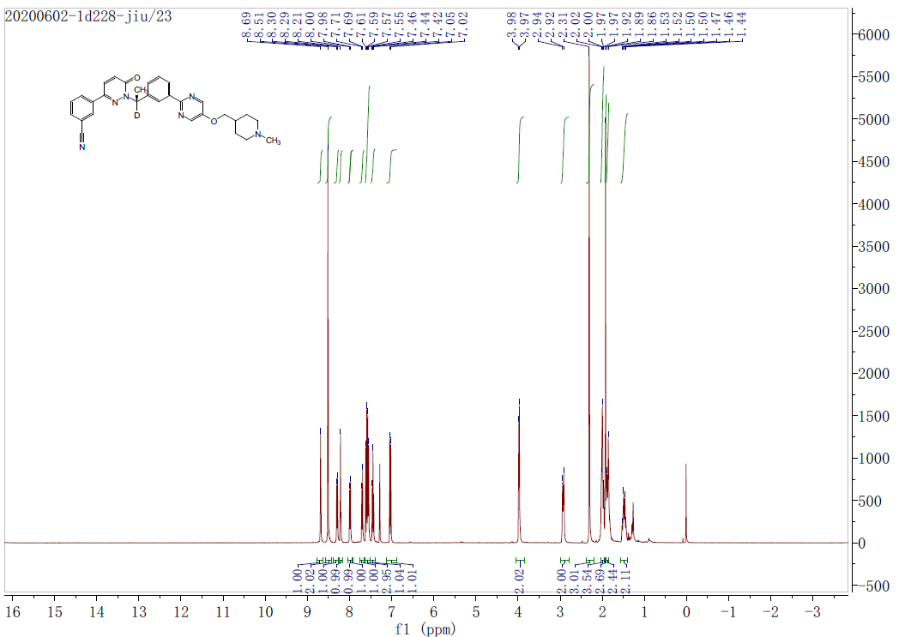
Fig S5 ¹H NMR of 1D228.

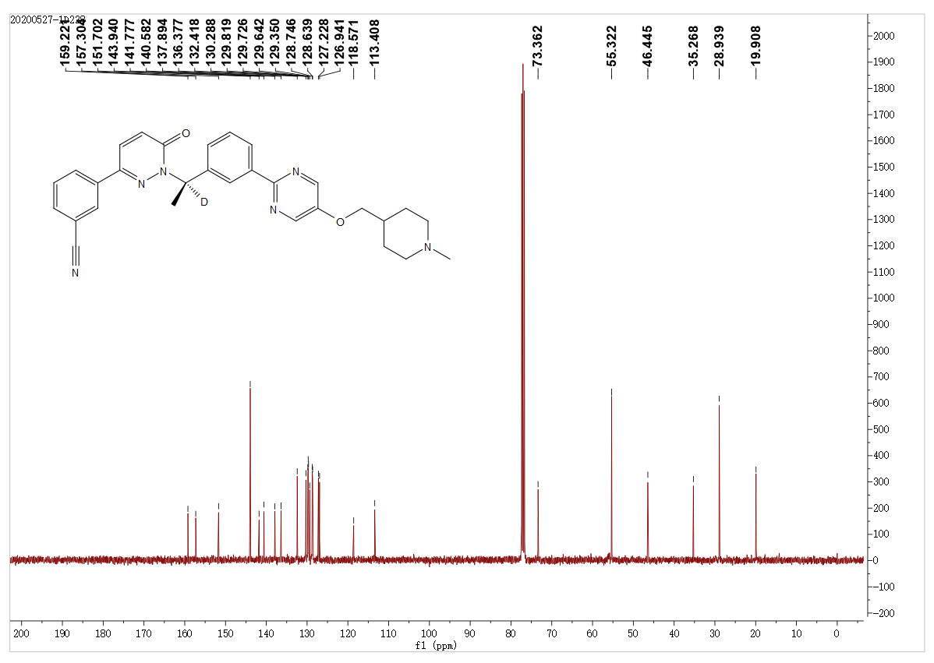
Fig S6 ¹³C NMR of 1D228.
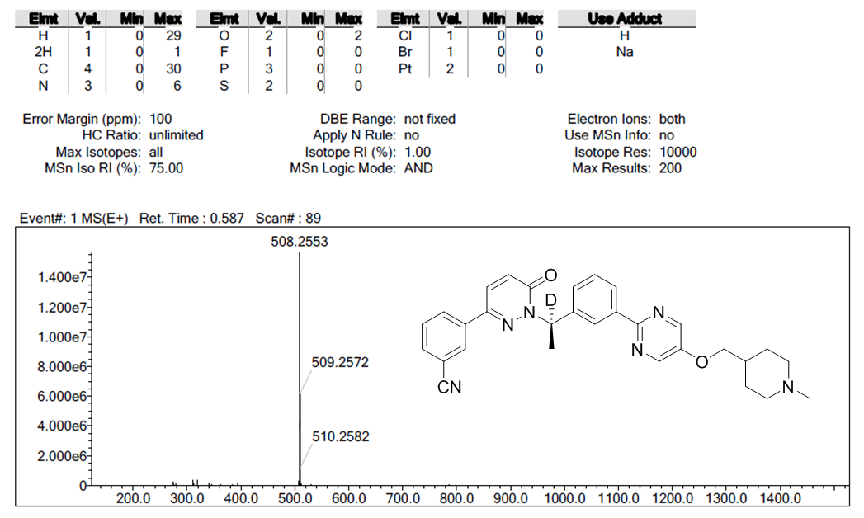
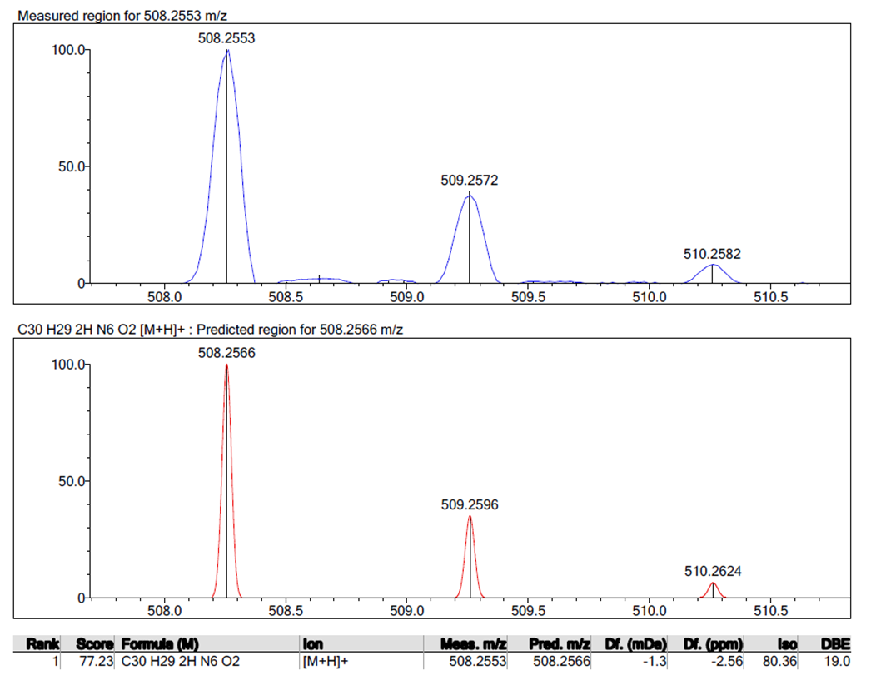
Fig S7 HRMS (ESI) Spectrum of 1D228.

