Supplementary Figures for: A combined compost and endophyte addition improves phytostabilization by a native perennial grass in metal contaminated mine tailings

Courtney A Creamer¹*, Mary-Cathrine Leewis², Martina Kracmarova-Farren³, Jakub Papík³, Sean Kacur⁴, John Freeman⁵, Ondřej Uhlík³, Andrea L Foster¹
¹US Geological Survey, Menlo Park, CA, United States
²Agriculture and Agri-Food Canada, Québec, QC, Canada
³University of Chemistry and Technology, Prague, Faculty of Food and Biochemical Technology, Department of Biochemistry and Microbiology, Prague 6, Czech Republic
⁴Subsurface Insights, Hanover, NH, United States
⁵Intrinsyx Environmental, Sunnyvale, CA, United States

*Corresponding author; ccreamer@usgs.gov
Journal: Plant and Soil

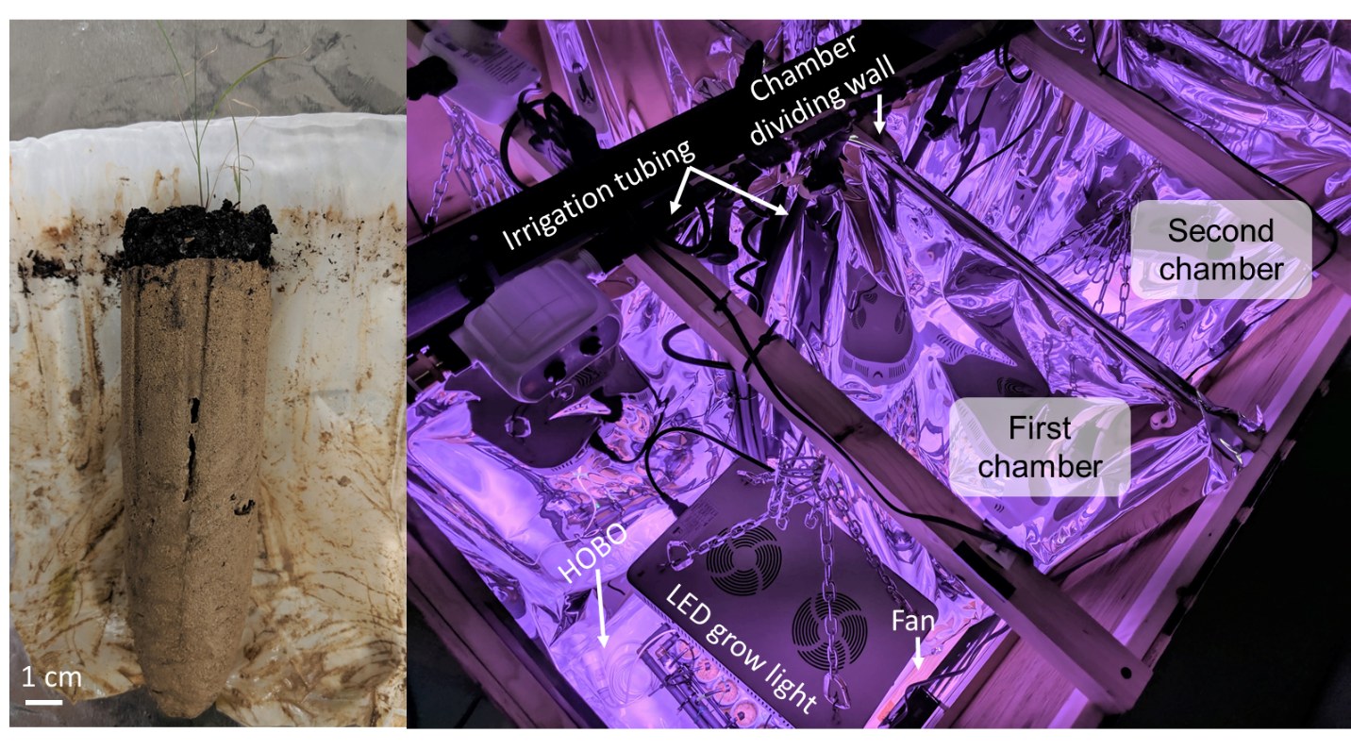
Supplementary Fig. 1 (Left) Opened nylon mesh showing the compost and tailings layers. At the end of the experiment the compost layer and seedlings were gently removed. The two layers were homogenized and analyzed separately. (Right) Looking down into the indoor growing complex. Each chamber was separated by a piece of plywood coated with mylar. Each chamber contained a small fan, and LED grow light, and a HOBO U23 Pro v2 Temperature/Relative Humidity Data Logger (Any use of trade, firm, or product names is for descriptive purposes only and does not imply endorsement by the U.S. Government). The gravity fed irrigation system automatically delivered water to each pot through low-flow button drippers connected to the DI water with commercial polyethylene irrigation tubing. There were a total of 6 chambers in the growing complex

Supplementary Fig. 2 Improved plant growth with soil amendments. The distribution of growth rates of Bouteloua curtipendula (in mg dry shoot biomass per day) during the 45-day experiment are represented as ridges for each treatment. Growth rates were calculated as the slope of linear increases in shoot biomass measured every 3 days of the growth experiment. Plant growth rates were higher when planted with compost (P = 0.004) or with compost and an endophyte seed coat (P < 0.001)

Supplementary Fig 3 Principal components analysis (PCA) of mean centered major, minor, and trace element concentrations in the (a) tailings, (b) water extracts, (c) Bouteloua curtipendula shoots, and (d) Bouteloua curtipendula roots. Treatments are distinguished by colors and symbols, where treatments with endophyte coated seeds are filled. Ellipses are only shown where treatments are significantly different (permutational ANOVA). Only the potentially toxic trace elements with positive or negative Pearson’s correlations ≥ 0.7 (tailings, shoots, and root) or ≥ 0.6 (water extracts) with PC1 or PC2 are shown. The following elements were included in the PCA (if measured and above detection limits): Ag, Al, As, Ca, Cd, Co, Cr, Cu, Fe, K, Mg, Mn, P, Pb, S, Sb, Si, Zn

Supplementary Fig. 4 Solid-phase concentrations of elements highly correlated (r ≥ 0.7) with PC1 in Supplementary Fig 2a. Solid phase concentrations of Cu (P =0.012), Fe (P = 0.001), Pb (P = 0.008), and Zn (P = 0.013) were lower in pots with endophyte coated seeds
Supplementary Fig. 5 Minor and trace elements (Ag, As, Cd, Co, Cu, Mn, Pb, and Zn) measured in the sodium pyrophosphate extracts of the compost. Pre-treatment (starting) and post-treatment values for each element are shown as points overlaid by a boxplot. Values of Cd, Cu, Mn, and Pb are higher after treatment compared to starting values, indicating their movement into compost during the experiment

Supplementary Fig. 6 Yields of minor and trace elements quantified in Bouteloua curtipendula shoots after 45 days of growth. Foliar yields of Cd (P = 0.023), Co (P = 0.022), Mn, (P = 0.026), and Zn (P = 0.034) were higher in plants growth with endophyte seed coats. Foliar yields of Cu and Pb did not vary with endophyte additions, but concentrations exceeded forage limits for grazing livestock

