S1: GPC analysis
dW/dLogM
dW/dLogM | Fitted M_{w}(g/mol)
Fitted M_{w}(g/mol)  30%-3h | 30%-3h-DMSO

Fig. S1: Shows the GPC analysis presenting the M_{w} distribution plot for the 30%-3h and 30%-3h-DMSO samples.

S2: DSC

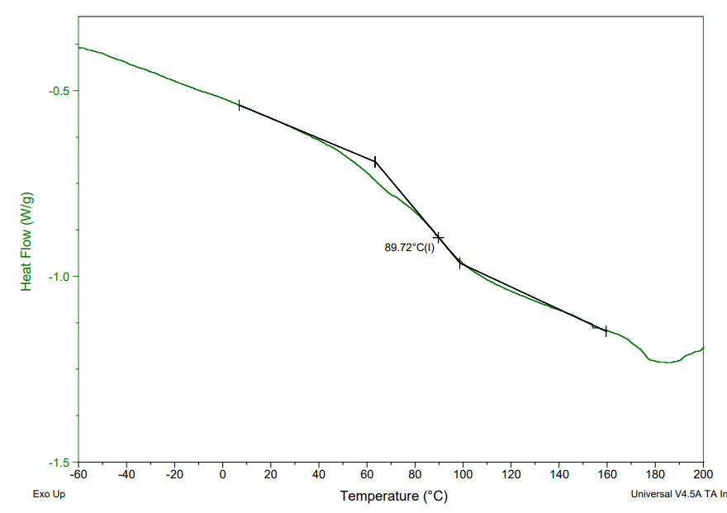 | 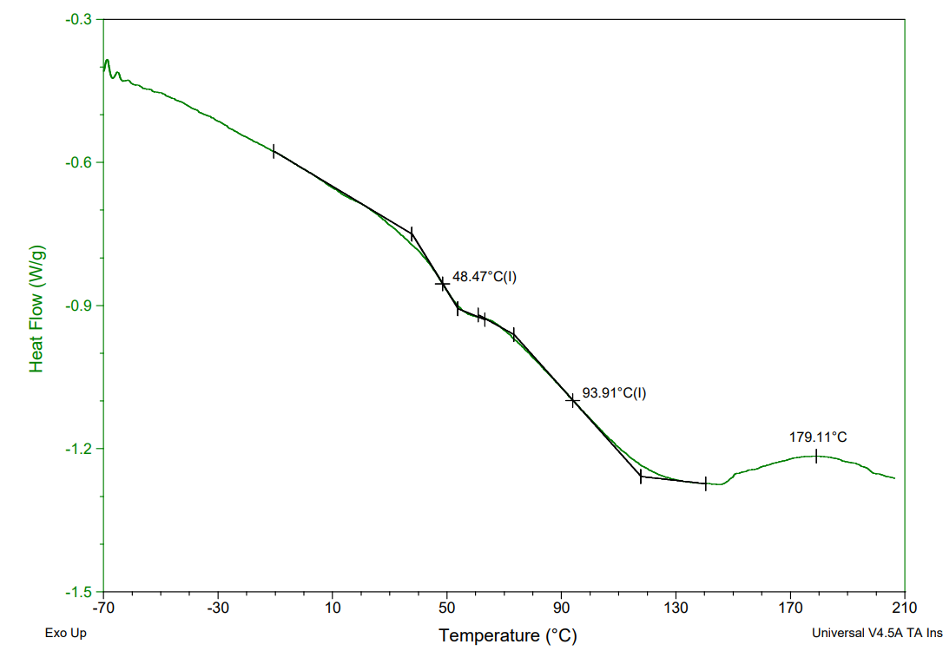
30%-3h | 30%-3h-DMSO

Fig. S2: Shows the DSC analysis of 30%-3h and 30%-3h-DMSO samples.

S3: Quantitative solubility study

Samples | Ethanol | Methanol | Acetone | Toluene
30%-3h | 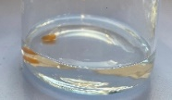 | 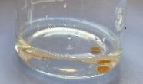 | 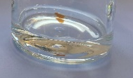 | 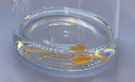
30%-3h-DMSO | 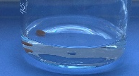 | 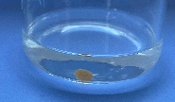 | 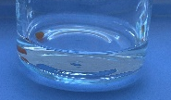 | 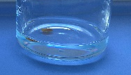
Fig. S3: Resistance of the sample 30%-3h and 30%-3h-DMSO to different solvents.

