Extended Data Figures

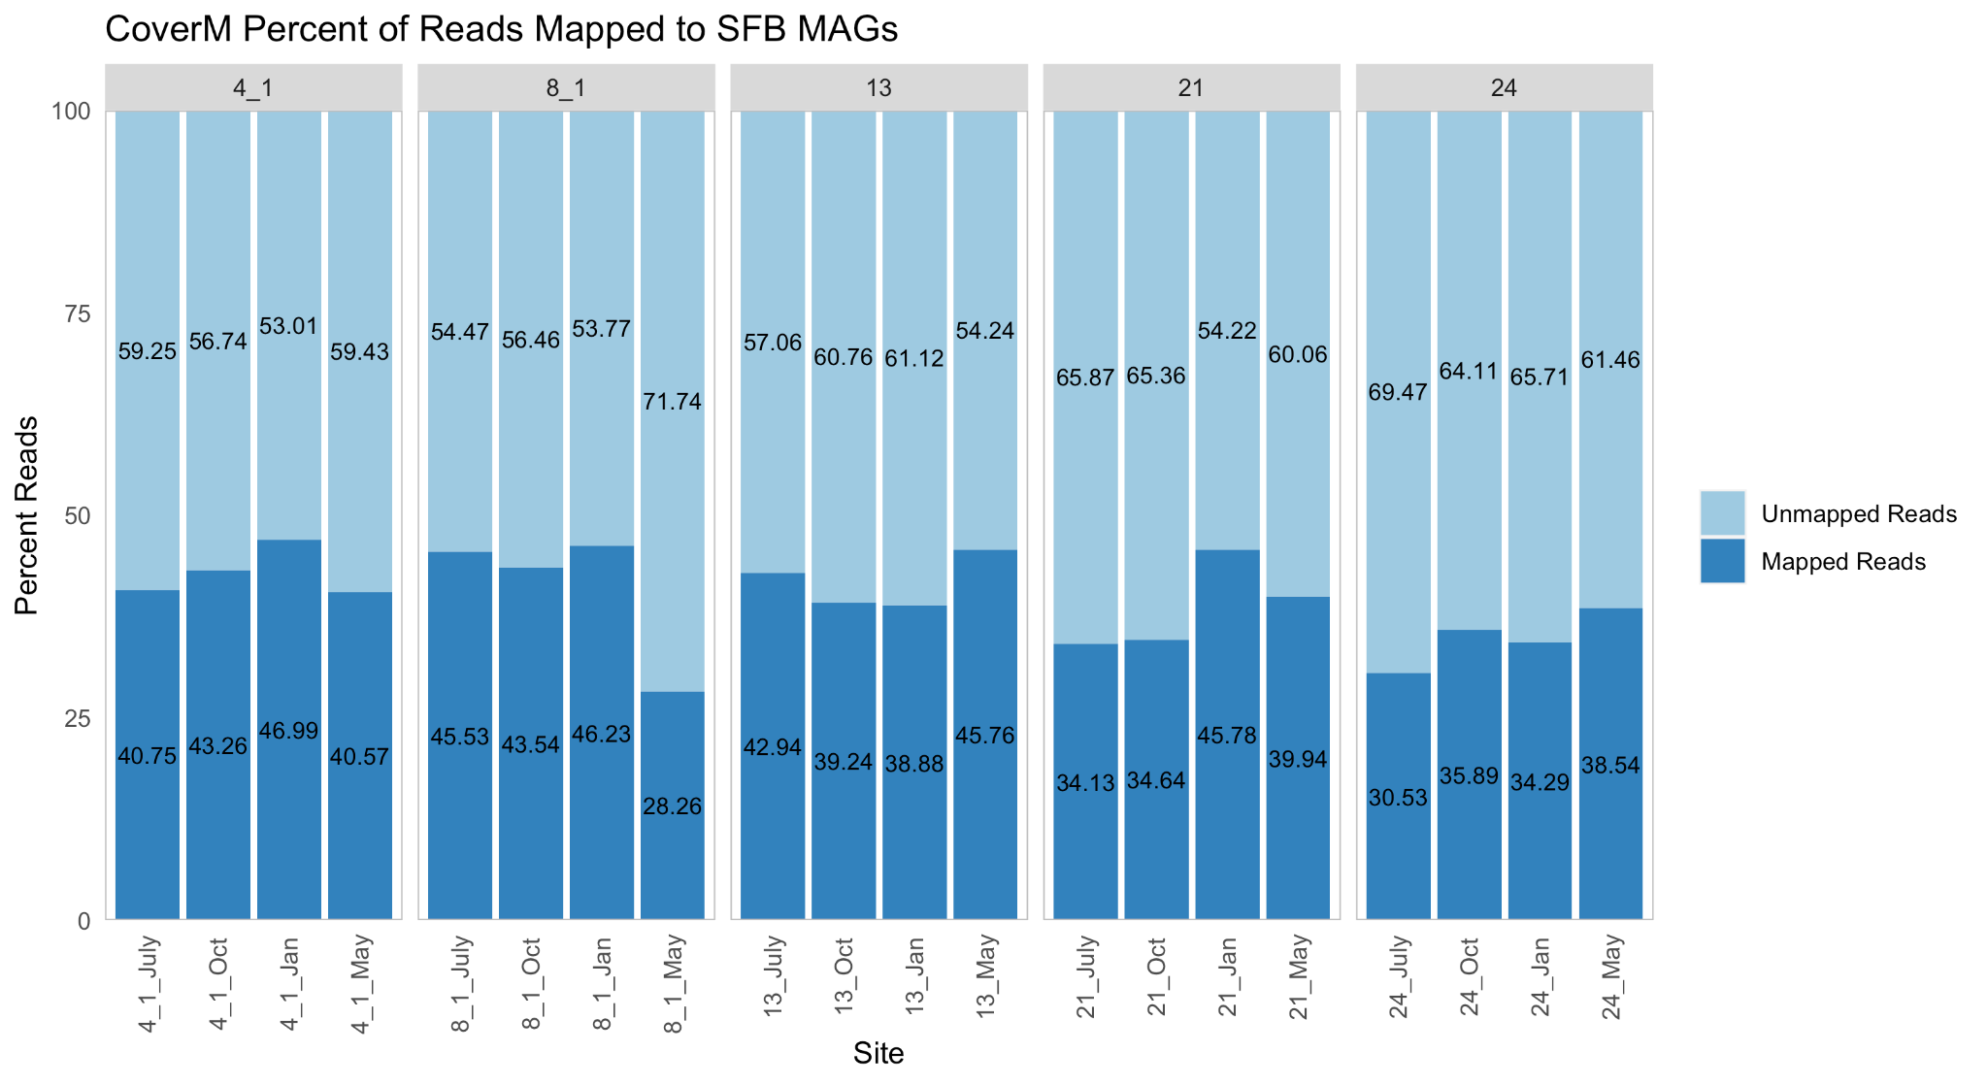
Extended Data Figure 1. Percent of San Francisco Bay (SFB) reads mapped to 639 SFB MAGs, calculated using CoverM (v0.2.0-alpha7). Sites and months are shown on the x axis and the percent of reads is shown on the y axis. Dark blue signifies reads that mapped to the 639 MAGs and light blue shows reads that were not mapped to the MAGs. The numbers inside the bars show the value associated with the light or dark blue bar. The script used to process the CoverM data and generate this figure is available at https://github.com/mlangwig/SanFranciscoBay/tree/main/Reads_Barplot.

A.
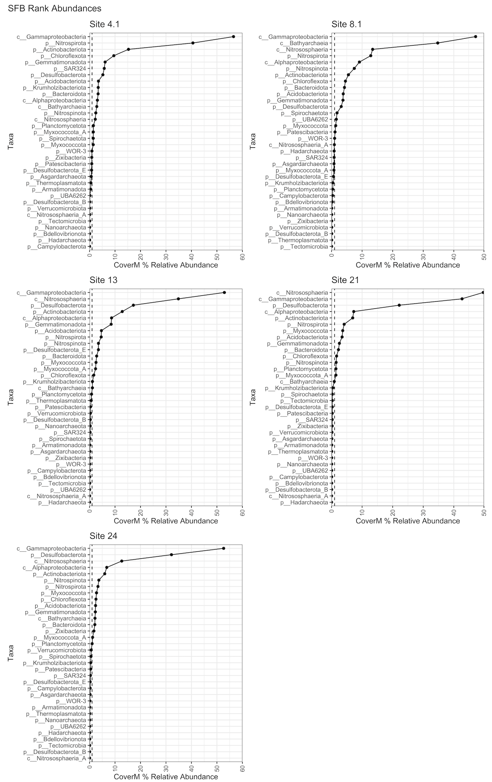
B.
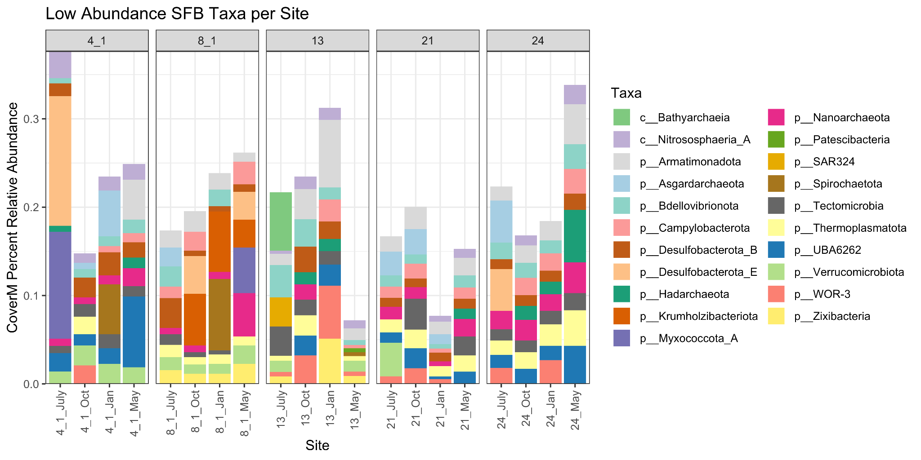
Extended Data Figure 2. A. Rank abundance curves for all 5 SFB sampling sites. Relative abundance was calculated using CoverM v0.2.0-alpha7 and is plotted on the x axis, while taxa at the phylum and class level are plotted on the y axis. A dotted line is drawn at 1% to illustrate the taxa that are part of the rare biosphere. The script used to generate this figure is available at https://github.com/mlangwig/SanFranciscoBay/tree/main/RankAbunPlots. B. SFB rare biosphere relative abundance. Sites and months are shown on the x axis and relative abundance is shown on the y axis, calculated using CoverM v0.2.0-alpha7. Taxa are shown in the legend with distinct colors and correspond to the same color in the stacked barplot. Rare biosphere taxa were identified using rank abundance plots of all the sites and identifying taxa below 1% relative abundance (Extended Data Figure 2).

A.
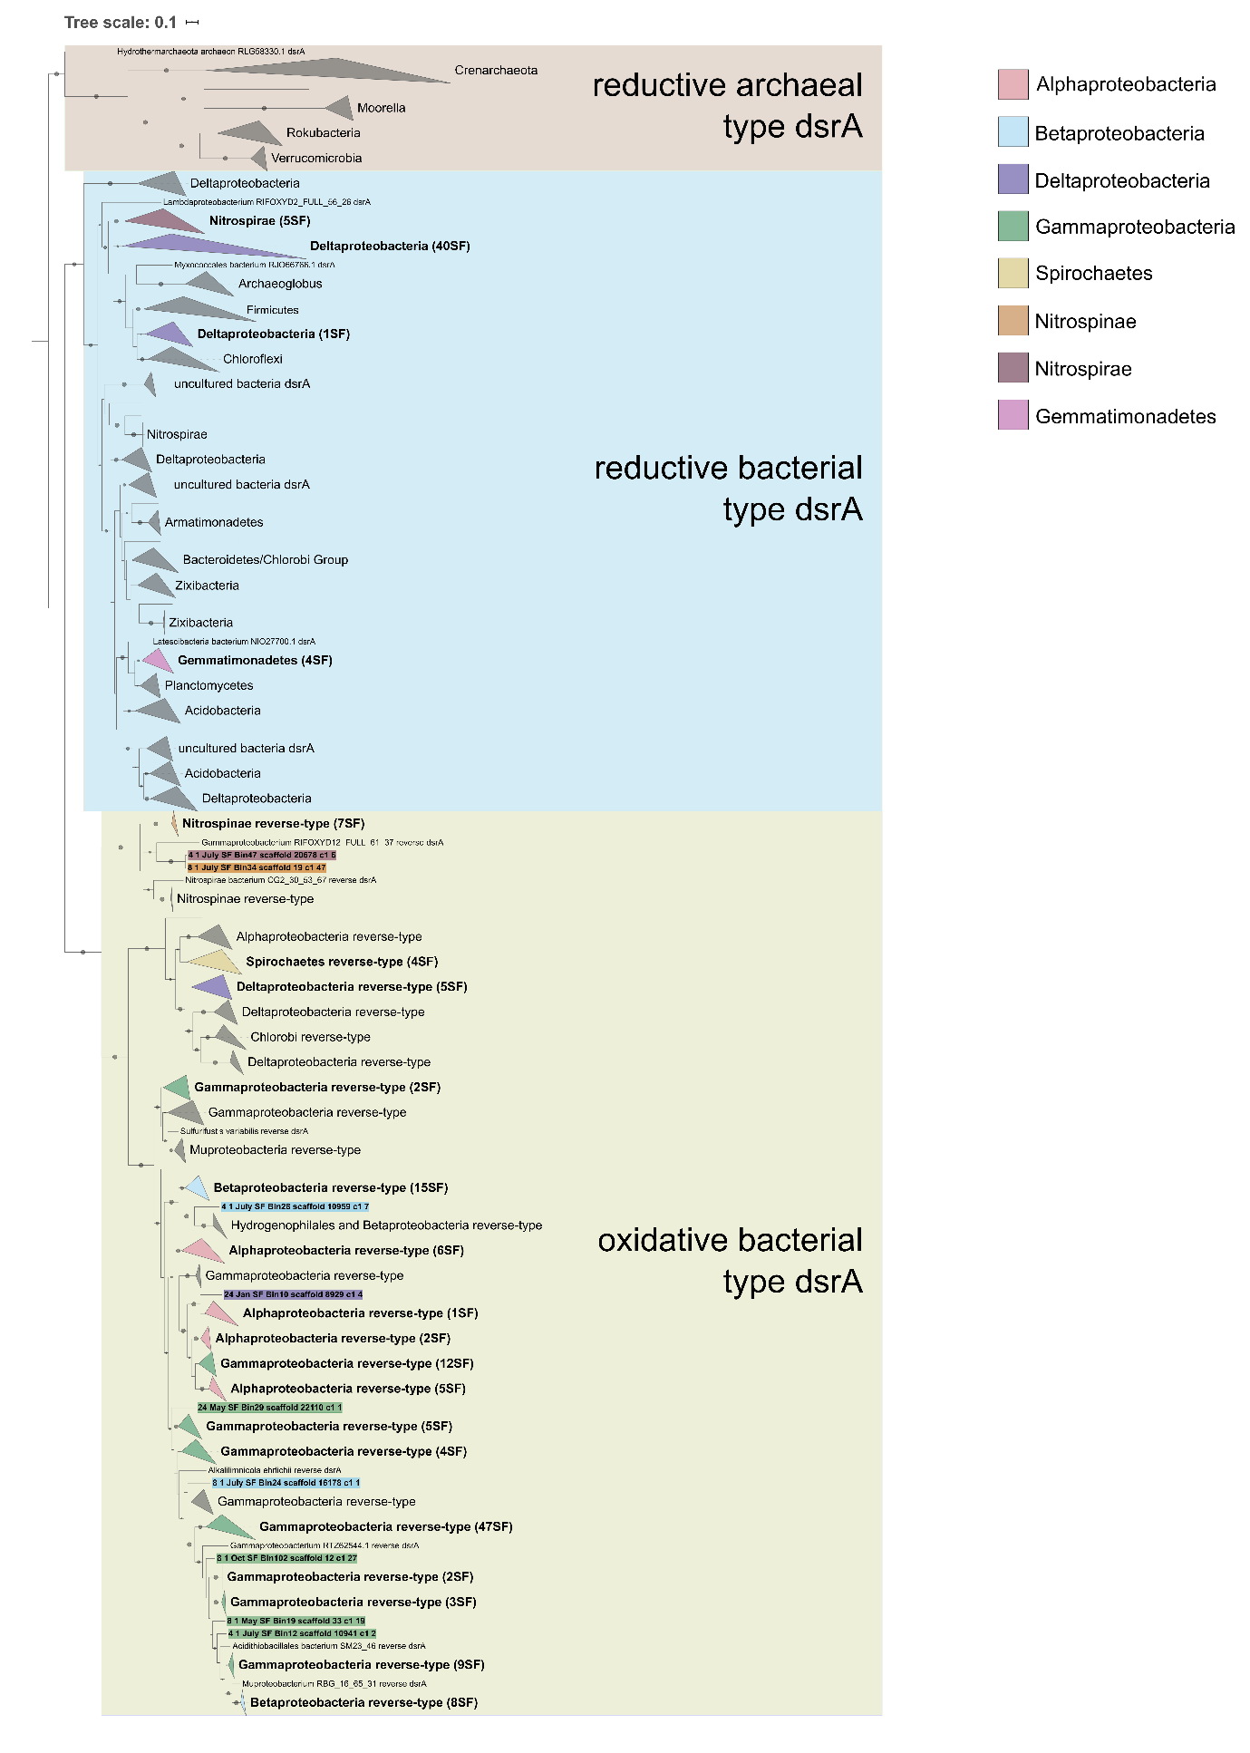
B.
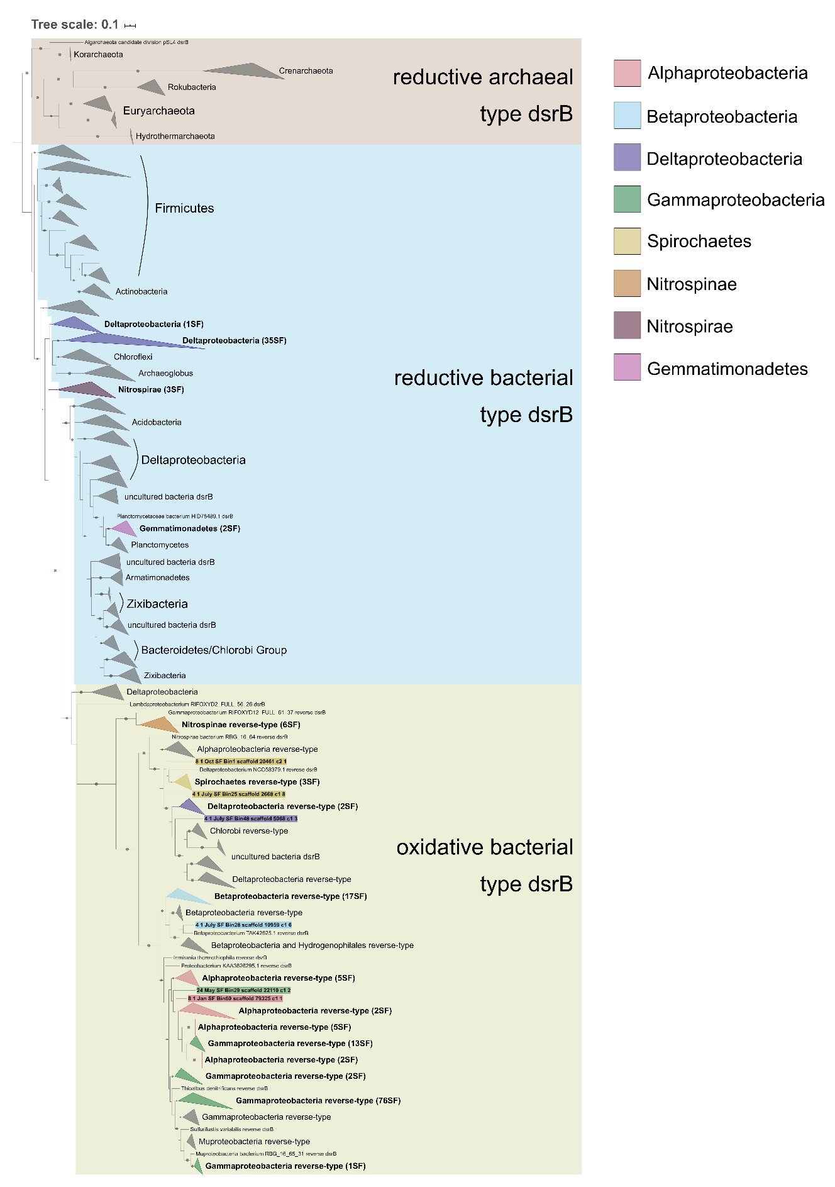
Extended Data Figure 3. A. 197 newly identified dissimilatory sulfite reductase subunit A (DsrA) sequences (indicated in bold and number of sequences in parentheses or with a colored background). The phylogeny also contains 1,306 reference dsrA sequences. This tree was constructed using IQ-TREE under the LG+R10 model with ultrafast bootstrapping option -bb 1000 and -bnni to reduce the impact of severe model violations. B. 181 newly identified dissimilatory sulfite reductase subunit B (DsrB) sequences (indicated in bold and number of sequences in parentheses or with a colored background). The phylogeny also contains 1,513 reference dsrB sequences. This tree was constructed using IQ-TREE under the LG+R10 model with ultrafast bootstrapping option -bb 1000 and -bnni to reduce the impact of severe model violations.

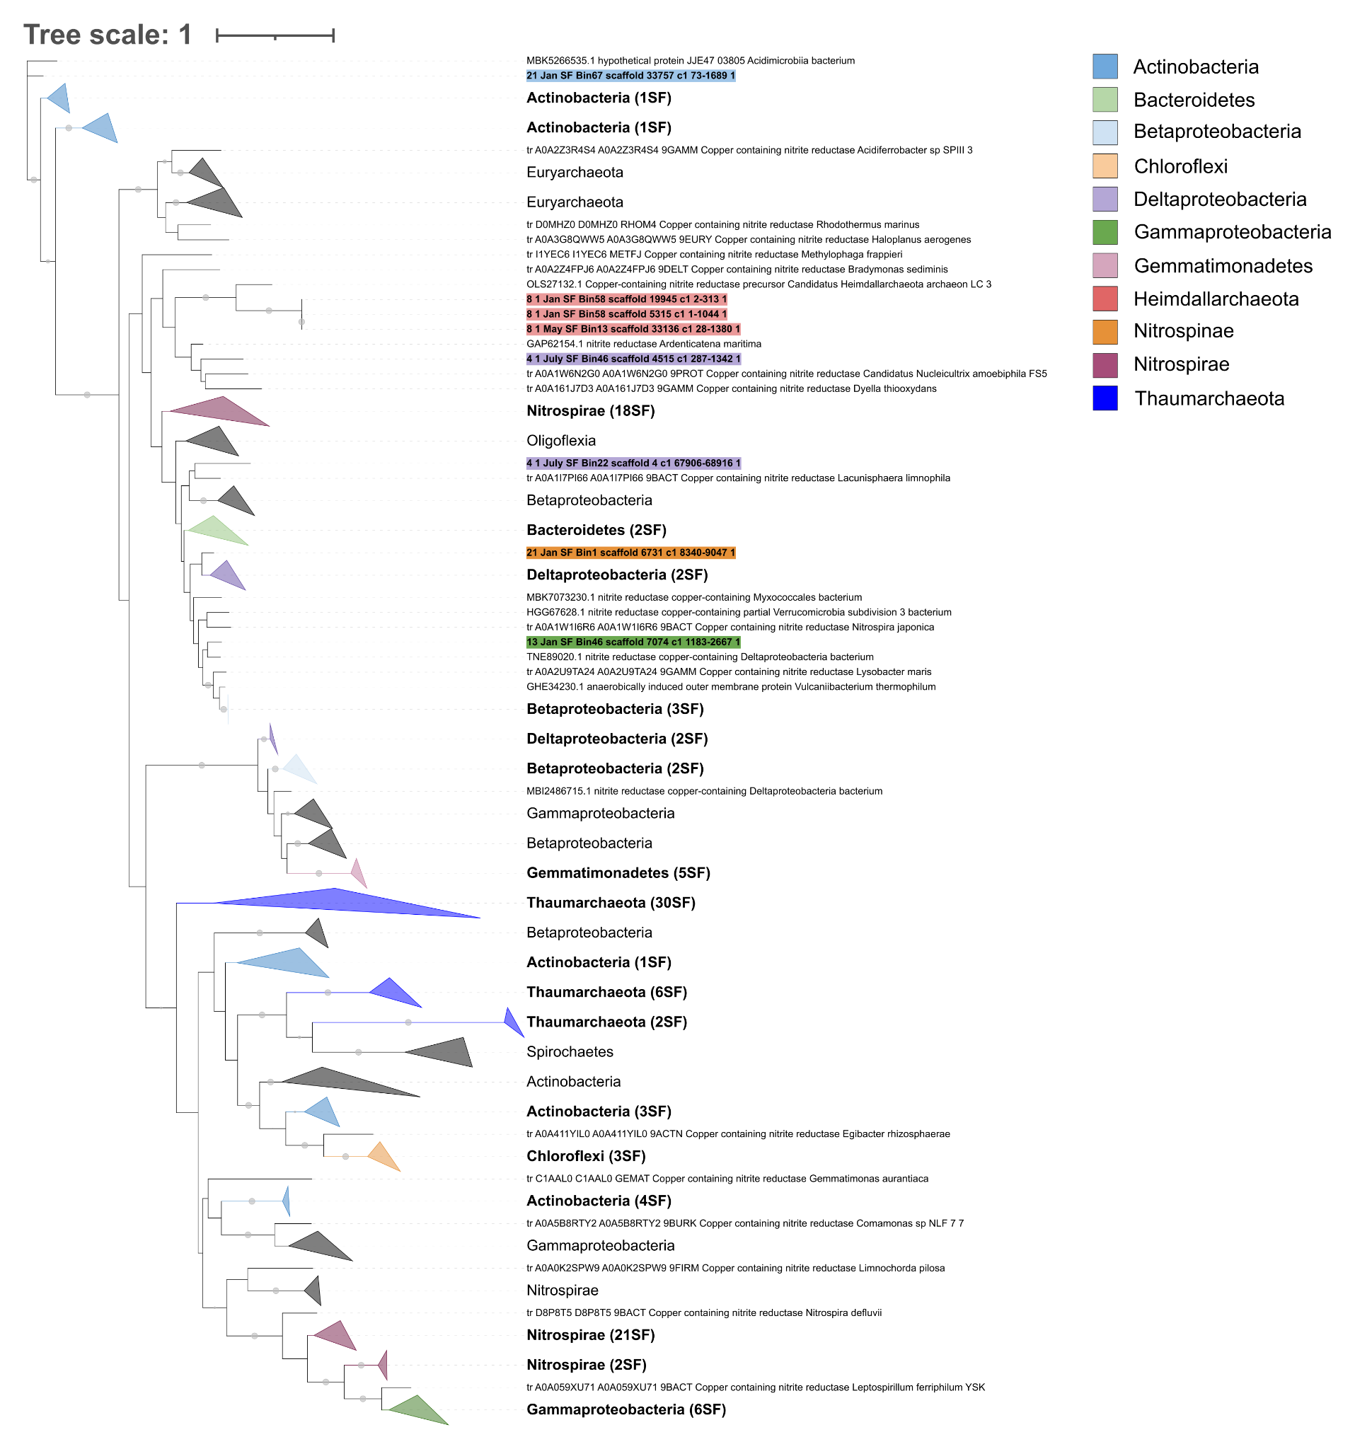
Extended Data Figure 4. Phylogeny of 122 NirK present in SFB MAGs and 229 reference NirK. Colors highlight different taxa, which are designated in the legend. The phylogeny was constructed using IQ-TREE under the LG+F+R7 model with ultrafast bootstrapping option -bb 1000 and -bnni to reduce the impact of severe model violations.

A.

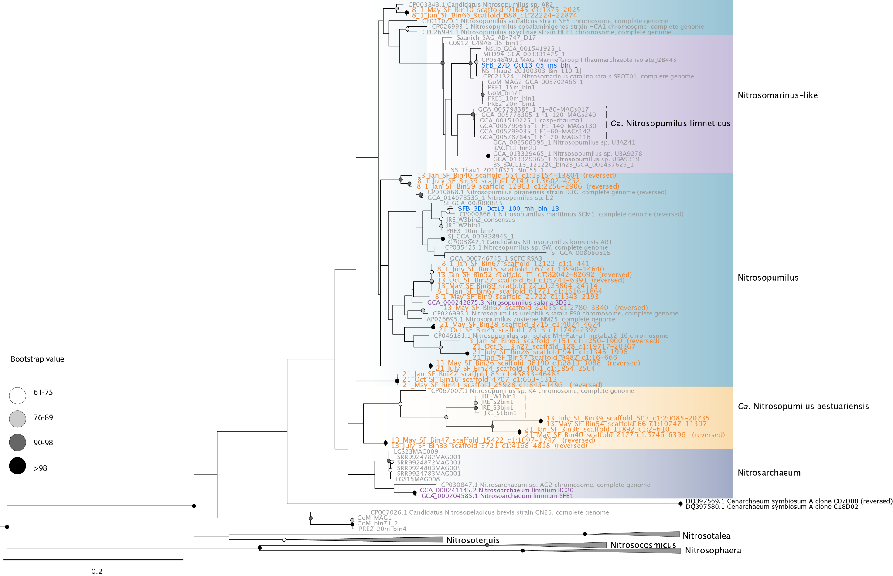

B.
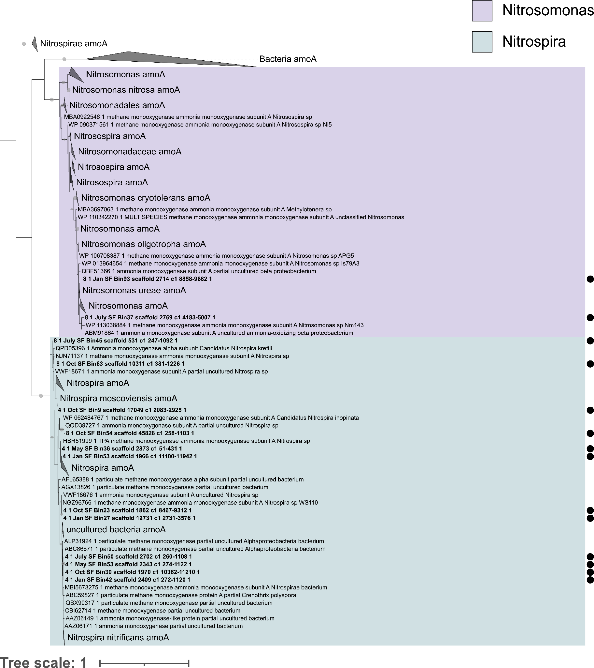
Extended Data Figure 5. A. 30 methane/ammonia monooxygenase subunit A (AmoA) identified in SFB archaea, as well as 78 reference AmoA sequences. AmoA sequences identified in this study are highlighted in orange. Reference amoA sequences in blue were reconstructed from the SFB water column and those in purple were reconstructed from SFB sediment. This phylogeny was constructed using RAxML under the GTR Gamma model with 1,000 bootstraps. B. 14 methane/ammonia monooxygenase subunit A (AmoA) identified in SFB bacteria, as well as 357 reference AmoA sequences. AmoA sequences identified in this study are highlighted in bold and with a black circle. This phylogeny was constructed using IQ-TREE under the LG+F+R6 model with ultrafast bootstrapping option –bb 1000 and –bnni to reduce the impact of severe model violations.

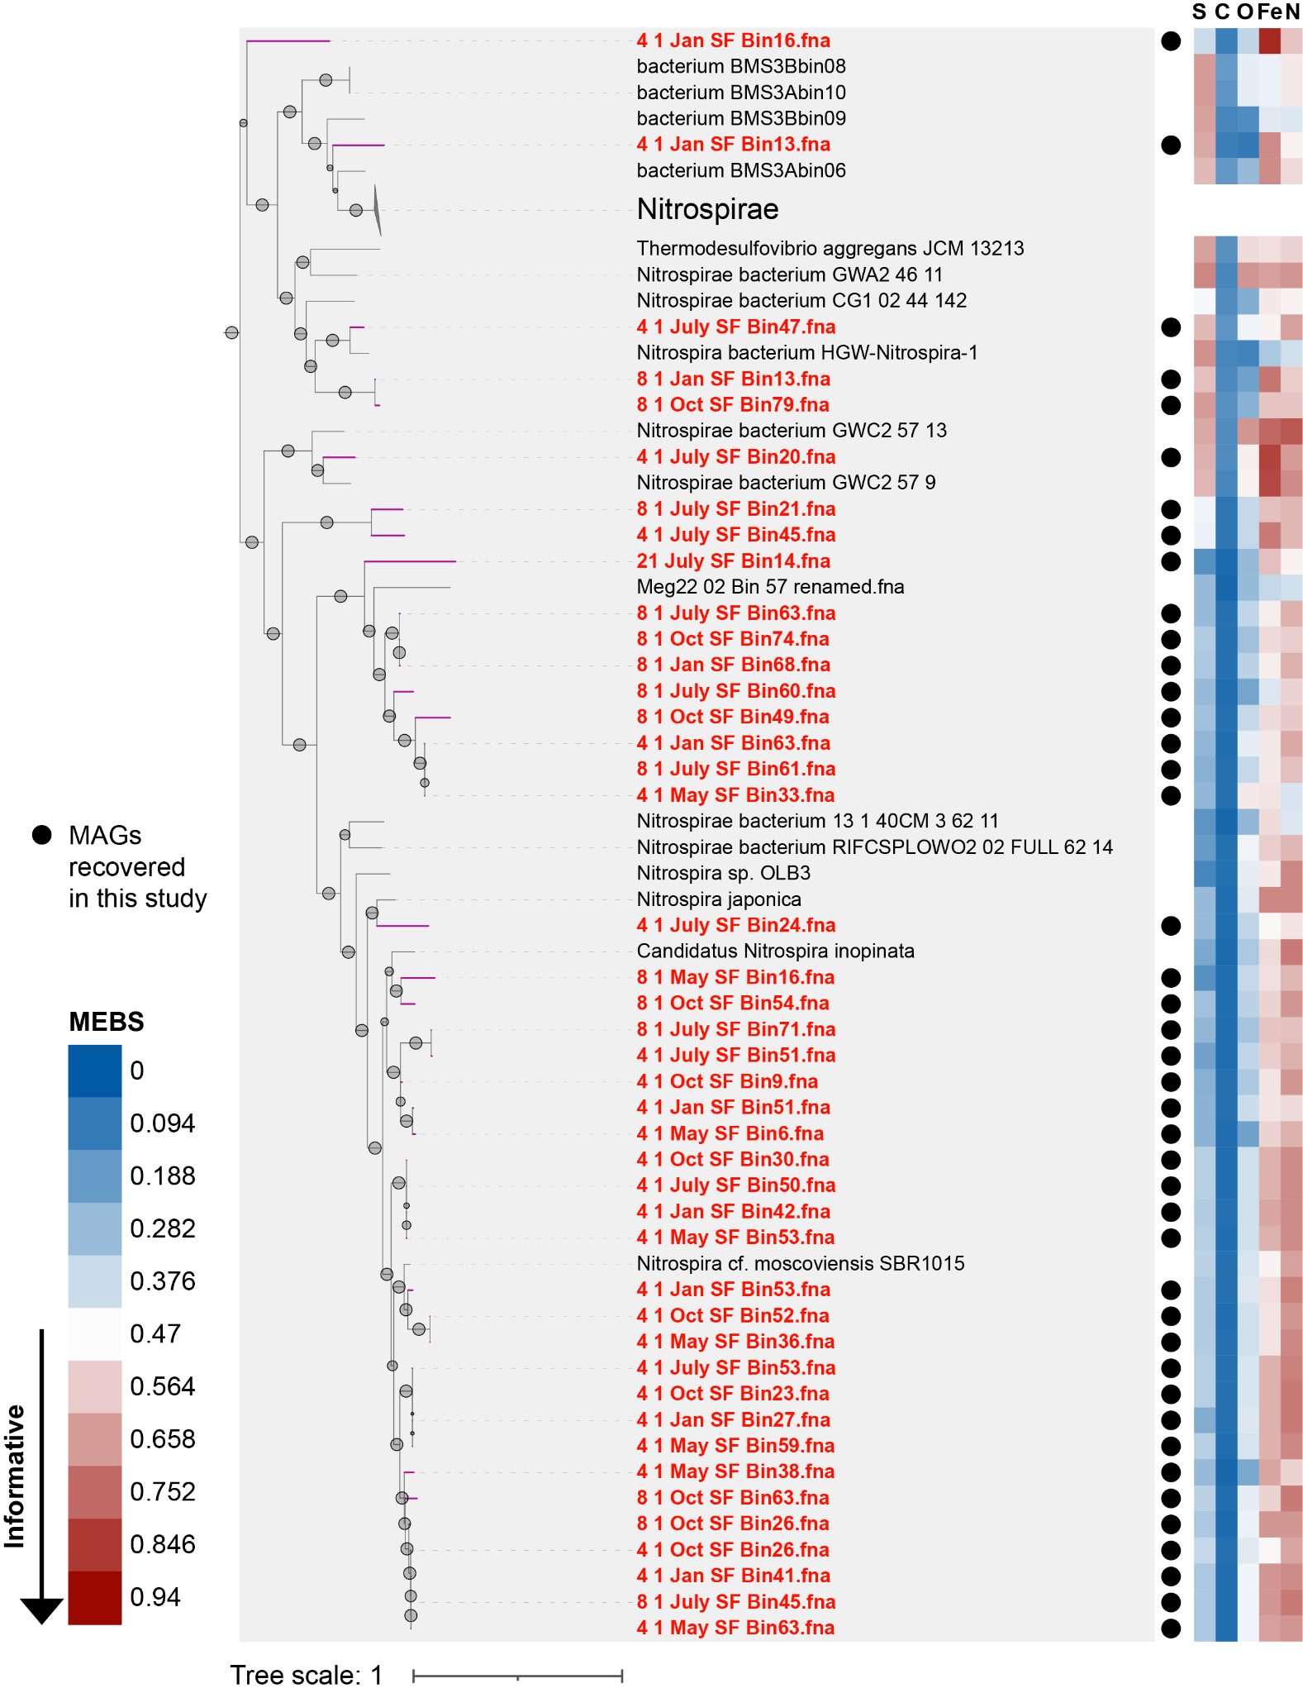
Extended Data Figure 6. Nitrospirota SFB MAG diversity based on 37 marker genes. This is a zoom in of Nitrospirota MAGs from Figure 2A. Black circles and red font signify MAGs reconstructed in this study. The heatmap shows entropy scores calculated with MEBS ⁷⁴ for nitrogen (the outermost heatmap ring), iron, oxygen, carbon, and sulfur (the innermost heatmap ring). White and red heatmap colors indicate a higher number of proteins present in a given genome for a cycle. This phylogeny was constructed with RAxML version 8.2.11 with the -f a option for rapid bootstrap analysis.
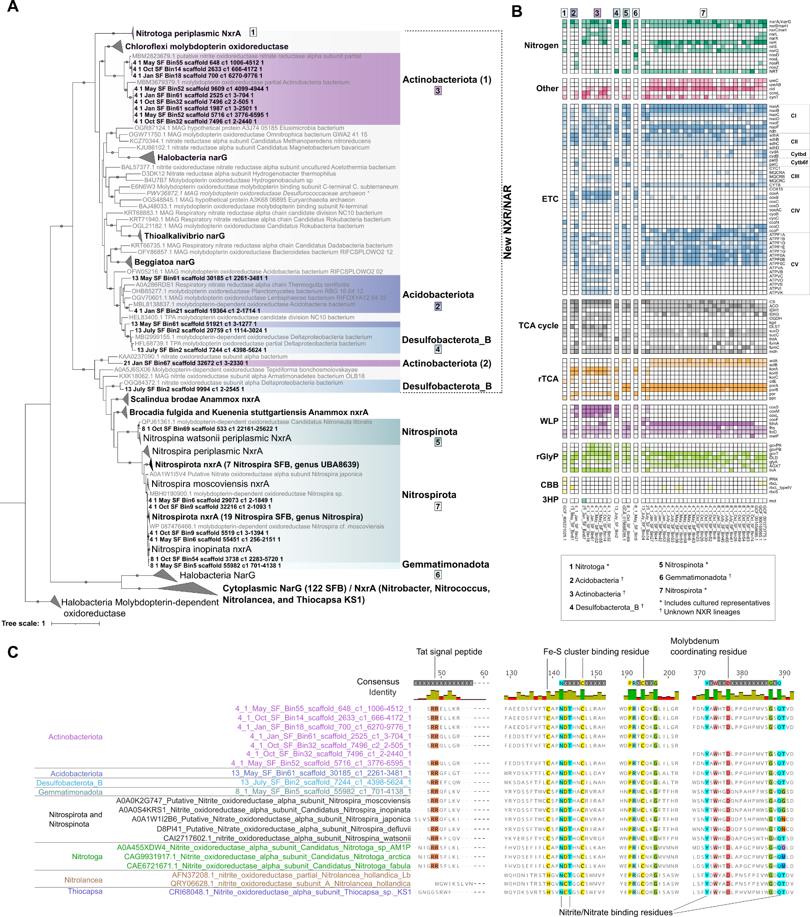
Extended Data Figure 7. A. 153 periplasmic NarG/NxrA proteins identified in SFB MAGs, as well as 255 reference NarG/NxrA. Asterisks in Actinobacteriota signify that these sequences are from distinct classes of Actinobacteriota, where the top 9 sequences were identified in class Thermoleophilia and the bottom sequence was identified in Acidimicrobiia. Sequence IDs are available in Supplementary Table 5. NxrA reference sequences and the phylogeny layout are based on Kitzinger et al. 2018⁴¹ and cytoplasmic NarG/NxrA are collapsed to highlight periplasmic sequences. The phylogeny was constructed using IQ-TREE version 1.6.1 with the ultrafast bootstrapping option –bb 1000, –bnni to reduce the impact of severe model violations, and model LG+R10. B. Key marker genes present in NarG/NxrA-encoding phyla from SFB MAGs. Marker gene category is shown on the left and gene names are shown on the right. Gene IDs and gene presence/absence are also shown in Supplementary Table 6. C. Partial alignment of important residues in 10 sequences from NarG/NxrA-encoding phyla and references. Positions that are highlighted and shown in the consensus identity are conserved in 100% of sequences. The alignment layout is adapted from Boddicker and Mosier, 2018⁴².

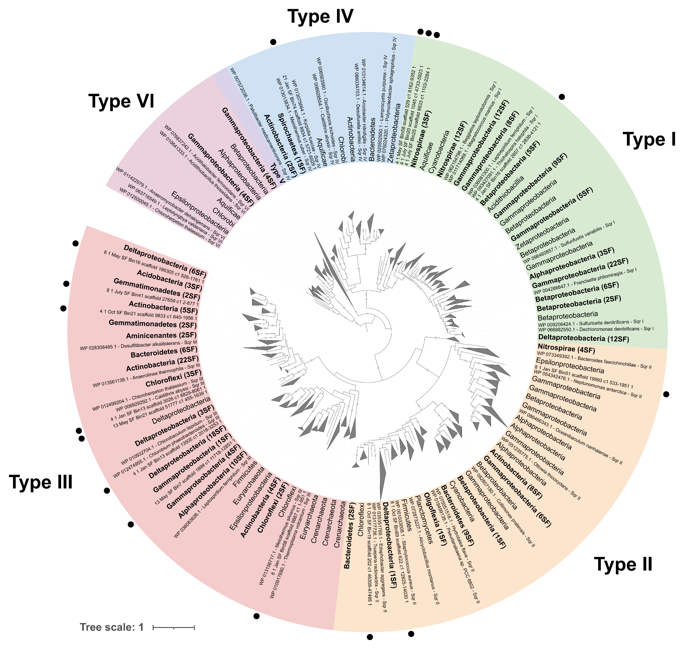
Extended Data Figure 8. A phylogenetic tree of 251 SFB MAG SQRs and 333 references. SQRs identified in this study are labeled with a black circle or have bolded font, if multiple sequences are collapsed. Different background colors signify the distinct SQR types, I-V. This phylogeny was constructed using IQ-TREE under the LG+R10 model with ultrafast bootstrapping option –bb 1000 and –bnni to reduce the impact of severe model violations.

A.
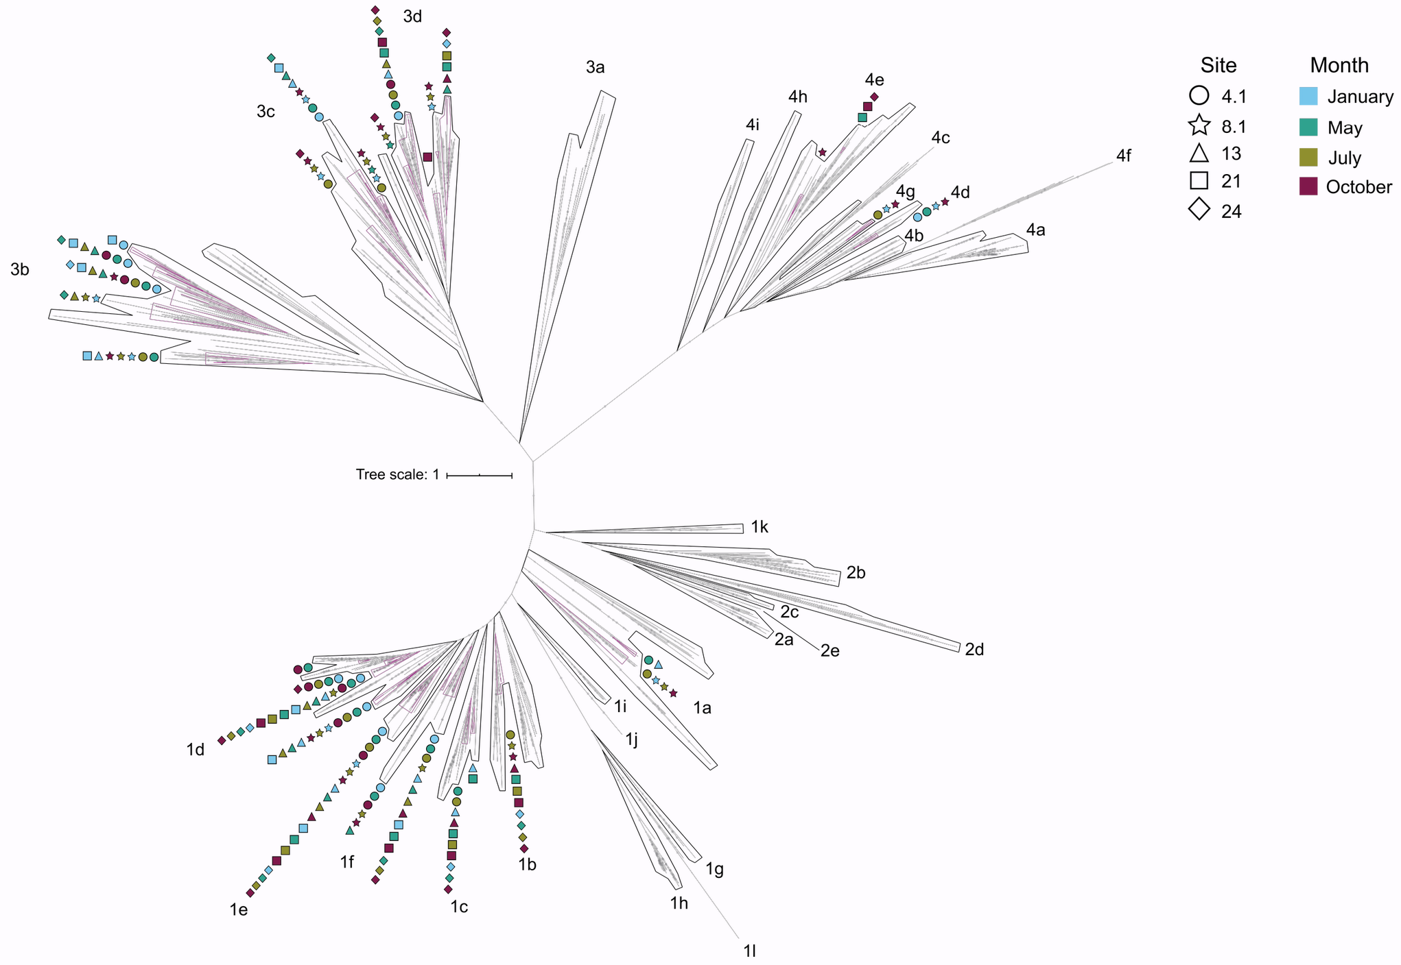
B. 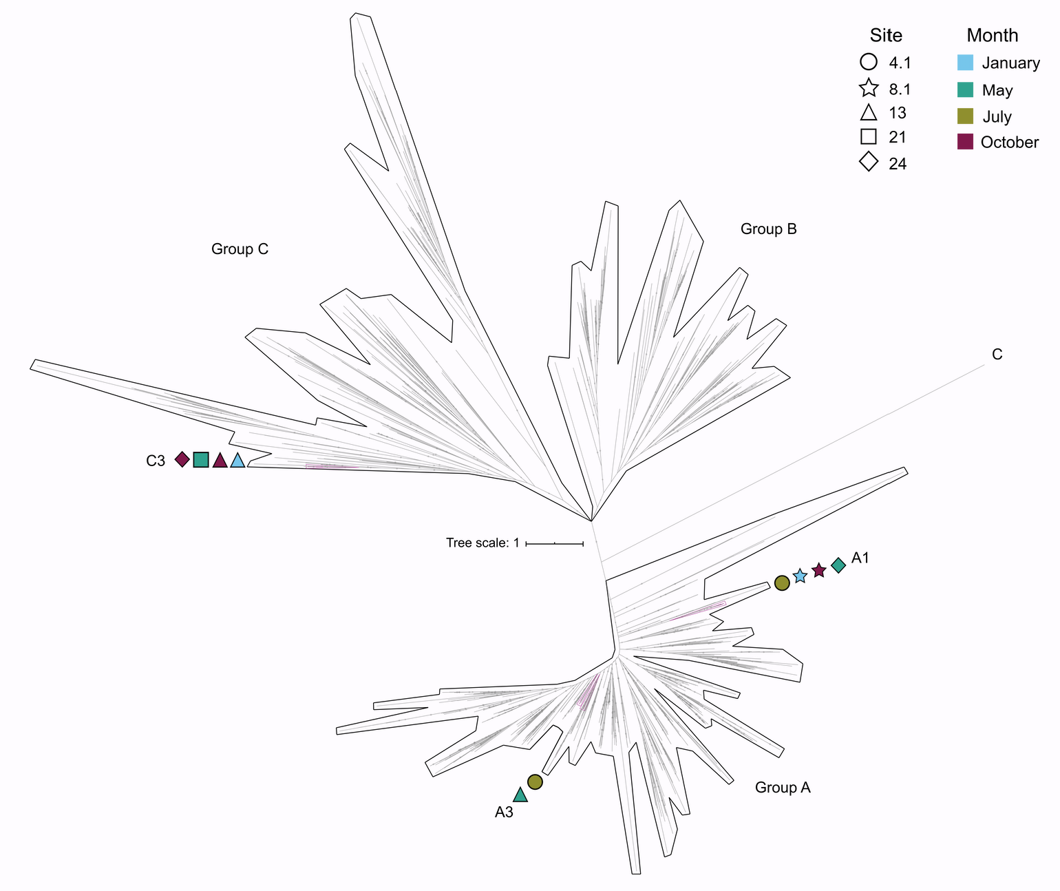
Extended Data Figure 9. A. 399 [NiFe]-group hydrogenases identified in SFB archaea and bacteria, and 2,015 reference [NiFe] sequences. Hydrogenases identified in this study are highlighted with purple branches and symbols outside of [NiFe] groups indicate the site (shape) and month (color) from which MAGs with that hydrogenase group were reconstructed. This phylogeny was constructed with IQ-TREE under the LG+R10 model with ultrafast bootstrapping option –bb 1000 and –bnni to reduce the impact of severe model violations. B. 13 FeFe group hydrogenases identified in SFB bacteria and 1,221 reference FeFe group hydrogenase sequences. Hydrogenases identified in this study are highlighted with purple branches. Symbols outside of FeFe group hydrogenases indicate the site (shape) and month (color) where MAGs were reconstructed. Note there are ten shapes rather than thirteen because some hydrogenases were identified from the same site and month. This phylogeny was constructed with IQ-TREE under the LG+R10 model with ultrafast bootstrapping option –bb 1000 and –bnni to reduce the impact of severe model violations.

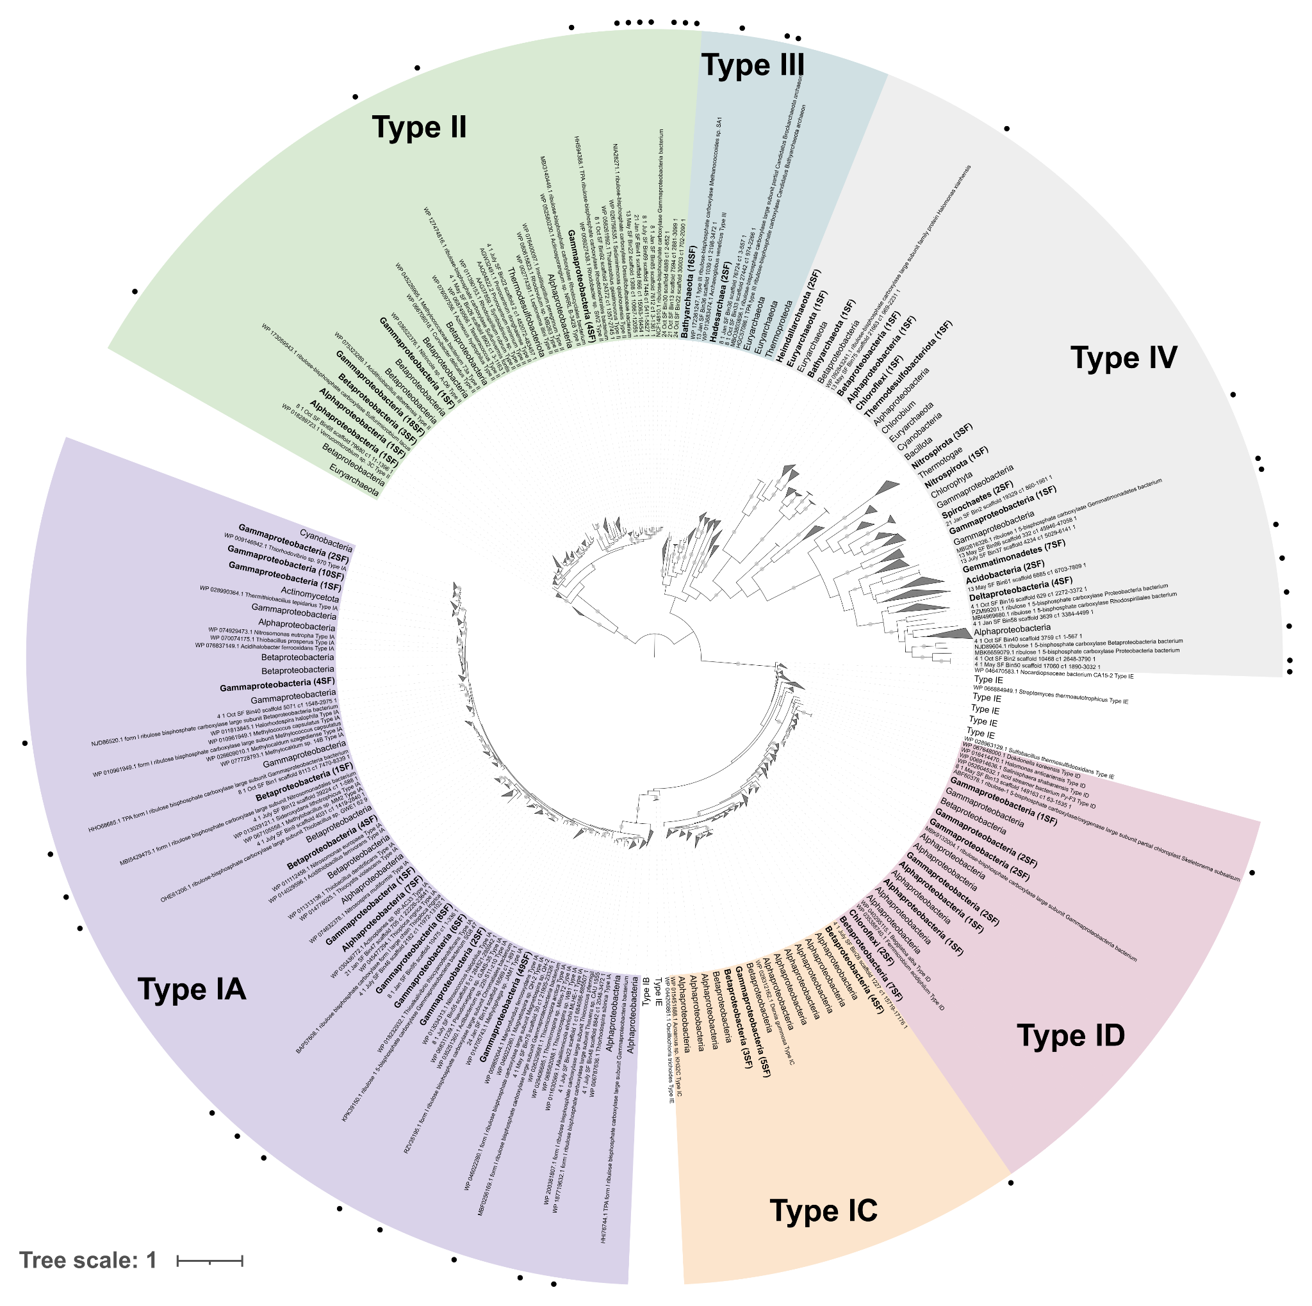
Extended Data Figure 10. A RuBisCO phylogeny of 237 RuBisCO genes identified in SFB MAGs and 885 reference RuBisCOs. RuBisCOs identified in this study are labeled with a black circle or have bolded font, if multiple sequences are collapsed. Different background colors signify the distinct RuBisCO types, IA-IV. This phylogeny was constructed using IQ-TREE under the LG+F+R10 model with ultrafast bootstrapping option –bb 1000 and –bnni to reduce the impact of severe model violations.

