Table S1: List of primers

Gene | Description |  | Sequence (5′ to 3′)
ACTB | Actin Beta | F | CCTGAGGCTCTTTTCCAGCC
ACTB | Actin Beta | R | GCCAGAGCAGTAATCTCCTTCTG
iNOS | Inducible nitric oxide synthase | F | TTGGAGCGAGTTGTGGATTGTC
iNOS | Inducible nitric oxide synthase | R | GCAGCCTCTTGTCTTTGACCCAG
IL6 | Interleukin 6 | F | GAGGATACCACTCCCAACAGACC
IL6 | Interleukin 6 | R | CTGCAAGTGCATCATCGTTGTTC
MCP-1 | Monocyte Chemoattractant Protein-1 | F | CTCATTCACCAGCAAGATGATCC
MCP-1 | Monocyte Chemoattractant Protein-1 | R | CCTTCTTGGGGTCAGCACAG
COX-2 | Cyclooxygenase-2 | F | CCTCTGCGATGCTCTTCC
COX-2 | Cyclooxygenase-2 | R | TCACACTTATACTGGTCAAATCC
NF-κB | Nuclear factor kappa-light-chain-enhancer of activated B cells | F | TGGCAGACGATGATCCCTACG
NF-κB |  | R | CGGAATCGAAATCCCCTCTGTT
TLR2 | Toll-like receptor 2 | F | CCGAAACCTCAGACAAAGC
TLR2 | Toll-like receptor 2 | R | GAGGACTGTTATGGCCACC
TLR4 | Toll-like receptor 4 | F | CTCTAGCCCACTGCTTCAGGC
TLR4 | Toll-like receptor 4 | R | CCCTGACTGGCACTAACCACAT
Clec7a/Dectin-1 | C-type lectin domain family 7 member A | F | GACCCAAGCTACTTCCTCA
Clec7a/Dectin-1 | C-type lectin domain family 7 member A | R | GCAGCACCTTTGTCATACTG
C/EBPβ | CCAAT/enhancer binding protein (C/EBP) beta | F | ACGACTTCCTCTCCGACCTCT
C/EBPβ | CCAAT/enhancer binding protein (C/EBP) beta | R | CGAGGCTCACGTAACCGTAGT
C/EBPα | CCAAT/enhancer binding protein (C/EBP) alpha | F | TGCGCAAGAGCCGAGATAA
C/EBPα | CCAAT/enhancer binding protein (C/EBP) alpha | R | CGGTCATTGTCACTGGTCAACT
PPARγ | Peroxisome proliferator-activated receptor gamma | F | CTATGGAGTTCATGCTTGTGAAGG
PPARγ | Peroxisome proliferator-activated receptor gamma | R | CTTCAATCGGATGGTTCTTCGGA
FABP4 | Fatty Acid-Binding Protein 4 | F | TGGAAGCTTGTCTCCAGTGA
FABP4 | Fatty Acid-Binding Protein 4 | R | AATCCCCATTTACGCTGATG
FAS | Fatty acid synthase | F | TTGGAGCCTGTGTAGCCTTCGAG
FAS | Fatty acid synthase | R | GGTGTGTGAGCCGTCAAACAGG
LPL | Lipoprotein lipase | F | CCATGGATGGACGGTAACGGG
LPL | Lipoprotein lipase | R | CCCGATACAACCAGTCTACTACA
SREBP-1 | Sterol regulatory element-binding protein 1 | F | AGCCACACTTCATCAAGGCA
SREBP-1 | Sterol regulatory element-binding protein 1 | R | TGGTCCCTCCACTCACCAG
Cdc45l | Cell division cycle 45 | F | AAGGGGAATCTGCGAGAAATG
Cdc45l | Cell division cycle 45 | R | GCCAGGAATTTATGCTTGAAC
Mcm3 | Minichromosome maintenance complex component 3 | F | CGACGCTACTCTGACCTCAC
Mcm3 | Minichromosome maintenance complex component 3 | R | CTGTCTCCAGGGGGTTGTTC
Gins1 | GINS complex subunit 1 | F | CTGGACGAGGGGATCTGATAC
Gins1 | GINS complex subunit 1 | R | CCCATATTCCCACCTGAGTGC
Cdc25 | Cell division cycle 25 | F | CCATTCAGATGGAGGAGGAAG
Cdc25 | Cell division cycle 25 | R | GTTTAAGGCTCCCAGGATGTG
CD36 | Cluster of differentiation 36 | F | TGGCCTTACTTGGGATTGG
CD36 | Cluster of differentiation 36 | R | CCAGTGTATATGTAGGCTCATCCA

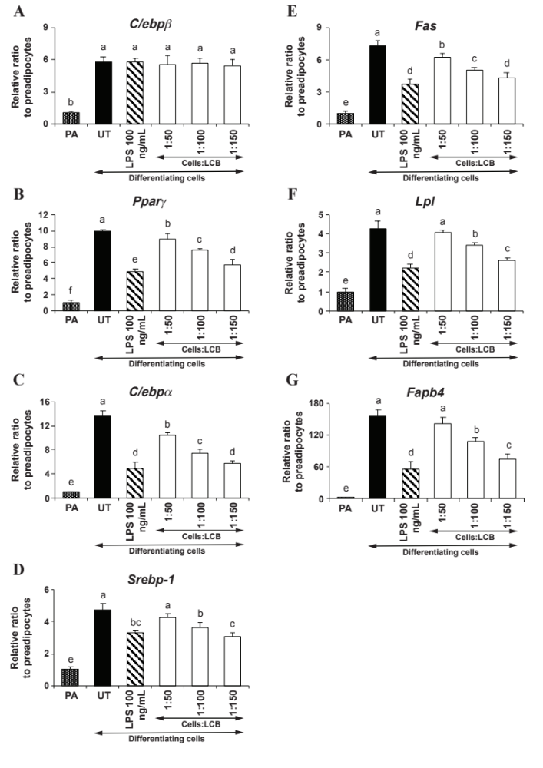

Fig. S1: LCB inhibits the D/A medium-induced expression of the key adipogenic markers in differentiating 3T3-L1 in a dose-dependent manner. (A), (B), (C), (D), (E), (F), and (G) show a representative qPCR results for C/ebpβ, Pparγ, C/ebpα, Srebp1, Fas, Lpl, and Fabp4 gene expression, respectively. Differentiation of 3T3-L1 adipocytes was induced by adding the D/A medium. The medium was added to the cells without or with LCB at the increasing amount (1:50, 1:100, and 1:150 cells:LCB ratios). PA (pre-adipocytes) is a negative control set, whereas LPS at 100 ng/mL was included as a positive control for inhibition of adipogenesis. The treatment was performed for 2 days before harvesting the cells for qPCR assay. Each bar is the average value from 3 independent experiments and the error bars represent standard deviations.

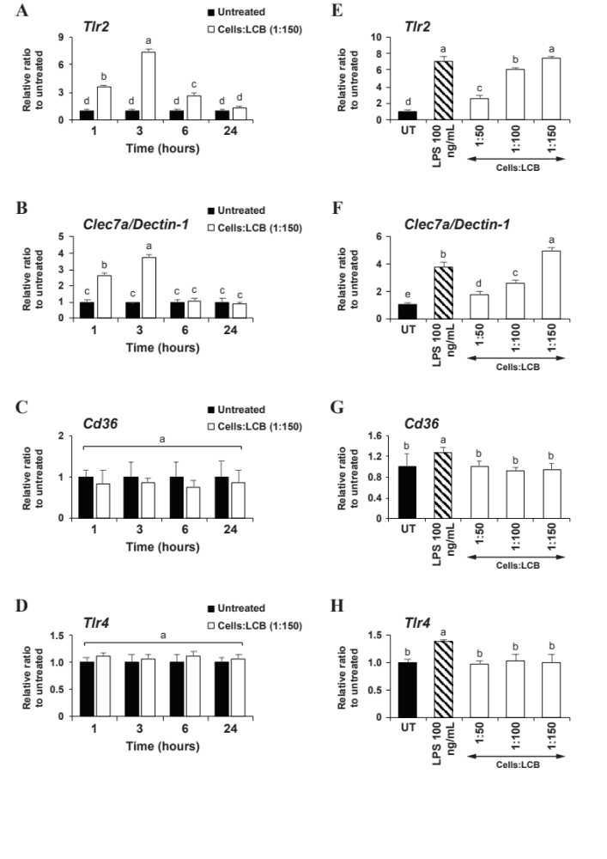

Fig. S2: LCB affects the expression of TLR2 and Clec7a/Dectin-1 but not CD36 and TLR4 genes in differentiating 3T3-L1 adipocytes in time- and dose-dependent manners. (A), (B), (C), and (D) show qPCR results for Tlr2, Clec7a/Dectin-1, Cd36, and Tlr4 gene expression, respectively. The D/A medium was added to the pre-adipocytes without or with LCB (1:150 cells:LCB). Cells were collected for qPCR assay after 1, 3, 6, and 24 hours of treatment. (E-H) also show qPCR results for the same set of genes as in (A-D), except that in the differentiating adipocytes were treated with an increased concentration of LCB (1:50, 1:100, and 1:150 cells:LCB) for 3 hours before being collected for qPCR analysis. LPS at 100 ng/mL was included as a positive control. UT, abbreviated for untreated, is the differentiating cells and serves as a reference for the gene expression.

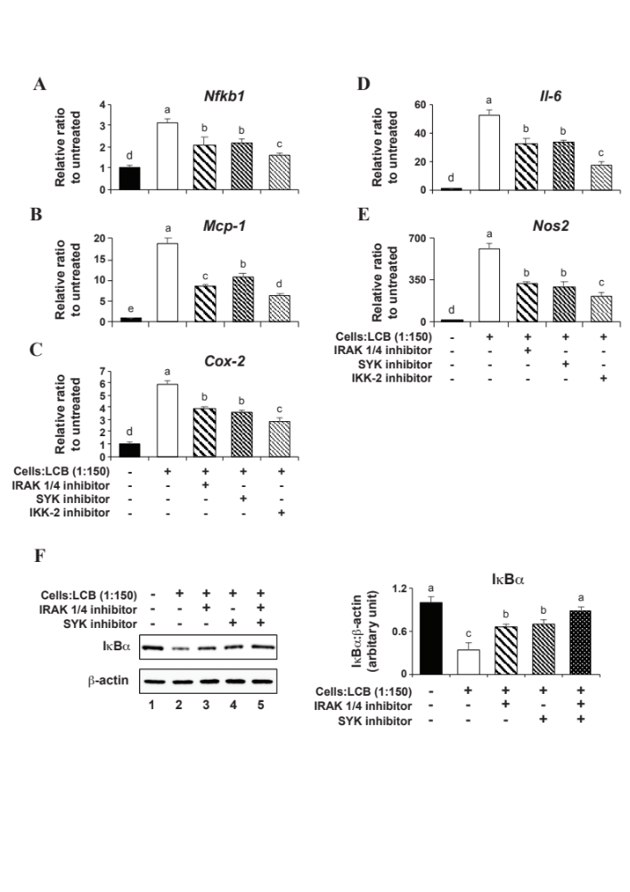

Fig. S3: IRAK 1/IRAK 4 and SYK signaling pathways mediate an inflammatory-stimulating effect of LCB on differentiating 3T3-L1 adipocytes. (A), (B), (C), (D), and (E) show qPCR results for Nfkb1, Mcp-1, Cox-2, Il-6, and Nos2, respectively. Pre-adipocytes were pre-treated with 10 μM IRAK 1/4, 10 μM SYK, or 50 μM IKK-2 inhibitor for 30 minutes. Then, the D/A medium together with LCB (1:150 cells:LCB) in the absence or the presence of each inhibitor were added to the cells, and the incubation was performed for 3 hours before collecting the cells for qPCR assay. (F) shows the IκBα protein expression in the D/A medium-induced differentiating 3T3-L1 adipocytes treated with either IRAK 1/4 or SYK inhibitor. The experiment was performed similarly to A-E, except that cells were treated with 1:150 cells:LCB for 30 minutes prior to being harvested for the Western blotting assay. The IκBα:β-actin protein intensity ratio at each time point was calculated and expressed as the relative ratio in respect to the value from the differentiating cells without LCB and the inhibitor treatment (lane 1).

Original Western blot pictures
Explanation: After transferring proteins to a PVDF membrane, the membrane was cut so that the Western blotting experiment with different antibodies could be performed in parallel. Areas presented in the manuscript figures are boxed. Each antibody used in this study is specific. Details for each lane are the same as described in its figure legend.
Fig.2A
C\EBPβ

C\EBPα

PPARγ

FAS

FABP4

ACC

β-actin

Fig.3A
C\EBPβ

C\EBPα

PPARγ

FAS

β-actin

Fig.5H
Cyclin D1

β-actin

Fig.6H
PPARγ

C\EBPα

β-actin

Fig.7A
p-AMPK

AMPK

p-ACC

ACC

β-actin

Fig.7B
p-AMPK

AMPK

p-ACC

ACC

β-actin

Fig.S3
IκBα

β-actin

