Supplementary Information for

The effect of whole blood logistics on neutrophil non-specific activation and kinetics ex vivo
Chao Li¹*, Mehtab Farooqui², Ravi Chandra Yada^{2,3,4}, Joseph B. Cai², Anna Huttenlocher^{5,6} & David J. Beebe^{1,2,3}*

*To whom correspondence may be addressed.
email: cli479@wisc.edu (Chao Li); djbeebe@wisc.edu (David J. Beebe)

This PDF file includes:
Supplementary Figures 1-10

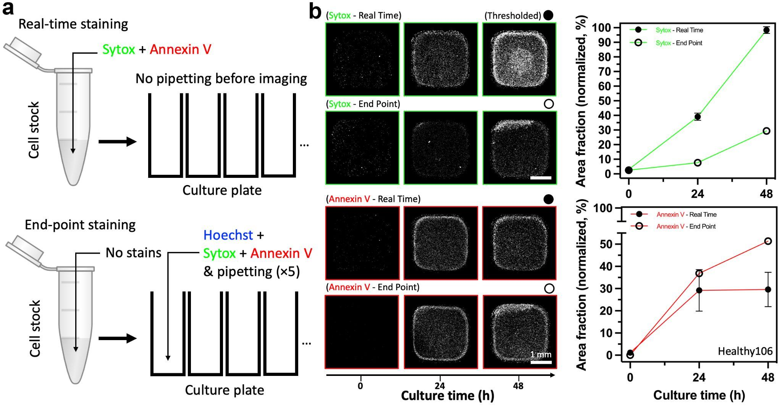

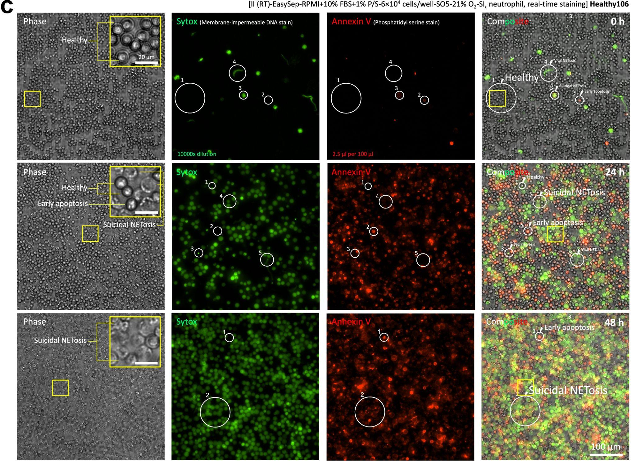
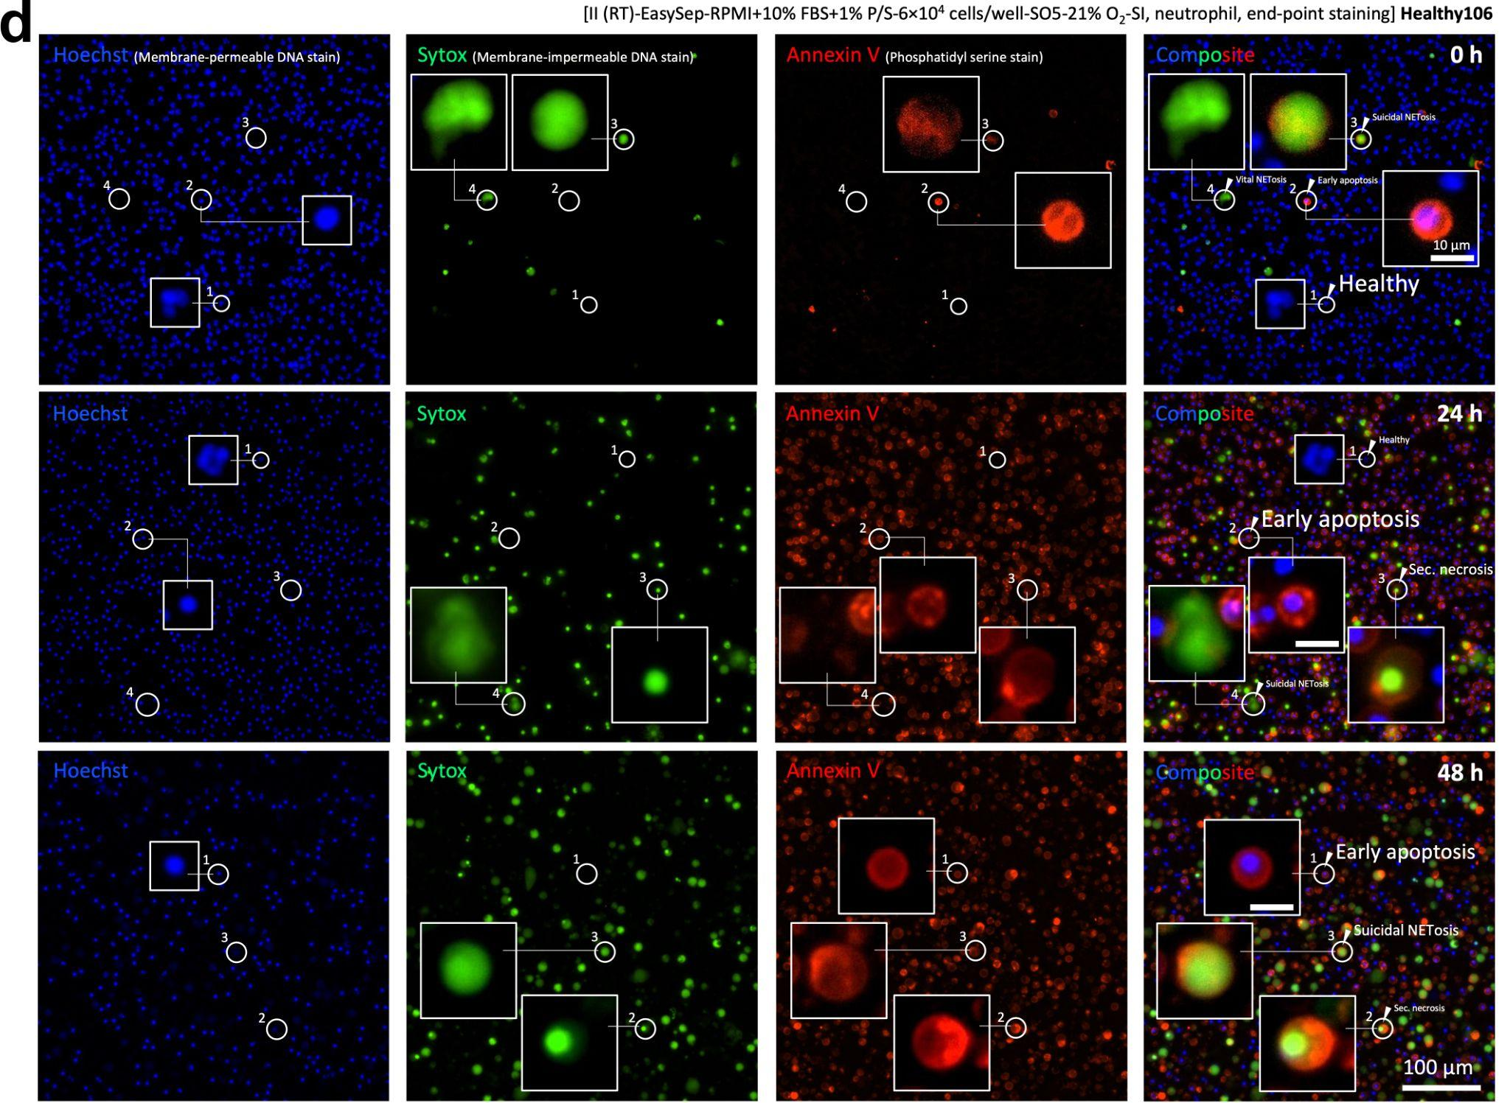
Supplementary Fig. 1 Real-time staining and end-point staining in the H-S-A method. a A schematic shows the workflow in each staining protocol. b Experimental results show the difference between real-time staining (positive error compared to no-dye control) and end-point staining (negative error compared to no-dye control). Real-time staining potentially inflicts irritation to the cells (especially the sensitive type) and thus may cause positive error of the fluorescence signals. By contrast, cells that undergo NETosis are fragile and break into debris from pipet mixing, and therefore, end-point staining (that requires mixing) causes negative error of the fluorescence signals. Typical microscopic images from real-time staining (c), and end-point staining (d). A summary of the function and readout of the three dyes is discussed in Table 2 in the main text.

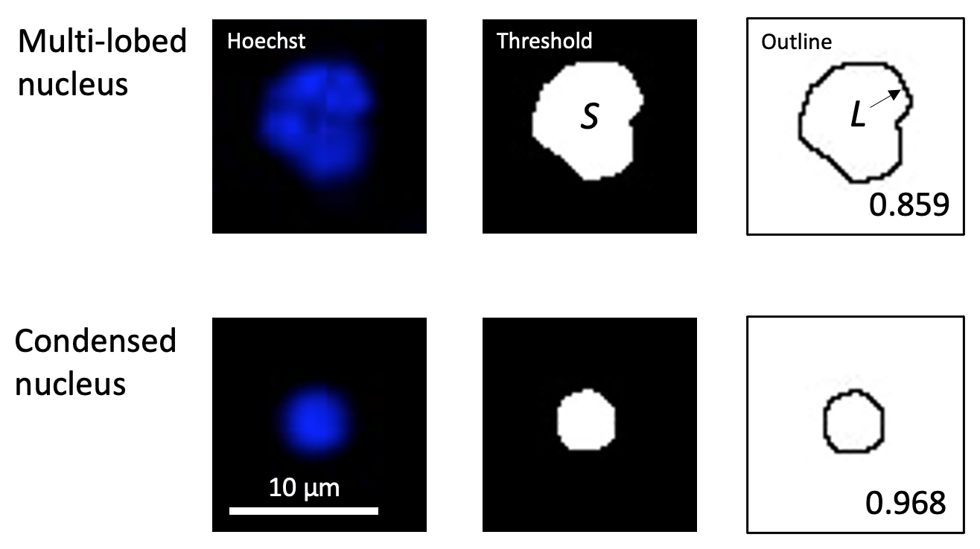
Supplementary Fig. 2 Circularity analysis for quantifying shape change of nuclei. Circularity [0.00-1.00] = S/S_{circle} = 4πS/L², where S is the area of the particle, L is the perimeter of the particle, S_{circle} is the area of a circle with perimeter L.

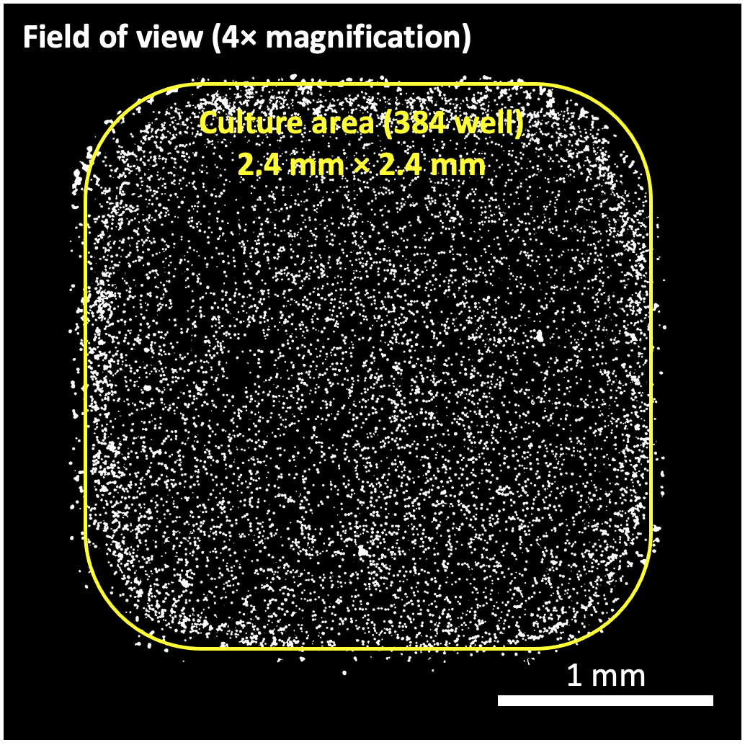
Supplementary Fig. 3 Area fraction analysis for quantifying non-specific activation (i.e. the baseline apoptosis and NETosis) of neutrophils. Non-specific activation_{Sytox or Annexin V} (%) = (S_{particles}/S_{culture area}) × 100% = Area fraction (Image J) × (S_{field of view}/S_{culture area}) × 100%, where Area fraction (Image J) = S_{particles}/S_{field of view}, S is for surface area.

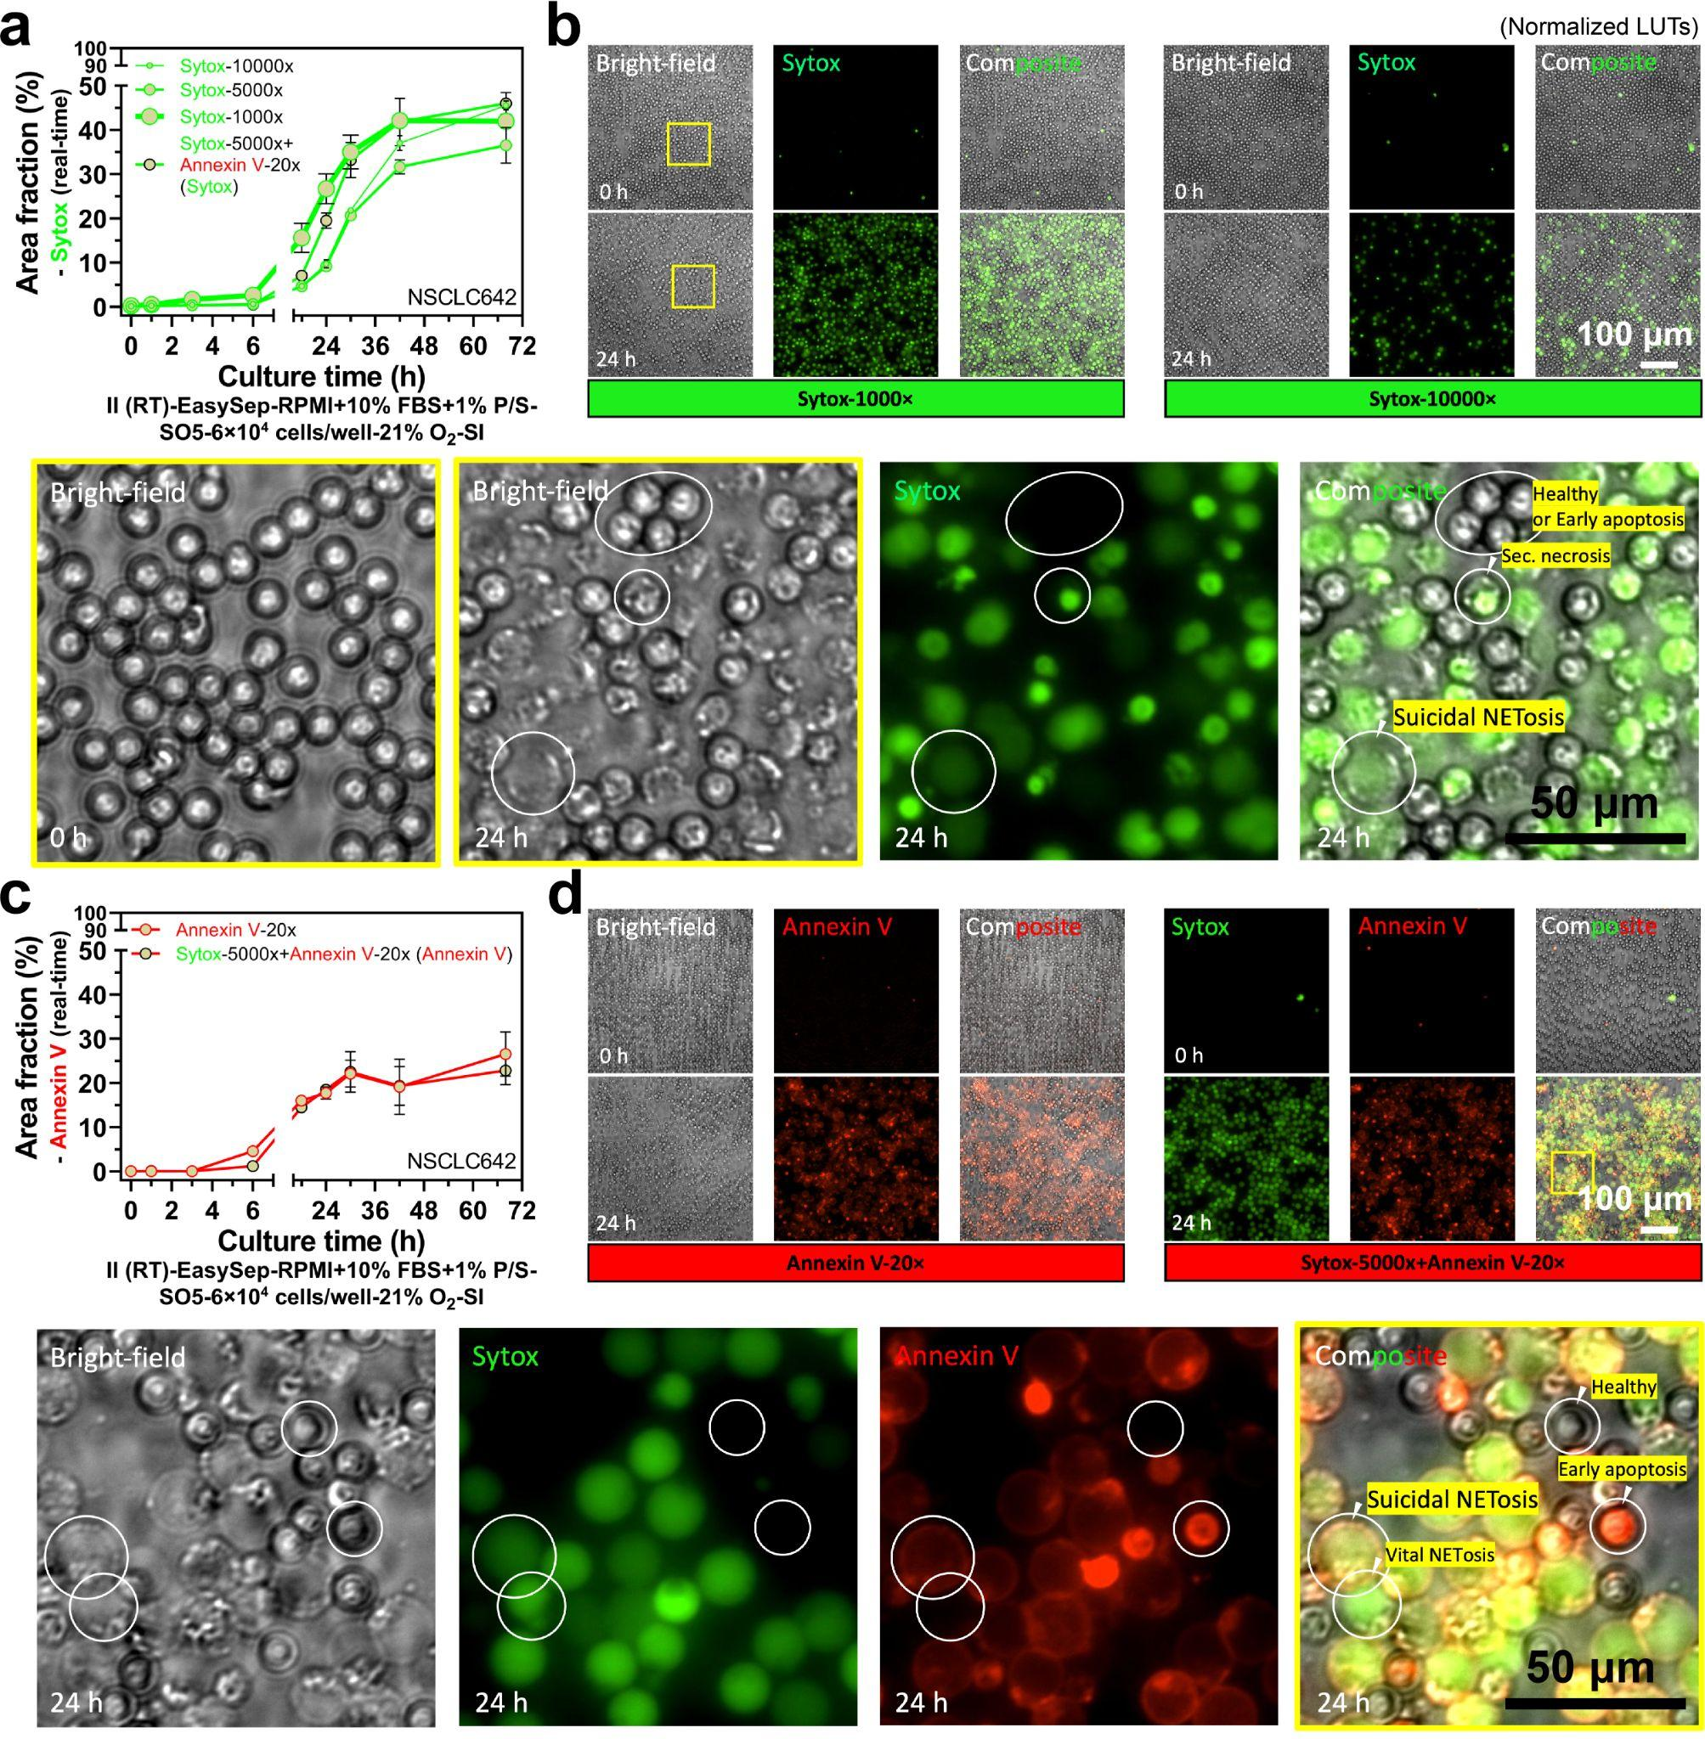
Supplementary Fig. 4 Influence of cell stains (Sytox and Annexin V, real-time staining) on non-specific activation and neutrophil kinetics in standard 2D monoculture. a Comparison of different concentrations of Sytox and the influence of addition of Annexin V to Sytox. Results are area fraction from the Sytox (real-time) channel. b The representative microscopic images in (a). c The influence of addition of Sytox to Annexin V. Results are area fraction from the Annexin V (real-time) channel. d The representative microscopic images in (c). The no-dye control and comparison are shown in Supplementary Fig. 5.

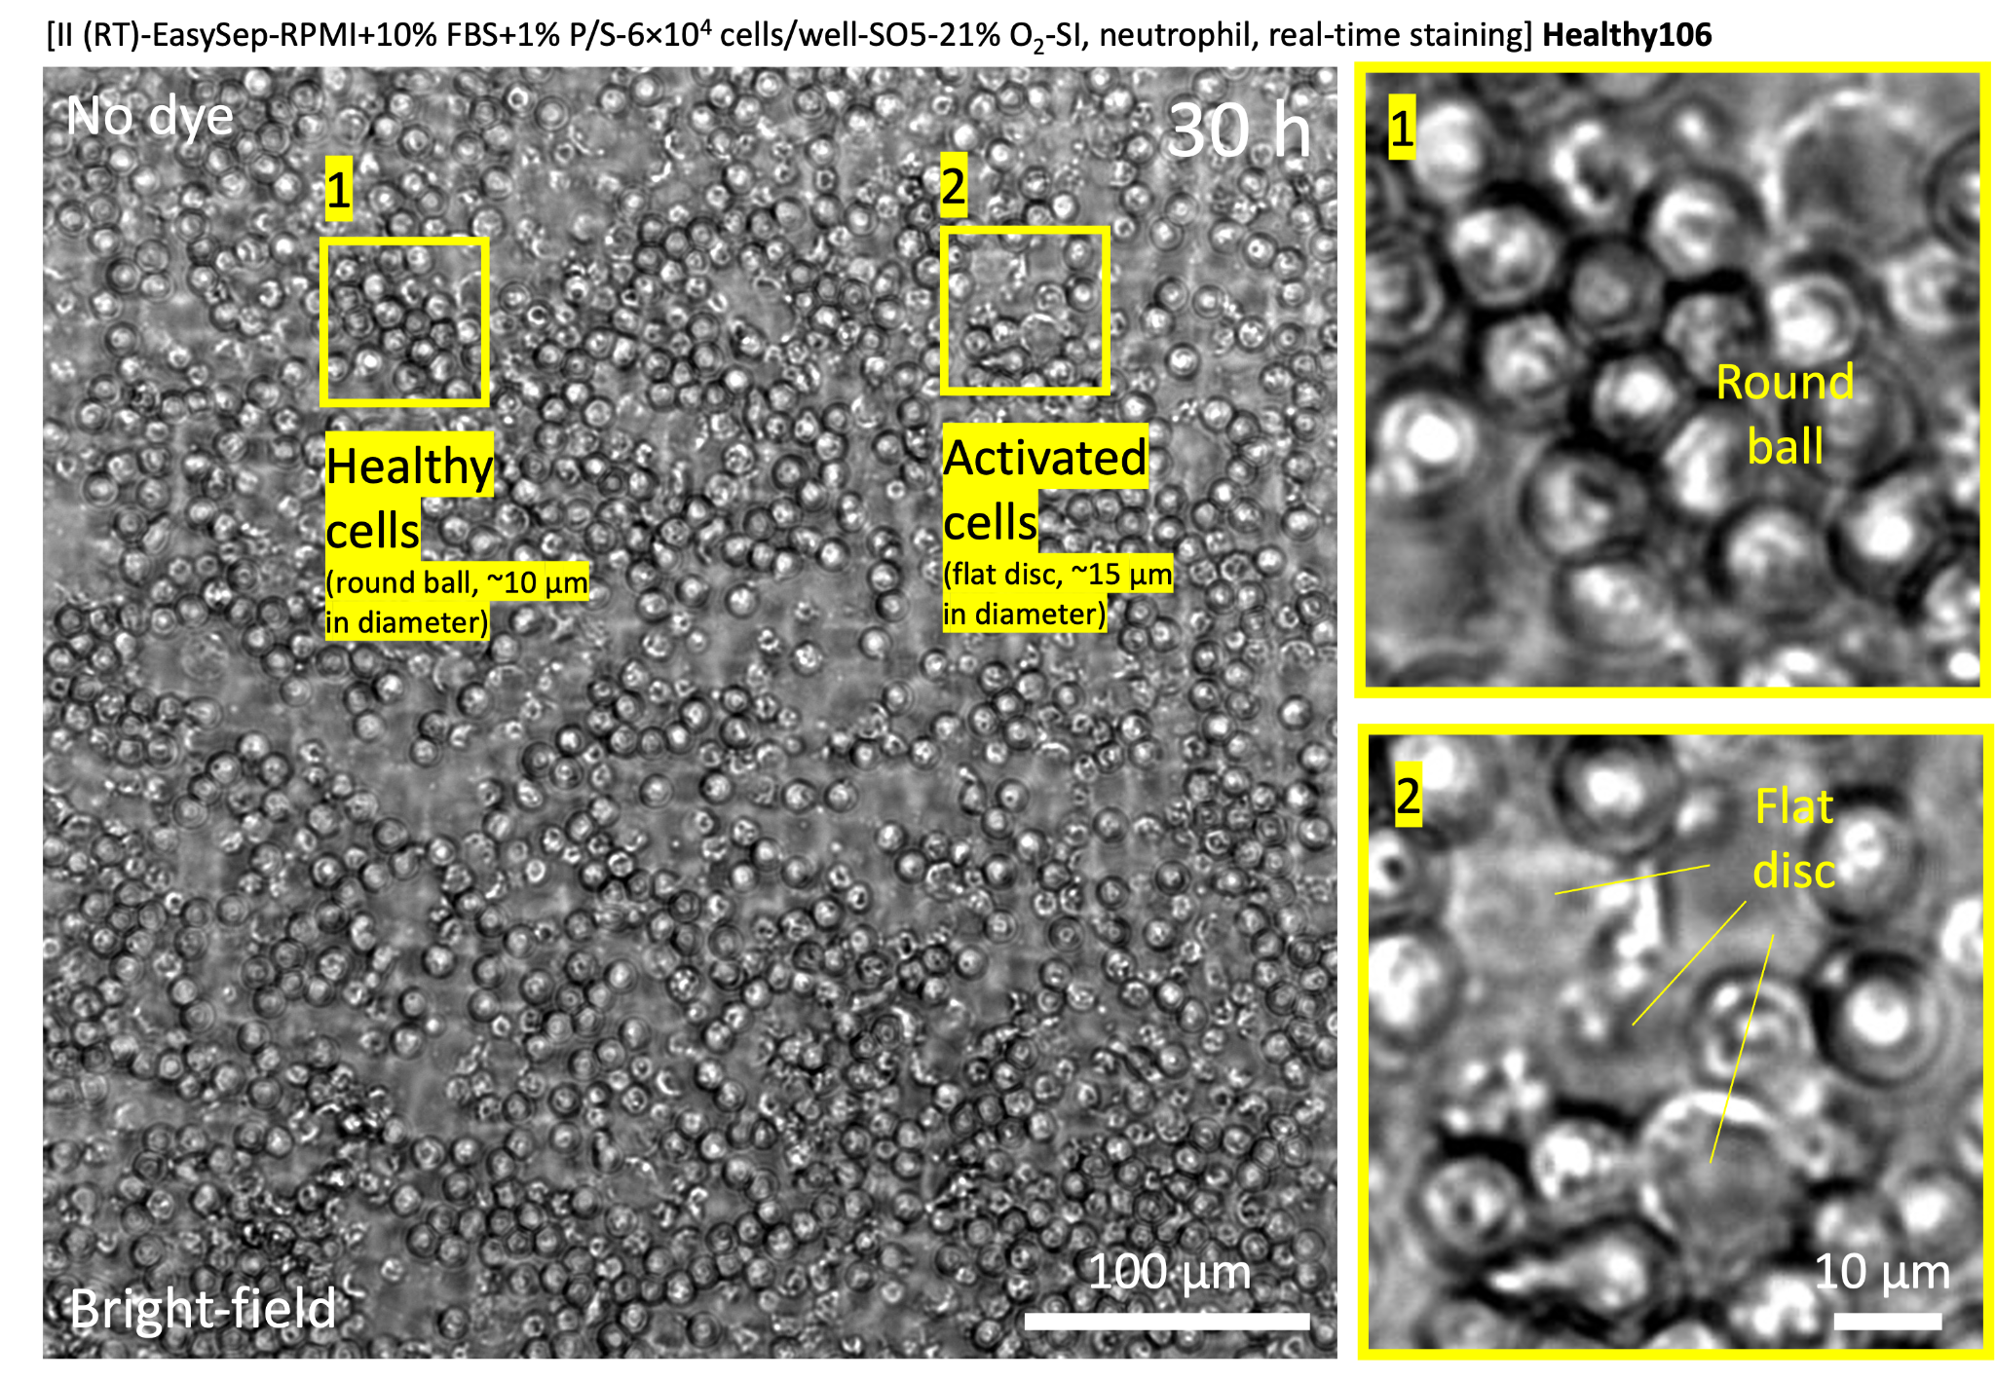
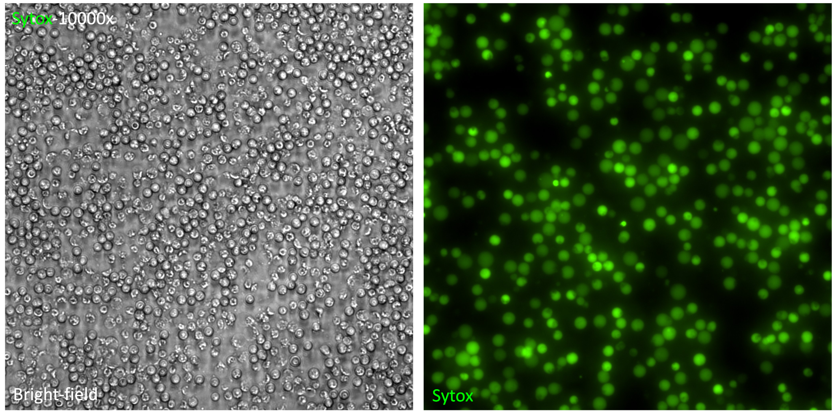
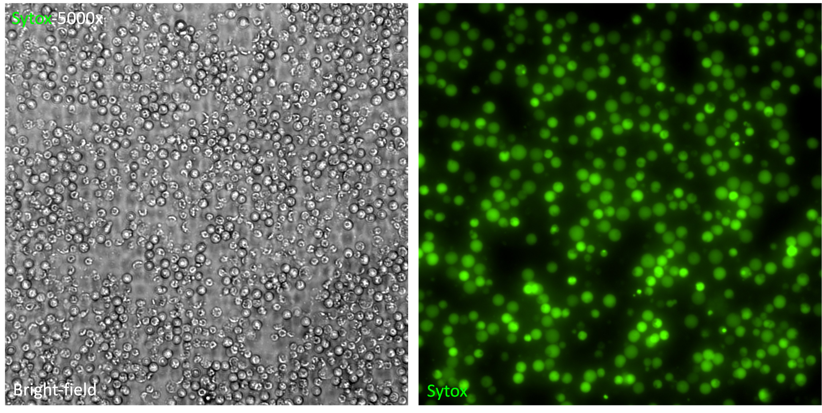
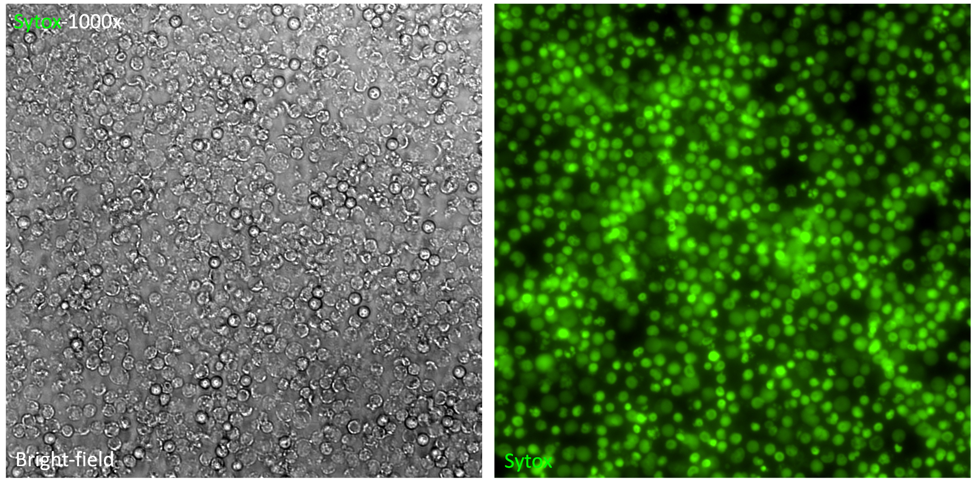
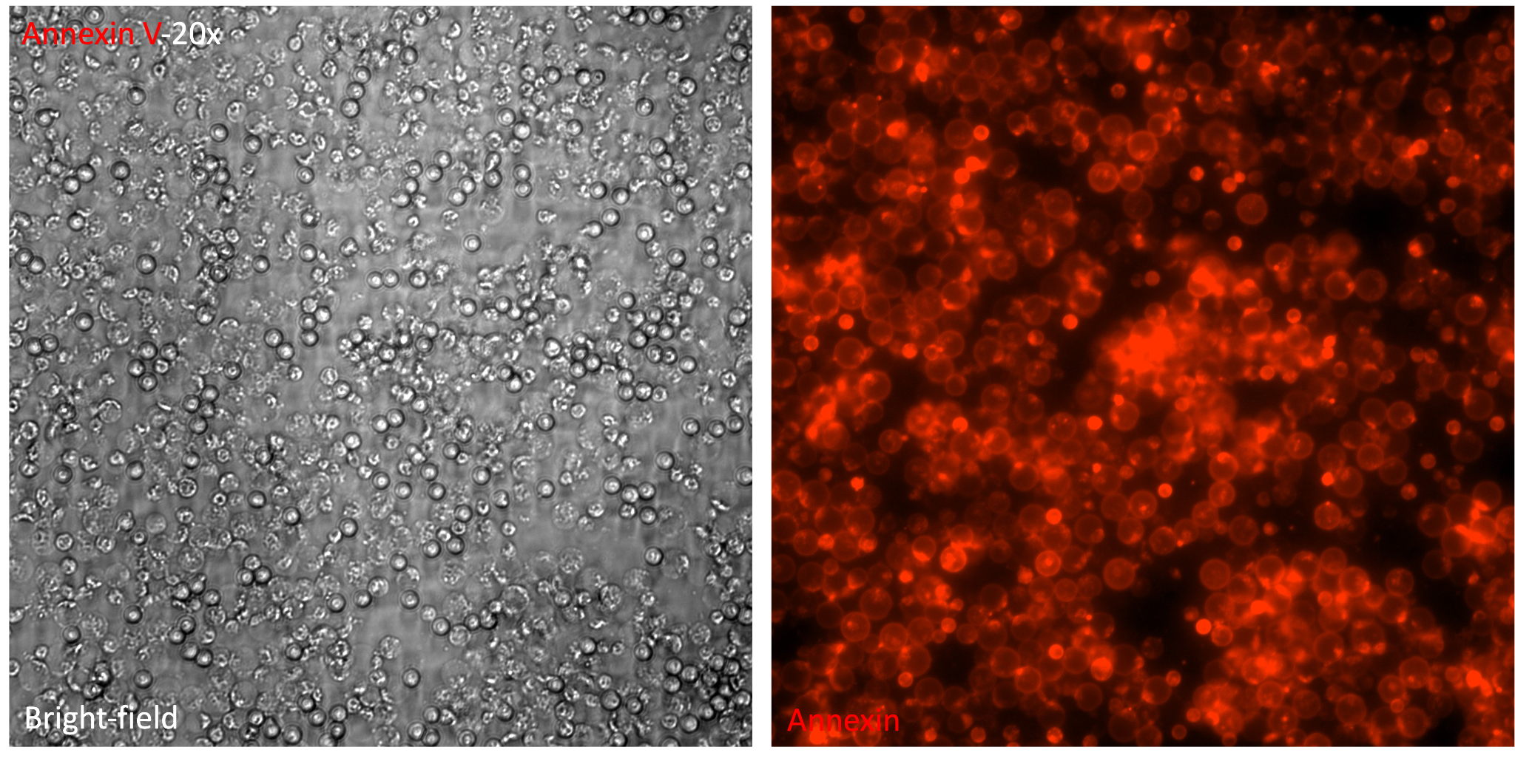
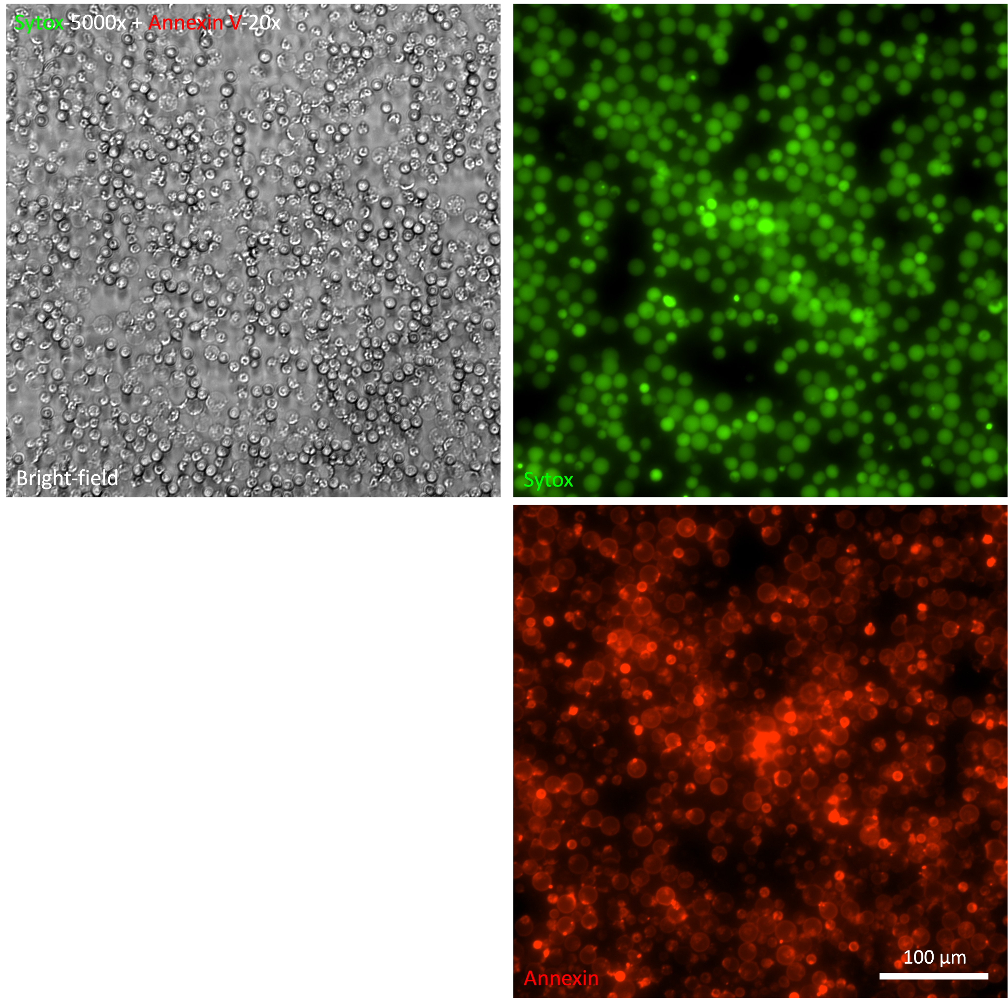
Supplementary Fig. 5 Comparison between no dye and cell stain on non-specific activation of neutrophils.

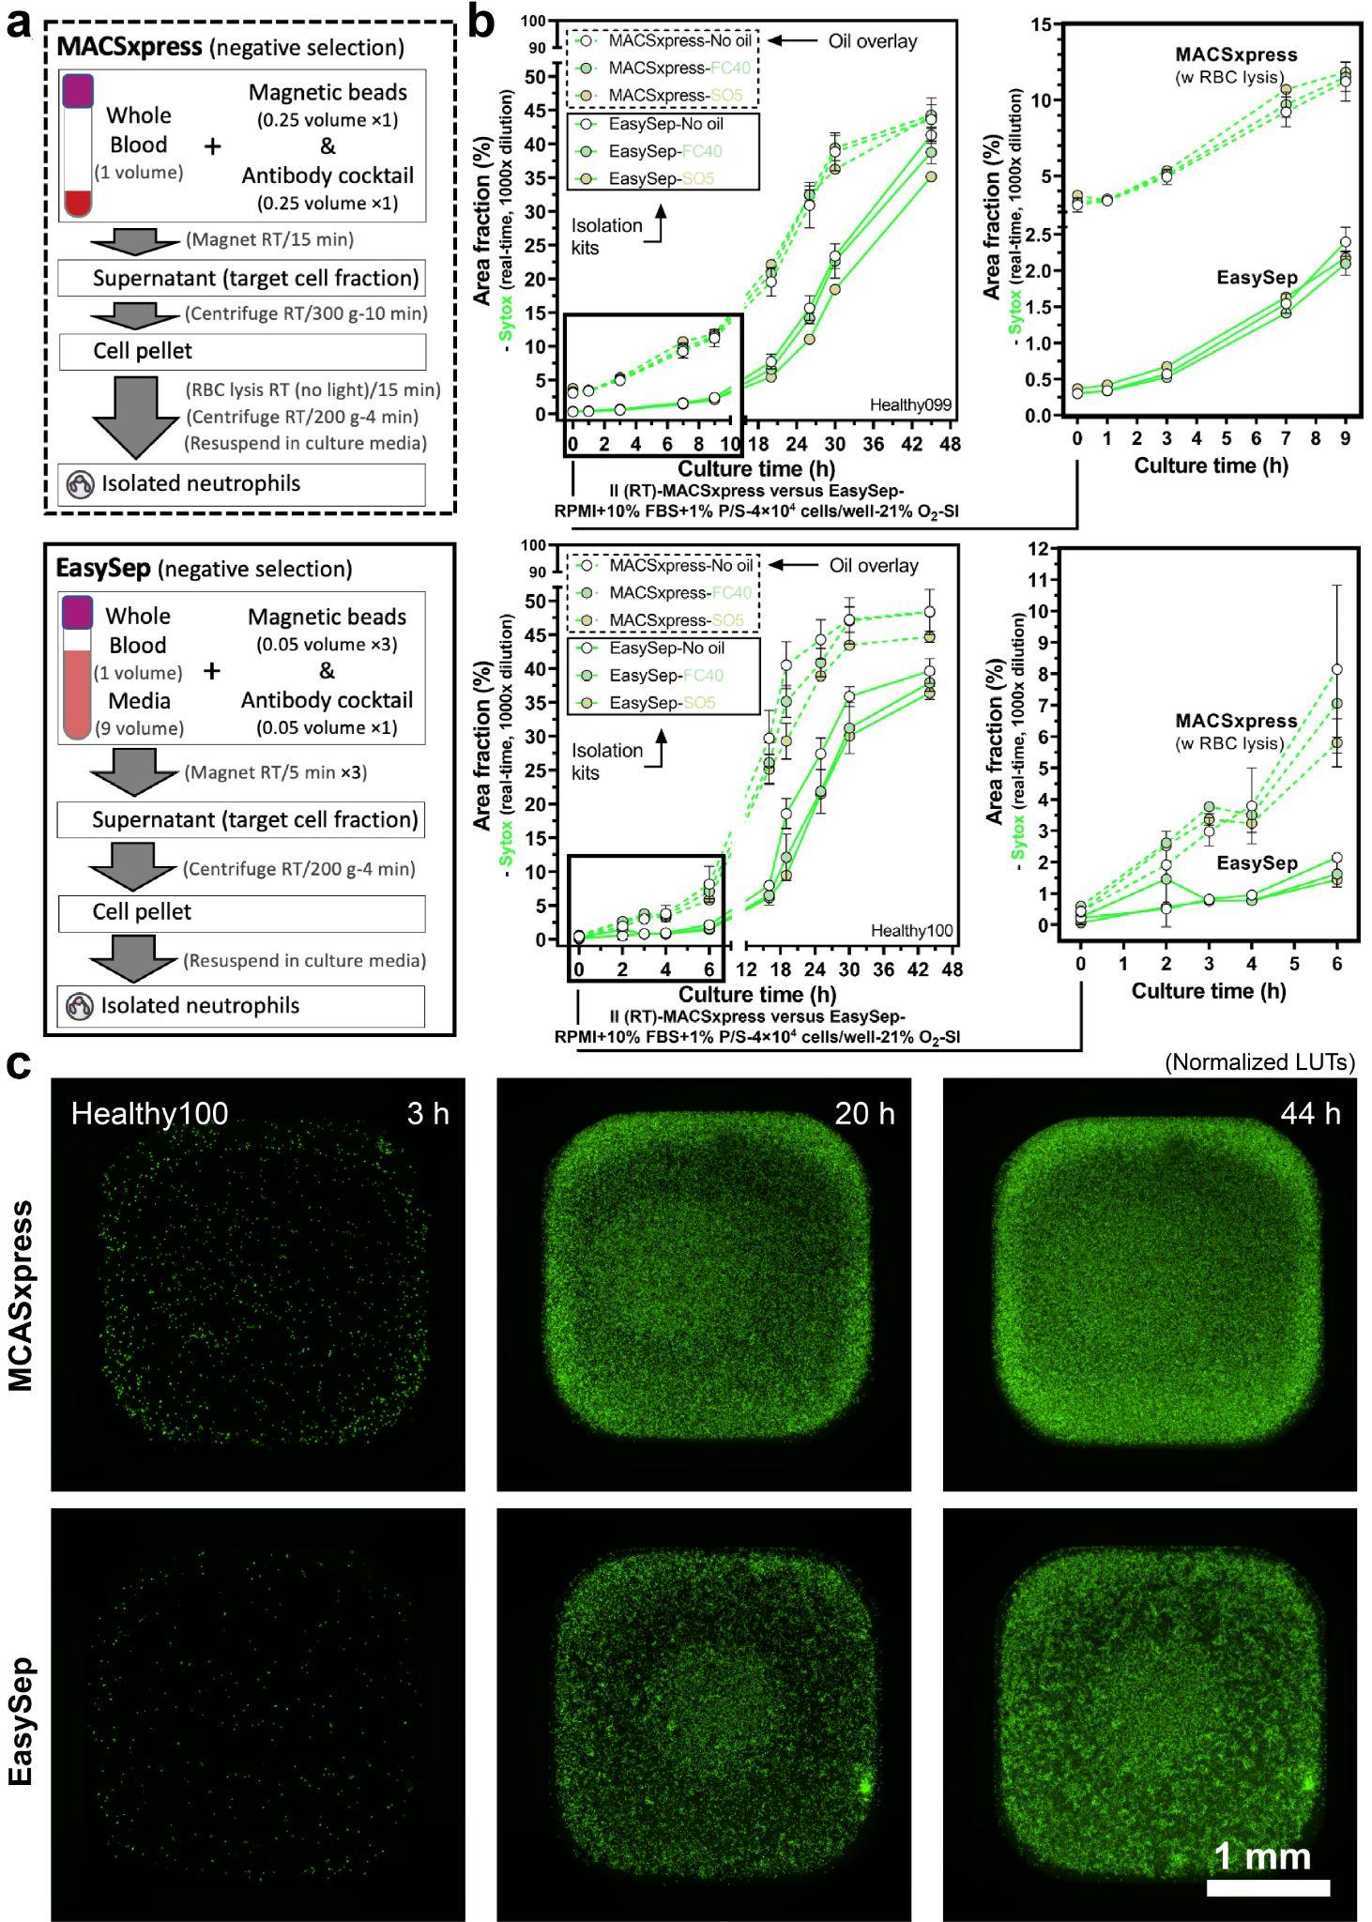
Supplementary Fig. 6 Influence of isolation method on non-specific activation and neutrophil kinetics in culture. a The workflow of two negative-selection based isolation kits - MACSxpress (top) and EasySep (bottom). b Comparison between the two kits on non-specific activation and neutrophil kinetics in culture. Results are area fraction from the Sytox (real-time, 1000× dilution) channel. c The representative microscopic images in (b), Healthy100.

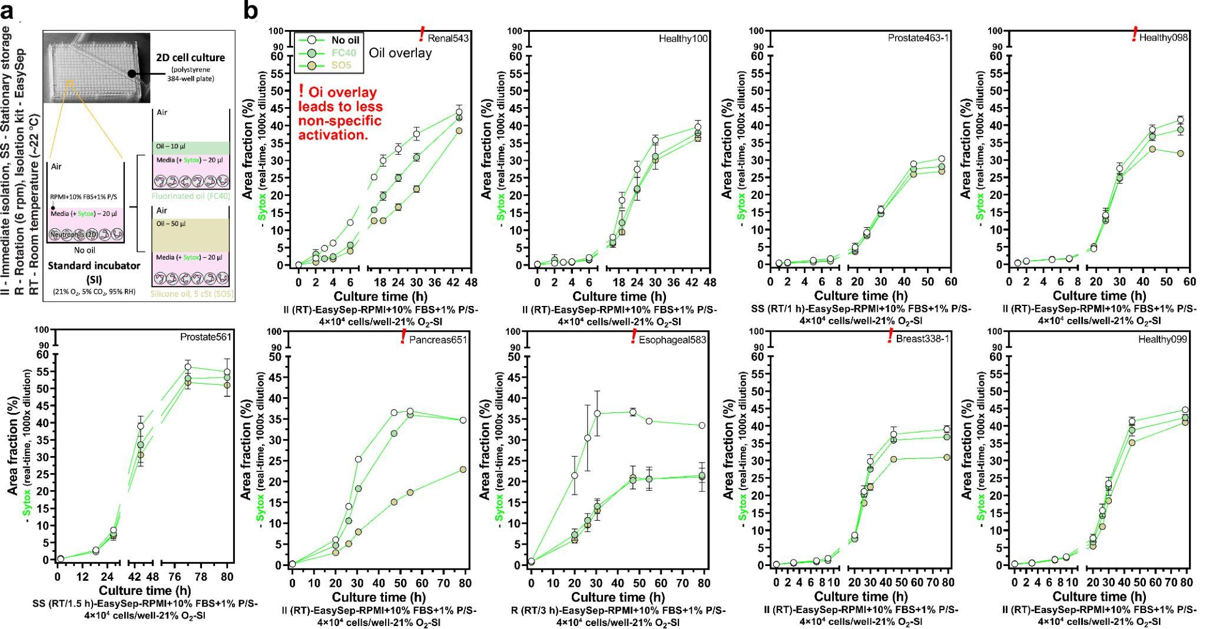
Supplementary Fig. 7 Influence of oil overlay on non-specific activation and neutrophil kinetics in standard 2D monoculture. a Schematic showing the culture condition with and without oil overlay in a 384-well plate. b Non-specific activation and neutrophil kinetics in culture from nine donors. Results are area fraction from the Sytox (real-time, 1000× dilution) channel. The red “!” indicates the experiments where oil (espeically silicone oil) overlay led to significantly less non-specific activations of neutrophils compared to the no oil control.

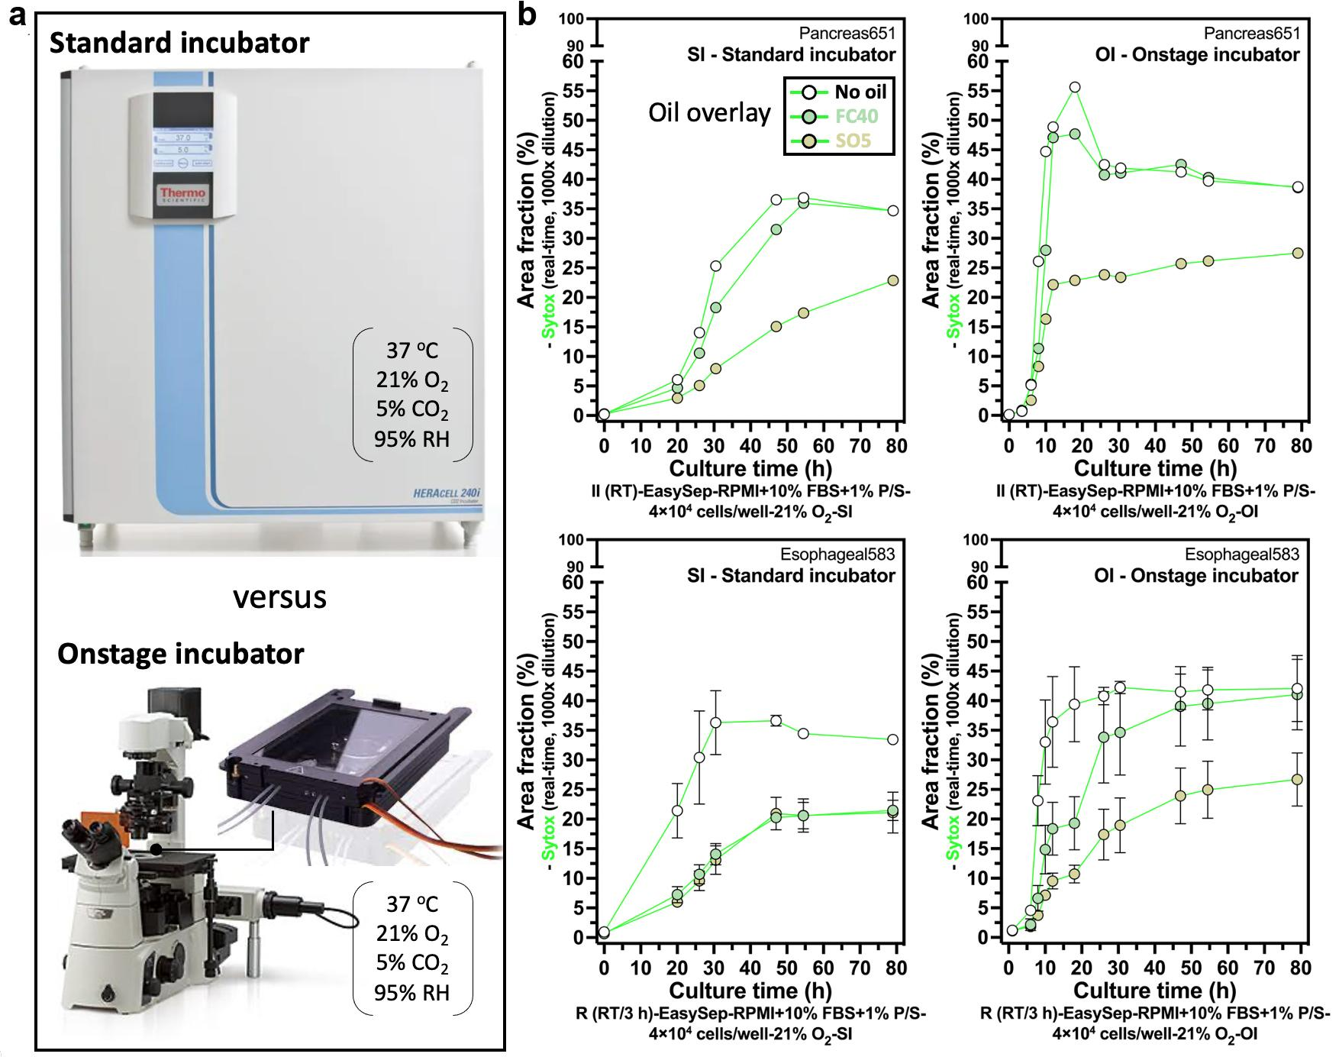
Supplementary Fig. 8 Influence of the type of incubator (standard incubator versus onstage incubator) on non-specific activation and neutrophil kinetics in standard 2D monoculture. a Pictures of the two incubator systems. b Comparison between the two incubator systems on non-specific activation and neutrophil kinetics in culture. Results are area fraction from the Sytox (real-time, 1000× dilution) channel. Data from Pancreas651 were extracted from one replicate of each condition due to the limited neutrophil yield given the conditions tested.
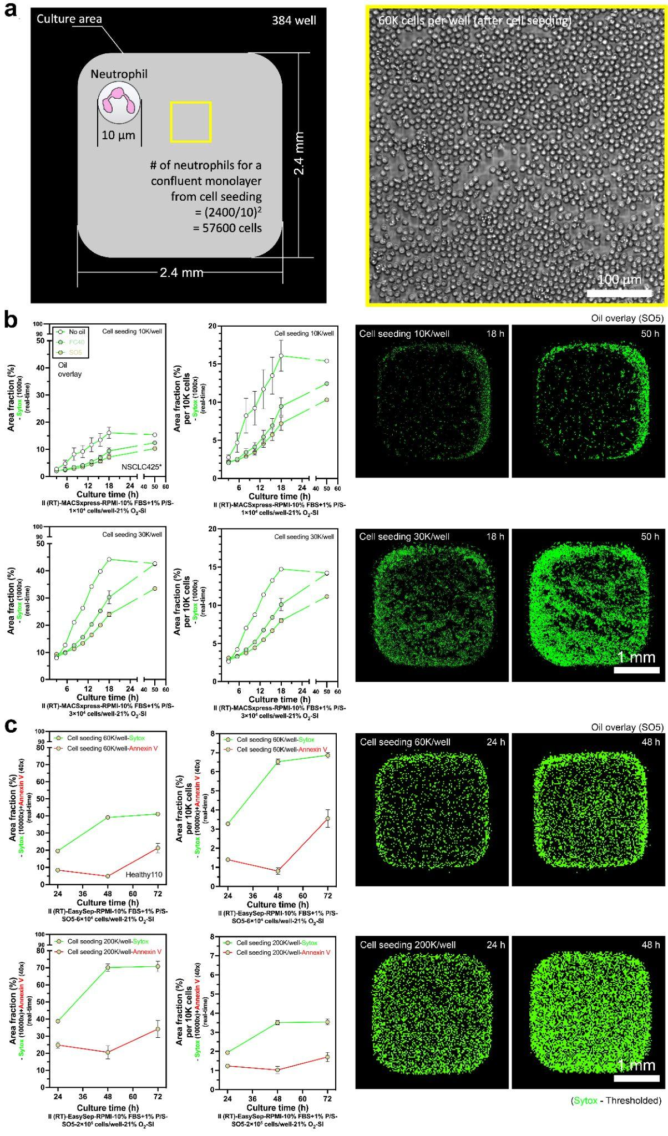
Supplementary Fig. 9 Influence of cell seeding density on non-specific activation and neutrophil kinetics in standard 2D monoculture. a Dimension of wells on a 384-well plate and estimation of cell seeding density that leads to a confluent monolayer. b 10K versus 30K cells per well. Results are area fraction from the Sytox (real-time, 1000× dilution) with the representative microscopic images. c 60K (confluent monolayer from cell seeding) versus 200K cells per well. Results are area fraction from the Sytox (real-time, 10000× dilution) and Annexin V (real-time, 40× dilution) channel with the representative microscopic images.

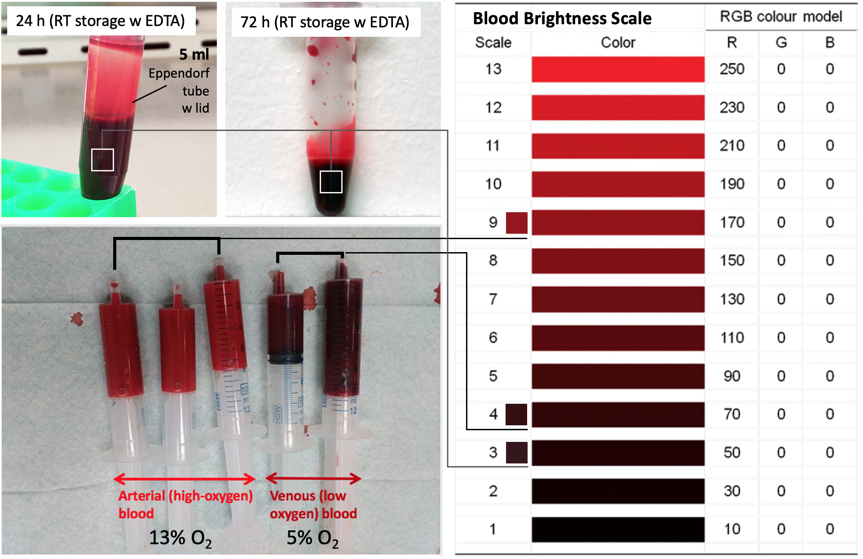
Supplementary Fig. 10 Oxygen level of whole blood (arterial blood, ~13% O₂ versus venous blood, ~5% O₂) and the color of whole blood in storage.

