Supplementary Materials
- Table
Supplementary Table 1 The P-values for t-test differences in the immune microenvironment compared the co-occurring with wild-type groups.
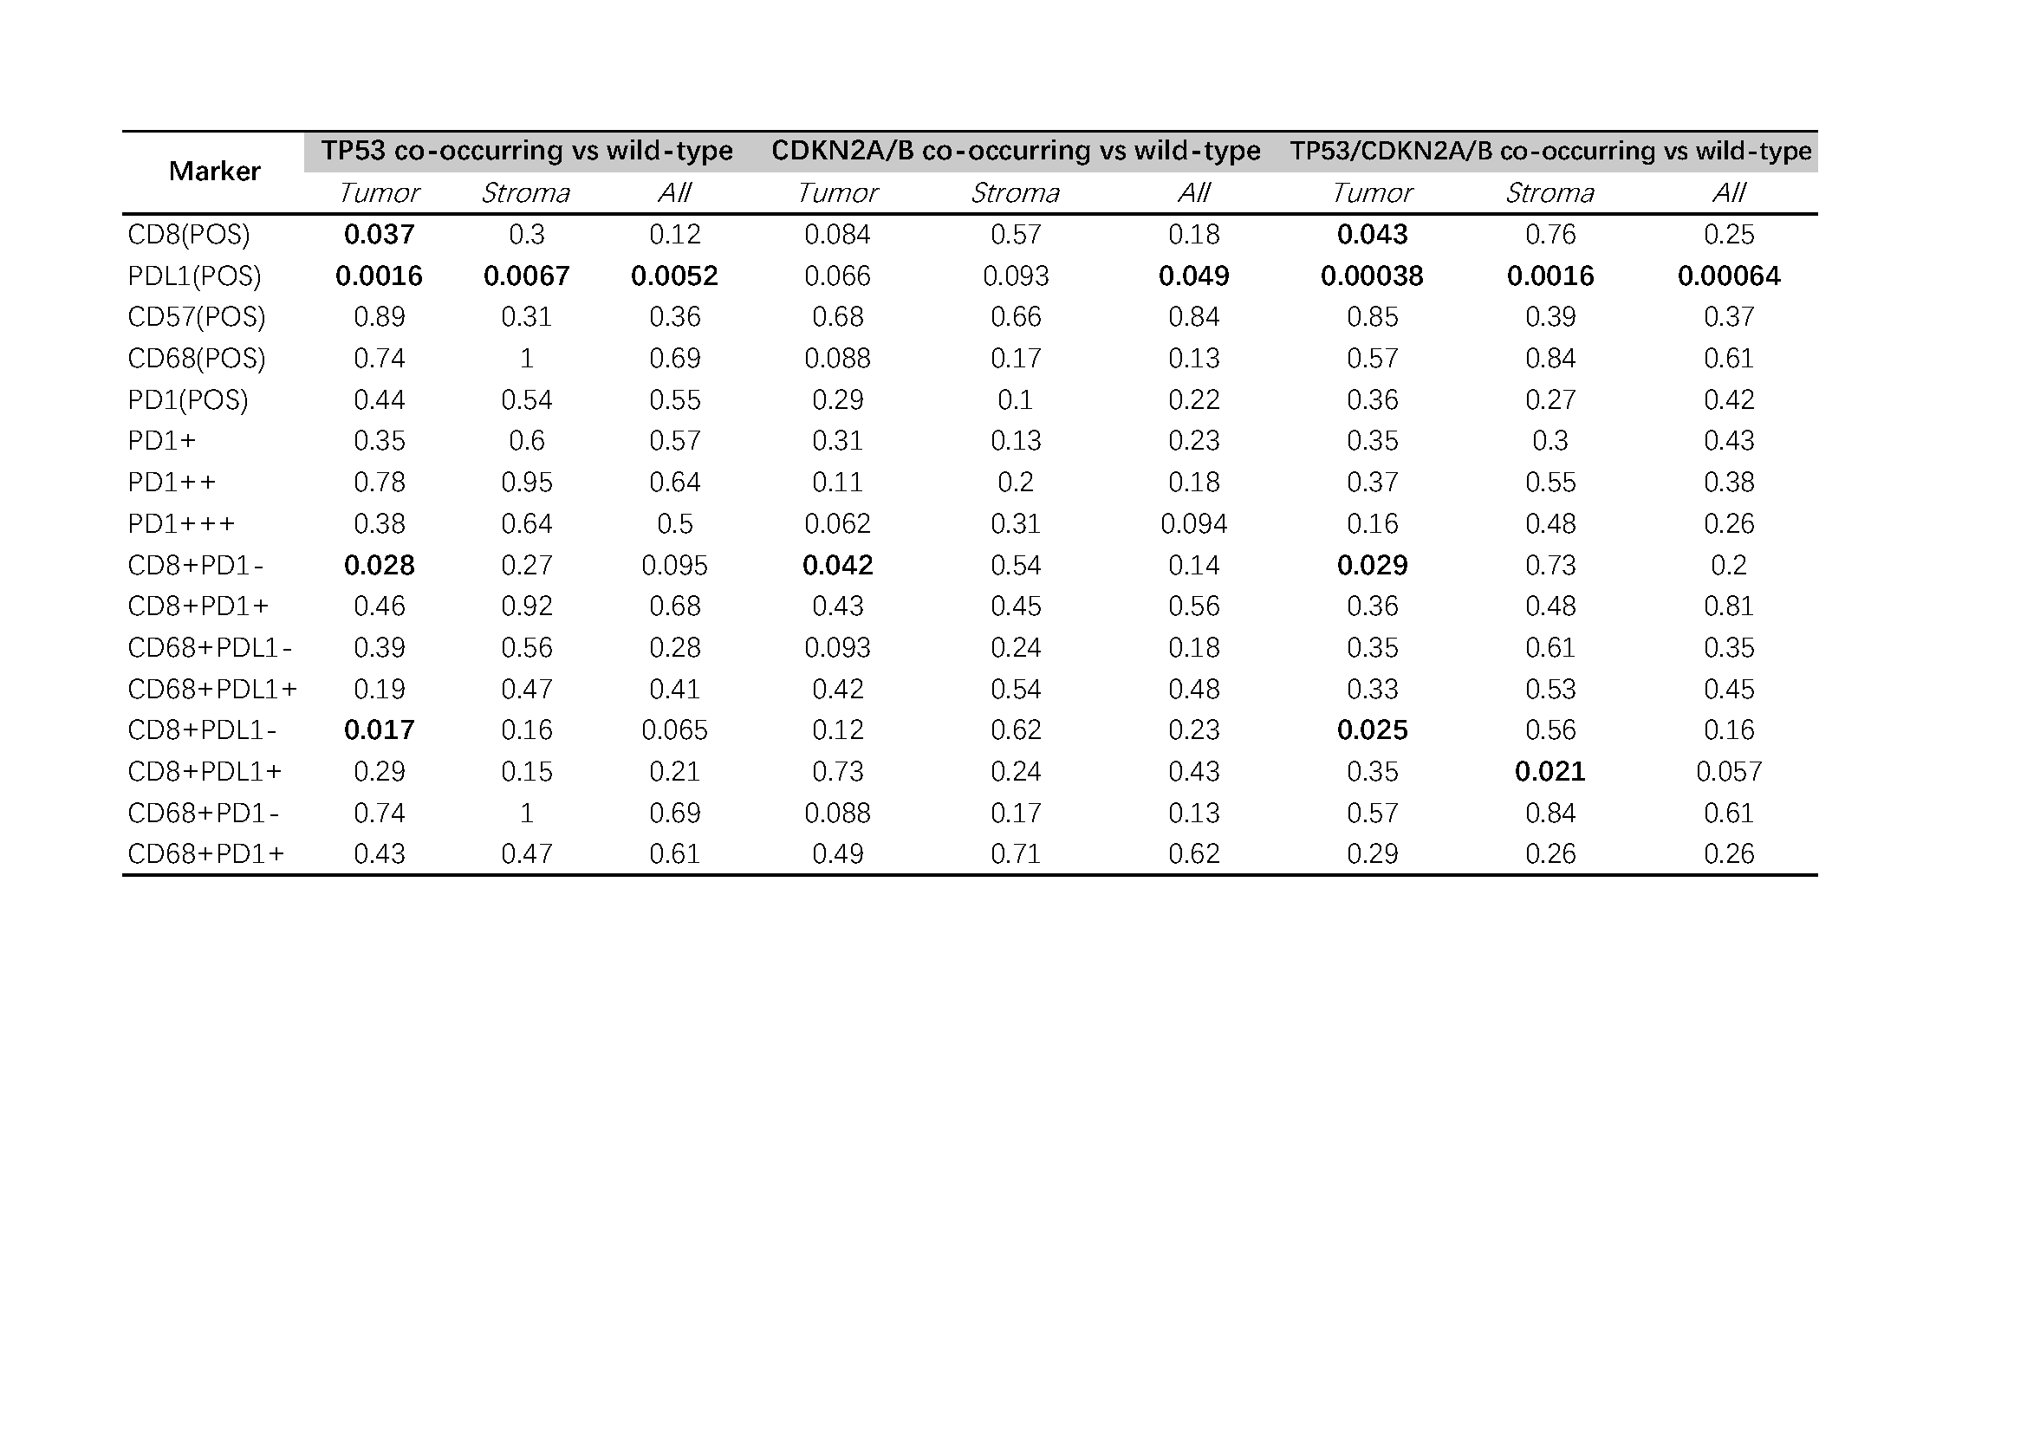
Supplementary Table 2 Clinical characteristics of patients in TCGA databases.
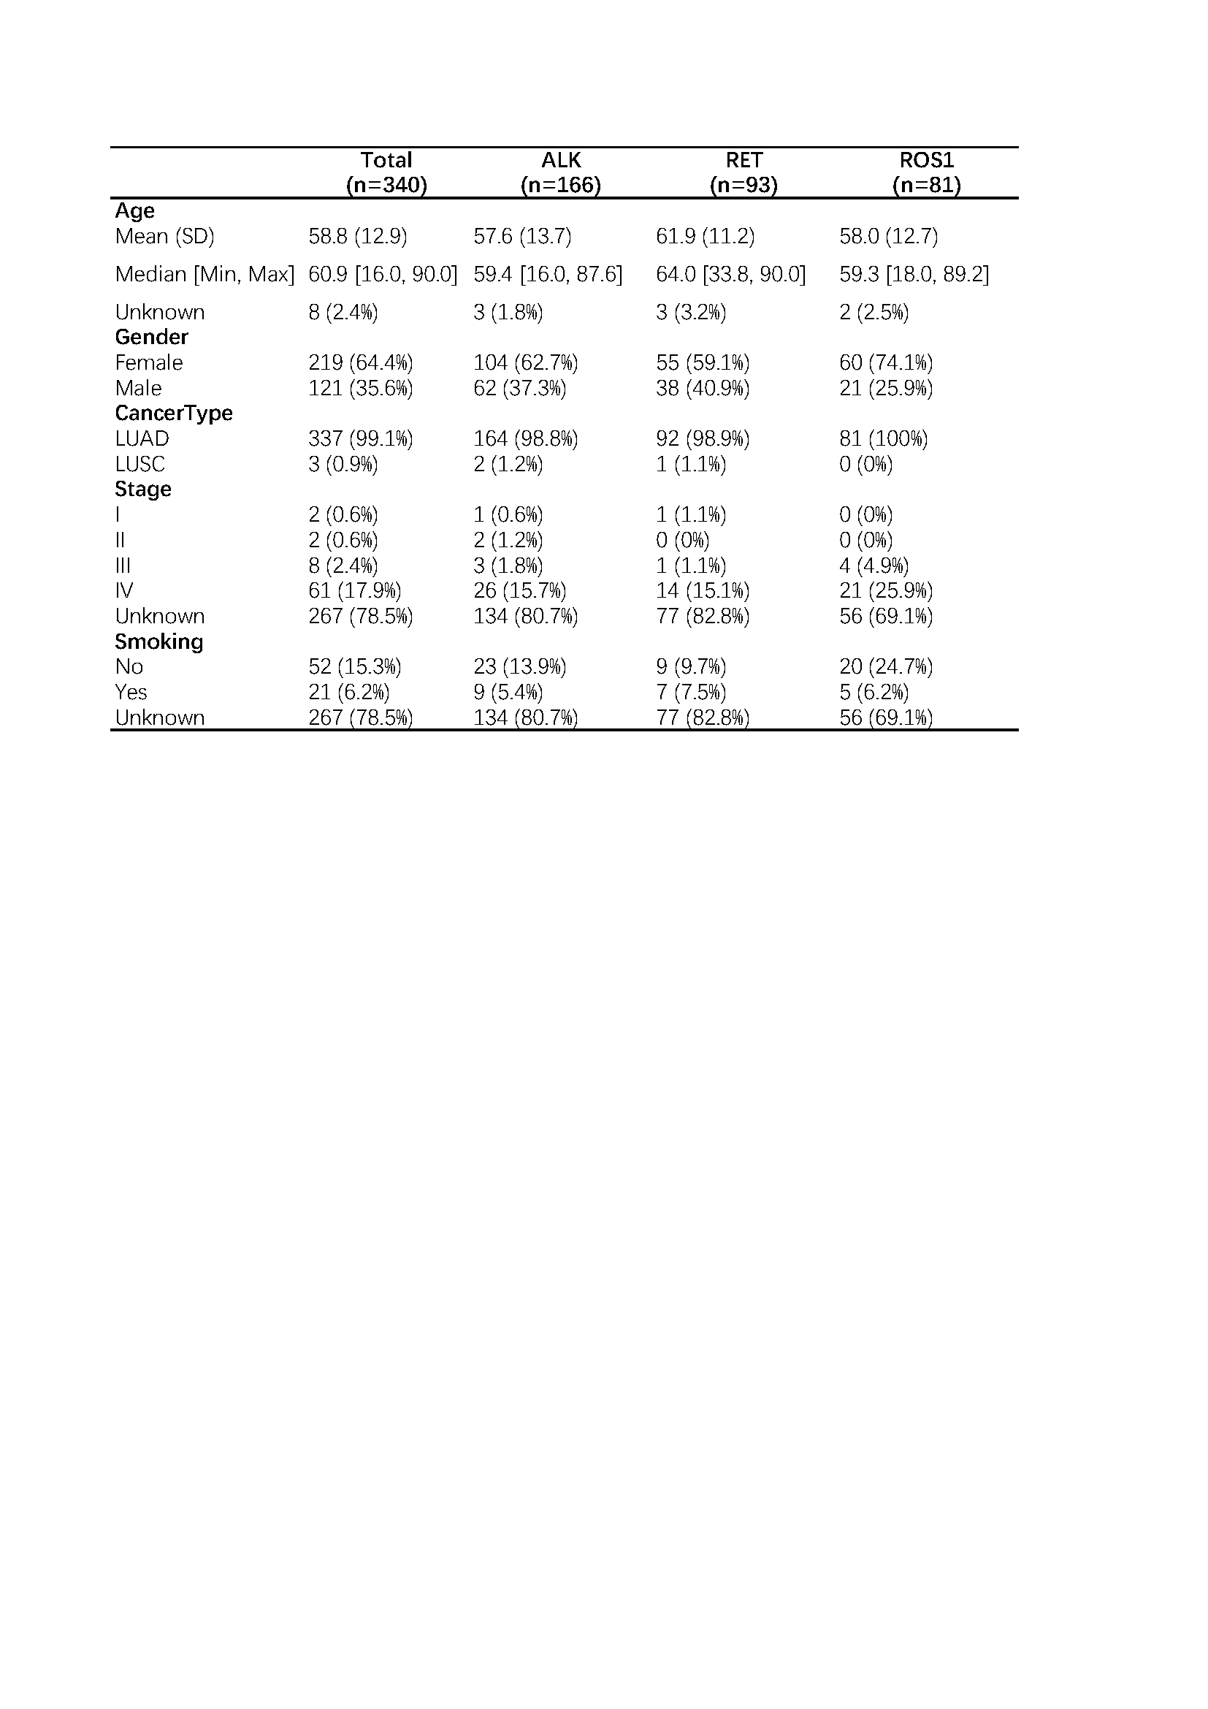

- Figure
Supplementary Figure 1 Other clinicopathologic characteristics related to co-occurring TP53 or CDKN2A/B alterations in NSCLC harboring ALK/RET/ROS1- rearrangement. The clinicopathologic characteristics including smoking, age, and cancer stage. (A) In the TP53 co-occurring group (Left), CDKN2A co-occurring group (Middle) and TP53/CDKN2A co-occurring group (Right), the number and percentage of patients in these 3 groups who smoked or not. (B) In the TP53 co-occurring group (Left), CDKN2A co-occurring group (Middle) and TP53/CDKN2A co-occurring group (Right), the number and percentage of patients in these 3 groups who aged over 60 or not. (C) In the TP53 co-occurring group (Left), CDKN2A co-occurring group (Middle) and TP53/CDKN2A co-occurring group (Right), the number and percentage of tumour types in patients in these 3 groups. Fisher-test was used to analysis the differences between the co-occurring and wild-type groups. No significant difference about those characteristics was evident.

Supplementary Figure 2 Heatmaps showed the percentage of classical markers of micro-environment in all samples. TP53 co-occurring mutation and TP53 wild-type groups in tumor areas (A), in stromal areas (B), and in all areas (C). CDKN2A/B co-occurring and CDKN2A/B wild-type groups in tumor areas (D), in stromal areas (E), and in all areas (F). Gradients indicated relative values, with redder colors indicating higher percentage of expression.

