Supporting Information
The intramolecular electronic interaction regulated by five-membered heterocycle spacer
Yuqiang Hu¹, Limin Han^{1,*}, and Na Wang ^{2,*}
¹ Chemical Engineering College, Inner Mongolia University of Technology, Hohhot, 010051, P. R. China
² Department of Chemistry, Baotou Teachers’College, Baotou, 014030, P. R. China

1. Characterization
Infrared spectra were obtained by a Thermo Nicolet FT-IR spectrometer using KBr pellets for sample preparation. Elemental analyzes were carried out with an Elementar var III-type analyzer. ¹H- and ¹³C-NMR spectra were recorded on a Bruker Avance III 500 FT-MHz apparatus in deuterated CDCl₃ solution. Mass spectra were obtained on a Shimadzu LCMS-2020 mass spectrometer. Crystal 6 and 8 were determined with graphite-monochromated Mo-Kα (λ = 0.71073 Å) radiation. Data were collected by the φ and ω scan techniques. The structures were solved through direct methods and expanded by Fourier techniques. Absorption correction based on SADABS was applied. Structure solution and refinement were performed by the SHELXSL 97 software. The molecular structure of 9 was reported by Heinrich Lang research group.
2. Single-crystal X-ray diffraction
Table S1 Crystal data and relevant structural parameters of compounds 6 and 8
compounds | 6 | 8
Empirical formula | C₂₃H₁₉ NSFe₂ | C₂₂H₁₈N₂OFe₂
Formula weight | 453.15 | 438.08
Temperature (K) | 273(2) | 273(2)
Wavelength (Å) | 0.71073 | 0.71073
Crystal system | orthorhombic | monoclinic
Space group | Pccn | P-21/c
a(Å) | 15.9436(15) | 10.8103(11)
b(Å) | 18.8580(18) | 7.4943(6)
c(Å) | 12.3635(11) | 23.350(2)
α(º) | 90(2) | 90(2)
β(º) | 90(2) | 110.081(5)
γ(º) | 90(2) | 90(2)
Volume (Å³), Z | 3717.3(6), 8 | 1776.7(3), 4
Density (Mg/m³) | 1.619 | 1.570
µ( mm⁻¹ ), F(000) | 1.680, 1856 | 1.645, 824
Crystal size (mm) | 0.20 × 0.10 × 0.10 | 0.30 × 0.20 × 0.04
θ range | 3.23 to 28.29 | 3.17 to 28.44
Limiting indices | -21≤ h ≤21, -25 ≤ k ≤24, -16 ≤ l ≤14 | -12≤ h ≤12, -8≤ k ≤8, -27≤ l ≤27
Reflections collected | 4615 | 35441
Independent eflections | 3741 | 2611
Completeness to θ | 99.8% | 99.5 %
Max. and min. | 0.845 and 0.817 | 0.995 and 0.995
Data/ restraints/ parameters | 4615/ 3/ 244 | 3114/ 0/ 244
Goodness-of-fit on F² | 1.072 | 1.091
Final Rindices[I > 2σ(I)] | R₁= 0.0480, wR₂= 0.0759 | R₁ =0.0933, wR₂ =0.2390
Rindices (all data) | R₁= 0.0332, wR₂= 0.0700 | R₁ =0.1083, wR₂ =0.2571
Largest diff. peak/ hole (e.Å⁻³) | 0.463 / -0.477 | 2.896 / -0.973

Table S2. Selected bond lengths (Å) and Selected angles (º) of compounds 6 and 8
compounds | bond lengths |  |  |  | Bond angles
6 | S1-C8 | 1.740(2) | C4-C6 | 1.463(3) | C8-S1-C6 | 89.23(9) | C7-C8-C9 | 126.64(18)
 | C4-C5 | 1.433(3) | N1-C6 | 1.2949(10) | C6-N1-C7 | 113.32(17) | C7-C8-S1 | 111.17(15)
 | N1-C7 | 1.400(10) | C22-C23 | 1.413(4) | N1-C6-C4 | 126.23(18) | C9-C8-S1 | 122.08(16)
 | C7-C8 | 1.320(3) | C8-C9 | 1.457(3) | N1-C6-S1 | 112.46(15) | C10-C9-C16 | 107.36(19)
 | S1-C6 | 1.743(2) | C9-C16 | 1.428(3) | C4-C6-S1 | 121.30(12) | C10-C9-C8 | 128.31(19)
 | Fe1-C3 | 2.040(2) | Fe2-C15 | 2.031(3) | C8-C7-N1 | 113.80(17) | C16-C9-C8 | 124.31(19)
8 | O1-C4 | 1.355(10) | N1-N2 | 1.423(10) | C4-O1-C9 | 102.0(6) | N2-C4-C2 | 127.8(8)
 | C2-C4 | 1.451(11) | N1-C9 | 1.279(11) | C9-N1-N2 | 105.9(7) | N1-C9-O1 | 113.4(8)
 | N2 -C4 | 1.286(11) | C1-C2 | 1.451(12) | C4-N2-N1 | 105.1(7) | O1-C4-C2 | 118.5(7)
 | O1-C9 | 1.358(10) | C3-C9 | 1.449(12) | N2-C4-O1 | 113.7(7) | O1-C9-C3 | 118.3(7)

Table S3. Selected torsion angles (º) of compounds 6 and 8
compounds | torsion angles
6 | S1-C6-C4-C3 | -3.15 | S1-C8-C9-C10 | 3.46 | C7-C8-C9-Fe2 | -88.40 | S1- C8-C9-Fe2 | 95.74
6 | N1-C6-C4-C5 | -3.59 | C7-C8-C9-C16 | 1.45 | N1-C6-C4-Fe1 | -92.31 | S1- C6-C4-Fe1 | 89.05
8 | O1-C12-C9-C10 | -18.51 | O1-C13-C14-C15 | 23.21 | O1-C12-C9-Fe2 | 73.20 | O1-C13-C14-Fe1 | -66.93
8 | N1- C12-C9-C8 | -18.31 | N2-C13-C14-C18 | 24.08 | N1- C12-C9-Fe2 | 108.07 | N2-C13-C14-Fe1 | 113.43

Table S4 The atoms NBO charge in central rings of compounds 1-9
Compound | C₁/ e | X₁/ e | X₂/ e | C₂/ e | X₃/ e
1 | 0.14718 | -0.28951 | -0.29099 | 0.14805 | -0.36285
2 | 0.30821 | -0.30320 | -0.30320 | 0.30821 | -0.45454
3 | -0.20166 | -0.25712 | -0.25712 | -0.20166 | 0.43772
4 | 0.38312 | -0.49167 | -0.06483 | 0.09952 | -0.54737
5 | 0.54259 | -0.48797 | -0.09338 | 0.26907 | -0.46470
6 | 0.07127 | -0.45862 | -0.04143 | -0.23490 | 0.40189
7 | 0.36263 | -0.30288 | -0.30289 | 0.36263 | -0.56883
8 | 0.51700 | -0.30650 | -0.30650 | 0.51700 | -0.47372
9 | 0.04445 | -0.26608 | -0.26608 | 0.04445 | 0.36804

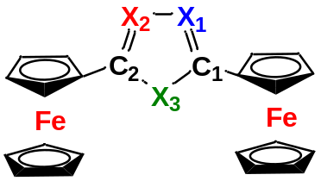
X₁= | C | C | C | C | C | C | N | N | N
X₂= | C | C | C | N | N | N | N | N | N
X₃= | N-Ph | O | S | N-H | O | O | N-H | O | S
Comp= | 1 | 2 | 3 | 4 | 5 | 6 | 7 | 8 | 9

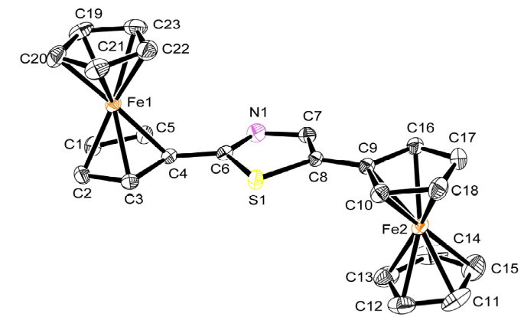

Figure S1 The molecular structure of 6 (Hydrogens have been omitted for clarity).
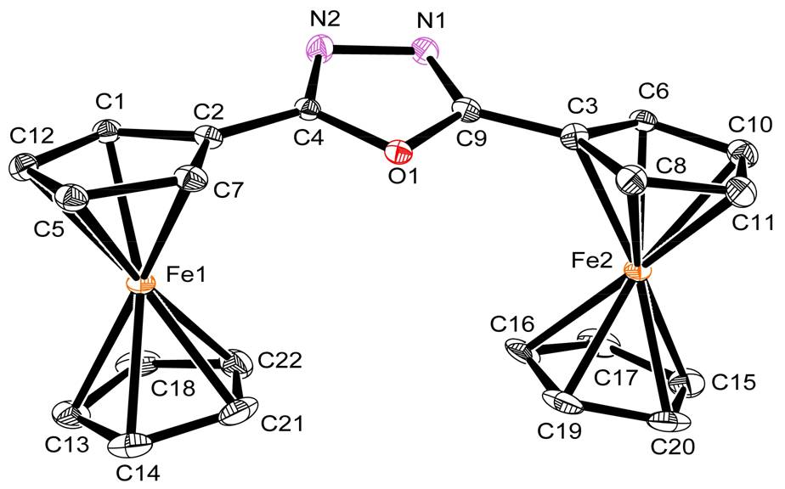
Figure S2 The molecular structure of 8 (Hydrogens have been omitted for clarity)

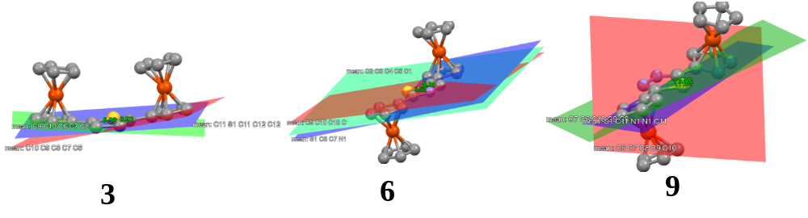
Figure S3 The dihedral angles of 3, 6 and 9

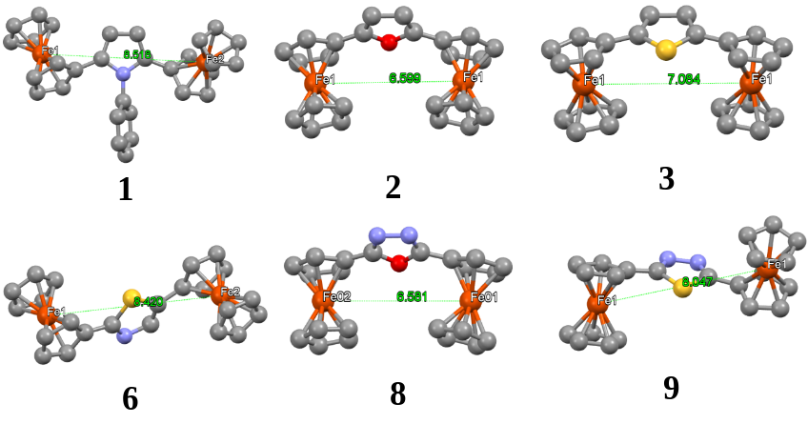
Figure S4 The bimetal center distance of 1, 2, 3, 6, 8 and 9

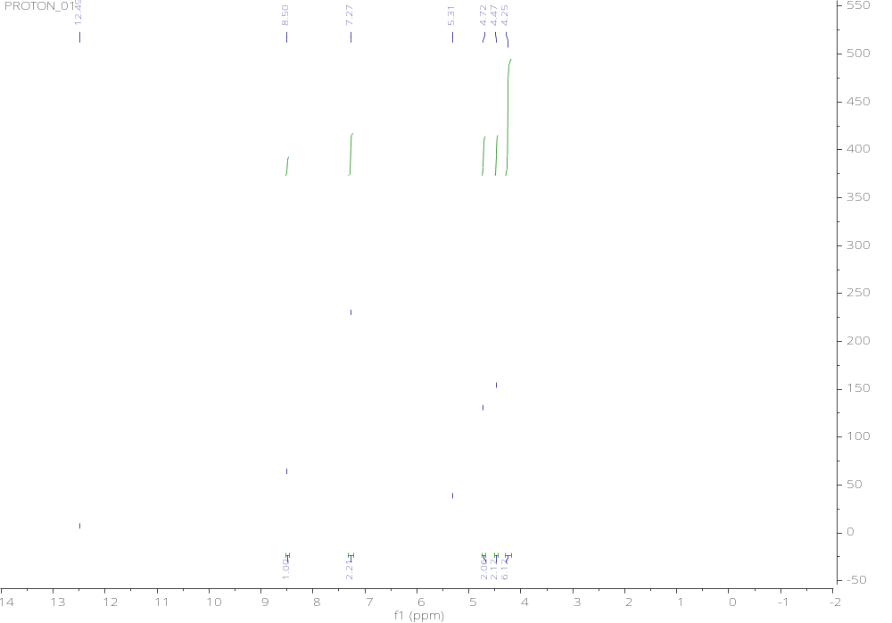

Figure S5 ¹H-NMR spectrum of compound (4) in CDCl₃ at 25℃

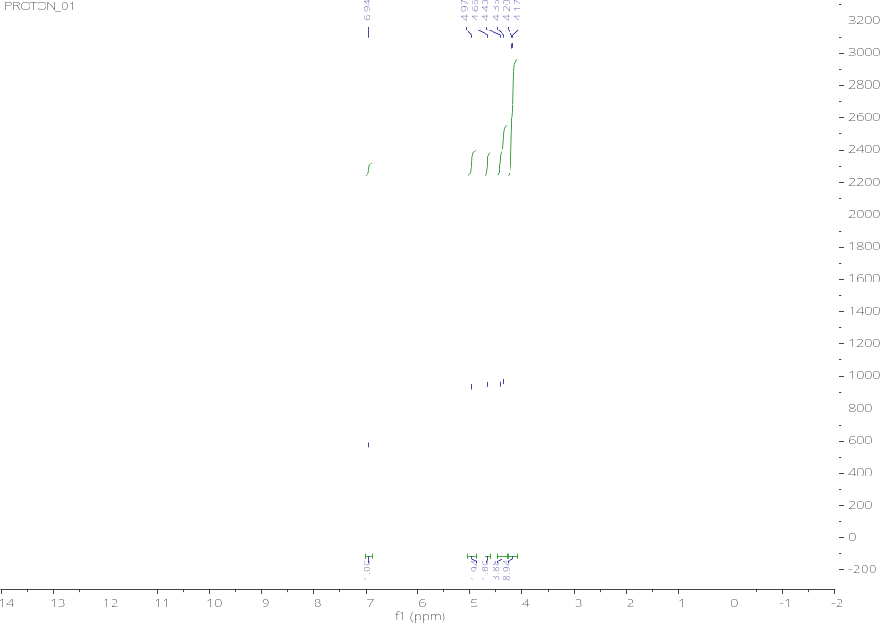

Figure S6 ¹H-NMR spectrum of compound (5) in CDCl₃ at 25℃

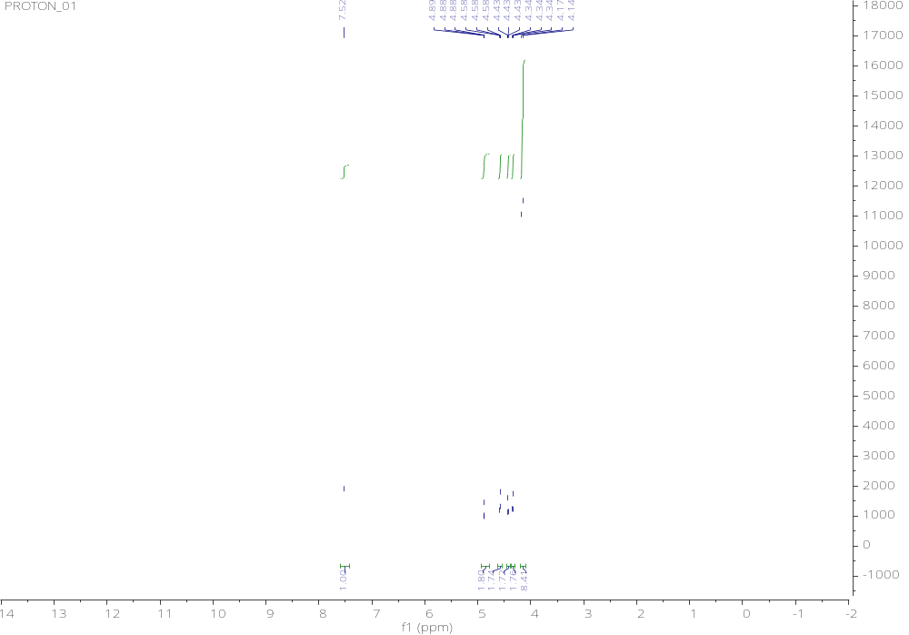

Figure S7 ¹H-NMR spectrum of compound (6) in CDCl₃ at 25℃
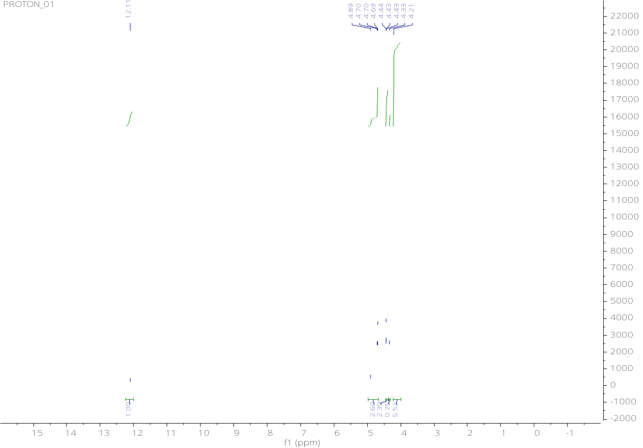

Figure S8 ¹H-NMR spectrum of compound (7) in CDCl₃ at 25℃

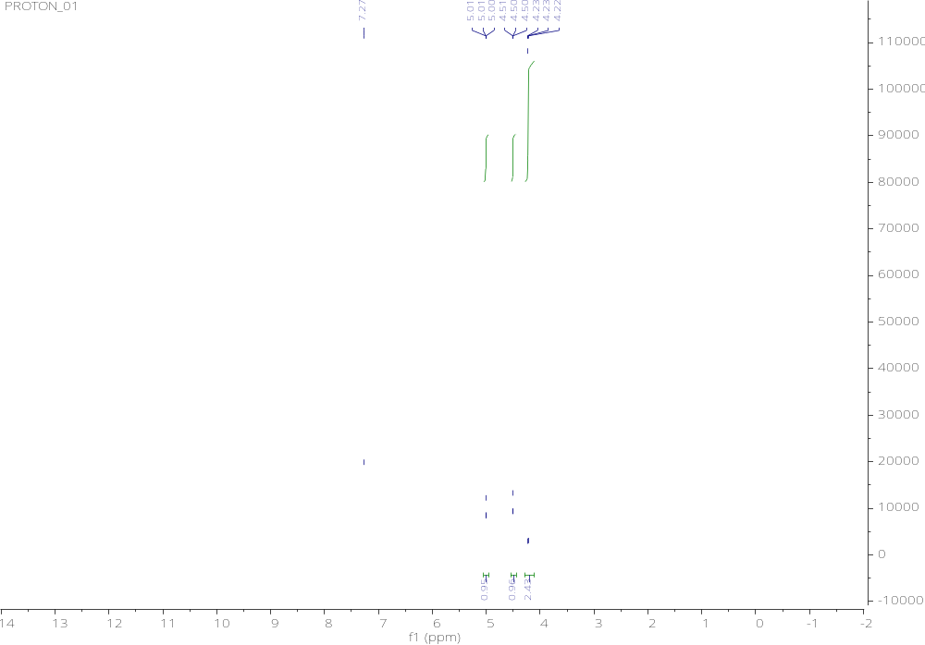

Figure S9 ¹H-NMR spectrum of compound (8) in CDCl₃ at 25℃
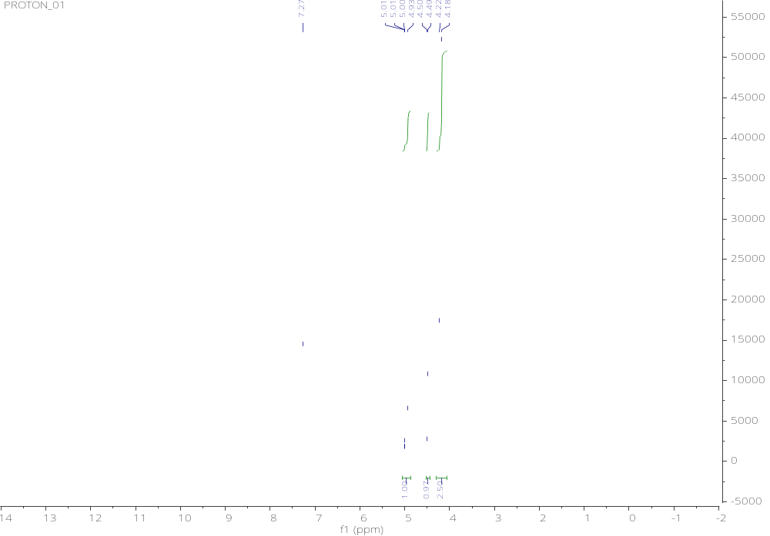

Figure S10 ¹H-NMR spectrum of compound (9) in CDCl₃ at 25℃
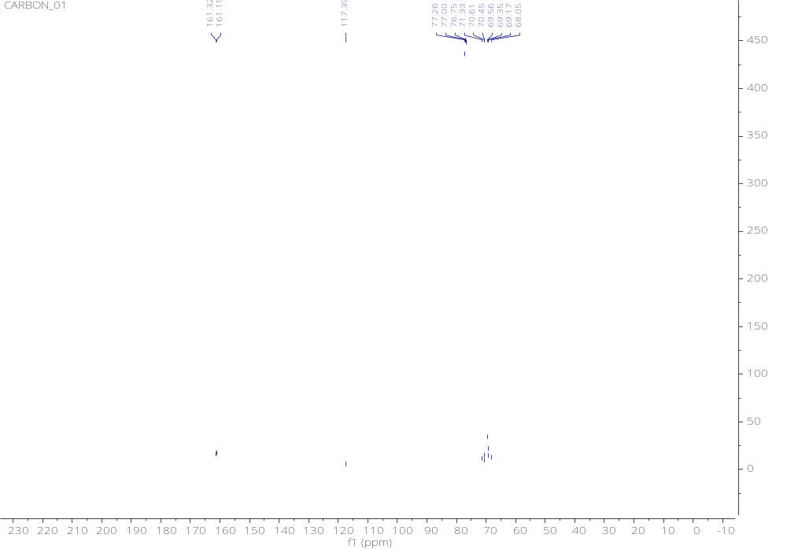
Figure S11 ¹³C-NMR spectrum of compound (4) in CDCl₃ at 25℃
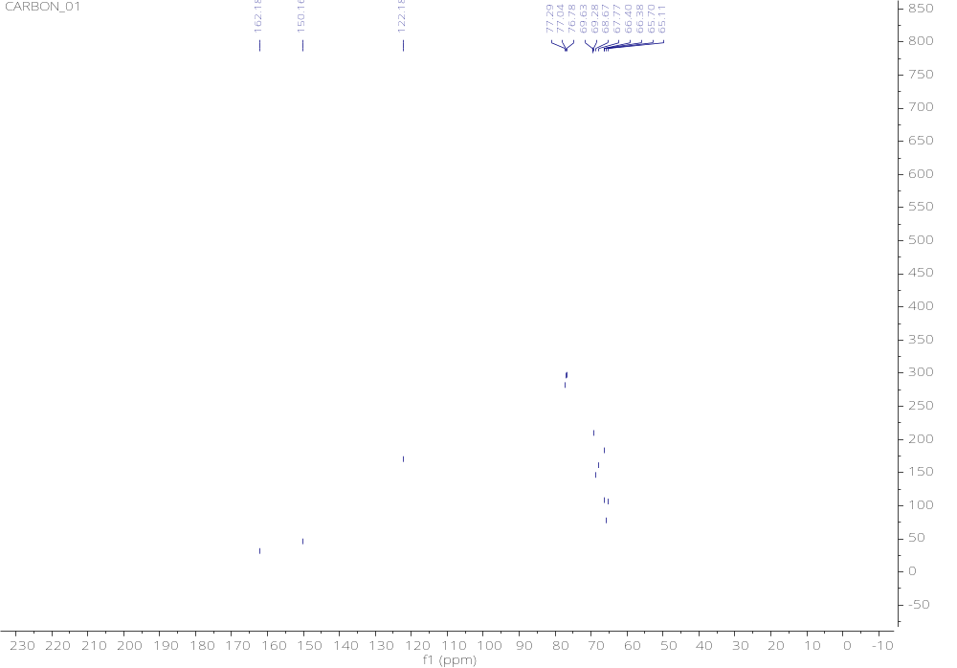
Figure S12 ¹³C-NMR spectrum of compound (5) in CDCl₃ at 25℃
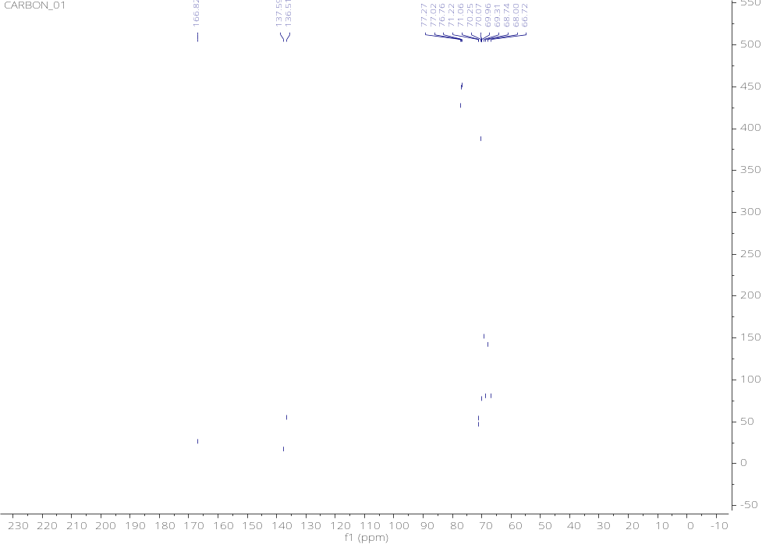
Figure S13 ¹³C-NMR spectrum of compound (6) in CDCl₃ at 25℃
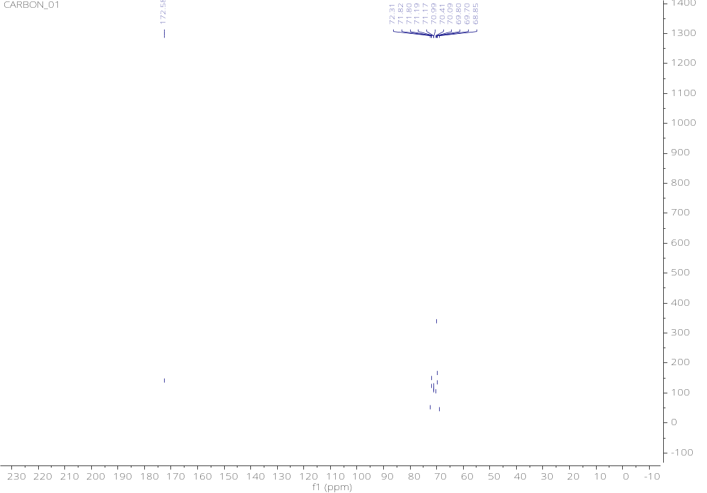
Figure S14 ¹³C-NMR spectrum of compound (7) in CDCl₃ at 25℃
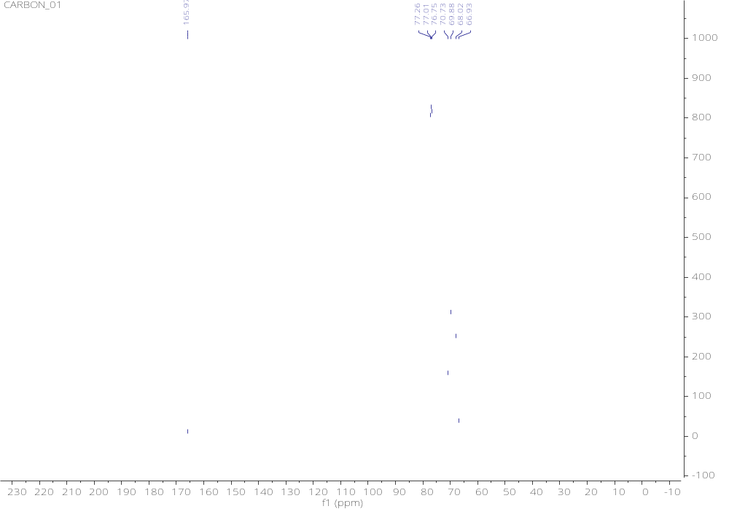
Figure S15 ¹³C-NMR spectrum of compound (8) in CDCl₃ at 25℃
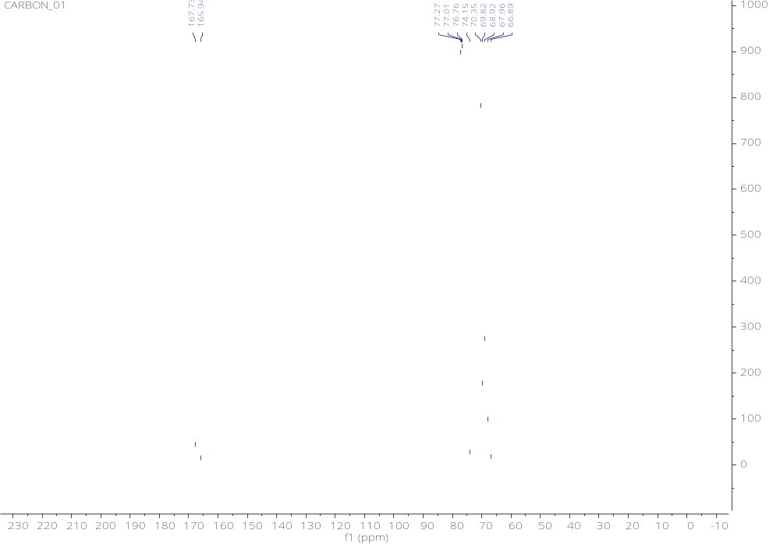
Figure S16 ¹³C-NMR spectrum of compound (9) in CDCl₃ at 25℃

