Table 1: Monitoring station
S.No. | State | City | Station Name
1 | Andhra Pradesh | Amaravati | Secretariat, Amaravati - APPCB
2 | Andhra Pradesh | Rajamahendravaram | Anand Kala Kshetram, Rajamahendravaram - APPCB
3 | Andhra Pradesh | Tirupati | Tirumala, Tirupati - APPCB
4 | Andhra Pradesh | Visakhapatnam | GVM Corporation, Visakhapatnam - APPCB
5 | Assam | Guwahati | Railway Colony, Guwahati - APCB
6 | Bihar | Gaya | Collectorate, Gaya - BSPCB
7 | Bihar | Gaya | SFTI Kusdihra, Gaya - BSPCB
8 | Bihar | Hajipur | Industrial Area, Hajipur - BSPCB
9 | Bihar | Muzaffarpur | Muzaffarpur Collectorate, Muzaffarpur - BSPCB
10 | Bihar | Patna | DRM Office Danapur, Patna - BSPCB
11 | Bihar | Patna | Govt. High School Shikarpur, Patna - BSPCB
12 | Bihar | Patna | IGSC Planetarium Complex, Patna - BSPCB
13 | Bihar | Patna | Muradpur, Patna - BSPCB
14 | Bihar | Patna | Rajbansi Nagar, Patna - BSPCB
15 | Bihar | Patna | Samanpura, Patna - BSPCB
16 | Chandigarh | Chandigarh | Sector-25, Chandigarh - CPCC
17 | Delhi | Delhi | Alipur, Delhi - DPCC
18 | Delhi | Delhi | Anand Vihar, Delhi - DPCC
19 | Delhi | Delhi | Ashok Vihar, Delhi - DPCC
20 | Delhi | Delhi | Aya Nagar, Delhi - IMD
21 | Delhi | Delhi | Bawana, Delhi - DPCC
22 | Delhi | Delhi | CRRI Mathura Road, Delhi - IMD
23 | Delhi | Delhi | DTU, Delhi - CPCB
24 | Delhi | Delhi | Dr. Karni Singh Shooting Range, Delhi - DPCC
25 | Delhi | Delhi | Dwarka-Sector 8, Delhi - DPCC
26 | Delhi | Delhi | IGI Airport (T3), Delhi - IMD
27 | Delhi | Delhi | IHBAS, Dilshad Garden, Delhi - CPCB
28 | Delhi | Delhi | ITO, Delhi - CPCB
29 | Delhi | Delhi | Jahangirpuri, Delhi - DPCC
30 | Delhi | Delhi | Jawaharlal Nehru Stadium, Delhi - DPCC
31 | Delhi | Delhi | Lodhi Road, Delhi - IMD
32 | Delhi | Delhi | Major Dhyan Chand National Stadium, Delhi - DPCC
33 | Delhi | Delhi | Mandir Marg, Delhi - DPCC
34 | Delhi | Delhi | Mundka, Delhi - DPCC
35 | Delhi | Delhi | NSIT Dwarka, Delhi - CPCB
36 | Delhi | Delhi | Najafgarh, Delhi - DPCC
37 | Delhi | Delhi | Narela, Delhi - DPCC
38 | Delhi | Delhi | Nehru Nagar, Delhi - DPCC
39 | Delhi | Delhi | North Campus, DU, Delhi - IMD
40 | Delhi | Delhi | Okhla Phase-2, Delhi - DPCC
41 | Delhi | Delhi | Patparganj, Delhi - DPCC
42 | Delhi | Delhi | Punjabi Bagh, Delhi - DPCC
43 | Delhi | Delhi | Pusa, Delhi - DPCC
44 | Delhi | Delhi | Pusa, Delhi - IMD
45 | Delhi | Delhi | R K Puram, Delhi - DPCC
46 | Delhi | Delhi | Rohini, Delhi - DPCC
47 | Delhi | Delhi | Shadipur, Delhi - CPCB
48 | Delhi | Delhi | Sirifort, Delhi - CPCB
49 | Delhi | Delhi | Sonia Vihar, Delhi - DPCC
50 | Delhi | Delhi | Sri Aurobindo Marg, Delhi - DPCC
51 | Delhi | Delhi | Vivek Vihar, Delhi - DPCC
52 | Delhi | Delhi | Wazirpur, Delhi - DPCC
53 | Gujarat | Ahmedabad | Maninagar, Ahmedabad - GPCB
54 | Gujarat | Ankleshwar | GIDC, Ankleshwar - GPCB
55 | Gujarat | Gandhinagar | Sector-10, Gandhinagar - GPCB
56 | Gujarat | Nandesari | GIDC, Nandesari - Nandesari Ind. Association
57 | Gujarat | Vapi | Phase-1 GIDC, Vapi - GPCB
58 | Gujarat | Vatva | Phase-4 GIDC, Vatva - GPCB
59 | Haryana | Ambala | Patti Mehar, Ambala - HSPCB
60 | Haryana | Bahadurgarh | Arya Nagar, Bahadurgarh - HSPCB
61 | Haryana | Ballabgarh | Nathu Colony, Ballabgarh - HSPCB
62 | Haryana | Bhiwani | H.B. Colony, Bhiwani - HSPCB
63 | Haryana | Charkhi Dadri | Mini Secretariat, Charkhi Dadri - HSPCB
64 | Haryana | Dharuhera | Municipal Corporation Office, Dharuhera - HSPCB
65 | Haryana | Faridabad | New Industrial Town, Faridabad - HSPCB
66 | Haryana | Faridabad | Sector 11, Faridabad - HSPCB
67 | Haryana | Faridabad | Sector 30, Faridabad - HSPCB
68 | Haryana | Faridabad | Sector- 16A, Faridabad - HSPCB
69 | Haryana | Fatehabad | Huda Sector, Fatehabad - HSPCB
70 | Haryana | Gurugram | NISE Gwal Pahari, Gurugram - IMD
71 | Haryana | Gurugram | Sector-51, Gurugram - HSPCB
72 | Haryana | Gurugram | Teri Gram, Gurugram - HSPCB
73 | Haryana | Gurugram | Vikas Sadan, Gurugram - HSPCB
74 | Haryana | Hisar | Urban Estate-II, Hisar - HSPCB
75 | Haryana | Jind | Police Lines, Jind - HSPCB
76 | Haryana | Kaithal | Rishi Nagar, Kaithal - HSPCB
77 | Haryana | Karnal | Sector-12, Karnal - HSPCB
78 | Haryana | Kurukshetra | Sector-7, Kurukshetra - HSPCB
79 | Haryana | Mandikhera | General Hospital, Mandikhera - HSPCB
80 | Haryana | Manesar | Sector-2 IMT, Manesar - HSPCB
81 | Haryana | Narnaul | Shastri Nagar, Narnaul - HSPCB
82 | Haryana | Palwal | Shyam Nagar, Palwal - HSPCB
83 | Haryana | Panchkula | Sector-6, Panchkula - HSPCB
84 | Haryana | Panipat | Sector-18, Panipat - HSPCB
85 | Haryana | Rohtak | MD University, Rohtak - HSPCB
86 | Haryana | Sirsa | F-Block, Sirsa - HSPCB
87 | Haryana | Sonipat | Murthal, Sonipat - HSPCB
88 | Haryana | Yamunanagar | Gobind Pura, Yamuna Nagar - HSPCB
89 | Jharkhand | Jorapokhar | Tata Stadium, Jorapokhar - JSPCB
90 | Karnataka | Bagalkot | Vidayagiri, Bagalkot - KSPCB
91 | Karnataka | Bengaluru | BTM Layout, Bengaluru - CPCB
92 | Karnataka | Bengaluru | BWSSB Kadabesanahalli, Bengaluru - CPCB
93 | Karnataka | Bengaluru | Bapuji Nagar, Bengaluru - KSPCB
94 | Karnataka | Bengaluru | City Railway Station, Bengaluru - KSPCB
95 | Karnataka | Bengaluru | Hebbal, Bengaluru - KSPCB
96 | Karnataka | Bengaluru | Hombegowda Nagar, Bengaluru - KSPCB
97 | Karnataka | Bengaluru | Jayanagar 5th Block, Bengaluru - KSPCB
98 | Karnataka | Bengaluru | Peenya, Bengaluru - CPCB
99 | Karnataka | Bengaluru | Sanegurava Halli, Bengaluru - KSPCB
100 | Karnataka | Bengaluru | Silk Board, Bengaluru - KSPCB
101 | Karnataka | Chikkaballapur | Chikkaballapur Rural, Chikkaballapur - KSPCB
102 | Karnataka | Chikkamagaluru | Kalyana Nagara, Chikkamagaluru - KSPCB
103 | Karnataka | Hubballi | Deshpande Nagar, Hubballi - KSPCB
104 | Karnataka | Kalaburagi | Lal Bahadur Shastri Nagar, Kalaburagi - KSPCB
105 | Karnataka | Mysuru | Hebbal 1st Stage, Mysuru - KSPCB
106 | Karnataka | Ramanagara | Vijay Nagar, Ramanagara - KSPCB
107 | Karnataka | Vijayapura | Ibrahimpur, Vijayapura - KSPCB
108 | Karnataka | Yadgir | Collector Office, Yadgir - KSPCB
109 | Kerala | Eloor | Udyogamandal, Eloor - Kerala PCB
110 | Kerala | Ernakulam | Kacheripady, Ernakulam - Kerala PCB
111 | Kerala | Kannur | Thavakkara, Kannur - Kerala PCB
112 | Kerala | Kochi | Vyttila, Kochi - Kerala PCB
113 | Kerala | Kollam | Polayathode, Kollam - Kerala PCB
114 | Kerala | Kozhikode | Palayam, Kozhikode - Kerala PCB
115 | Kerala | Thiruvananthapuram | Kariavattom, Thiruvananthapuram - Kerala PCB
116 | Kerala | Thiruvananthapuram | Plammoodu, Thiruvananthapuram - Kerala PCB
117 | Madhya Pradesh | Bhopal | T T Nagar, Bhopal - MPPCB
118 | Madhya Pradesh | Damoh | Shrivastav Colony, Damoh - MPPCB
119 | Madhya Pradesh | Dewas | Bhopal Chauraha, Dewas - MPPCB
120 | Madhya Pradesh | Gwalior | City Center, Gwalior - MPPCB
121 | Madhya Pradesh | Gwalior | Phool Bagh, Gwalior - Mondelez Ind. Food
122 | Madhya Pradesh | Indore | Chhoti Gwaltoli, Indore - MPPCB
123 | Madhya Pradesh | Jabalpur | Marhatal, Jabalpur - MPPCB
124 | Madhya Pradesh | Katni | Gole Bazar, Katni - MPPCB
125 | Madhya Pradesh | Maihar | Sahilara, Maihar - KJS Cements
126 | Madhya Pradesh | Mandideep | Sector-D Industrial Area, Mandideep - MPPCB
127 | Madhya Pradesh | Pithampur | Sector-2 Industrial Area, Pithampur - MPPCB
128 | Madhya Pradesh | Ratlam | Shasthri Nagar, Ratlam - IPCA Lab
129 | Madhya Pradesh | Sagar | Deen Dayal Nagar, Sagar - MPPCB
130 | Madhya Pradesh | Satna | Bandhavgar Colony, Satna - Birla Cement
131 | Madhya Pradesh | Singrauli | Vindhyachal STPS, Singrauli - MPPCB
132 | Madhya Pradesh | Ujjain | Mahakaleshwar Temple, Ujjain - MPPCB
133 | Maharashtra | Aurangabad | More Chowk Waluj, Aurangabad - MPCB
134 | Maharashtra | Chandrapur | Chandrapur, Chandrapur - MPCB
135 | Maharashtra | Chandrapur | MIDC Khutala, Chandrapur - MPCB
136 | Maharashtra | Kalyan | Khadakpada, Kalyan - MPCB
137 | Maharashtra | Mumbai | Bandra, Mumbai - MPCB
138 | Maharashtra | Mumbai | Borivali East, Mumbai - MPCB
139 | Maharashtra | Mumbai | Chhatrapati Shivaji Intl. Airport (T2), Mumbai - MPCB
140 | Maharashtra | Mumbai | Colaba, Mumbai - MPCB
141 | Maharashtra | Mumbai | Kurla, Mumbai - MPCB
142 | Maharashtra | Mumbai | Powai, Mumbai - MPCB
143 | Maharashtra | Mumbai | Sion, Mumbai - MPCB
144 | Maharashtra | Mumbai | Vasai West, Mumbai - MPCB
145 | Maharashtra | Mumbai | Vile Parle West, Mumbai - MPCB
146 | Maharashtra | Mumbai | Worli, Mumbai - MPCB
147 | Maharashtra | Nagpur | Opp GPO Civil Lines, Nagpur - MPCB
148 | Maharashtra | Nashik | Gangapur Road, Nashik - MPCB
149 | Maharashtra | Navi Mumbai | Airoli, Navi Mumbai - MPCB
150 | Maharashtra | Navi Mumbai | Mahape, Navi Mumbai - MPCB
151 | Maharashtra | Navi Mumbai | Nerul, Navi Mumbai - MPCB
152 | Maharashtra | Pune | Karve Road, Pune - MPCB
153 | Maharashtra | Solapur | Solapur, Solapur - MPCB
154 | Maharashtra | Thane | Pimpleshwar Mandir, Thane - MPCB
155 | Meghalaya | Shillong | Lumpyngngad, Shillong - Meghalaya PCB
156 | Mizoram | Aizawl | Sikulpuikawn, Aizawl - Mizoram PCB
157 | Odisha | Brajrajnagar | GM Office, Brajrajnagar - OSPCB
158 | Odisha | Talcher | Talcher Coalfields,Talcher - OSPCB
159 | Punjab | Amritsar | Golden Temple, Amritsar - PPCB
160 | Punjab | Bathinda | Hardev Nagar, Bathinda - PPCB
161 | Punjab | Jalandhar | Civil Line, Jalandhar - PPCB
162 | Punjab | Khanna | Kalal Majra, Khanna - PPCB
163 | Punjab | Ludhiana | Punjab Agricultural University, Ludhiana - PPCB
164 | Punjab | Mandi Gobindgarh | RIMT University, Mandi Gobindgarh - PPCB
165 | Punjab | Patiala | Model Town, Patiala - PPCB
166 | Punjab | Rupnagar | Ratanpura, Rupnagar - Ambuja Cements
167 | Rajasthan | Alwar | Moti Doongri, Alwar - RSPCB
168 | Rajasthan | Ajmer | Civil Lines, Ajmer - RSPCB
169 | Rajasthan | Bhiwadi | RIICO Ind. Area III, Bhiwadi - RSPCB
170 | Rajasthan | Jaipur | Adarsh Nagar, Jaipur - RSPCB
171 | Rajasthan | Jaipur | Police Commissionerate, Jaipur - RSPCB
172 | Rajasthan | Jaipur | Shastri Nagar, Jaipur - RSPCB
173 | Rajasthan | Jodhpur | Collectorate, Jodhpur - RSPCB
174 | Rajasthan | Kota | Shrinath Puram, Kota - RSPCB
175 | Rajasthan | Pali | Indira Colony Vistar, Pali - RSPCB
176 | Rajasthan | Udaipur | Ashok Nagar, Udaipur - RSPCB
177 | Tamil Nadu | Chennai | Alandur Bus Depot, Chennai - CPCB
178 | Tamil Nadu | Chennai | Manali Village, Chennai - TNPCB
179 | Tamil Nadu | Chennai | Manali, Chennai - CPCB
180 | Tamil Nadu | Chennai | Velachery Res. Area, Chennai - CPCB
181 | Tamil Nadu | Coimbatore | SIDCO Kurichi, Coimbatore - TNPCB
182 | Telangana | Hyderabad | Bollaram Industrial Area, Hyderabad - TSPCB
183 | Telangana | Hyderabad | Central University, Hyderabad - TSPCB
184 | Telangana | Hyderabad | ICRISAT Patancheru, Hyderabad - TSPCB
185 | Telangana | Hyderabad | IDA Pashamylaram, Hyderabad - TSPCB
186 | Telangana | Hyderabad | Sanathnagar, Hyderabad - TSPCB
187 | Telangana | Hyderabad | Zoo Park, Hyderabad - TSPCB
188 | Uttar Pradesh | Agra | Sanjay Palace, Agra - UPPCB
189 | Uttar Pradesh | Bulandshahr | Yamunapuram, Bulandshahr - UPPCB
190 | Uttar Pradesh | Ghaziabad | Indirapuram, Ghaziabad - UPPCB
191 | Uttar Pradesh | Ghaziabad | Loni, Ghaziabad - UPPCB
192 | Uttar Pradesh | Ghaziabad | Sanjay Nagar, Ghaziabad - UPPCB
193 | Uttar Pradesh | Ghaziabad | Vasundhara, Ghaziabad - UPPCB
194 | Uttar Pradesh | Greater Noida | Knowledge Park - III, Greater Noida - UPPCB
195 | Uttar Pradesh | Greater Noida | Knowledge Park - V, Greater Noida - UPPCB
196 | Uttar Pradesh | Hapur | Anand Vihar, Hapur - UPPCB
197 | Uttar Pradesh | Kanpur | Nehru Nagar, Kanpur - UPPCB
198 | Uttar Pradesh | Lucknow | Central School, Lucknow - CPCB
199 | Uttar Pradesh | Lucknow | Gomti Nagar, Lucknow - UPPCB
200 | Uttar Pradesh | Lucknow | Lalbagh, Lucknow - CPCB
201 | Uttar Pradesh | Lucknow | Talkatora District Industries Center, Lucknow - CPCB
202 | Uttar Pradesh | Meerut | Ganga Nagar, Meerut - UPPCB
203 | Uttar Pradesh | Meerut | Jai Bhim Nagar, Meerut - UPPCB
204 | Uttar Pradesh | Meerut | Pallavpuram Phase 2, Meerut - UPPCB
205 | Uttar Pradesh | Moradabad | Lajpat Nagar, Moradabad - UPPCB
206 | Uttar Pradesh | Muzaffarnagar | New Mandi, Muzaffarnagar - UPPCB
207 | Uttar Pradesh | Noida | Sector - 125, Noida - UPPCB
208 | Uttar Pradesh | Noida | Sector - 62, Noida - IMD
209 | Uttar Pradesh | Noida | Sector-1, Noida - UPPCB
210 | Uttar Pradesh | Noida | Sector-116, Noida - UPPCB
211 | Uttar Pradesh | Varanasi | Ardhali Bazar, Varanasi - UPPCB
212 | West Bengal | Asansol | Asansol Court Area, Asansol - WBPCB
213 | West Bengal | Howrah | Belur Math, Howrah - WBPCB
214 | West Bengal | Howrah | Ghusuri, Howrah - WBPCB
215 | West Bengal | Howrah | Padmapukur, Howrah - WBPCB
216 | West Bengal | Kolkata | Ballygunge, Kolkata - WBPCB
217 | West Bengal | Kolkata | Bidhannagar, Kolkata - WBPCB
218 | West Bengal | Kolkata | Fort William, Kolkata - WBPCB
219 | West Bengal | Kolkata | Jadavpur, Kolkata - WBPCB
220 | West Bengal | Kolkata | Rabindra Bharati University, Kolkata - WBPCB
221 | West Bengal | Kolkata | Rabindra Sarobar, Kolkata - WBPCB
222 | West Bengal | Kolkata | Victoria, Kolkata - WBPCB
223 | West Bengal | Siliguri | Ward-32 Bapupara, Siliguri - WBPCB

Table 2: Case Processing Summary
 |  | N | Percent
Sample | Training | 251 | 69.1%
Sample | Testing | 112 | 30.9%
Valid |  | 363 | 100.0%
Excluded |  | 0
Total |  | 363

Table 3: Network Information
Input Layer | Covariates | 1 | PM2.5
Input Layer | Covariates | 2 | PM10
Input Layer | Covariates | 3 | NO2
Input Layer | Covariates | 4 | NH3
Input Layer | Covariates | 5 | SO2
Input Layer | Covariates | 6 | CO
Input Layer | Covariates | 7 | OZONE
Input Layer | Number of Unitsª |  | 7
Input Layer | Rescaling Method for Covariates |  | Standardized
Hidden Layer(s) | Number of Hidden Layers |  | 1
Hidden Layer(s) | Number of Units in Hidden Layer 1ª |  | 5
Hidden Layer(s) | Activation Function |  | Hyperbolic tangent
Output Layer | Dependent Variables | 1 | AQI
Output Layer | Number of Units |  | 1
Output Layer | Rescaling Method for Scale Dependents |  | Standardized
Output Layer | Activation Function |  | Identity
Output Layer | Error Function |  | Sum of Squares
a. Excluding the bias unit

Table 4: Model Summary
Training | Sum of Squares Error | 1.548
Training | Relative Error | .012
Training | Stopping Rule Used | 1 consecutive step(s) with no decrease in errorª
Training | Training Time | 0:00:00.16
Testing | Sum of Squares Error | 1.055
Testing | Relative Error | .021
Dependent Variable: AQI
a. Error computations are based on the testing sample.

Table 5: Parameter Estimates
Predictor |  | Predicted
 |  | Hidden Layer 1 |  |  |  |  | Output Layer
 |  | H(1:1) | H(1:2) | H(1:3) | H(1:4) | H(1:5) | AQI
Input Layer | (Bias) | .573 | -.192 | .834 | -.717 | .153
Input Layer | PM2.5 | .449 | -.115 | -.908 | .268 | .028
Input Layer | PM10 | -.664 | .298 | .608 | .255 | .304
Input Layer | NO2 | .183 | .476 | .072 | .054 | -.074
Input Layer | NH3 | -.041 | -.298 | -.012 | .011 | .132
Input Layer | SO2 | -.036 | -.361 | -.049 | -.064 | .252
Input Layer | CO | -.102 | .088 | -.043 | -.218 | .102
Input Layer | OZONE | -.065 | .158 | -.156 | -.425 | .323
Hidden Layer 1 | (Bias) |  |  |  |  |  | 1.742
Hidden Layer 1 | H(1:1) |  |  |  |  |  | -.887
Hidden Layer 1 | H(1:2) |  |  |  |  |  | .404
Hidden Layer 1 | H(1:3) |  |  |  |  |  | -1.306
Hidden Layer 1 | H(1:4) |  |  |  |  |  | 1.058
Hidden Layer 1 | H(1:5) |  |  |  |  |  | .505

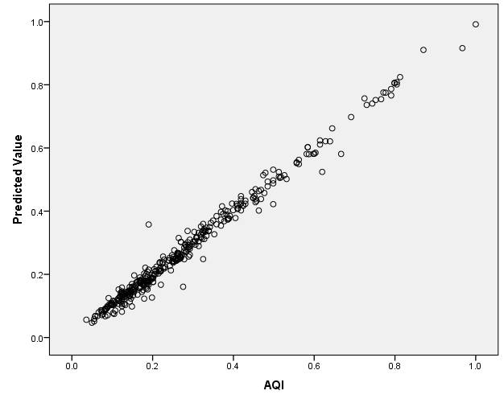

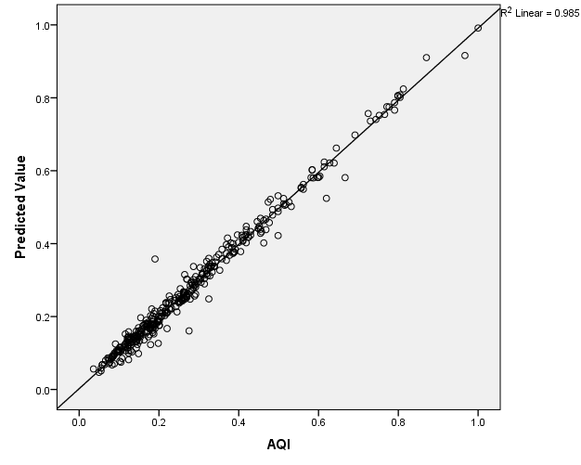

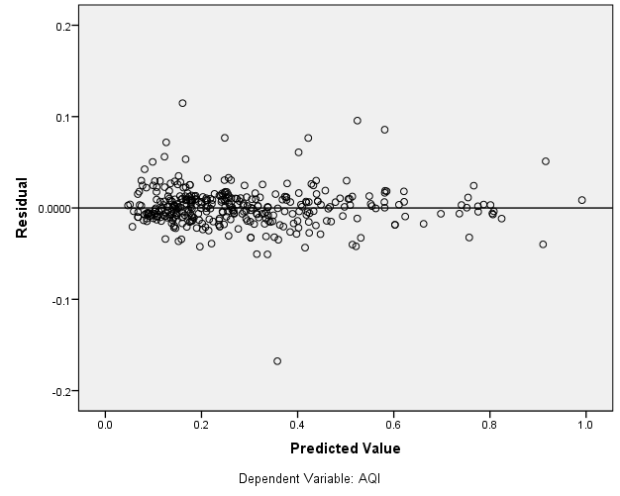

Table 6: Independent Variable Importance
 | Importance | Normalized Importance
PM2.5 | .366 | 100.0%
PM10 | .337 | 92.2%
NO2 | .029 | 8.0%
NH3 | .025 | 6.9%
SO2 | .040 | 10.9%
CO | .056 | 15.3%
OZONE | .147 | 40.3%

