Supplemental Table S1: Comprehensive evaluation system for the indicators of technological innovation in China from 2007 to 2019. Technological innovation increases with increasing values of an indicator.
System | Target layer | Indicator layer | Calculation method
Comprehensive level of technological innovation | Technological innovation inputs | Technology spending per capita | Technology spending / total population
Comprehensive level of technological innovation | Technological innovation outputs | Number of invention patents granted per 10 000 people | (Number of invention patents granted / total population) × 10 000
Comprehensive level of technological innovation | Technological innovation applications | Internet access users per 10000 people | (Internet access users /total population) × 10 000

Supplemental Table S2: Names and calculation methods for the nine evaluated factors that drove China's technological innovation in the comprehensive framework developed in this study. The variable sign indicates whether the indicator is expected to increase (+) or decrease (–) technological innovation. Abbreviations: TOL, tolerance; VIF, variance inflation factor.
Variables | Calculation method | Variable sign | TOL | VIF
Population density | Population per unit regional area | + | 0.621 | 1.611
Marketization | Number of urban workers employed by the private sector or self-employed as a proportion of the total workers | + | 0.625 | 1.599
Fiscal decentralization | Local fiscal revenue divided by regional GDP | + | 0.731 | 1.368
Industrialization | Value added by secondary industries divided by regional GDP | + | 0.331 | 3.020
Industrial upgrading | Value added by tertiary industries divided by regional GDP | + | 0.247 | 4.043
Infrastructure | Length of road divided by the urban population | + | 0.694 | 1.441
Basic education | Number of students who have completed higher education school (college or university) divided by the total population | + | 0.582 | 1.717
Medical level | Number of hospital beds divided by the total population | + | 0.614 | 1.629
Environmental pollution | Total emissions of three industrial wastes(Industrial dust, industrial wastewater and industrial sulfur dioxide) divided by the total population | – | 0.868 | 1.152

Supplemental Figure S1: Spatial distribution of the 286 prefecture-level cities included in the study.
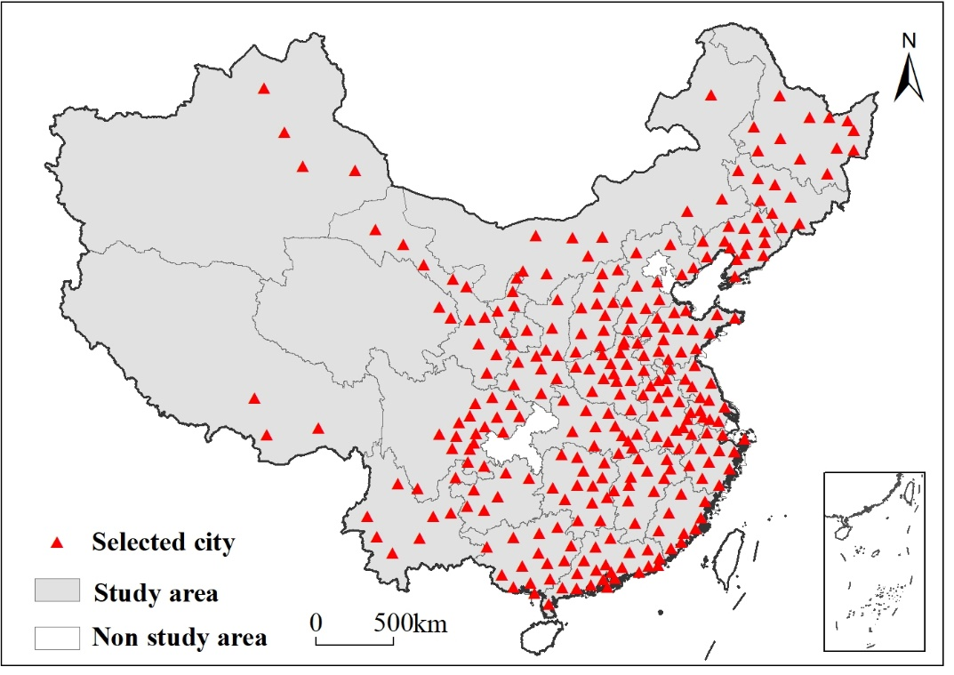

Supplemental Figure S2: Spatial and temporal trends of China's technological innovation level. D, comprehensive index of technological innovation (equation 3).
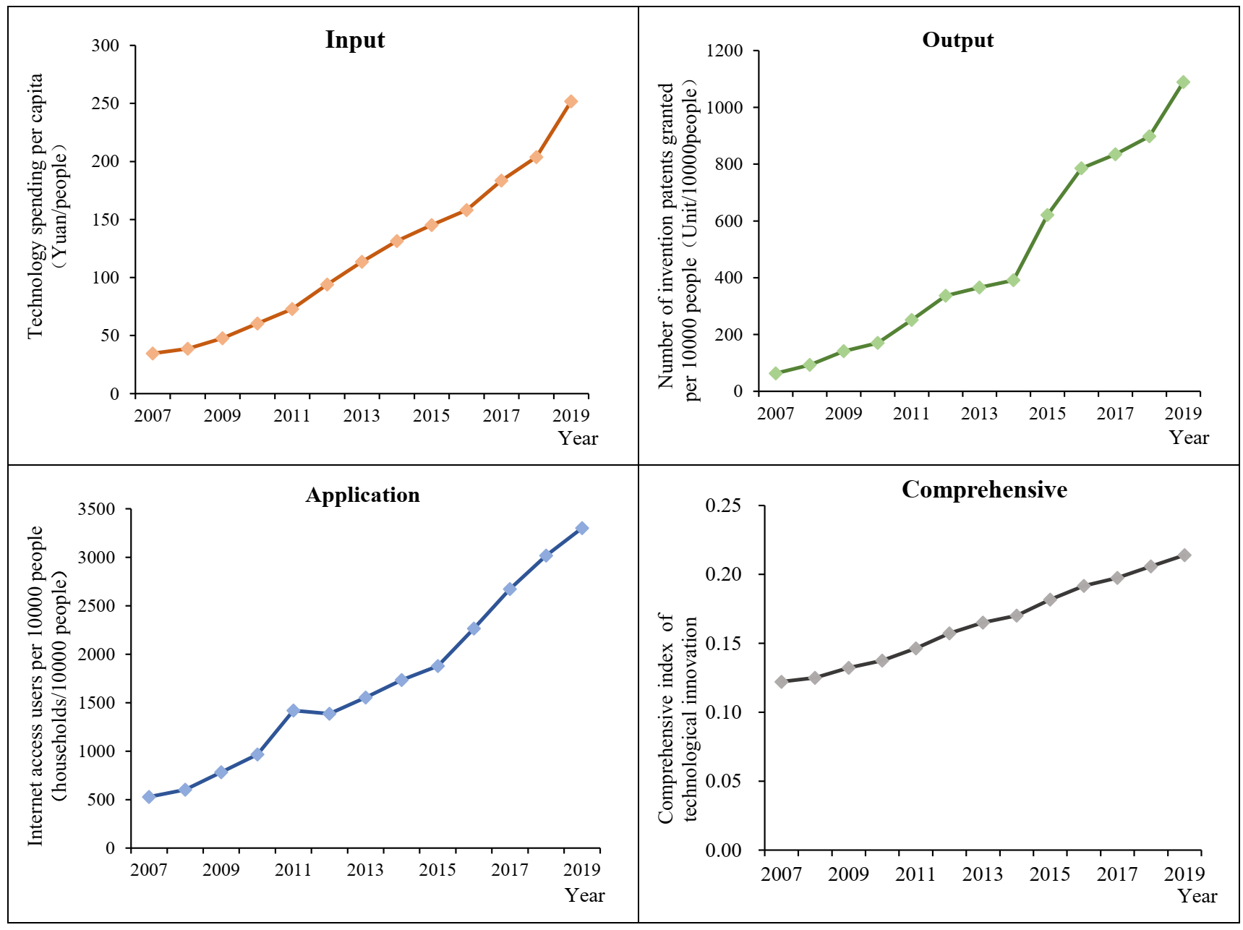
Supplemental Figure S3: Temporal trends for D, the comprehensive index of technological innovation (equation 3), in China.
