Title Occupational burnout, job satisfaction and flourishing among healthcare workers in western China: a network analysis

Supplementary information

Table S1. Description of the key variables used in this study 2
Table S2. Baseline characteristics and medians (IQR) for occupational burnout, job satisfaction and flourishing of the participants 3
Table S3. Weighted adjacency matrix 4-5
Figure S1. Flowchart of the study sample 1
Figure S2. Bootstrap 95% confidence intervals of the partial correlation coefficients 6-7
Figure S3. Estimation of edge weight differences by bootstrapped difference test 8
Figure S4. Bootstrap partial correlation coefficients difference test of the node’s strength 9
Figure S5. Stability of centrality indices by case dropping bootstrap in female and male 10
Figure S6. Bootstrap 95% confidence intervals of partial correlation coefficients of the network in female and male 11-12
Figure S7. Estimation of edge weight difference in female and male 13-14
Figure S8. Bootstrap partial correlation coefficients difference test of node’s strength in female and male 15-16
Figure S9. Comparison of network properties in female and male 17

Designated Hospital for treatment (n=105)
County Governments (n=95)
Community Health Service Centers (n=591)
Others ¹ (n=25)
Centers for Disease Control and Prevention (n=91)
907 participants included in the analysis
Excluded for the following reasons (n=15)
12 participants with missing data on relevant variables used in the analysis
3 participants with a contradiction between age and job tenure
922 individuals recruited enrolled participants
Figure S1. Flowchart of the study sample

¹ Others are self-selected designation that indicates the institution is not listed.

Table S1. Description of the key variables used in this study
Covariates | Categories | Description
Socio-demographic characteristics
Age (years) | 18-29 years, 30-39 years, 40-49 years, ≥ 50 years
Sex | Female, male
Marital status | Unmarried, married/living together, divorced/widowed/living separately
Educational level | High school or below, junior college, undergraduate or above
Personal monthly income (RMB） | <3000 RMB, 3000-4000 RMB, 4000-5000 RMB, ≥5000 RMB
Living situation | Alone, with friends or others, with parents
Work-related characteristics
Professional status | Physicians, AIDS specialist, nurses, public health physicians, others | Others are self-selected designation that indicates the institution is not listed.
Job tenure (years) | <2 years, 2-5 years, 5-10 years, 10-20 years, ≥20 years
Years in HIV/AIDS units | <2 years, 2-5 years, 5-10 years, ≥10 years
Type of institution | Centers for Disease Control and Prevention, Designated Hospital for treatment, County Governments, Community Health Service Centers, others | Others are self-selected designation that indicates the institution is not listed.
Levels of institution | Municipal-level, district-level, county-level | The institution levels were categorized as municipal-level, district-level and county-level according to the administrative divisions of China.

Table S2. Baseline characteristics and medians (IQR) for occupational burnout, job satisfaction and flourishing of the participants
Variables | N | Occupational burnout  (Median [IQR]) | Job satisfaction  (Median [IQR]) | Flourishing  (Median [IQR])
Age (years)
18-29 | 224 | 31.0 (25.0, 34.0) | 89.0 (78.0, 99.0) | 40.0 (32.0, 48.0)
30-39 | 300 | 29.0 (24.0, 34.0) | 94.0 (82.0, 103.0) | 44.0 (36.0, 48.0)
40-49 | 253 | 30.0 (26.0, 34.0) | 92.0 (82.0, 102.0) | 44.0 (38.0, 48.0)
≥50 | 130 | 31.0 (27.0, 34.0) | 92.0 (78.0, 101.8) | 44.0 (39.3, 48.0)
Sex
Female | 627 | 30.0 (25.0, 33.0) | 92.0 (80.5, 101.0) | 43.0 (35.0, 48.0)
Male | 280 | 31.0 (27.0, 35.0) | 93.0 (80.8, 103.0) | 44.0 (37.0, 48.0)
Marital status
Unmarried | 118 | 31.0 (23.3, 35.0) | 88.0 (76.3, 102.0) | 40.0 (32.0, 48.0)
Married/Living together | 706 | 30.0 (25.0, 34.0) | 92.0 (81.0, 102.0) | 44.0 (37.0, 48.0)
Divorce/Widowed/Living separately | 83 | 30.0 (26.0, 33.0) | 90.0 (78.0, 97.5) | 42.0 (34.5, 47.5)
Educational level
High school or below | 123 | 30.0 (26.0, 33.5) | 92.0 (82.5, 101.5) | 44.0 (36.0, 48.0)
Junior college | 449 | 31.0 (26.0, 35.0) | 91.0 (79.0, 102.0) | 43.0 (35.0, 48.0)
Undergraduate or above | 335 | 29.0 (24.0, 33.0) | 92.0 (81.0, 102.0) | 43.0 (36.0, 48.0)
Personal monthly income (RMB）
<3000 | 253 | 30.0 (25.0, 33.0) | 90.0 (79.0, 101.0) | 42.0 (35.0, 48.0)
3000-4000 | 304 | 30.0 (24.0, 34.0) | 90.0 (79.0, 102.0) | 43.0 (34.0, 48.0)
4000-5000 | 176 | 31.0 (27.0, 34.0) | 92.0 (81.0, 99.3) | 43.0 (37.0, 48.0)
≥5000 | 174 | 29.0 (25.0, 34.0) | 96.0 (85.0, 104.0) | 45.0 (39.0, 48.0)
Living situation
Alone | 74 | 31.0 (27.0, 37.0) | 88.5 (75.0, 96.8) | 41.5 (32.0, 46.8)
With friends or others | 41 | 30.0 (27.0, 35.0) | 82.0 (70.0, 98.0) | 41.0 (32.0, 48.0)
With parents | 792 | 30.0 (25.0, 34.0) | 92.0 (82.0, 102.0) | 44.0 (36.0, 48.0)
Professional status
Physicians | 180 | 31.0 (26.0, 34.0) | 94.5 (83.8, 103.0) | 44.0 (37.8, 48.0)
AIDS specialist | 334 | 29.0 (25.0, 33.0) | 92.0 (81.0, 100.0) | 43.0 (36.0, 48.0)
Nurses | 103 | 31.0 (26.0, 34.0) | 89.0 (79.0, 103.0) | 40.0 (32.0, 47.0)
Public health physicians | 104 | 32.0 (27.0, 36.0) | 83.5 (75.0, 96.0) | 41.5 (34.8, 47.0)
Others ¹ | 186 | 29.0 (24.0, 33.0) | 94.0 (80.0, 104.0) | 44.0 (36.0, 48.0)
Job tenure (years)
<2 | 29 | 29.0 (25.0, 34.0) | 84.0 (78.0, 100.0) | 41.0 (36.0, 47.0)
2-5 | 85 | 29.0 (23.0, 32.0) | 92.0 (82.0, 100.0) | 46.0 (38.0, 48.0)
5-10 | 181 | 30.0 (26.0, 34.0) | 88.0 (78.0, 99.0) | 43.0 (34.0, 47.0)
10-20 | 268 | 31.0 (25.0, 34.3) | 92.0 (81.0, 102.0) | 42.0 (35.0, 48.0)
≥20 | 344 | 30.0 (26.0, 34.0) | 93.0 (81.0, 103.3) | 44.0 (36.0, 48.0)
Years working in HIV/AIDS units
<2 | 170 | 29.5 (25.0, 34.0) | 91.0 (80.0, 102.0) | 42.0 (34.3, 48.0)
2-5 | 318 | 30.0 (25.0, 33.0) | 91.0 (80.0, 101.0) | 43.0 (32.3, 48.0)
5-10 | 174 | 31.0 (26.0, 35.0) | 90.0 (81.0, 101.0) | 44.0 (35.3, 48.0)
≥10 | 245 | 30.0 (25.0, 34.0) | 93.0 (82.0, 103.0) | 44.0 (37.0, 48.0)
Types of institution
CDC | 91 | 31.0 (25.5, 34.0) | 85.0 (75.5, 96.0) | 40.0 (34.0, 47.0)
Designated Hospital for treatment | 105 | 28.0 (23.0, 33.0) | 96.0 (89.0, 105.0) | 45.0 (36.0, 49.0)
County Governments | 95 | 28.0 (22.5, 33.0) | 96.0 (81.0, 108.0) | 46.0 (37.5, 48.0)
Community Health Service Centers | 591 | 31.0 (26.0, 35.0) | 92.0 (80.0, 102.0) | 43.0 (35.0, 48.0)
Others ¹ | 25 | 30.0 (25.0, 33.0) | 93.0 (87.0, 108.0) | 45.0 (40.0, 48.0)
Levels of institution
Municipal-level | 136 | 30.0 (25.0, 34.0) | 89.0 (70.0, 100.3) | 44.0 (34.8, 48.0)
District-level | 307 | 29.0 (25.0, 33.0) | 94.0 (81.0, 103.0) | 44.0 (37.0, 48.0)
County-level | 464 | 30.0 (25.8, 34.0) | 96.0 (84.0, 102.0) | - (37.0, 48.0)
Abbreviations: IQR, interquartile range; CDC, Centers for Disease Control and Prevention.
¹ Others is a self-selected designation that indicates the institution is not listed.

Table S3. Weighted adjacency matrix
 | W1 | W2 | W3 | H1 | H2 | H3 | H4 | H5 | H6 | H7 | H8 | E1 | E2 | E3 | E4 | E5 | E6 | E7 | E8 | E9 | E10 | E11
W1 | 0 | 0.20 | 0.38 | 0 | 0 | 0.11 | 0.01 | 0 | 0 | 0 | 0.04 | 0 | -0.05 | 0 | 0.04 | 0 | 0 | 0.01 | 0 | 0 | 0 | 0
W2 | 0.20 | 0 | 0.32 | 0 | 0 | 0.03 | 0 | 0 | 0 | 0.04 | 0.01 | -0.02 | -0.02 | 0 | 0 | -0.03 | 0 | 0 | 0.06 | 0 | -0.03 | 0
W3 | 0.38 | 0.32 | 0 | 0.01 | 0.07 | 0.10 | 0 | -0.04 | 0.05 | 0 | 0.03 | 0 | 0 | 0 | 0.03 | 0 | 0.02 | 0 | 0 | 0 | -0.04 | 0
H1 | 0 | 0 | 0.01 | 0 | 0.29 | 0.30 | 0.08 | 0 | 0.07 | 0.20 | 0.02 | -0.03 | 0 | -0.02 | 0.03 | 0 | 0 | 0 | 0.01 | 0.02 | -0.05 | 0
H2 | 0 | 0 | 0.07 | 0.29 | 0 | 0.24 | 0.11 | 0 | 0 | 0 | 0.02 | 0 | 0.01 | 0 | 0 | 0 | 0.02 | 0 | 0 | 0 | 0 | -0.01
H3 | 0.11 | 0.03 | 0.10 | 0.30 | 0.24 | 0 | 0.22 | -0.02 | 0.01 | 0.10 | 0.09 | 0 | -0.05 | 0 | 0 | 0 | 0 | 0.03 | 0 | 0 | 0 | 0
H4 | 0.01 | 0 | 0 | 0.08 | 0.11 | 0.22 | 0 | 0.39 | 0.03 | 0 | 0.01 | 0 | 0 | 0.07 | -0.08 | -0.02 | -0.05 | 0 | 0 | 0.04 | 0.04 | 0
H5 | 0 | 0 | -0.04 | 0 | 0 | -0.02 | 0.39 | 0 | 0.25 | 0.01 | 0.22 | 0.06 | 0.02 | 0 | 0 | 0 | 0 | -0.07 | 0.05 | -0.06 | 0 | 0
H6 | 0 | 0 | 0.05 | 0.07 | 0 | 0.01 | 0.03 | 0.25 | 0 | 0.49 | 0.15 | 0 | 0 | 0 | 0 | 0 | 0 | 0 | 0.02 | 0 | 0 | 0
H7 | 0 | 0.04 | 0 | 0.20 | 0 | 0.10 | 0 | 0.01 | 0.49 | 0 | 0.31 | -0.01 | 0 | 0 | 0 | 0 | 0 | 0 | 0 | 0 | -0.02 | 0
H8 | 0.04 | 0.01 | 0.03 | 0.02 | 0.02 | 0.09 | 0.01 | 0.22 | 0.15 | 0.31 | 0 | 0 | 0 | 0 | 0 | 0 | -0.07 | 0.05 | 0.02 | 0 | -0.03 | 0
E1 | 0 | -0.02 | 0 | -0.03 | 0 | 0 | 0 | 0.06 | 0 | -0.01 | 0 | 0 | 0.55 | 0.19 | 0.02 | 0 | 0.02 | 0 | 0.07 | 0 | 0.10 | 0.01
E2 | -0.05 | -0.02 | 0 | 0 | 0.01 | -0.05 | 0 | 0.02 | 0 | 0 | 0 | 0.55 | 0 | 0.45 | 0.12 | 0.02 | -0.06 | -0.01 | 0 | 0.04 | 0.04 | 0
E3 | 0 | 0 | 0 | -0.02 | 0 | 0 | 0.07 | 0 | 0 | 0 | 0 | 0.19 | 0.45 | 0 | 0 | 0.01 | 0 | 0.05 | 0.05 | 0.01 | 0 | 0.07
E4 | 0.04 | 0 | 0.03 | 0.03 | 0 | 0 | -0.08 | 0 | 0 | 0 | 0 | 0.02 | 0.12 | 0 | 0 | 0.59 | 0.13 | 0 | -0.14 | 0.06 | 0 | 0.02
E5 | 0 | -0.03 | 0 | 0 | 0 | 0 | -0.02 | 0 | 0 | 0 | 0 | 0 | 0.02 | 0.01 | 0.59 | 0 | 0.27 | 0 | 0 | 0.09 | 0.09 | 0
E6 | 0 | 0 | 0.02 | 0 | 0.02 | 0 | -0.05 | 0 | 0 | 0 | -0.07 | 0.02 | -0.06 | 0 | 0.13 | 0.27 | 0 | 0.38 | 0 | 0.02 | 0.01 | 0.17
E7 | 0.01 | 0 | 0 | 0 | 0 | 0.03 | 0 | -0.07 | 0 | 0 | 0.05 | 0 | -0.01 | 0.05 | 0 | 0 | 0.38 | 0 | 0.16 | 0.03 | 0.07 | 0
E8 | 0 | 0.06 | 0 | 0.01 | 0 | 0 | 0 | 0.05 | 0.02 | 0 | 0.02 | 0.07 | 0 | 0.05 | -0.14 | 0 | 0 | 0.16 | 0 | 0.35 | 0.05 | 0.02
E9 | 0 | 0 | 0 | 0.02 | 0 | 0 | 0.04 | -0.06 | 0 | 0 | 0 | 0 | 0.04 | 0.01 | 0.06 | 0.09 | 0.02 | 0.03 | 0.35 | 0 | 0.37 | 0.12
E10 | 0 | -0.03 | -0.04 | -0.05 | 0 | 0 | 0.04 | 0 | 0 | -0.02 | -0.03 | 0.10 | 0.04 | 0 | 0 | 0.09 | 0.01 | 0.07 | 0.05 | 0.37 | 0 | 0.33
E11 | 0 | 0 | 0 | 0 | -0.01 | 0 | 0 | 0 | 0 | 0 | 0 | 0.01 | 0 | 0.07 | 0.02 | 0 | 0.17 | 0 | 0.02 | 0.12 | 0.33 | 0
Weighted adjacency matrix based on three job satisfaction dimensions (10 direct job satisfaction items, 6 job environment satisfaction items and 8 job reward satisfaction items), eight flourishing items, and eleven occupational burnout items to represent the partial correlation coefficients between nodes in the network.
E1: feeling emotional exhaustion at work; E2: feeling exhausted at work; E3: feeling can do everything; E4: become cold after taking this job; E5: be afraid job will make emotionally numbness; E6: having no emotion for some patients; E7: don't care what happens to some patients; E8: finding working with people all day is a test; E9: feeling a lot of pressure when dealing with people; E10: feeling frustrated at work; E11: feeling patients would blame for some of their problems. H1: leading a purposeful and meaningful life; H2: having supportive and rewarding social relationships ; H3: interested in daily activities; H4: contributing to the happiness and well-being of others; H5: be competent and capable in the activities; H6: be a good person and live a good life; H7: be optimistic about future; H8: feeling respectable. W: three dimensions of job satisfaction, including W1, satisfaction with job itself; W2, job environment satisfaction; W3, job reward satisfaction.

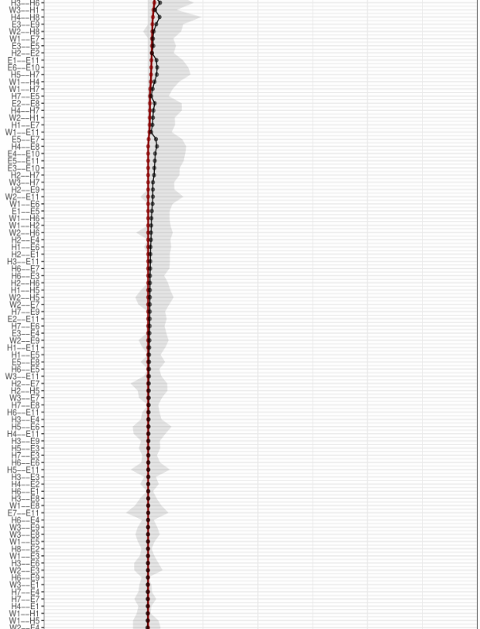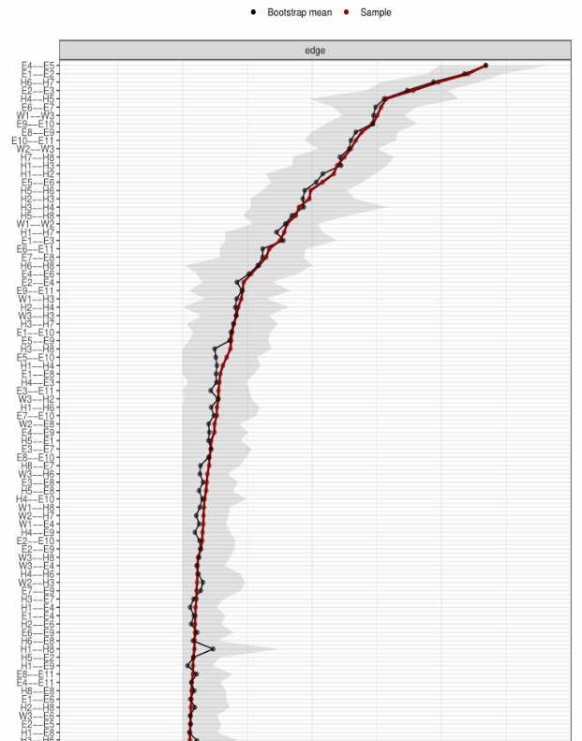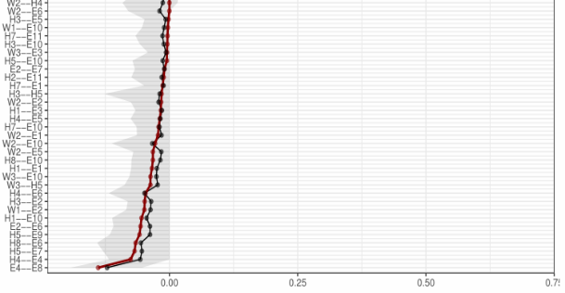
Figure S2. Bootstrap 95% confidence intervals of the partial correlation coefficients of the network shown in Figure 1 (The bootstrap was repeated 1000 times). Individual edges are represented by a horizontal grey line, the original edges’ weight and bootstrap edges’ weight are indicated by the red line and black line, respectively. The grey area represents the bootstrap 95% confidence interval.
E1: feeling emotional exhaustion at work; E2: feeling exhausted at work; E3: feeling can do everything; E4: become cold after taking this job; E5: be afraid job will make emotionally numbness; E6: having no emotion for some patients; E7: don't care what happens to some patients; E8: finding working with people all day is a test; E9: feeling a lot of pressure when dealing with people; E10: feeling frustrated at work; E11: feeling patients would blame for some of their problems. H1: leading a purposeful and meaningful life; H2: having supportive and rewarding social relationships ; H3: interested in daily activities; H4: contributing to the happiness and well-being of others; H5: be competent and capable in the activities; H6: be a good person and live a good life; H7: be optimistic about future; H8: feeling respectable. W: three dimensions of job satisfaction, including W1, satisfaction with job itself; W2, job environment satisfaction; W3, job reward satisfaction.

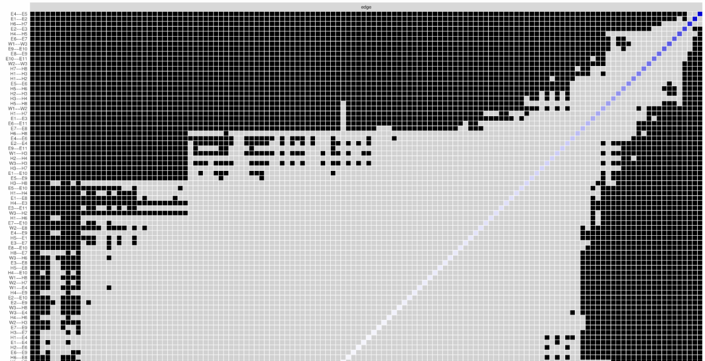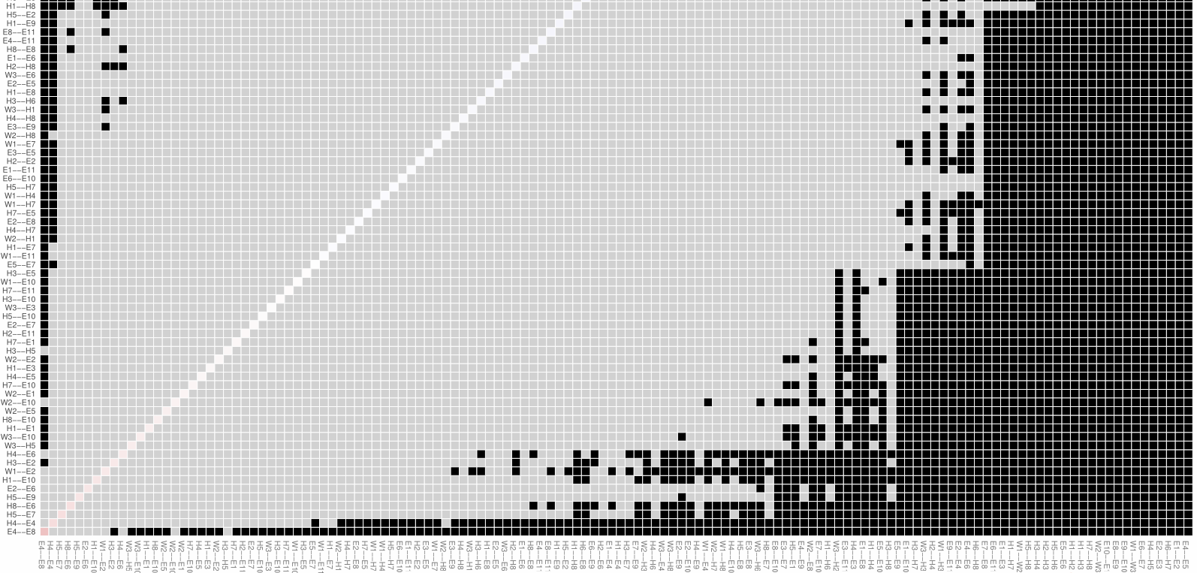
Figure S3. Estimation of partial correlation coefficients difference by bootstrapped difference test (The bootstrap was repeated 1000 times). Bootstrapped difference tests between partial correlation coefficients in the network. Gray boxes indicate edges that do not differ from one-another significantly. Black boxes represent edges with significant difference from one another (α = 0.05). Blue boxes in the edge-weight plot correspond to positive correlations and red boxes to negative correlations.
E1: feeling emotional exhaustion at work; E2: feeling exhausted at work; E3: feeling can do everything; E4: become cold after taking this job; E5: be afraid job will make emotionally numbness; E6: having no emotion for some patients; E7: don't care what happens to some patients; E8: finding working with people all day is a test; E9: feeling a lot of pressure when dealing with people; E10: feeling frustrated at work; E11: feeling patients would blame for some of their problems. H1: leading a purposeful and meaningful life; H2: having supportive and rewarding social relationships ; H3: interested in daily activities; H4: contributing to the happiness and well-being of others; H5: be competent and capable in the activities; H6: be a good person and live a good life; H7: be optimistic about future; H8: feeling respectable. W: three dimensions of job satisfaction, including W1, satisfaction with job itself; W2, job environment satisfaction; W3, job reward satisfaction.
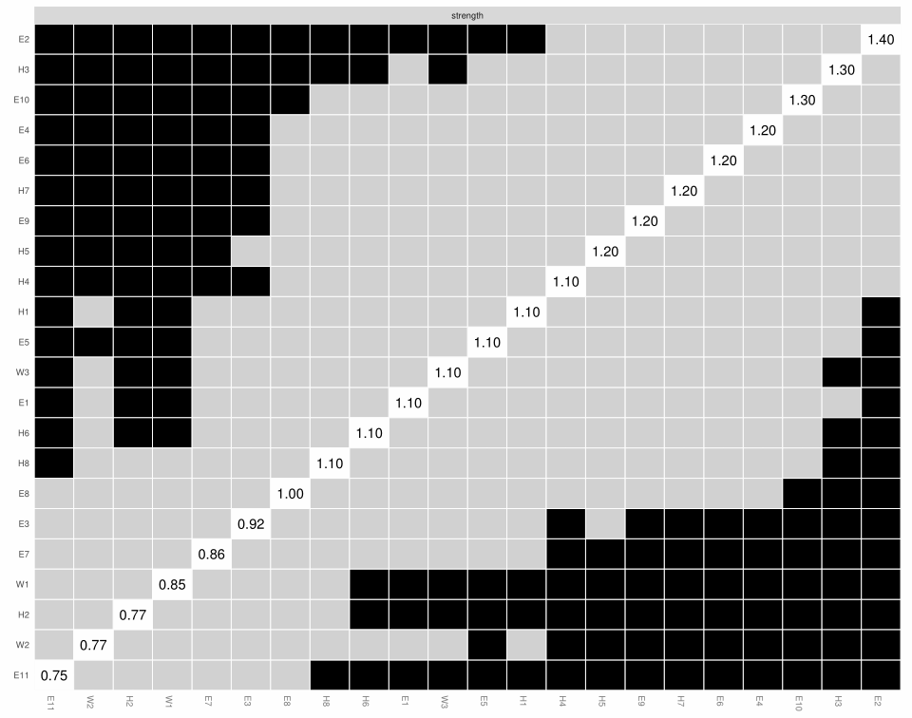
Figure S4. Bootstrap partial correlation coefficients difference test of the node’s strength (The bootstrap was repeated 1000 times). Grey boxes indicate non-significant differences while black boxes represent significant differences in strength between two variables (α = 0.05). The numerical magnitude of each nodes’ strength is indicated in the diagonal boxes.
E1: feeling emotional exhaustion at work; E2: feeling exhausted at work; E3: feeling can do everything; E4: become cold after taking this job; E5: be afraid job will make emotionally numbness; E6: having no emotion for some patients; E7: don't care what happens to some patients; E8: finding working with people all day is a test; E9: feeling a lot of pressure when dealing with people; E10: feeling frustrated at work; E11: feeling patients would blame for some of their problems. H1: leading a purposeful and meaningful life; H2: having supportive and rewarding social relationships ; H3: interested in daily activities; H4: contributing to the happiness and well-being of others; H5: be competent and capable in the activities; H6: be a good person and live a good life; H7: be optimistic about future; H8: feeling respectable. W: three dimensions of job satisfaction, including W1, satisfaction with job itself; W2, job environment satisfaction; W3, job reward satisfaction.
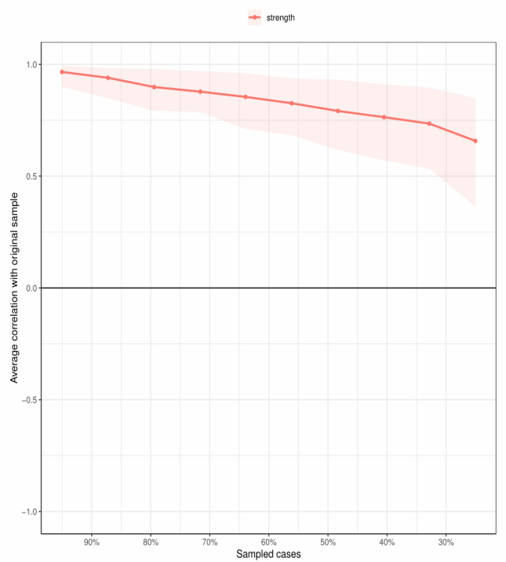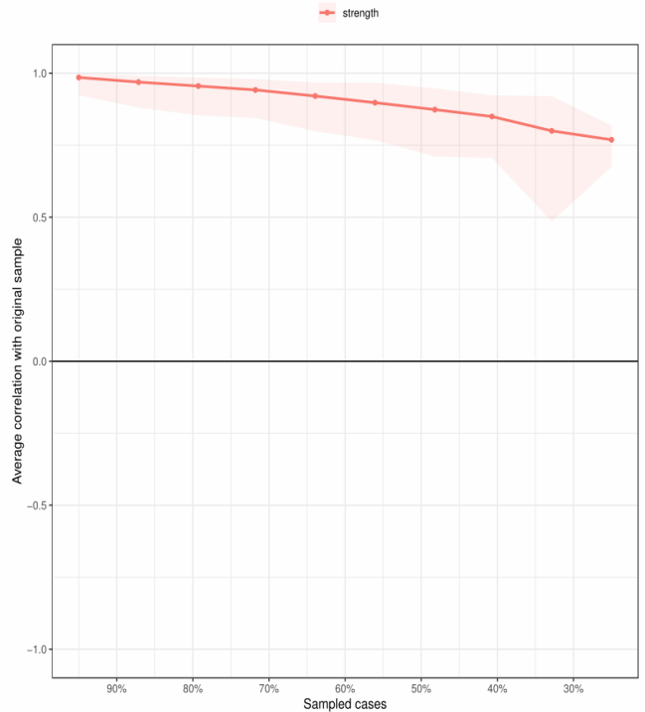
(A)
(B)
Figure S5. Stability of centrality indices by case dropping bootstrap in female (A) and male (B) (The bootstrap was repeated 1000 times). The x-axis represents the percentage of cases of original sample used at each step. The y-axis represents the average of correlations between the centrality indices from the original network and the centrality indices from the networks that were re-estimated after dropping increasing percentages of cases. Each line indicates the correlations of strength, while areas indicate 95% CI.

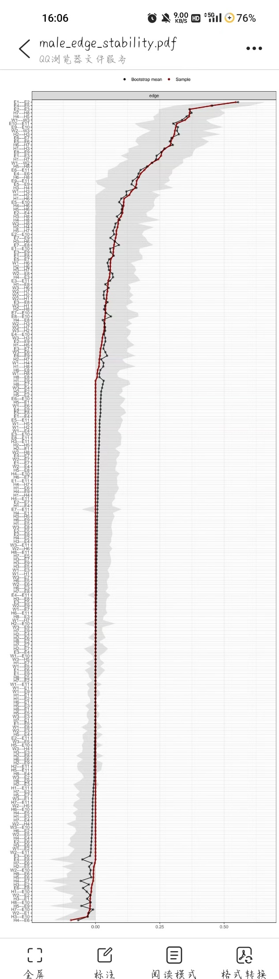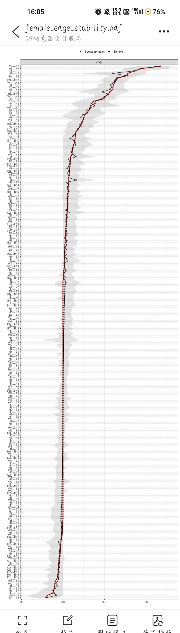
(A)
(B)
Figure S6. Bootstrap 95% confidence intervals of the partial correlation coefficients of the network in female (A) and male (B) (The bootstrap was repeated 1000 times). Individual edges are represented by a horizontal grey line, the original edges’ weight and bootstrap edges’ weight are indicated by the red line and black line, respectively. The grey area represents the bootstrap 95% confidence interval.
E1: feeling emotional exhaustion at work; E2: feeling exhausted at work; E3: feeling can do everything; E4: become cold after taking this job; E5: be afraid job will make emotionally numbness; E6: having no emotion for some patients; E7: don't care what happens to some patients; E8: finding working with people all day is a test; E9: feeling a lot of pressure when dealing with people; E10: feeling frustrated at work; E11: feeling patients would blame for some of their problems. H1: leading a purposeful and meaningful life; H2: having supportive and rewarding social relationships ; H3: interested in daily activities; H4: contributing to the happiness and well-being of others; H5: be competent and capable in the activities; H6: be a good person and live a good life; H7: be optimistic about future; H8: feeling respectable. W: three dimensions of job satisfaction, including W1, satisfaction with job itself; W2, job environment satisfaction; W3, job reward satisfaction.

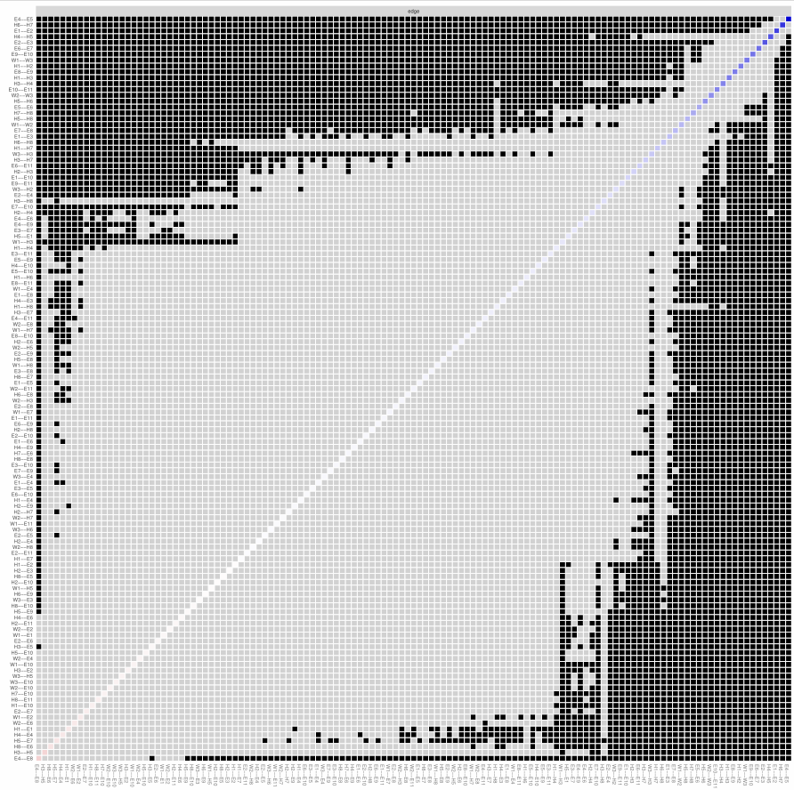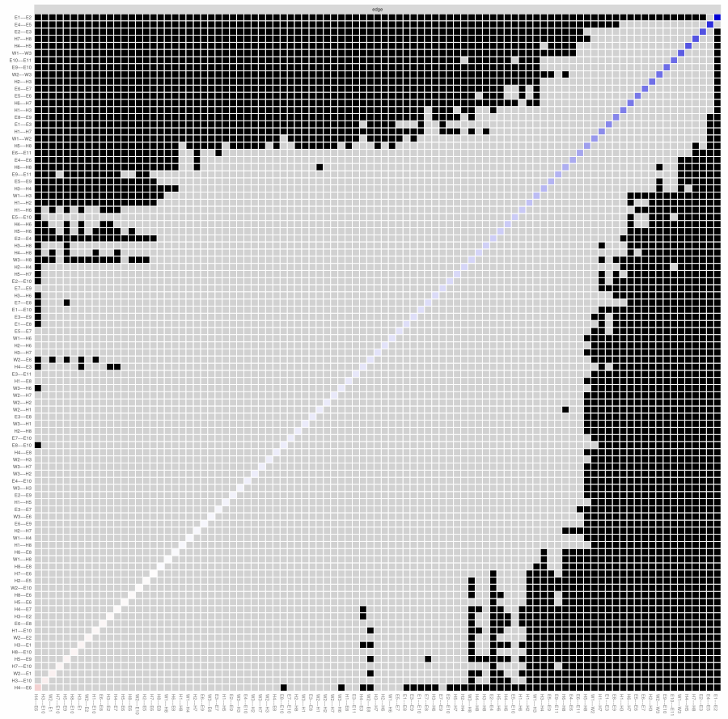
(A)
(B)
Figure S7. Estimation of partial correlation coefficients difference by bootstrapped difference test in female (A) and male (B) (The bootstrap was repeated 1000 times). Bootstrapped difference tests between partial correlation coefficients in the network. Gray boxes indicate edges that do not differ from one-another significantly, while black boxes represent edges with significant difference from one another (α = 0.05). Blue boxes in the edge-weight plot correspond to positive correlations and red boxes to negative correlations.
E1: feeling emotional exhaustion at work; E2: feeling exhausted at work; E3: feeling can do everything; E4: become cold after taking this job; E5: be afraid job will make emotionally numbness; E6: having no emotion for some patients; E7: don't care what happens to some patients; E8: finding working with people all day is a test; E9: feeling a lot of pressure when dealing with people; E10: feeling frustrated at work; E11: feeling patients would blame for some of their problems. H1: leading a purposeful and meaningful life; H2: having supportive and rewarding social relationships ; H3: interested in daily activities; H4: contributing to the happiness and well-being of others; H5: be competent and capable in the activities; H6: be a good person and live a good life; H7: be optimistic about future; H8: feeling respectable. W: three dimensions of job satisfaction, including W1, satisfaction with job itself; W2, job environment satisfaction; W3, job reward satisfaction.

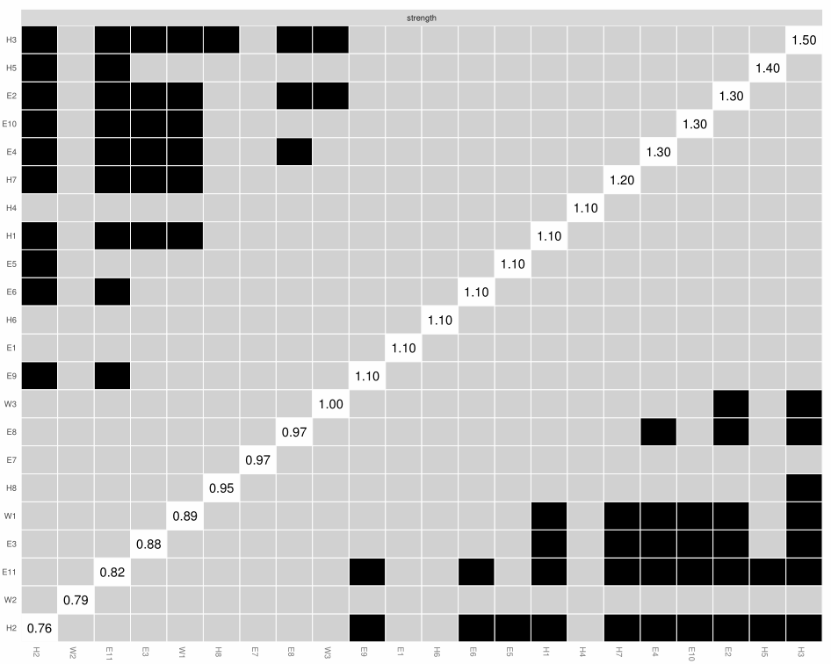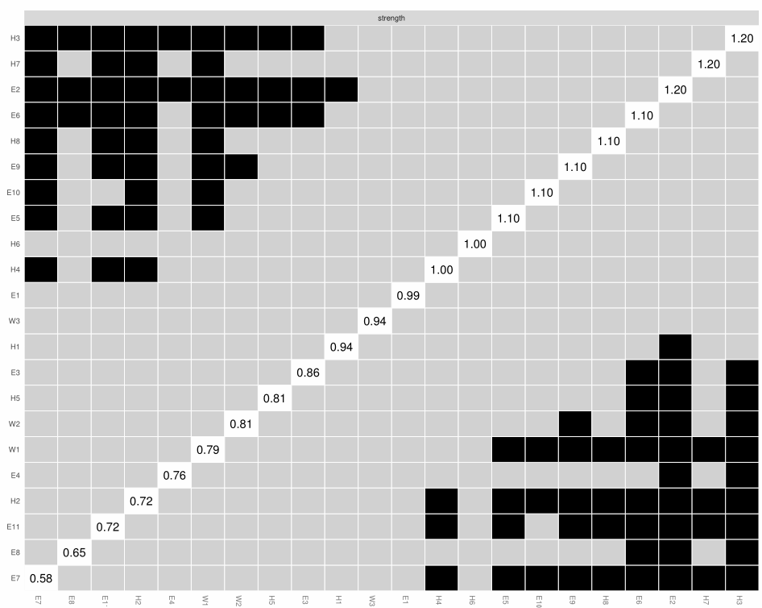
(A)
(B)
Figure S8. Bootstrap partial correlation coefficients difference test of the node’s strength in female (A) and male (B) (The bootstrap was repeated 1000 times). Grey boxes indicate non-significant differences， while black boxes represent significant differences in strength between two variables (α = 0.05). The numerical magnitude of each nodes’ strength is indicated in the diagonal boxes.
E1: feeling emotional exhaustion at work; E2: feeling exhausted at work; E3: feeling can do everything; E4: become cold after taking this job; E5: be afraid job will make emotionally numbness; E6: having no emotion for some patients; E7: don't care what happens to some patients; E8: finding working with people all day is a test; E9: feeling a lot of pressure when dealing with people; E10: feeling frustrated at work; E11: feeling patients would blame for some of their problems. H1: leading a purposeful and meaningful life; H2: having supportive and rewarding social relationships ; H3: interested in daily activities; H4: contributing to the happiness and well-being of others; H5: be competent and capable in the activities; H6: be a good person and live a good life; H7: be optimistic about future; H8: feeling respectable. W: three dimensions of job satisfaction, including W1, satisfaction with job itself; W2, job environment satisfaction; W3, job reward satisfaction.

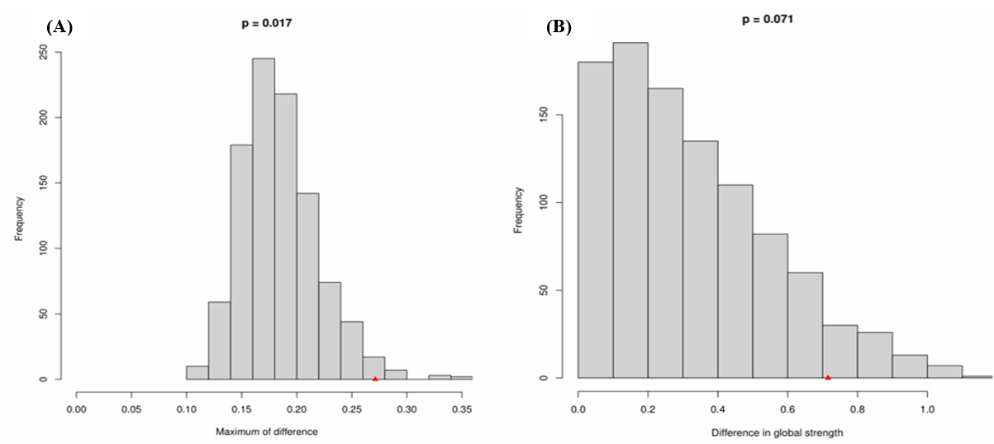
Figure S9. Comparison of network properties in female and male. (A) Plot of bootstrap value of the maximum of difference in distribution of partial correlation coefficients (1000 permutations). The difference was significant (M=0.271, p=0.017). (B) Plot of bootstrap value of the difference in network global strength. The difference was not significant (network strength among female subjects: 10.62984; network strength among male subjects: 9.914365; S: 0.7155, p=0.071). The red triangle indicates the test statistic based on the observed (real) data. Invariance in edges weights was tested using the permutation test, generating sets of p values for each edge-edge comparison. Holm-Bonferroni corrected p values were all >0.05 indicating absence of significant differences.

