Deubiquitinase USP1 enhances CCAAT/enhancer-binding protein beta (C/EBPβ) stability and accelerates adipogenesis and lipid accumulation

Running title: USP1 deubiquitinases C/EBPβ and increases adipogenesis

Myung Sup Kim^{1, 2, 3, *}, Jung-Hwan Baek^{1, 2, 3, *}, JinAh Lee¹, Kyung-Hee Chun^{1, 2, 3, #}

¹Department of Biochemistry & Molecular Biology, ²Graduate School of Medical Science, Brain Korea 21 Project, ³Institute of Genetic Science, Yonsei University College of Medicine, 50-1 Yonsei-ro, Seodaemun-gu, Seoul, 03722, Republic of Korea.

*These two authors contributed equally to this work.

# Correspondence: Kyung-Hee Chun Ph.D., Department of Biochemistry & Molecular Biology, Yonsei University College of Medicine, 50-1 Yonsei-ro, Seodaemun-gu, Seoul 03722, Republic of Korea. TEL: 82-2-2228-1699, FAX: 82-2-312-5041, E-mail: khchun@yuhs.ac

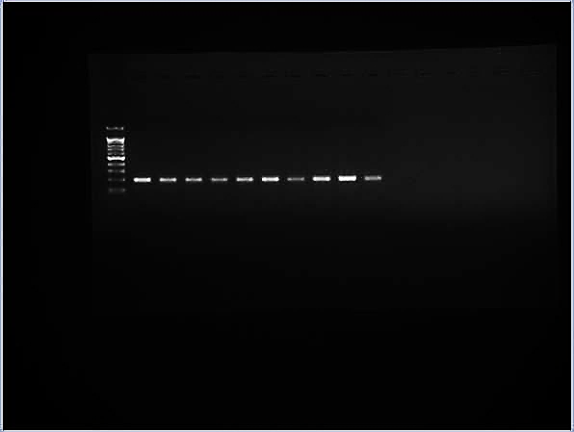
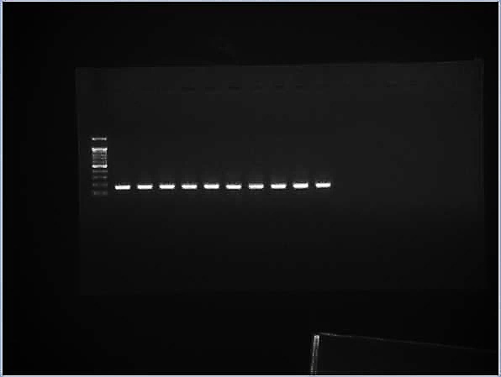
Brain
Liver
Heart
Lung
BAT
iWAT
Kidney
Spleen
Muscle
gWAT
USP1
β-actin
RT-PCR

Supplementary Fig. 1. The expression levels of Usp1 from tissues of normal mice. Representative image of Usp1 mRNA levels in various tissues of three normal 8-week-old C57BL/6 mice. Results were normalized using β-actin. Each experiment was repeated for more than three times independently.

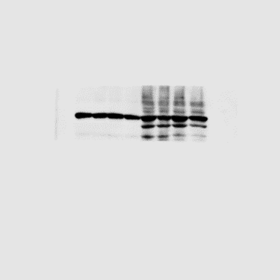
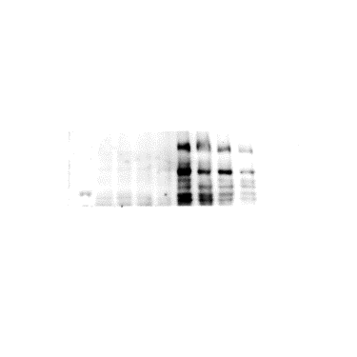
Liver
NFD
HFD
USP1
β-actin

Supplementary Fig. 2. Elevated USP1 expression levels in livers from HFD-fed mice. Western blot images of USP1 protein levels from liver tissues after 16 weeks of NFD or HFD. Results were normalized using β-actin.

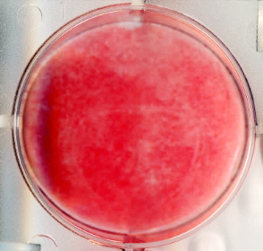
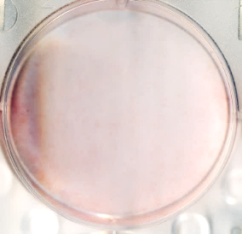
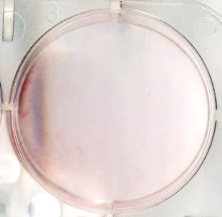
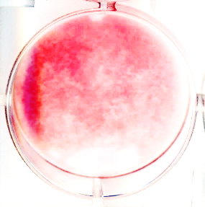
NC
siUSP1#1
siUSP1#2
siUSP1#3

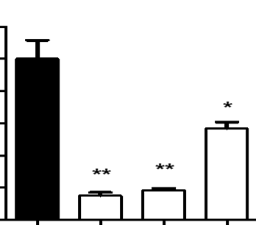
Lipid accumulation (fold)
-
#1
#2
#3
siRNA;
0
1.0
1.2
0.4
0.2
0.8
0.6

Supplementary Fig. 3. Reduced lipid accumulation by Usp1 knock down of siRNA. ORO staining. 3T3-L1 cells were transfected with siRNA for 48 h followed by DMI induction and differentiation for 6 days. Each experiment was repeated for more than three times independently.

Supplementary Fig. 4. Quantification of relative protein expression in response to MG132. AML12 cells were treated with 20 μM MG132 for 8 h and normalized to DMSO treated control samples. Each experiment was repeated for more than three times independently.

Supplementary Fig. 5. Relative expression levels of Usp1 and Cebpb by siRNA knockdown of Usp1. Expression levels of Usp1 and Cebpb from total mRNA isolated from AML12 cells. AML12 cells were transfected with siRNA against Usp1 for 48 h.

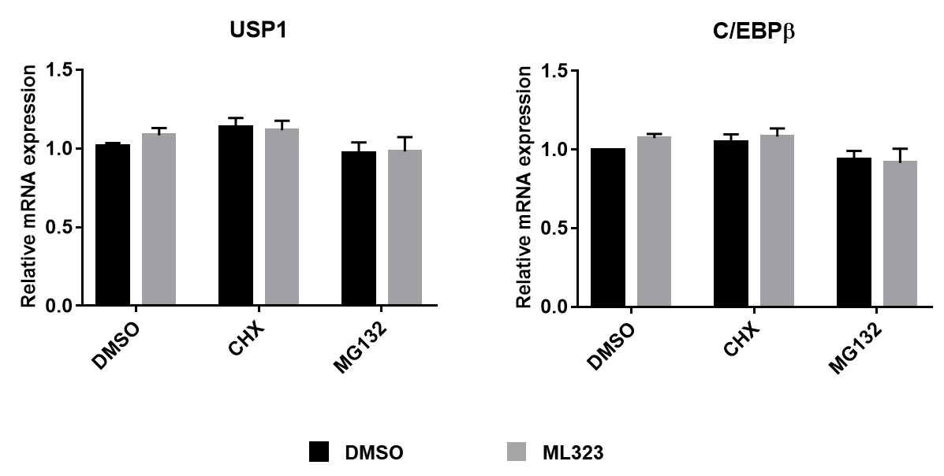

Supplementary Fig. 6. Relative expression levels of Usp1 and Cebpb when treated with cycloheximide or MG132. Expression levels of Usp1 and Cebpb from total mRNA isolated from AML12 cells. AML12 cells were treated with either cycloheximide or MG132 and normalized by β-actin.

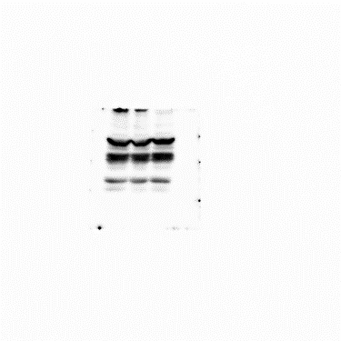
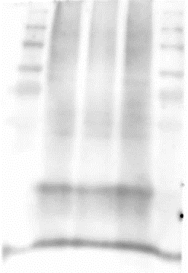
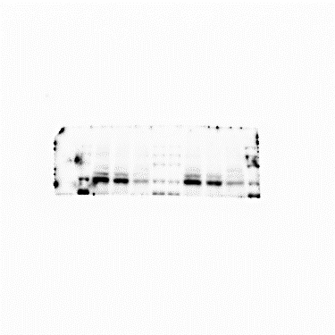
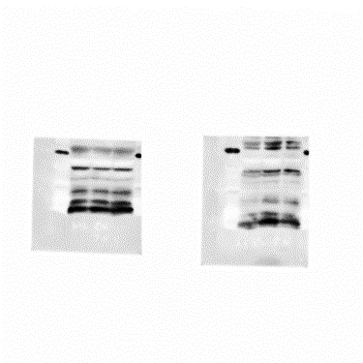
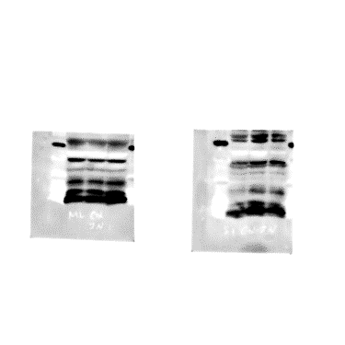
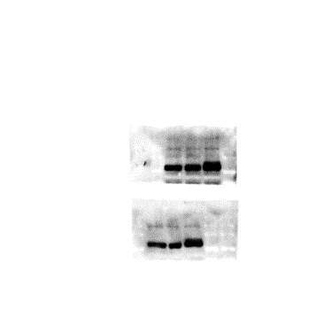
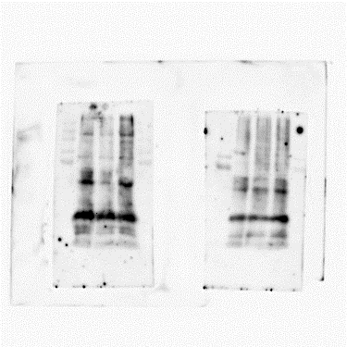
MG132
+
+
+
HA-Ub
-
+
+
siUSP1
-
-
+
HA
IP: C/EBPα
C/EBPα
C/EBPα
Input
USP1
ML323
MG132
+
+
+
HA-Ub
-
+
+
-
-
+
HA
IP: C/EBPα
CEBPα
C/EBPα
Input
USP1

Supplementary Fig. 7. De-ubiquitination assay of C/EBPα in response to Usp1 siRNA or ML323 treatment. AML12 cells were transfected with siRNA against Usp1 or treated with ML323 followed by MG132 treatment for 8 h.

