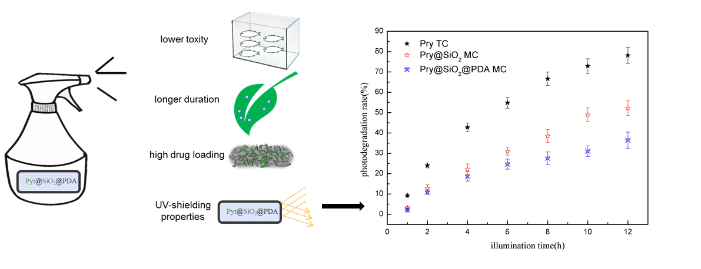

·Fabricated near-rod structure Pyr@SiO₂@PDA microcapsule in a straightforward way.
·The pyraclostrobin-loaded microcapsules with maximum drug loading of 55% showed sustained release for up to 200 hours.
·Microcapsule processes excellent UV-shielding properties and longer duration against Fusarium oxysporum f.sp.vasinfectum
·Microcapsulation could provide a degree of protection against zebrafish on the first 24 h.
·This formulation could enhance utilization efficiency while exert less unintended negative effects on environment.

