Supplementary Information 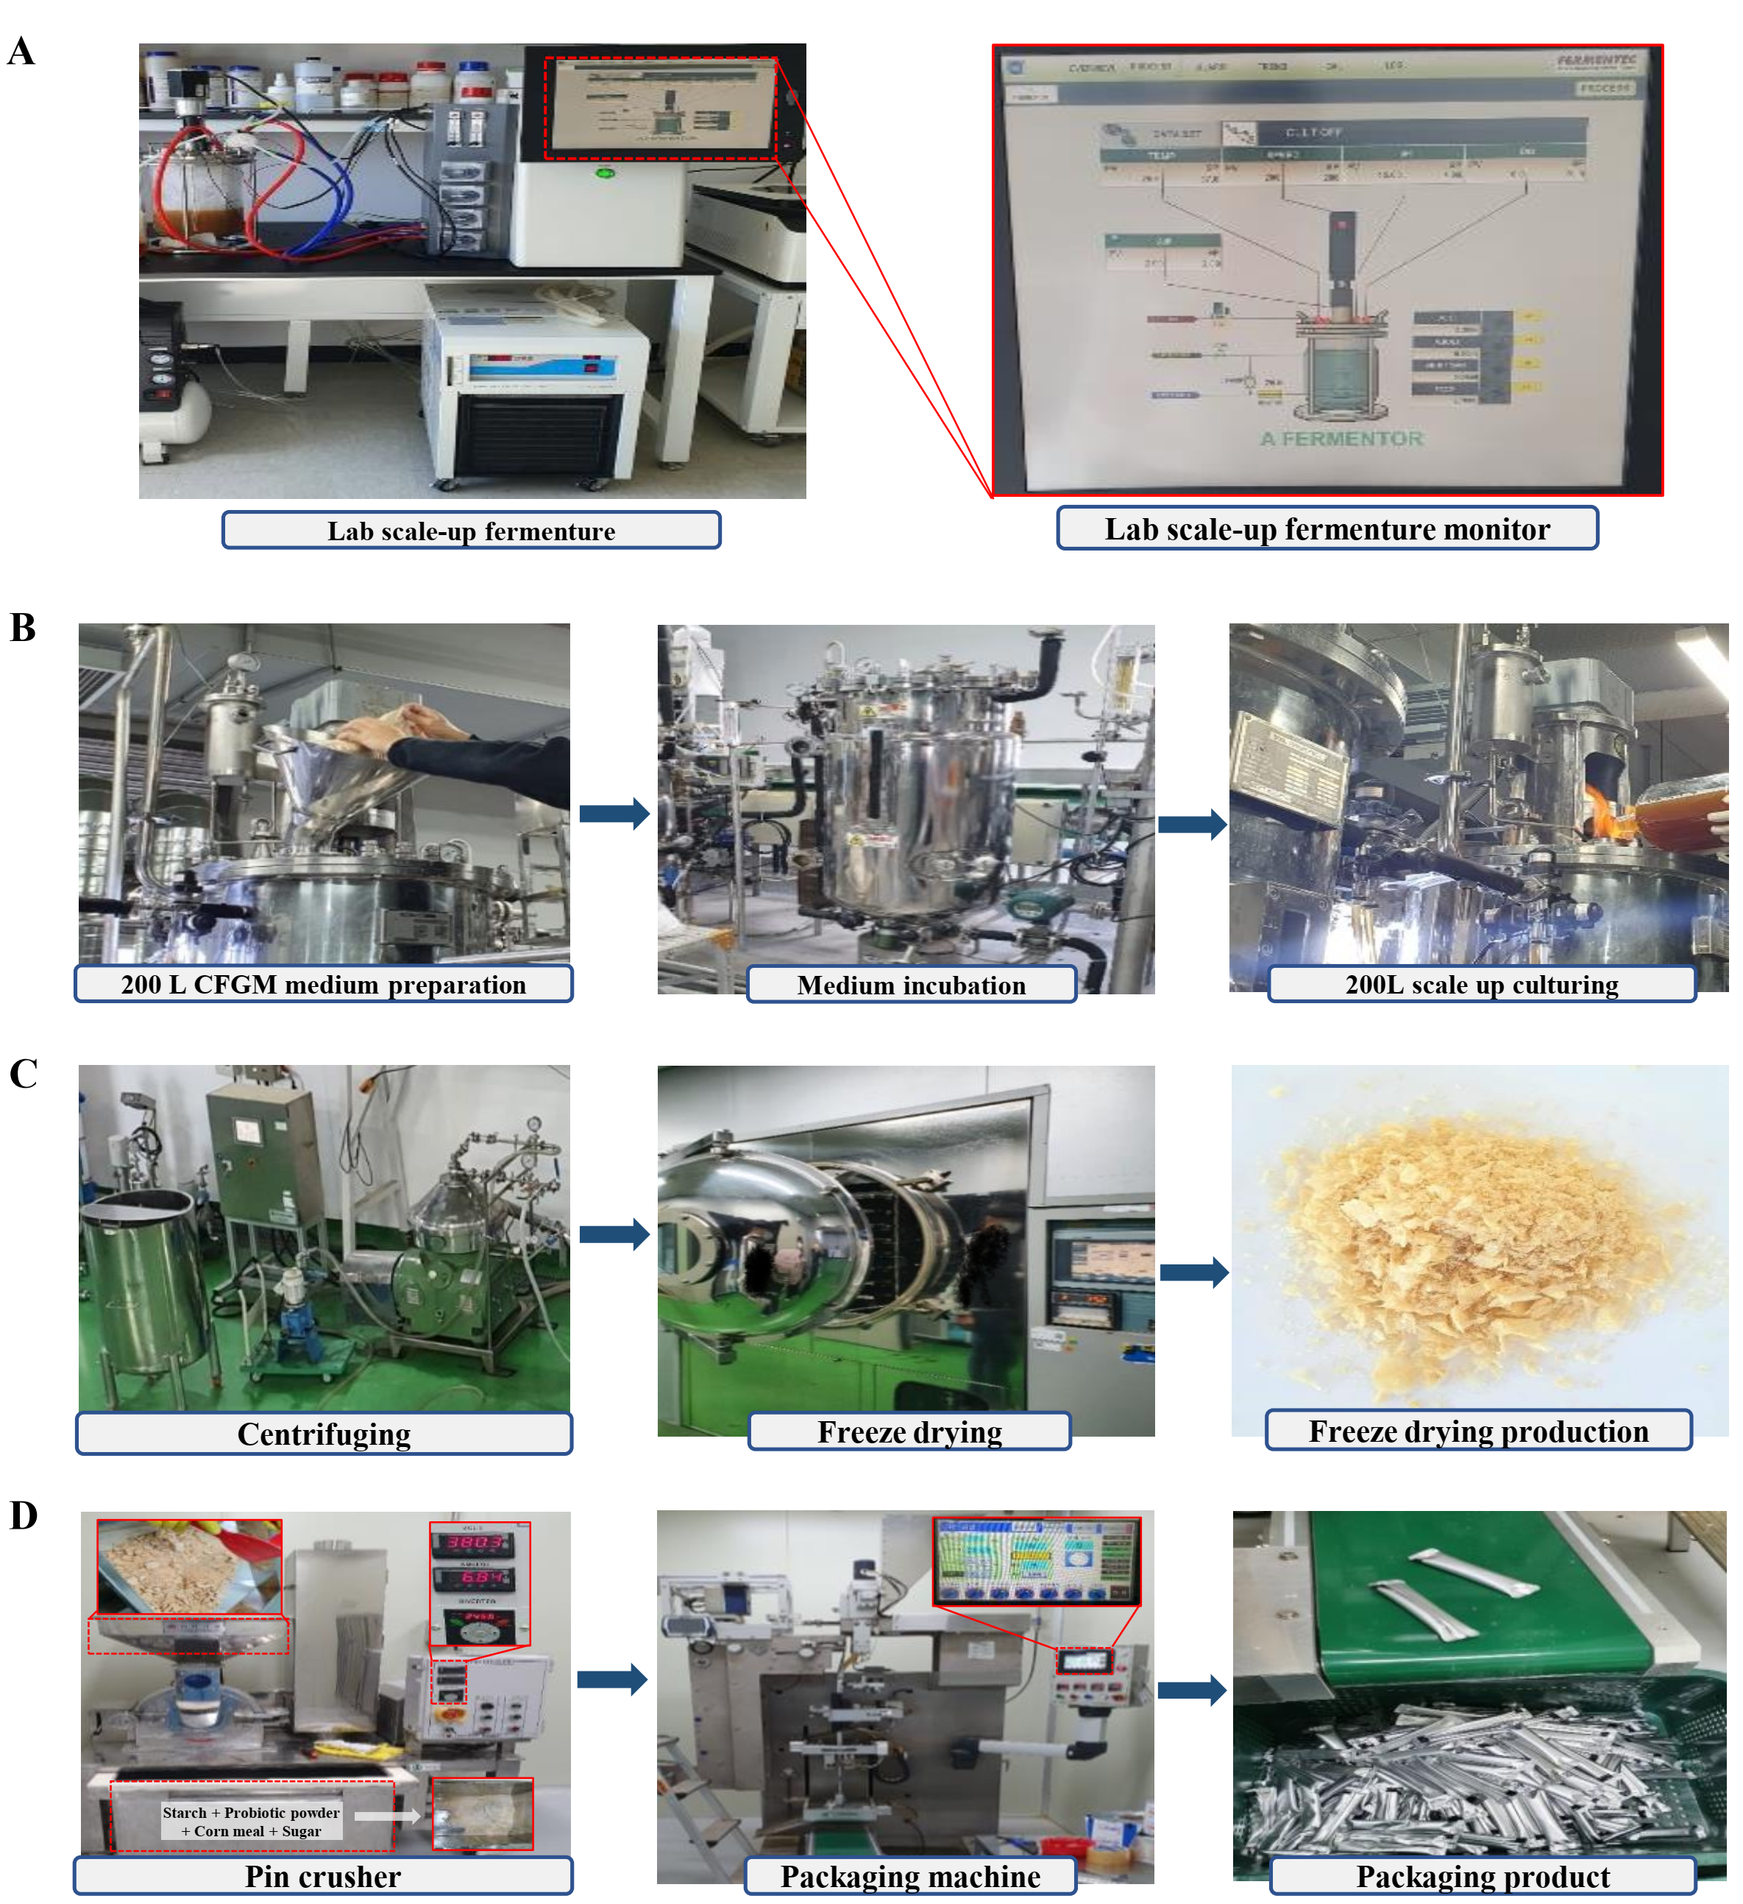
Fig. S1. The proposed scale-up process steps from laboratory cultivation to packaging. (A) Laboratory scale-up, (B) Pilot scale-up (200L), (C) Freeze-drying, and (D) Packaging.
Table S1. Compositions of EFGM medium
Ingredient’s name | Commercial name of ingredients | Number of Hits
Soy peptone A2 SC | Soy peptone A2 SC |  | 10
Yeast extract | Amberferm |  | 10
Glucose | Dextrose |  | 20
Tween 80 | Tween 80 |  | 1.0*
Magnesium sulfate | Magnesium sulfate (Heptahydrate) |  | 0.1
Sodium chloride | Sodium chloride |  | 5.0
*mL

Table S2. Taxonomic identification of the isolated bacterial strain based on NBLAST similarity score
Organisms | Scores | Number of Hits
Lactobacillus sakei | 2787 | 186
Lactobacillus sakei subsp. sakei DSM 20017 | 2785 | 1
Lactobacillus sakei subsp. sakei | 2785 | 28
Lactobacillus sakei subsp. carnosus | 2785 | 4
Lactobacillus sakei subsp. sakei 23K | 2785 | 1
Latilactobacillus sp. | 2778 | 16
Lactobacillus sp. CWBI/B-659/(E912) | 2785 | 1
Uncultured Lactobacillus sp. | 2774 | 1

Table S3. Clinical signs and mortality in an acute oral dose toxicity study using guinea pigs
Group | No. of animals | Clinical signs | Days after dosing
Group | No. of animals | Clinical signs | 1 | 3 | 5 | 7 | 9 | 10 | 14
Control | 4 | Loss weight | 0 | 0 | 0 | 0 | 0 | 0 | 0
Control | 4 | Loss of fur | 0 | 0 | 0 | 0 | 0 | 0 | 0
Control | 4 | Salivation (after dosing) | 0 | 0 | 0 | 0 | 0 | 0 | 0
Control | 4 | Blackish stool | 0 | 0 | 0 | 0 | 0 | 0 | 0
Control | 4 | Decrease in fecal volume | 0 | 0 | 0 | 0 | 0 | 0 | 0
Control | 4 | Mucous stool | 0 | 0 | 0 | 0 | 0 | 0 | 0
Control | 4 | Irregular respiration | 0 | 0 | 0 | 0 | 0 | 0 | 0
Control | 4 | Lying on side | 0 | 0 | 0 | 0 | 0 | 0 | 0
Control | 4 | Death | 0 | 0 | 0 | 0 | 0 | 0 | 0
Control | 4 | No observable abnormality (NOA) | 4 | 4 | 4 | 4 | 4 | 4 | 4
L. sakei | 4 | Loss weight | 0 | 0 | 0 | 0 | 0 | 0 | 0
L. sakei | 4 | Loss of fur | 0 | 0 | 0 | 0 | 0 | 0 | 0
L. sakei | 4 | Salivation (after dosing) | 0 | 0 | 0 | 0 | 0 | 0 | 0
L. sakei | 4 | Blackish stool | 0 | 0 | 0 | 0 | 0 | 0 | 0
L. sakei | 4 | Decrease in fecal volume | 0 | 0 | 0 | 0 | 0 | 0 | 0
L. sakei | 4 | Mucous stool | 0 | 0 | 0 | 0 | 0 | 0 | 0
L. sakei | 4 | Irregular respiration | 0 | 0 | 0 | 0 | 0 | 0 | 0
L. sakei | 4 | Lying on side | 0 | 0 | 0 | 0 | 0 | 0 | 0
L. sakei | 4 | Death | 0 | 0 | 0 | 0 | 0 | 0 | 0
L. sakei | 4 | No observable abnormality (NOA) | 4 | 4 | 4 | 4 | 4 | 4 | 4

