Table 1 Body weight, organ weights/length, and carcass weights after being given MOLP
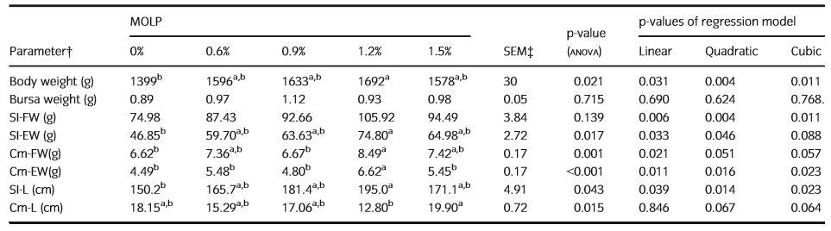
Table 2 MOLP supplemented broiler chickens' morphometric characteristics of the intestine.
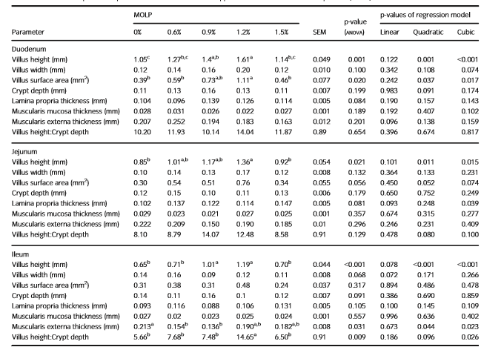
Table 3 goblet cells in the digestive tract after being given MOLP
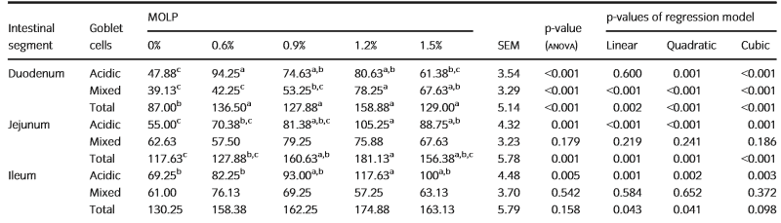

Table 4 M. oleifera leaf powder (MOLP) supplemented broiler chickens, morphometric parameters of the Fabricius bursa were measured.
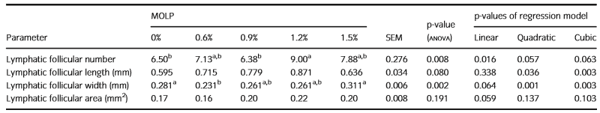

Table 5 Moringa Oleifera leaf powder (MOLP)-supplemented broiler chickens' caecal tonsils' morphometric characteristics.
