Supplementary Figures and Tables

[Attached as Wang_et_al_Supplementary_Document_1.csv]

Supplementary Document 1: REDCap Data Dictionary. Variables unused in study were commonly missing in patients or shown to be non-significant in preliminary studies and
omitted. Data dictionary can be uploaded in REDCap in the dictionary tab to add tools.

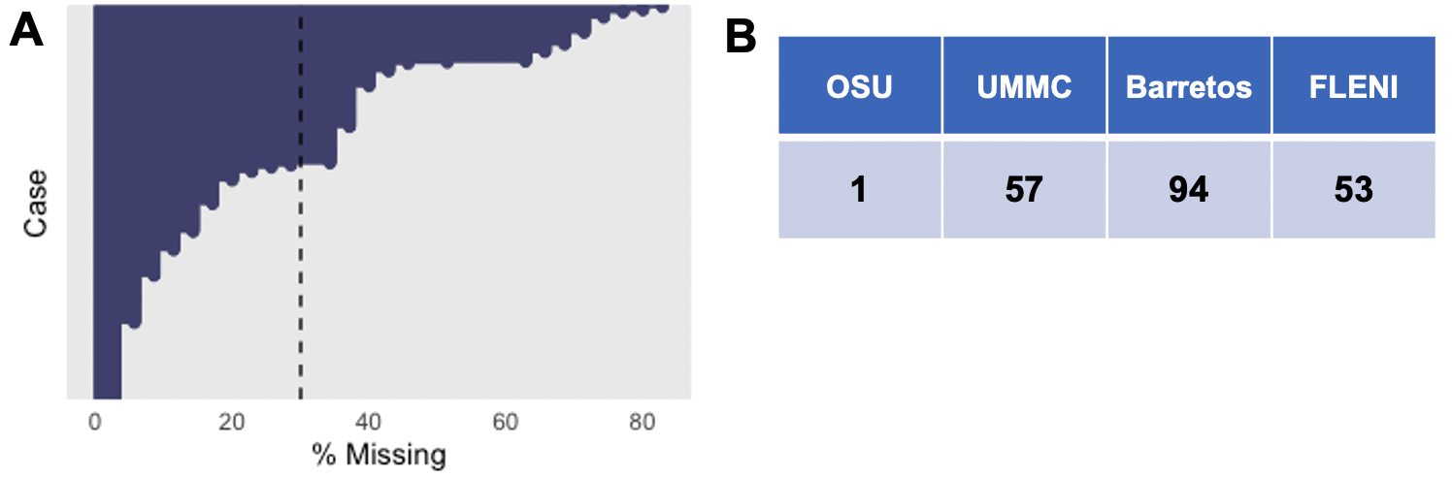
Supplementary Figure 1: Missingness of cases for clinical features. Distribution of clinical cases for percent missing clinical data is shown in (A). Cases with more than 30% missing data were omitted in the eigenvector feature plot due to needs of data imputation. Cutoff is shown in the dotted line with the distribution of cases omitted in table (B).

Count Measure | Lower Cut-off | Upper Cut-off
White Blood Cell (WBC) | 6.70 | 11.90
Neutrophils | 4.40 | 9.26
Neutrophil:Lymphocyte Ratio (NLR) | 2.58 | 8.35

Supplementary Table 1: CBC cut-offs for quartile groupings. Utilized cut-offs to define upper and lower 25% of patients in population. Cut-offs were calculated in R and set so that 25% of patients would be contained below or above the lower or upper cut-off respectively. CBC cutoffs are defined in (x10^9/L) units.

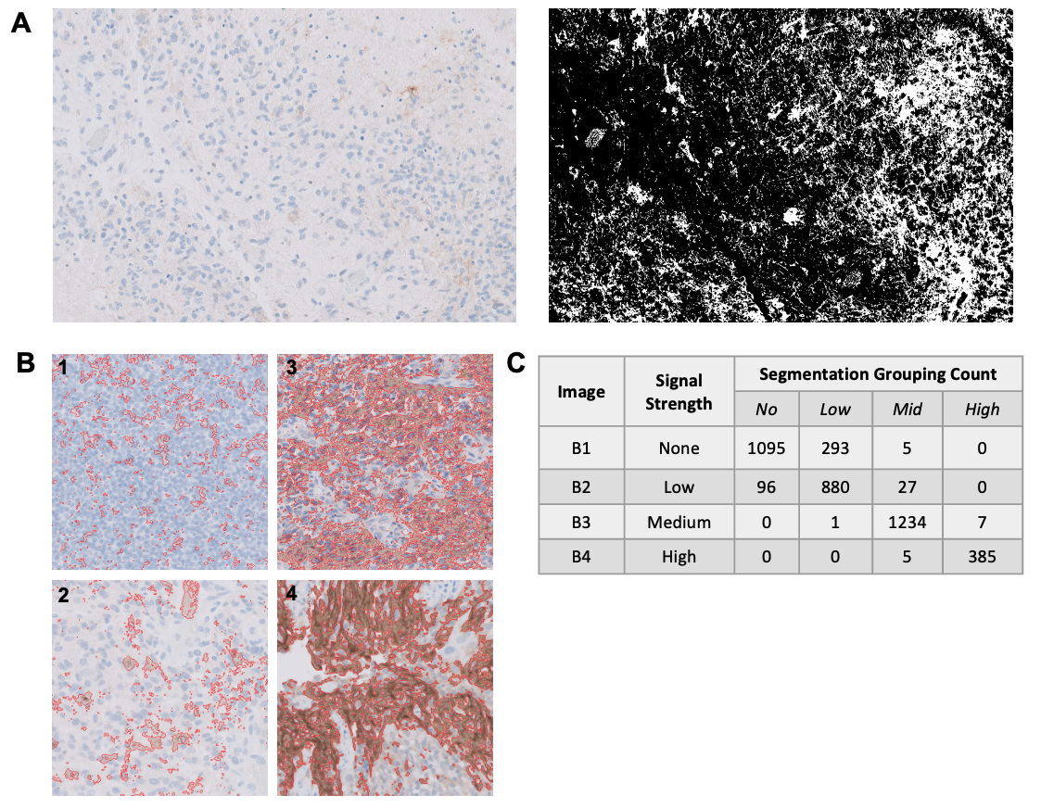
Supplementary Figure 2: Random Forest model performance of PDL-1 intensity grading. (A) Thresholding of PDL-1 image with no-low signal highlights tendency of workflow to segment regions of noise that do not capture reality of PDL-1 staining. (B) Representative images of (1) no signal, (2) low signal, (3) medium signal, and (4) high signal intensity for PDL-1 staining were selected and used to train random forest model to classify segments as no, low, mid, or high signal strength using image intensity features. Model performance was assessed using training images as shown in (B) for the relevant signal intensities. (C) Performance of model is highlighted with categorization counts of all segments found in image showing accurate detection of segmentations into representative majority stain.

