Supporting Information:
All-Optical Edge Detection in Visible Wavelengths
Ibrahim Tanriover¹, Sina Abedini Dereshgi¹ and Koray Aydin¹

¹Department of Electrical and Computer Engineering, Northwestern University, Evanston, Illinois 60208, United States

a) Corresponding author: aydin@northwestern.edu

SI-1 Unit Cell Simulations in NIR
Figure S1 shows the transmission and phase response of the unit cell library along the near-IR (NIR) range from 800 nm to 1600 nm wavelengths. As seen in the Figure S1 a, all the unit cell library provides the required range of transmission values. Additionally, there is no resonances disrupting the spectral response, which results in gradual and smooth differences between the frequency points enabling broadband operation. Figures S1c-f shows the comparison of optical response of the selected unit cell set and the target response. As seen in the figure, the selected set of unit cells block the smaller spatial frequency components, which is essential for edge detection. The created set also provides the required gradual increase in transmission and phase deviations within a small range. However, the unit cell transmission is larger than the target response as their corresponding position moves away from the center, i.e. towards larger spatial frequencies, which will be an error sources for the images with large spatial frequencies but mainly tolerable. Also note that the difference between the unit cells and the target response increases with the operation wavelength.
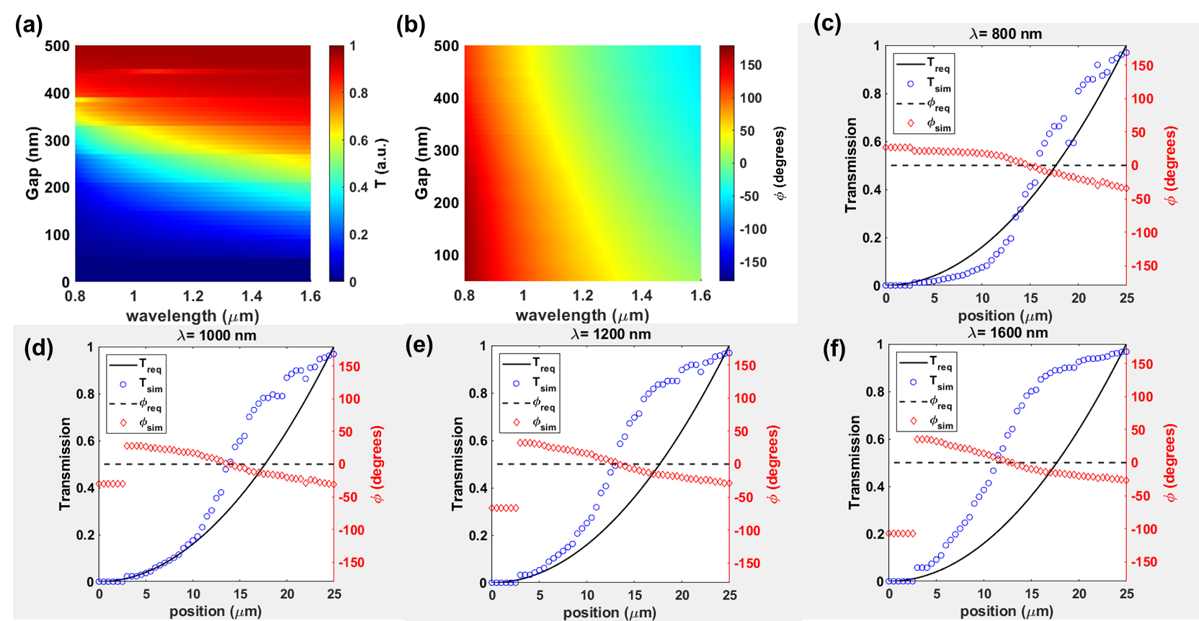
Figure S1. Unit Cell Simulations in NIR. (a) Transmission and (b) Phase response for varying gap width from 800 nm to 1600 nm wavelengths. The required versus simulated optical response of the selected set of unit cells at (c) 800 nm, (d) 1000 nm, (e) 1200 nm, and (f) 1600 nm wavelengths.

SI-2 Device Simulations in NIR
Figure S2a-c show the distribution of the transmitted electric field amplitude and Figure S2d-f show the distribution for the phase at 800 nm, 1200 nm, and 1600 nm wavelengths, respectively. As seen in these figures, the optical response of the 3D device shows good agreement with the 2D simulations.
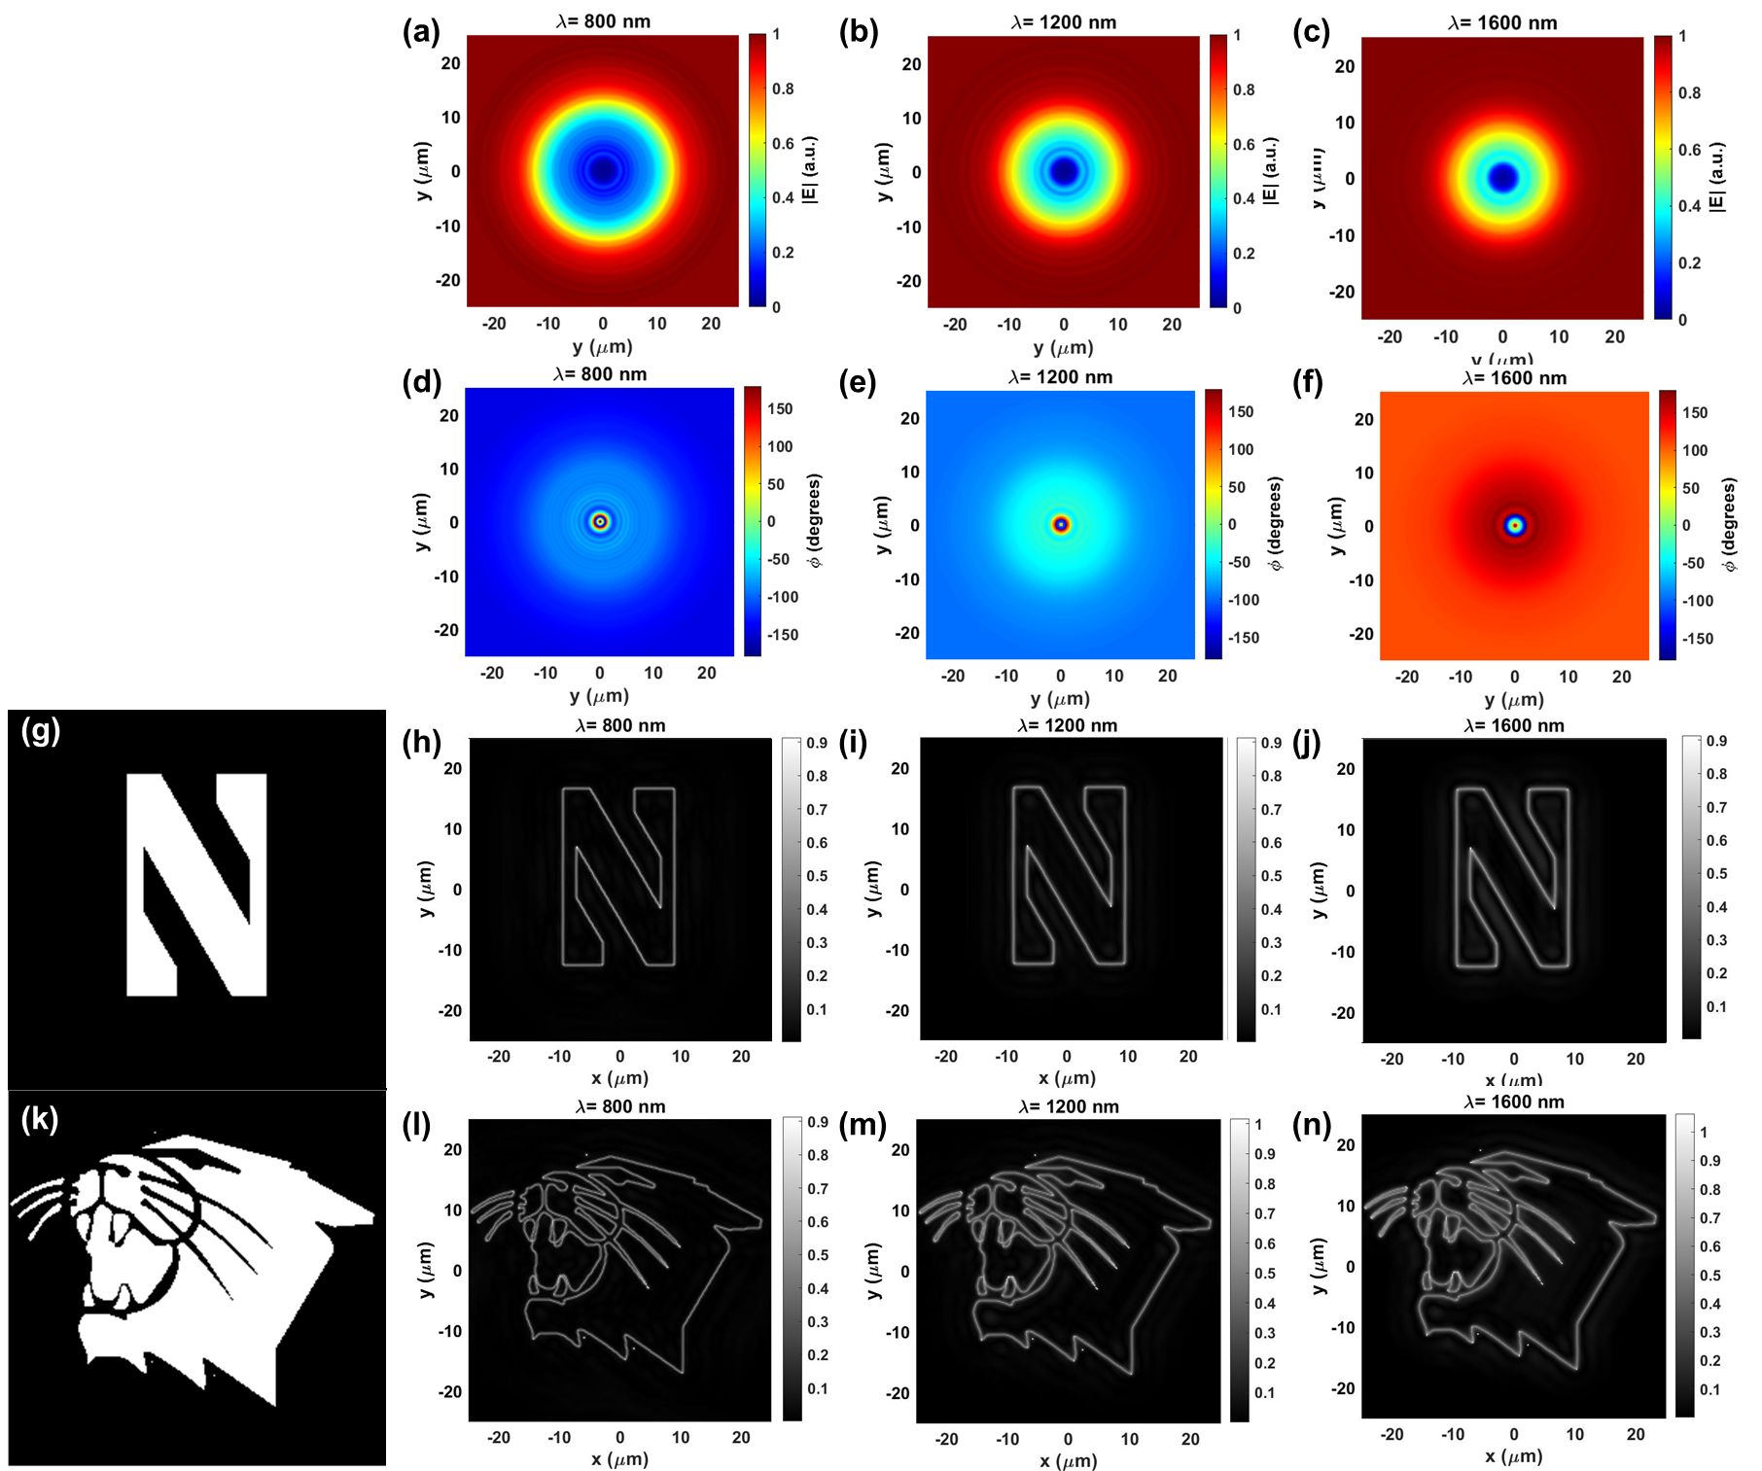
Figure S2. (a-c) The amplitude and (d-f) phase maps of the transmitted electric field at 800,1200, and 1600 nm wavelengths. (g) The letter “N” of Northwestern University logo and (k) the Northwestern Wildcats logo as the input fields. (h-j), (l-n) The calculated output fields of the 4f system with the metasurface.
For the input fields used as test cases in the manuscript, the output of the 4f system with the metasurface as the spatial filter is numerically calculated at NIR wavelengths too. The calculated output fields are shown in Figure S2(h-j) and (l-n) for the test cases; letter “N” of Northwestern University logo and the Northwestern Wildcats logo. As seen in the Figures, the metasurface successfully performs edge detection operation in 2D with unpolarized illumination 800nm, 1000nm, and 1600 nm wavelengths. Note that the clear edge detection is achieved in spite of the deviations from the target response (Figure S1 c-f) since the device maintains high pass filter operation in spatial frequency domain.

SI-3 Spatial Transmission Profile at NIR
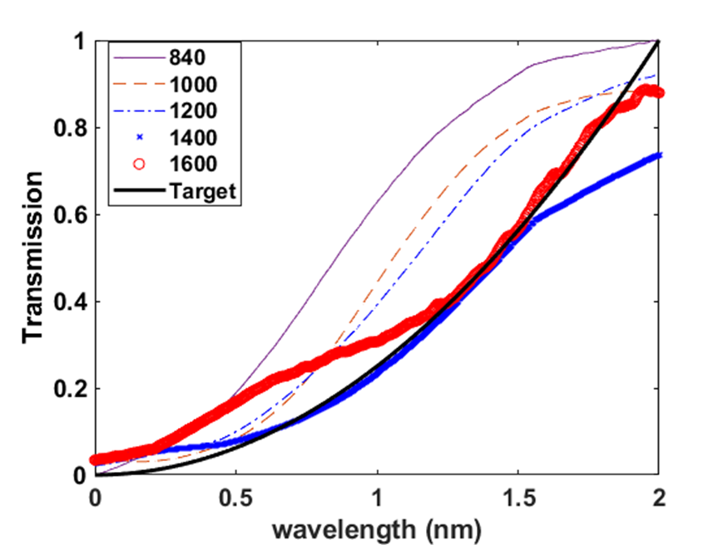
Figure S3 exhibits the measured spatial transmission profile in the NIR wavelengths. As seen in the Figure, the metasurface maintains high pass spatial filtering at NIR wavelengths. The measurements are in a good agreement with the simulations as seen in the Figure S1 and Figure S3.
Figure S3. The measured and target spatial transmission profiles at NIR. The target (black line), 840 nm (purple line), 1000 nm (red dashed line), 1200 nm (blue dashed-dotted line), 1400 nm (blue asterisk), 1600 nm (red circle)
SI-4 White Light Experiment with Lower Input Intensity
Figure S4 shows the edge detection experiment with the incoherent unpolarized white input field. In this case, the field intensity of input is lowered to avoid detector saturation. The results for the low input intensity are used to calculate performance metric discussed in the manuscript.
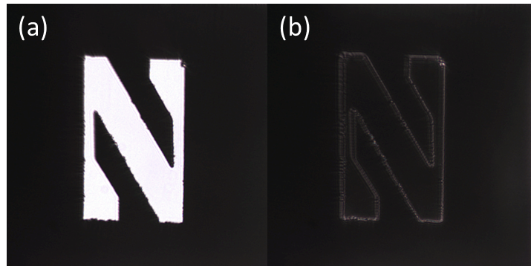
Figure S4. Edge detection experiments with Xe light bulb as the light source. (a) The reference (no metasurface) and (b) edge detected (with metasurface) images of the letter “N” of Northwestern University logo.

