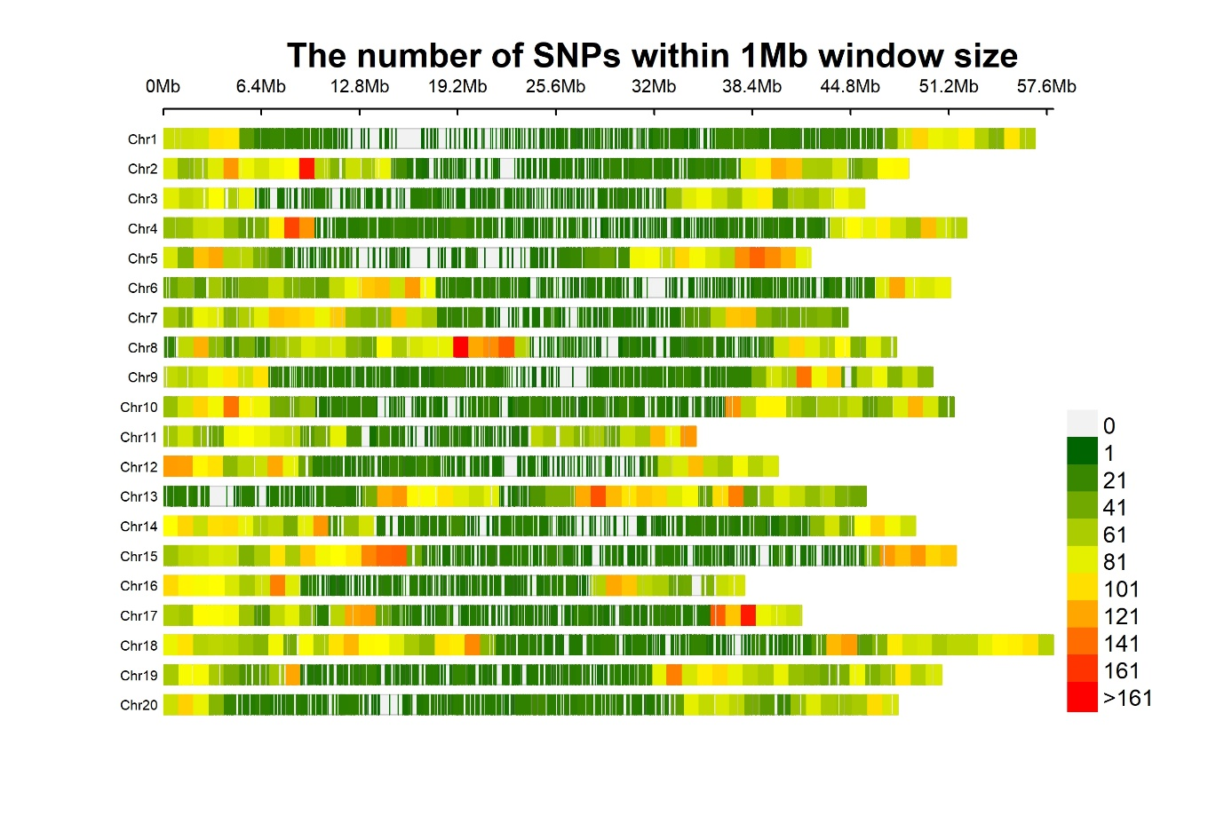
Fig. S1 The density and distribution of single nucleotide polymorphism (SNP) across 20 soybean chromosomes

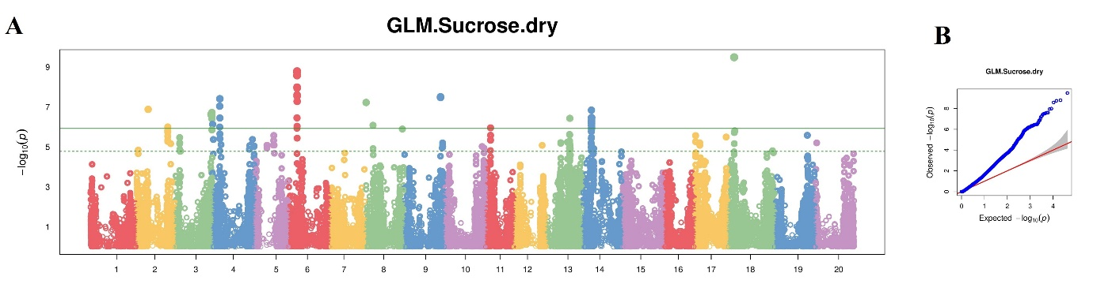
Fig. S2 (A) Manhattan plot distribution of SNPs on 20 soybean chromosomes with GLM model. X- and y-axes indicate chromosomes and LOD values respectively. (B) QQ-plot distribution of observed vs expected LOD values

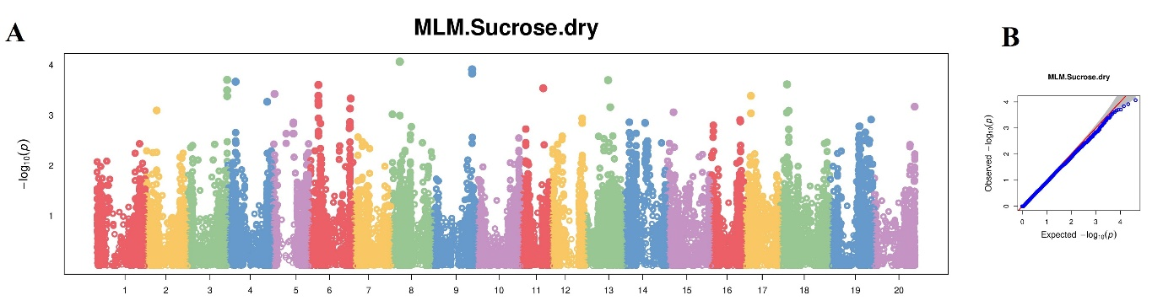
Fig. S3 (A) Manhattan plot distribution of SNPs on 20 soybean chromosomes with MLM model. X- and y-axes indicate chromosomes and LOD values respectively. (B) QQ-plot distribution of observed vs expected LOD values

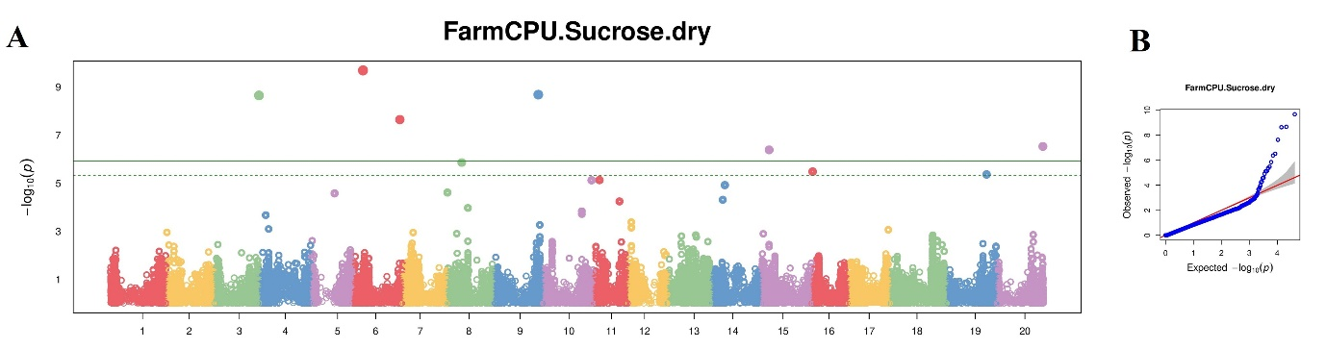
Fig. S4 (A) Manhattan plot distribution of SNPs on 20 soybean chromosomes with FarmCPU model. X- and y-axes indicate chromosomes and LOD values respectively. (B) QQ-plot distribution of observed vs expected LOD values

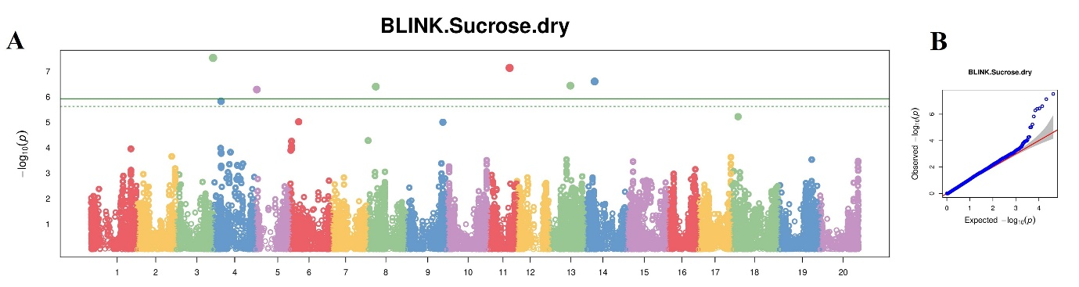
Fig. S5 (A) Manhattan plot distribution of SNPs on 20 soybean chromosomes with BLINK model. X- and y-axes indicate chromosomes and LOD values respectively. (B) QQ-plot distribution of observed vs expected LOD values

