Supplemental Figure 1: Model Fitting for Covariate Category A
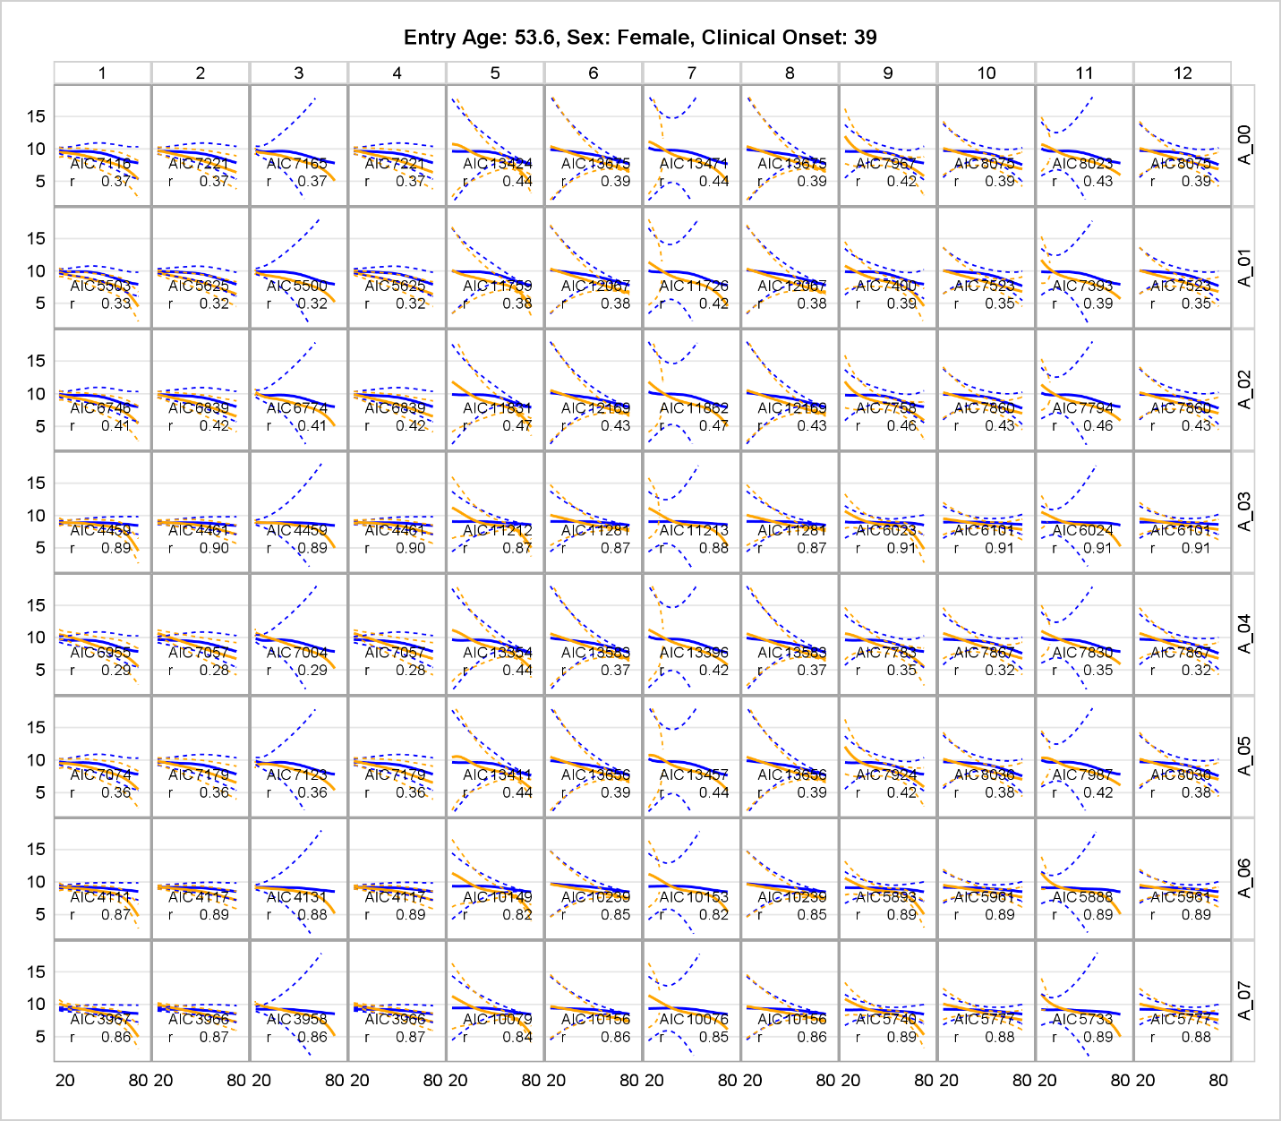
Column number 1-12 represents 12 different mixed spline structures:
1=cubic spline with bspline basis and random TOEPLIZ
2=cubic spline with tpf basis and random TOEPLIZ
3=restricted cubic spline with tpf basis and random TOEPLIZ
4=restricted cubic bspline with pspline basis and random TOEPLIZ
5=cubic spline with bspline basis and random pspline
6=cubic spline with tpf basisand and random pspline
7=restricted cubic spline with tpf basis and random pspline
8=restricted cubic bspline with pspline basis and random pspline
9=cubic spline with bspline basis and random radial smoother
10=cubic spline with tpf basisand and random radial smoother
11=restricted cubic spline with tpf basis and random radial smoother
12=restricted cubic bspline with pspline basis and random radial smoother
Row number A_00-A07 represents 7 models with different covariates (category A):
00: age-spline MS-status age-spline×MS-status
01: age-spline MS-status age-spline×MS-status ICV
02: age-spline MS-status age-spline×MS-status sex
03: age-spline MS-status age-spline×MS-status thalamus0
04: age-spline MS-status age-spline×MS-status age-of-onset
05: age-spline MS-status age-spline×MS-status DMT0
06: age-spline MS-status age-spline×MS-status ICV sex thalamus0 DMT0
07: age-spline MS-status age-spline×MS-status ICV sex thalamus0 DMT0 age-of-onset

Supplemental Figure 2: Model Fitting for Covariate Category B
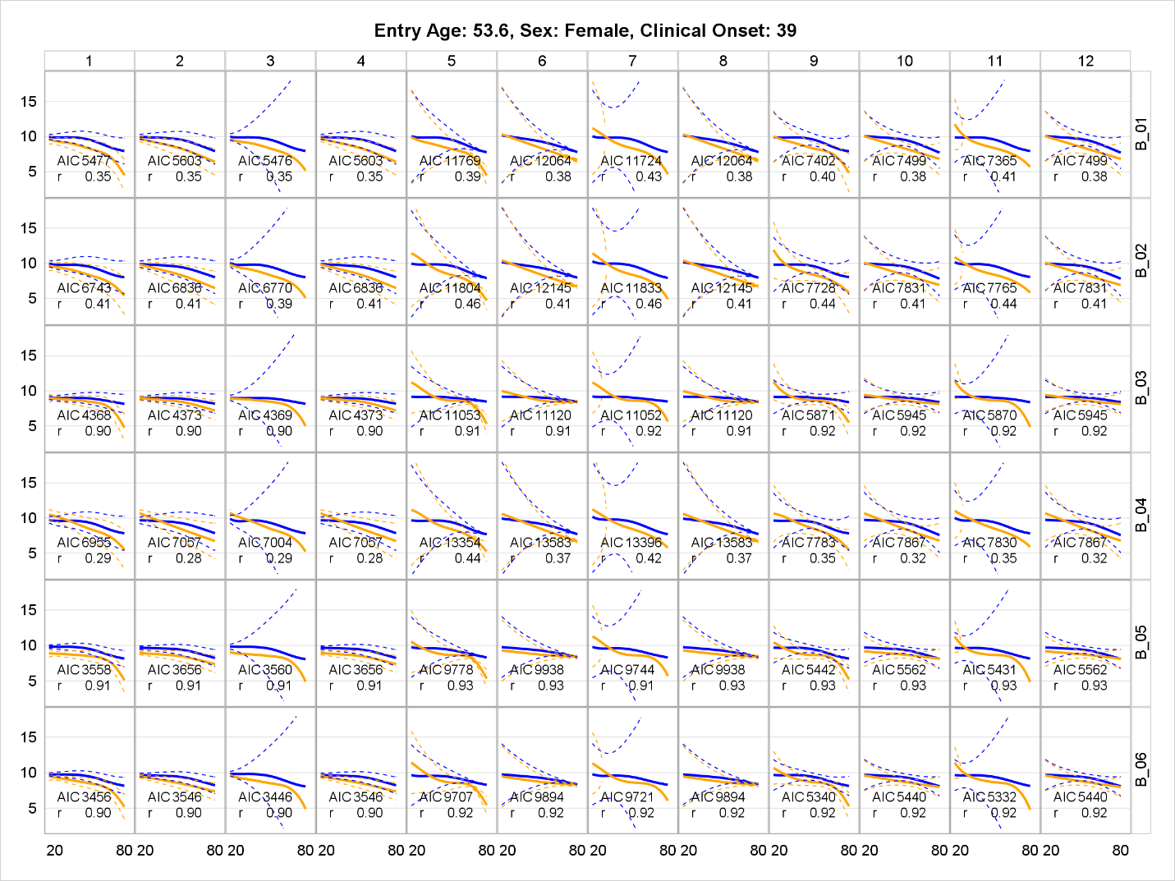

01: age-spline MS-status age-spline×MS-status ICV ICV×MS-status
02: age-spline MS-status age-spline×MS-status sex sex×MS-status
03: age-spline MS-status age-spline×MS-status thalamus0 thalamus0×MS-status
04: age-spline MS-status age-spline×MS-status age-of-onset
05: age-spline MS-status age-spline×MS-status DMT0 ICV ICV×MS-status sex×MS-status thalamus0 thalamus0×MS-status
06: age-spline MS-status age-spline×MS-status DMT0 ICV ICV×MS-status sex×MS-status thalamus0 thalamus0×MS-status age-of-onset

Supplemental Figure 3: Model Fitting for Covariate Category C

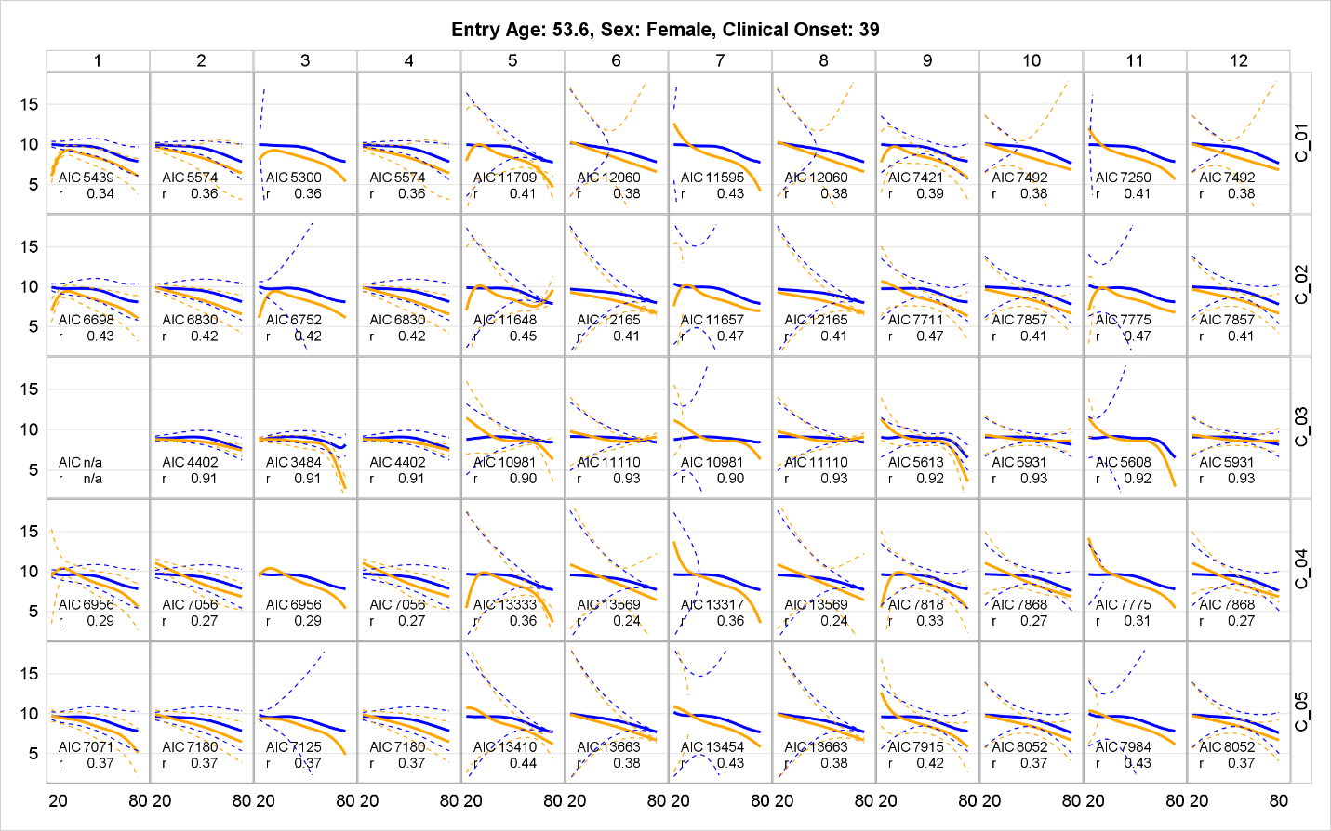

X: ICV ICV×MS-status ICV×age-spline ICV×age-spline×MS-status
Y: sex sex×MS-status sex×age-spline sex×age-spline×MS-status
Z: thalamus0 thalamus0×MS-status thalamus0×age-spline thalamus0×age-spline×MS-status
V: age-of-onset age-of-onset×age-spline
W: DMT0 DMT0×age-spline

01: age-spline MS-status X
02: age-spline MS-status Y
03: age-spline MS-status Z
04: age-spline MS-status V
05: age-spline MS-status W

Supplemental Figure 4A: Model Fitting for Covariate Category D (01-05)
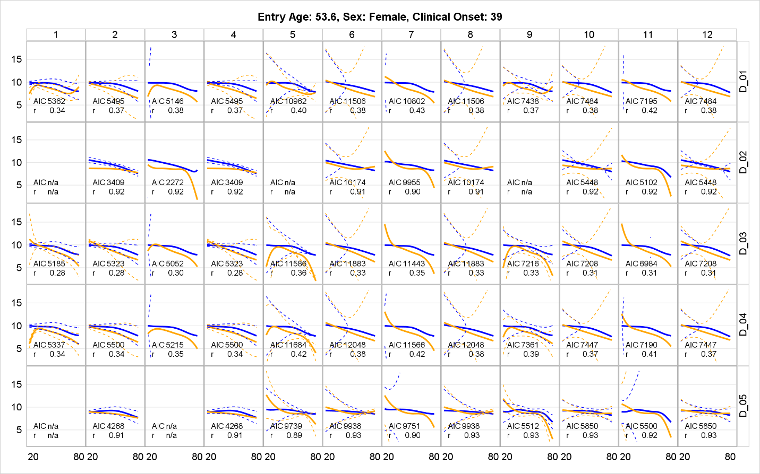
01: age-spline MS-status X Y
02: age-spline MS-status Y Z
03: age-spline MS-status X V
04: age-spline MS-status X W
05: age-spline MS-status Y Z

Supplemental Figure 4B: Model Fitting for Covariate Category D (06-10)

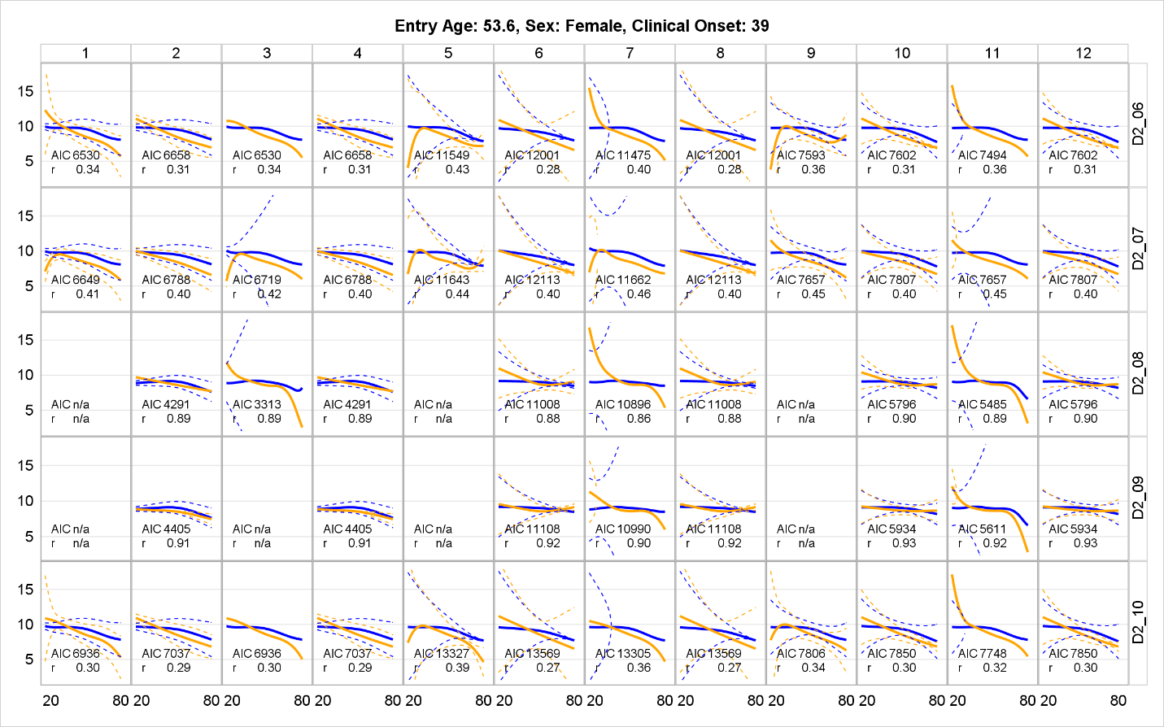

06: age-spline MS-status X V
07: age-spline MS-status Y W
08: age-spline MS-status Z V
09: age-spline MS-status Z W
10: age-spline MS-status V W

Supplemental Figure 5A: Model Fitting for Covariate Category E (01-05)
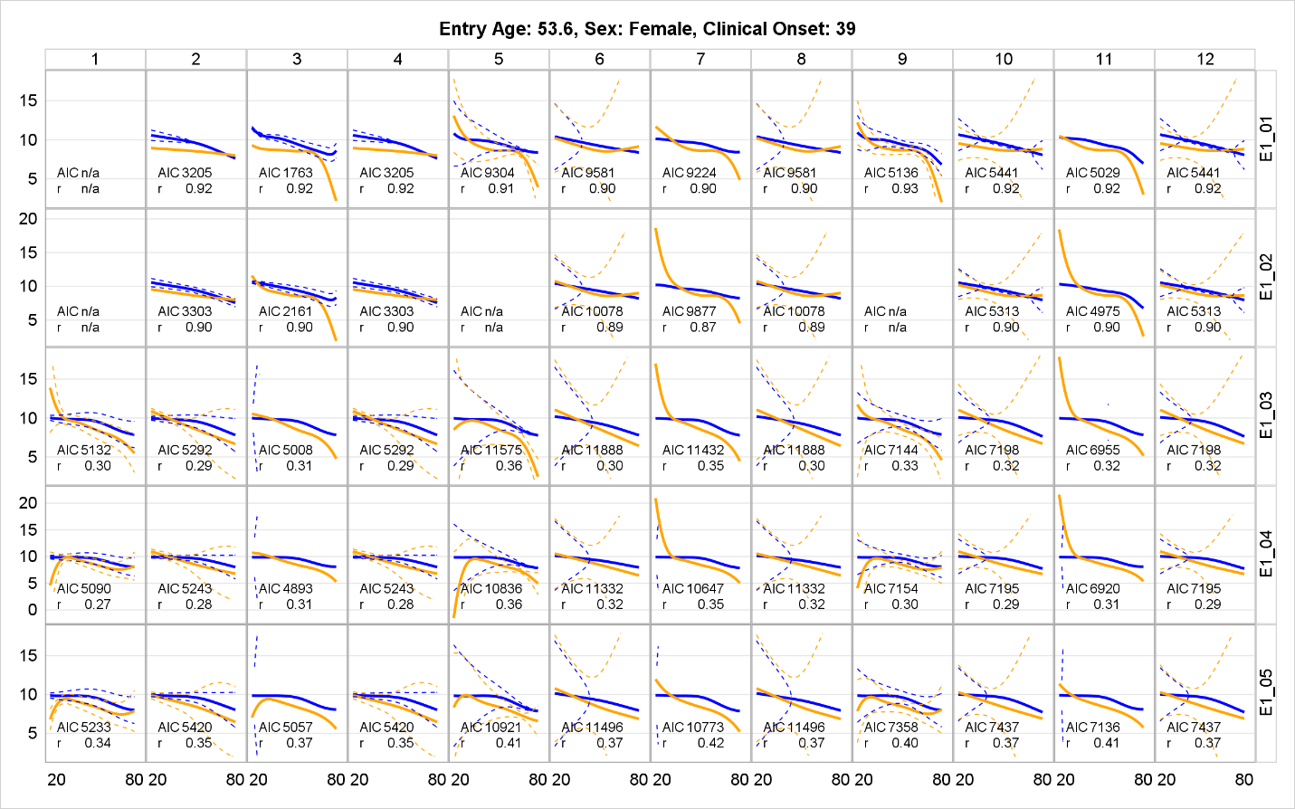

01: age-spline MS-status X Y Z
02: age-spline MS-status X Z V
03: age-spline MS-status X V W
04: age-spline MS-status X Y V
05: age-spline MS-status X Y W

Supplemental Figure 5B: Model Fitting for Covariate Category E (06-10)

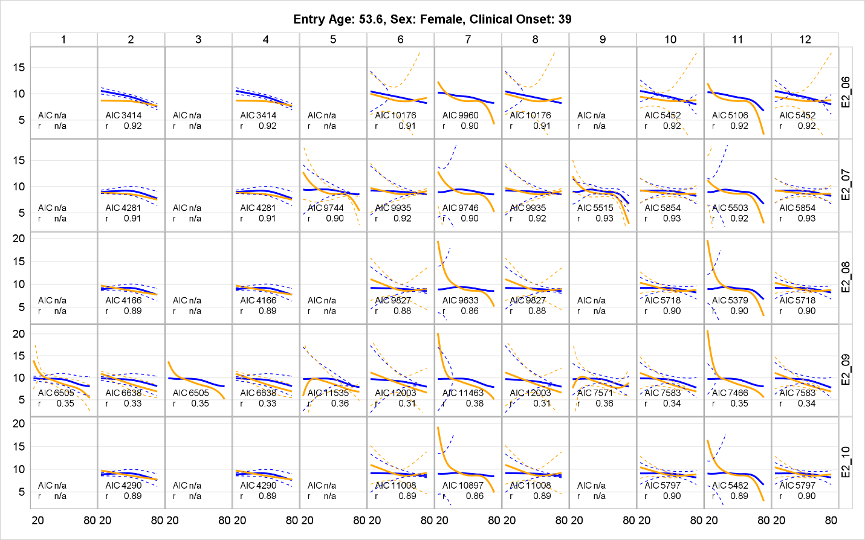

06: age-spline MS-status X Z W
07: age-spline MS-status Y Z W
08: age-spline MS-status Y Z V
09: age-spline MS-status Y V W
10: age-spline MS-status Z V W

Supplemental Figure 6: Model Fitting for Covariate Category F (01-06)
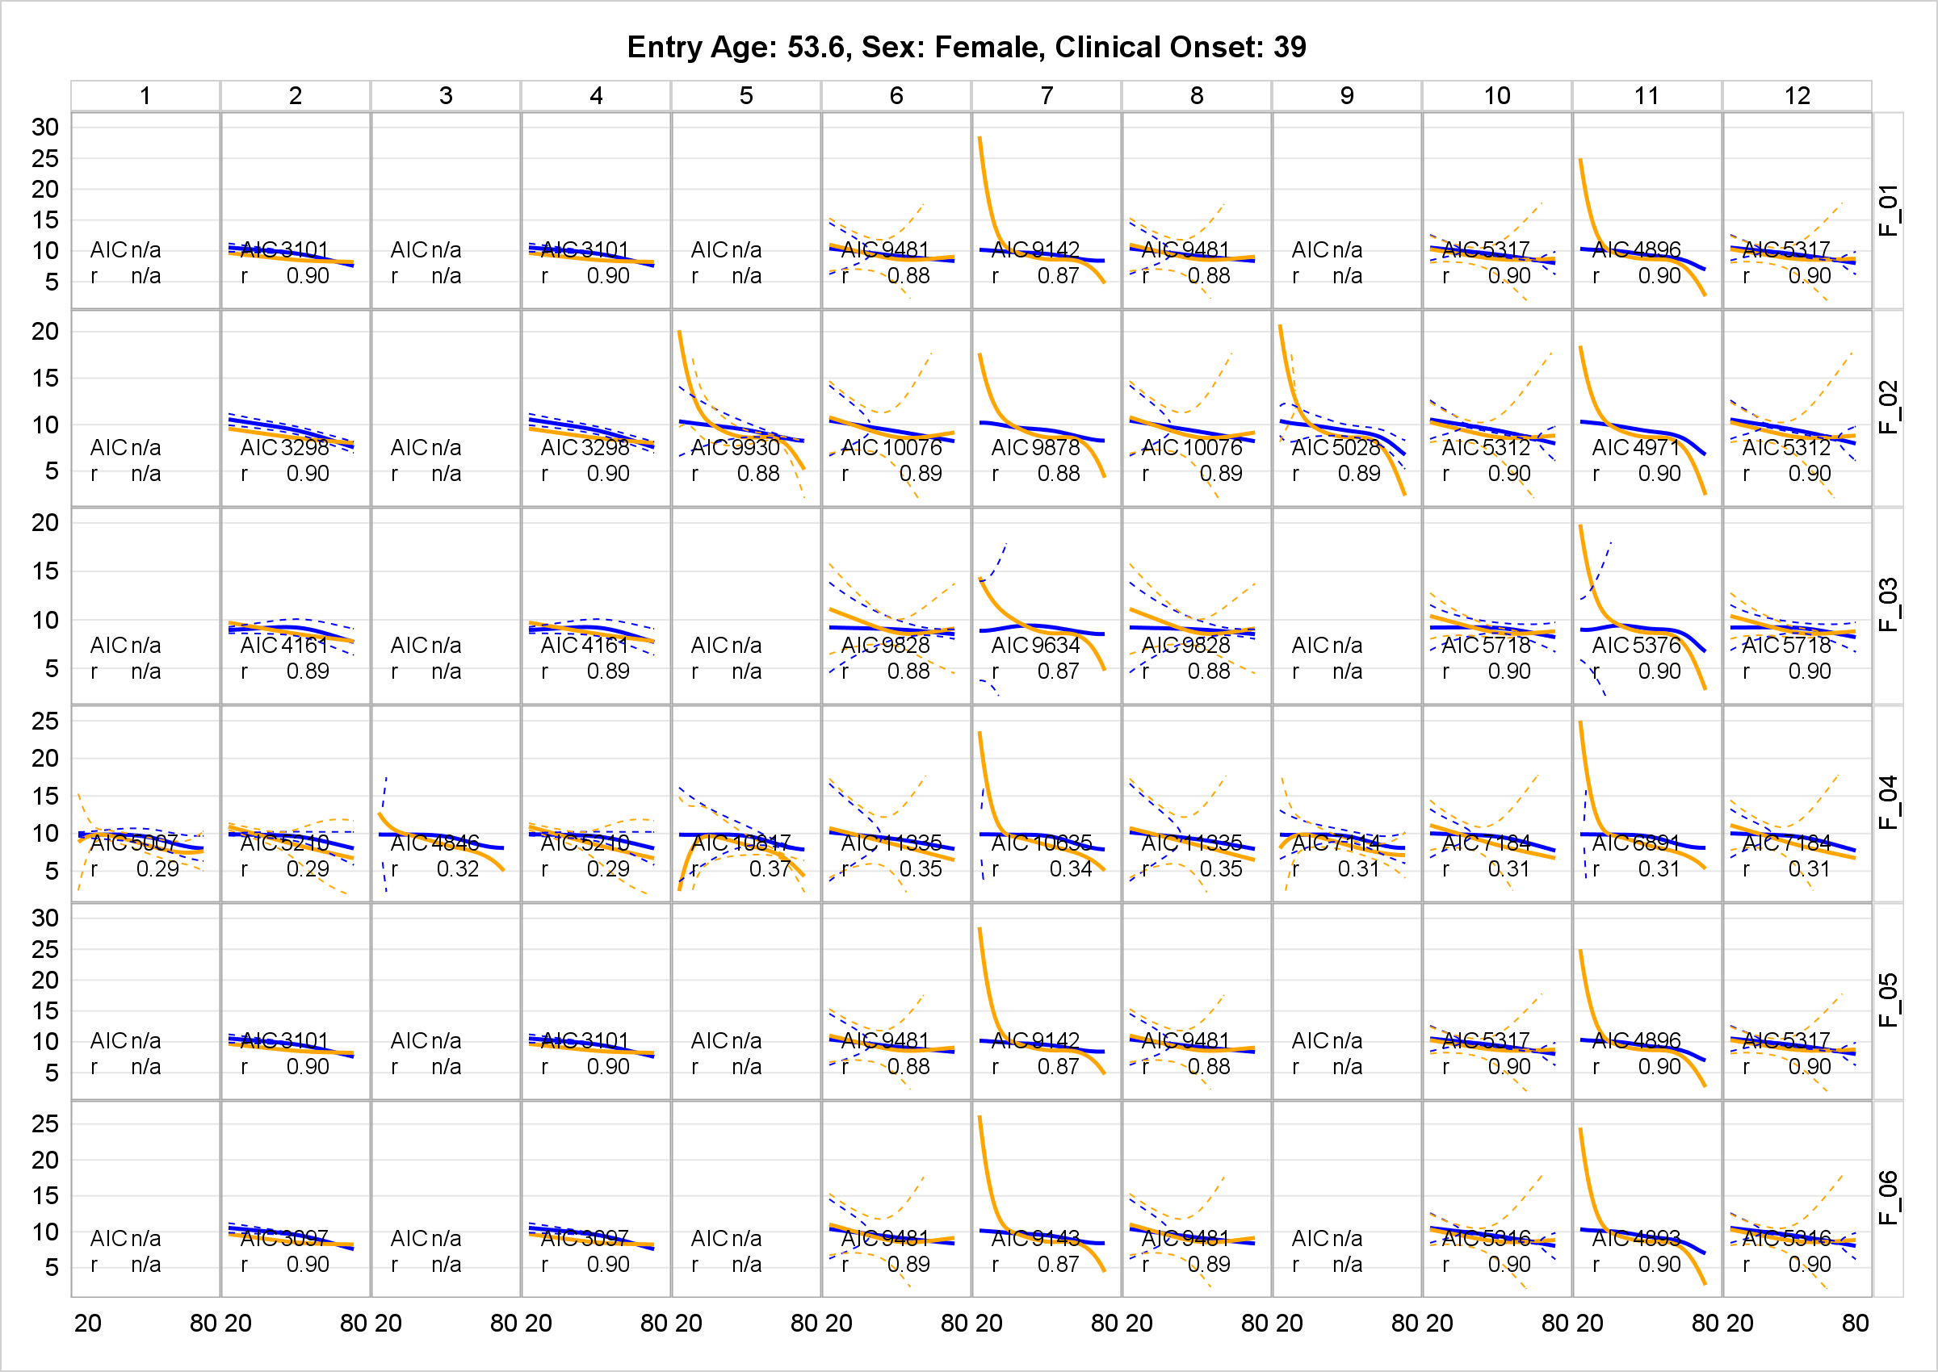

01: age-spline MS-status X Y Z V
02: age-spline MS-status X Z V W
03: age-spline MS-status X Z V W
04: age-spline MS-status X Y V W
05: age-spline MS-status X Y Z V
06: age-spline MS-status X Y Z V W

Supplemental Figure 7: Model Fitting for Covariate Category G (01-06)
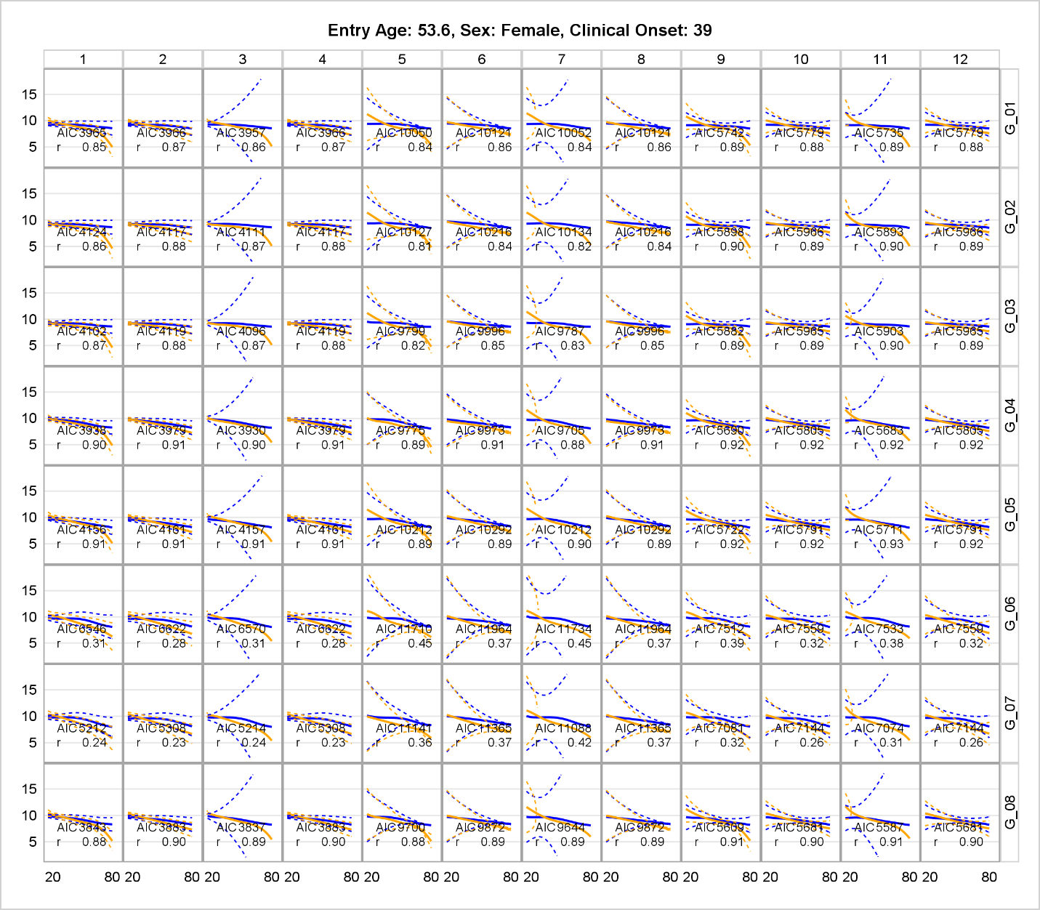

01: age-spline MS-status icv sex sex*MS-status Thalamus0 age-of-onset DMT0
02: age-spline MS-status icv sex sex*MS-status Thalamus0
03: age-spline MS-status icv sex sex*MS-status Thalamus0 sex*age-spline
04: age-spline MS-status icv sex sex*MS-status Thalamus0 sex*age-spline age-at-study-entry
05: age-spline MS-status sex sex*MS-status Thalamus0 sex*age-spline age-at-study-entry
06: age-spline MS-status sex sex*MS-status sex*age-spline age-at-study-entry
07: age-spline MS-status icv sex sex*MS-status age-at-study-entry age-of-onset DMT0
08: age-spline MS-status icv sex sex*MS-status Thalamus0 sex*age-spline age-at-study-entry age-of-onset DMT0

Supplemental Figure 8: HDT and MS Trajectory Curves for 50 Individuals from Cross-Validation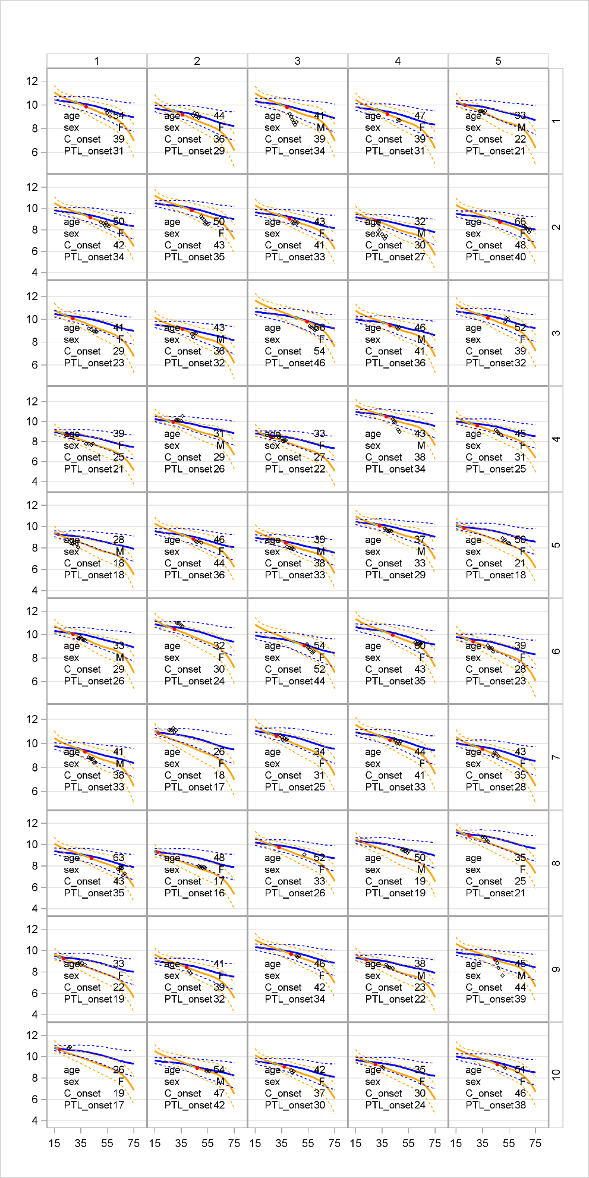
Rad Dots: Age of Clinical Onset (C_onset)
Green Circle: Age of Onset from Progressive Brain Tissue Loss (PTL_onset)
Black Diamond: Observed % Thalamus

Supplemental Figure 9: Distribution of Percent Thalamus Volume before and after Neuro-Combat Harmonization

Supplemental Figure 10: Spaghetti Plot for MS and Spline Trend Based on Baseline Data

