Satellite images of water bodies
Feedback Coefficient
Distance between samples

$$ω$$

Edge-preserved noise eliminated preprocessed image

Block diagram of Nonlinear Neighbor Recursive Filter

5.3 Block Diagram
Preprocessing
Satellite images of water bodies
Noise elimination
Edge preservation
Preprocessed images

Feature Extraction
Preprocessed images

Relevant feature Extraction
Training CNN model
Training Data

Classification
Relevant feature Extraction
images
Accurate water body identification
Classifications
Testing
Data

Figure 4 Flow chart of Water body identification of Satellite image

5.4 CNN Architecture of Proposed Model
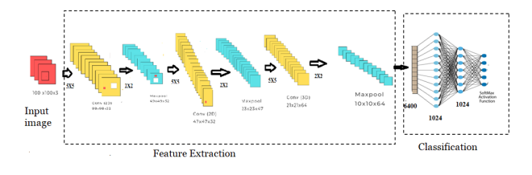
Fig.3 CNN Architecture of Proposed model

