Supplementary Information
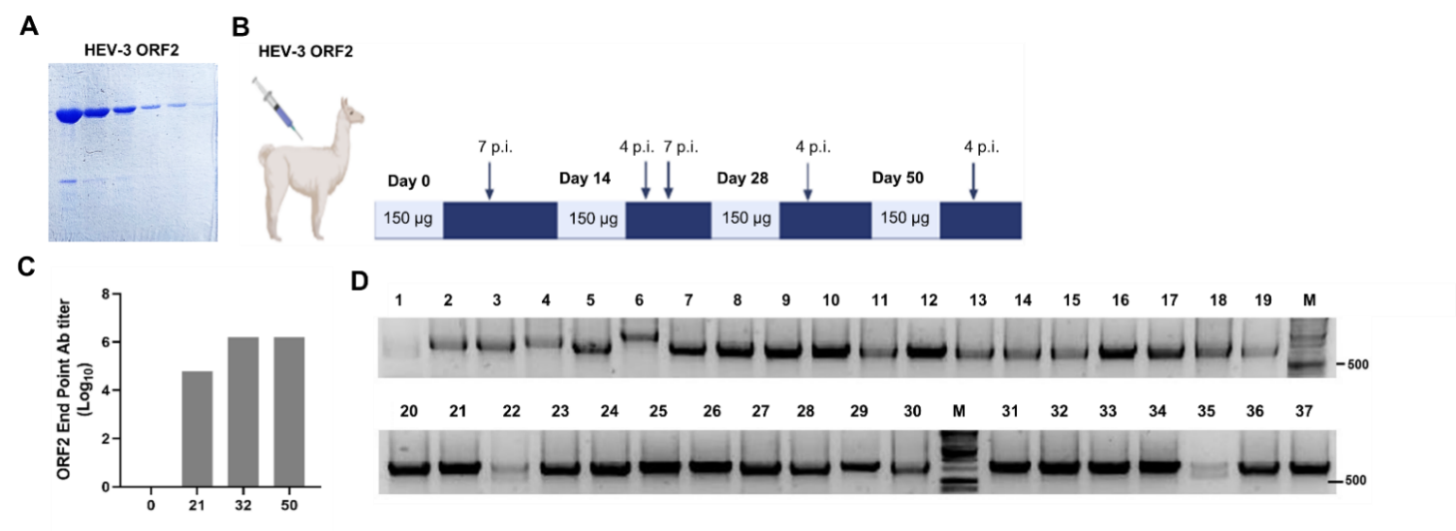
Supplementary Figure S1. Antigen preparation and llama immunization. (A) SDS-PAGE and Coomassie blue staining showing the expression and purification of the recombinant HEV-3 ORF2 protein. (B) Schematic representation of the llama immunization protocol depicting boosting, antigen dose and blood extraction time (p.i.: post immunization). (C) Antibody titer against HEV-3 ORF2 in llama sera after immunization, a maximum response is reached at PID 32. (D) Agarose gel showing the ~700 bp PCR fragments corresponding to VHHs of variable size amplified from randomly picked individual colonies.

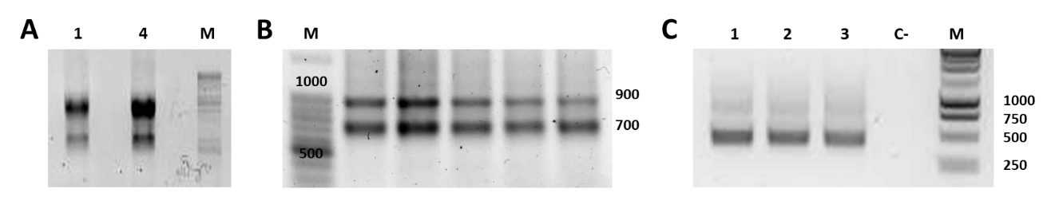
Supplementary Figure S2. Construction of an immune Nb library. (A) Total RNA extracted from llama lymphocytes (sample 1 and 4) was reversed transcribed into cDNA and used as templates for the nested PCR. (B) First PCR, a fragment of ~700 bp representing the heavy chain–only antibody repertoire and a fragment of 1,000 bp corresponding to the heavy chain of the conventional antibodies were obtained. (C) The band of 700 bp was isolated and used as template for the second PCR, a fragment of 400 bp, corresponding to the VHHs was observed.
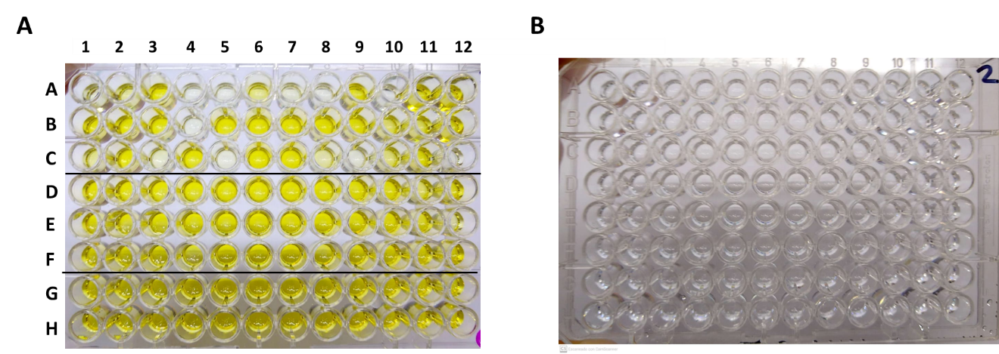
Supplementary Figure S3. Screening of specific Nbs against HEV-3 ORF2 protein extracted from periplasm of infected TG1 bacteria. (A) ELISA on a plate coated HEV-3 ORF2 protein. (B) ELISA on a plate coated with an irrelevant protein (negative control). Specific reaction was developed using horseradish peroxidase (HRP)-linked anti-HA antibody and the TMB substrate. Colonies were picked from agar plates seeded with infected TG1 after different round of panning and elution strategies as follows: A1-A12 and B1-B4 (first round of panning - cell elution); B5-B12 and C1-C12 (first round of panning - trypsin elution); D1-D12 and E1-E4 (second round of panning - cell elution); E5-E12 and F1-F12 (second round of panning - trypsin elution); G1-G12 and H1-H6 (third round of panning - trypsin elution) and H6-H12 (third round of panning – cell elution).

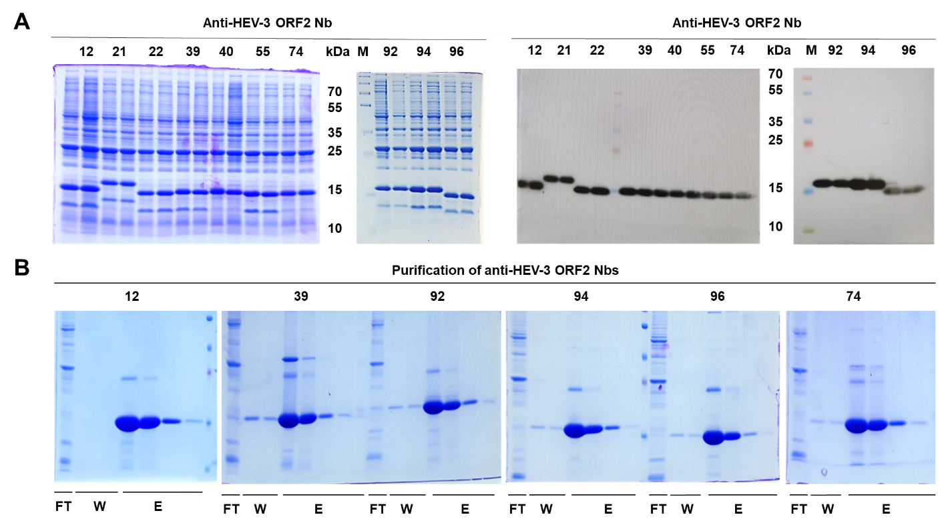
Supplementary Figure S4. Expression and purification of anti-HEV-3 ORF2 Nbs. (A) Ten Nbs (two different clones for each Nb) were analyzed by SDS-PAGE and Western blot, proteins with small differences in size were observed. (B) Purification of 6 Nbs by affinity chromatography (Ni-NTA resin), FT: flow through, W: wash, and E: elution.
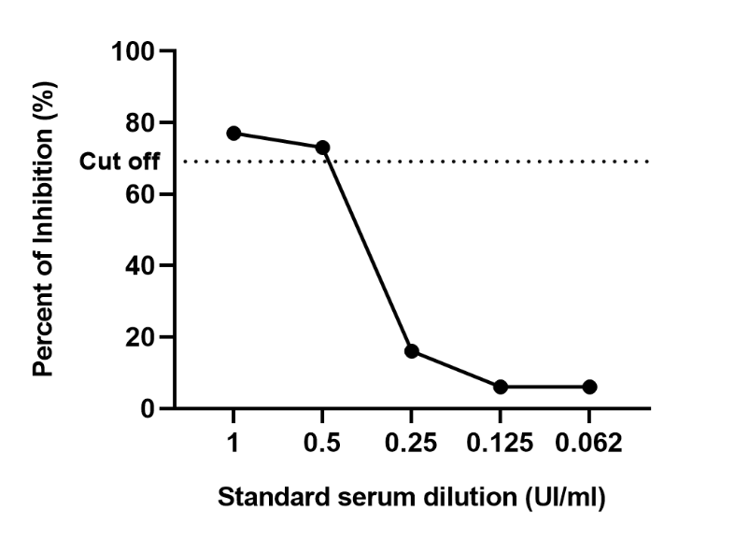
Supplementary Figure S5. Limit of detection of the cELISA. Standard serum for HEV antibodies was diluted and analyzed by developed cELISA.

Supplementary Table 1 Determination of the positive/negative ratio to select the optimal conditions of a novel cELISA for human and swine sera

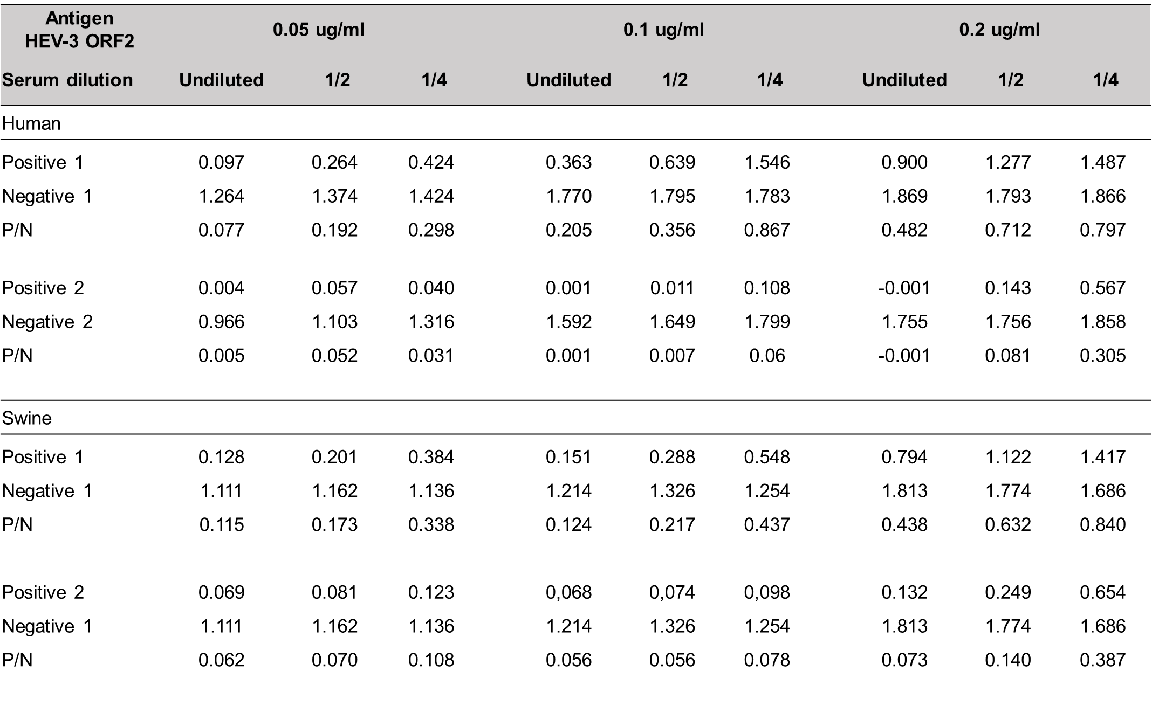

Supplementary Table 2 Reproducibility of novel cELISA

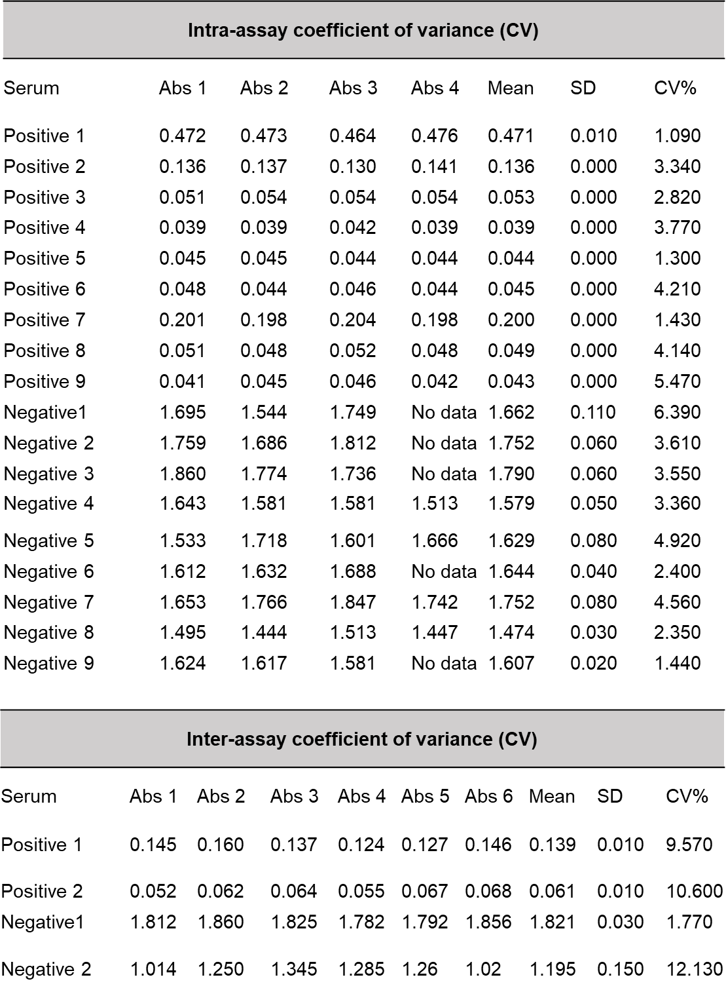

Supplementary Table 3 Agreements of the cELISA with a commercial ELISA with samples from different species
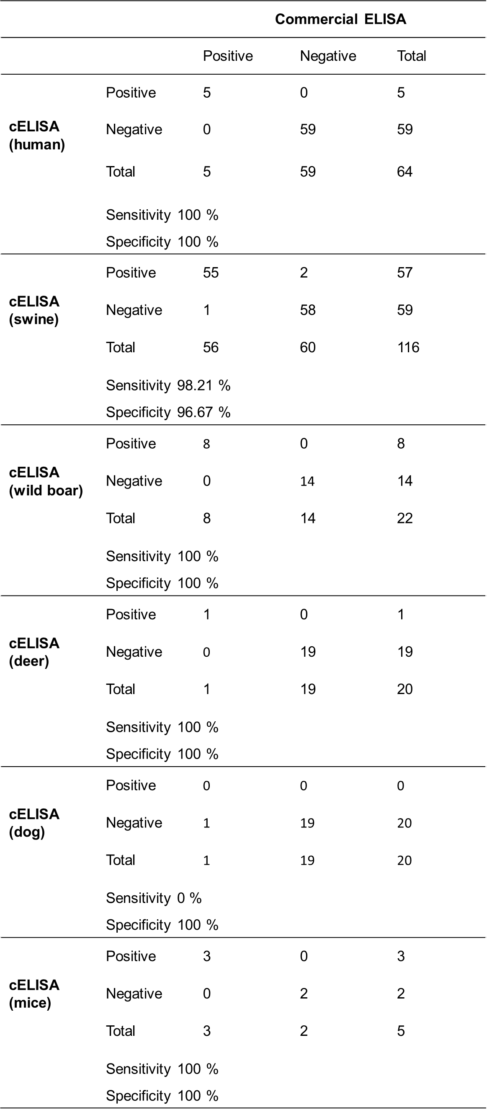

Unmodified gels
Supplementary Figure S1.
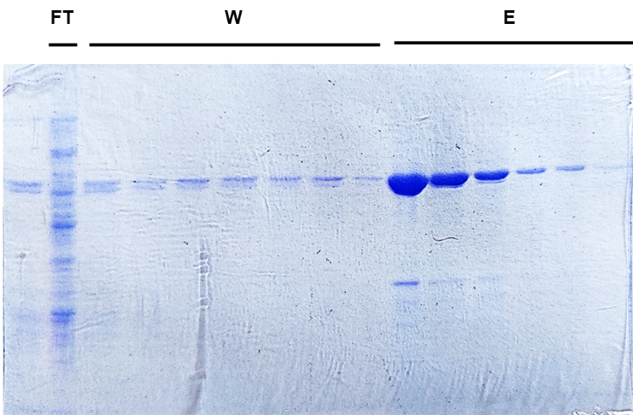

(A) SDS-PAGE and Coomassie blue staining showing the expression and purification of the recombinant HEV-3 ORF2 protein. FT: flow through, W: wash, and E: elution.

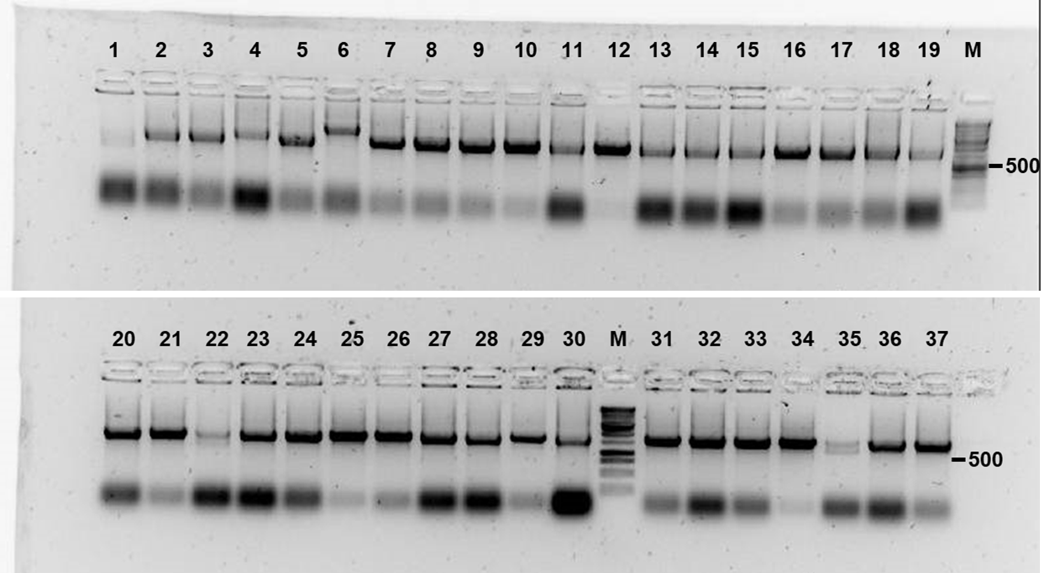

(D) Agarose gel showing the ~700 bp PCR fragments corresponding to VHHs of variable size amplified from randomly picked individual colonies.

Supplementary Figure S2.
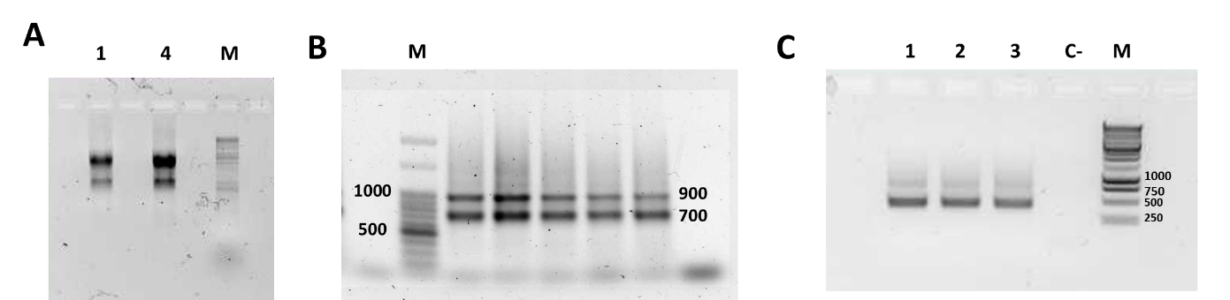
(A) Total RNA extracted from llama lymphocytes (sample 1 and 4) was reversed transcribed into cDNA and used as templates for the nested PCR.
(B) First PCR, a fragment of ~700 bp representing the heavy chain–only antibody repertoire and a fragment of 1,000 bp corresponding to the heavy chain of the conventional antibodies were obtained.
(C) The band of 700 bp was isolated and used as template for the second PCR, a fragment of 400 bp, corresponding to the VHHs was observed.

Supplementary Figure S4.

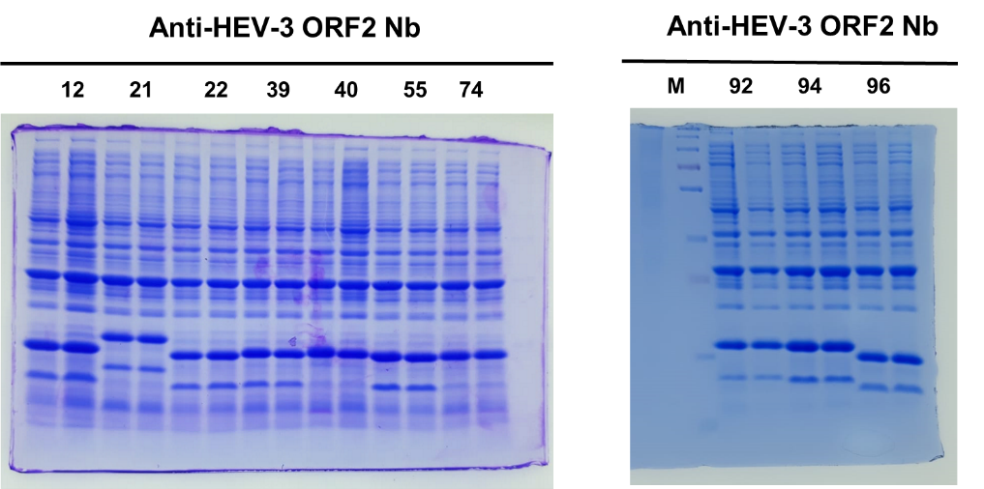

(A) Ten Nbs (two different clones for each Nb) were analyzed by SDS-PAGE and Western blot, proteins with small differences in size were observed.

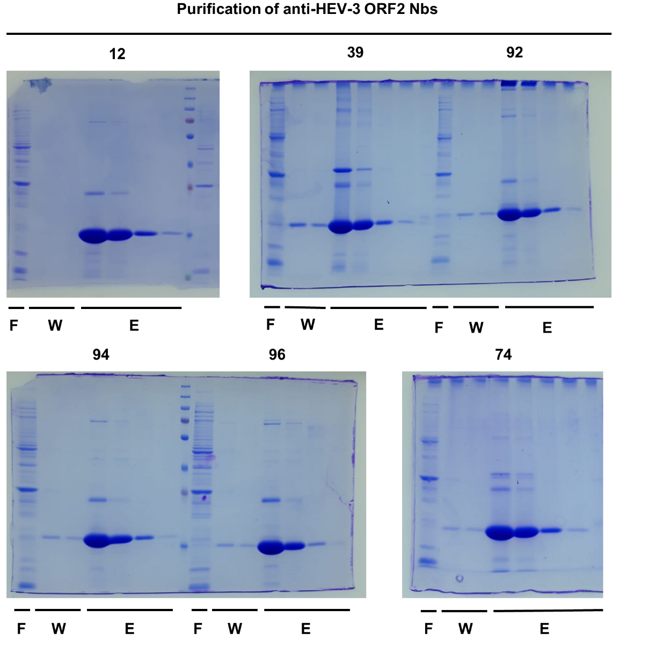

(B) Purification of 6 Nbs by affinity chromatography (Ni-NTA resin), FT: flow through, W: wash, and E: elution.

