Supplementary data

Description of Sporanaerobium hydrogeniformans gen. nov., sp. nov., an obligately anaerobic, hydrogen producing bacterium of Lachnospiraceae family isolated from Aravali hot spring in India

Sai Suresh Hivarkar^{1,2}, Gowdaman Vasudevan¹, Prashant K. Dhakephalkar^{1,2} and Sumit Singh Dagar^{1,2}*

¹Bioenergy Group, Agharkar Research Institute, Pune, India
²Savitribai Phule Pune University, Ganeshkhind, Pune, India

Running title: A new anaerobic bacterial genus Sporanaerobium

*Corresponding author:
Mailing address: Bioenergy Group, Agharkar Research Institute, Gopal Ganesh Agarkar Road, Pune – 411004, India.
E-mail: ssdagar@aripune.org, dagarsumit@gmail.com

Supplementary tables
Table S1. Comparison of substrate utilization profiles of Sporanaerobium hydrogeniformans XHS1971^{T} and Cellulosilyticum lentocellum DSM 5427^{T}.
Strains: 1, Sporanaerobium hydrogeniformans XHS1971^{T}; 2, Cellulosilyticum lentocellum DSM 5427 ^{T}

Sr. no. | Substrate | 1 | 2 | Sr. no. | Substrate | 1 | 2 | Sr. no. | Substrate | 1 | 2
1 | N-Acetyl-D-Galactosamine | - | - | 36 | α-Methyl-D-Galactoside | - | - | 71 | Urocanic Acid | - | -
2 | N-Acetyl-D-Glucosamine | - | - | 37 | β-Methyl-D-Galactoside | - | - | 72 | L-Alaninamide | - | -
3 | N-Acetyl-D-Mannosamine | - | - | 38 | α-Methyl-D-Glucoside | - | - | 73 | L-Alanine | - | -
4 | Adonitol | - | - | 39 | β-Methyl-D-Glucoside | - | - | 74 | L-Alanyl-L-Glutamine | - | -
5 | Amygdalin | - | + | 40 | Palatinose | + | + | 75 | L-Alanyl-L-Histidine | - | -
6 | D-Arabitol | - | - | 41 | D-Raffinose | - | - | 76 | L-Alanyl-L-Threonine | - | -
7 | Arbutin | - | + | 42 | L-Rhamnose | + | + | 77 | L-Asparagine | - | -
8 | D-Cellobiose | - | + | 43 | Salicin | - | + | 78 | L-Glutamic Acid | - | -
9 | α-Cyclodextrin | - | - | 44 | D-Sorbitol | - | + | 79 | L-Glutamine | - | -
10 | β-Cyclodextrin | - | + | 45 | Stachyose | - | - | 80 | Glycyl-L-Aspartic Acid | - | -
11 | Dextrin | - | + | 46 | Sucrose | - | + | 81 | Glycyl-L-Glutamine | - | -
12 | Dulcitol | - | - | 47 | D-Trehalose | - | - | 82 | Glycyl-L-Methionine | - | -
13 | i-Erythritol | - | - | 48 | Turanose | - | + | 83 | Glycyl-L-Proline | - | -
14 | D-Fructose | + | + | 49 | Acetic Acid | - | - | 84 | L-Methionine | - | -
15 | L-Fucose | + | + | 50 | Formic Acid | - | + | 85 | L-Phenylalanine | - | -
16 | D-Galactose | - | + | 51 | Fumaric Acid | - | - | 86 | L-Serine | - | +
17 | D-Galacturonic Acid | + | - | 52 | Glyoxylic Acid | - | - | 87 | L-Threonine | - | -
18 | Gentibiose | - | + | 53 | α-Hydroxybutyric acid | - | - | 88 | L-Valine | - | -
19 | D-Gluconic Acid | - | - | 54 | β -Hydroxybutyric Acid | - | - | 89 | L-Valine plus L-Aspartic Acid | - | -
20 | D-Glucosaminic Acid | - | + | 55 | Itaconic Acid | - | - | 90 | 2’-Deoxy Adenosine | - | -
21 | α-D-Glucose | - | + | 56 | α-Ketobutyric acid | - | - | 91 | Inosine | - | -
22 | Glucose-1- Phosphate | - | - | 57 | α-Ketovaleric Acid | - | - | 92 | Thymidine | - | -
23 | Glucose-6-Phosphate | - | + | 58 | D,L,-Lactic Acid | - | - | 93 | Uridine | - | -
24 | Glycerol | - | - | 59 | L-Lactic Acid | - | - | 94 | Thymidine-5’-Monophosphate | - | -
25 | D,L-α-Glycerol Phosphate | - | - | 60 | D-Lactic Acid Methyl Ester | - | + | 95 | Uridine-5’-Monophosphate | - | -
26 | m-Inositol | - | - | 61 | D-Malic Acid | - | +
27 | α-D-Lactose | - | + | 62 | L-Malic Acid | - | +
28 | Lactulose | - | - | 63 | Propionic Acid | - | -
29 | Maltose | - | + | 64 | Pyruvic Acid | - | +
30 | Maltotriose | - | + | 65 | Pyruvic Acid Methyl Ester | - | +
31 | D-Mannitol | - | + | 66 | D-Saccharic Acid | - | +
32 | D-Mannose | - | - | 67 | Succinamic Acid | - | -
33 | D-Melezitose | - | + | 68 | Succinic Acid | - | -
34 | D-Melibiose | - | + | 69 | Succinic Acid Mono-Methyl Ester | - | -
35 | 3-Methyl-D-Glucose | - | + | 70 | m-Tartaric acid | - | -
Legends: +, utilized; -, not utilized

Table S2. Comparison of glucose fermentation products of Sporanaerobium hydrogeniformans XHS1971^{T} and Cellulosilyticum lentocellum DSM 5427^{T}.

Fermentation product (in mM) | Sporanaerobium hydrogeniformans strain XHS1971^{T} | Cellulosilyticum lentocellum DSM 5427^{T}
Hydrogen | 163±3.98 | nd
Carbon dioxide | 1.64±0.18 | 1.15±0.05
Formic acid | 27.35±0.70 | 18.71±0.56
Acetic acid | 22.52±0.10 | 19.66±0.21
Propionic acid | 1.55±0.04 | 1.56±0.04
Butyric acid | 2.57±0.13 | nd
Lactic acid | 0.45±0.01 | 0.31±0.02
Succinic acid | 0.18±0.02 | 0.15±0.00
Ethanol | 29.18±0.78 | 13.05±0.13
Legends: nd- not detected; values are expressed as mean ± standard deviation (n=3)

Table S3. Comparison of enzyme activities of Sporanaerobium hydrogeniformans XHS1971^{T} and Cellulosilyticum lentocellum DSM 5427^{T}.

Enzyme activity (µmol/mL/h) | Sporanaerobium hydrogeniformans XHS1971 ^{T} | Cellulosilyticum lentocellum DSM 5427^{T}
Avicelase | 0.38±0.09 | 2.06±0.29
CMCase | 1.70±0.13 | 8.74±1.64
Xylanase | 0.89±0.42 | 12.06±0.59
Values are expressed as mean ± standard deviation (n=3)

Table S4. Comparison of major cellular fatty acids of Sporanaerobium hydrogeniformans XHS1971^{T} and Cellulosilyticum ruminicola JCM 14822^{T}.

Fatty acids  (as % of total peak area) | Sporanaerobium hydrogeniformans XHS1971^{T} | Cellulosilyticum ruminicola JCM 14822^{T}  (Cai and Dong 2010)
Saturated straight chain
C_{12 : 0} | 2.63 | 3.39
C_{13 : 0} | 0.3 | 1.36
C_{14 : 0} | 12.82 | 9.2
C_{15 : 0} | 1.71 | 3.74
C_{16 : 0} | 23.52 | 27.1
C_{16 : 0} DMA | 2.02 | Nd
C_{17 : 0} | 0.38 | 4.2
C_{18 : 0} | 5.36 | 4.1
Saturated branched chain
iso-C_{12 : 0} | nd | 2.64
iso-C_{14 : 0} | 0.68 | 2.91
iso-C_{16 : 0} | 0.44 | 6.4
anteiso-C_{13 : 0} | 0.32 | 1.46
anteiso-C_{15 : 0} | 1.38 | 1.28
anteiso-C_{17 : 0} | nd | 2.15
Unsaturated straight chain
C_{16 : 1} ω5c | 1.91 | nd
C_{16 : 1} ω7c | 13.29 | nd
C_{16 : 1} ω7c DMA | 1.1 | nd
C_{17 : 1} ω8c | nd | 2.69
C_{18 : 1} ω7c | nd | 4.7
C_{18 : 1} ω7c DMA | 2.43 | nd
C_{18 : 1} ω9c | 1.57 | 3.84
Sum in feature*
anteiso-C_{15 : 0} 3-OH and/or C_{16 : 1}ω9c DMA | 1.18 | nd
C_{18 : 1}ω7c and/or unknown 17.834 | 11.51 | nd
C_{16 : 1} ω7c and/or iso-C₁₅ 2-OH | nd | 4.1
iso-C_{17 : 1} I and/or anteiso-C_{17 : 1} B | nd | 2.19
Legends: nd- not detected
Fatty acid values of less than 1% are not given, except in case of comparison.
Major fatty acids (>5%) are highlighted in bold; values are mean of triplicate.
*Sum in feature are groups of two or three fatty acids that could not be separated using the Microbial Identiﬁcation System.

Table S5. Genome annotation of Sporanaerobium hydrogeniformans XHS1971^{T} using RAST server.

Attributes | Values
Genome size | 3,743,071 bp
Total number of contigs | 65
G + C content (%) | 35.3
Total number of subsystems | 360
Total number of coding sequence | 3481
N50 | 137680
tRNAs | 80
rRNAs | 23

Supplementary Figures
Fig. S1. Phylogenetic tree based on 16S rRNA gene sequences showing the phylogenetic positions of Sporanaerobium hydrogeniformans XHS1971^{T} (in bold) among the closest relatives within the family Lachnospiraceae. Relatedness was inferred using the neighbor-joining method in NGPhylogeny.fr (FastME/OneClick) and rooted with Thermoanaerobacter ethanolicus strain ATCC 31550^{T}. Numbers on the tree branches indicate bootstrap values calculated for 1000 subsets for branch points >34%. The GenBank accession number of each strain is listed in parentheses. The scale bar indicates 0.05 nucleotide substitutions per site.

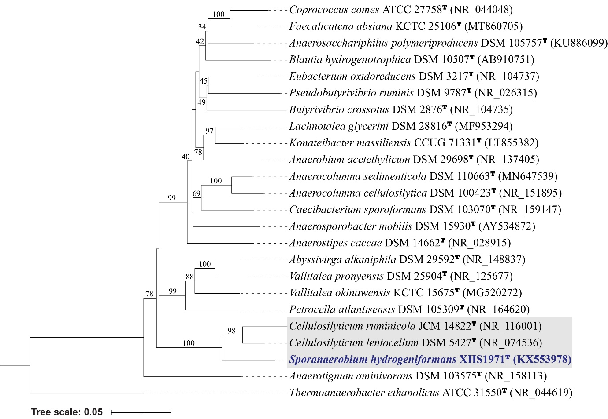

Fig. S2. Phylogenetic tree based on 16S rRNA gene sequences showing the phylogenetic positions of Sporanaerobium hydrogeniformans XHS1971^{T} (in bold) among the closest relatives within the family Lachnospiraceae. Relatedness was inferred using the maximum parsimony method in MEGA11 and rooted with Thermoanaerobacter ethanolicus strain ATCC 31550^{T}. Numbers on the tree branches indicate bootstrap values calculated for 500 subsets for branch points >27%. The GenBank accession number of each strain is listed in parentheses. The scale bar indicates 20 nucleotide substitutions per site.

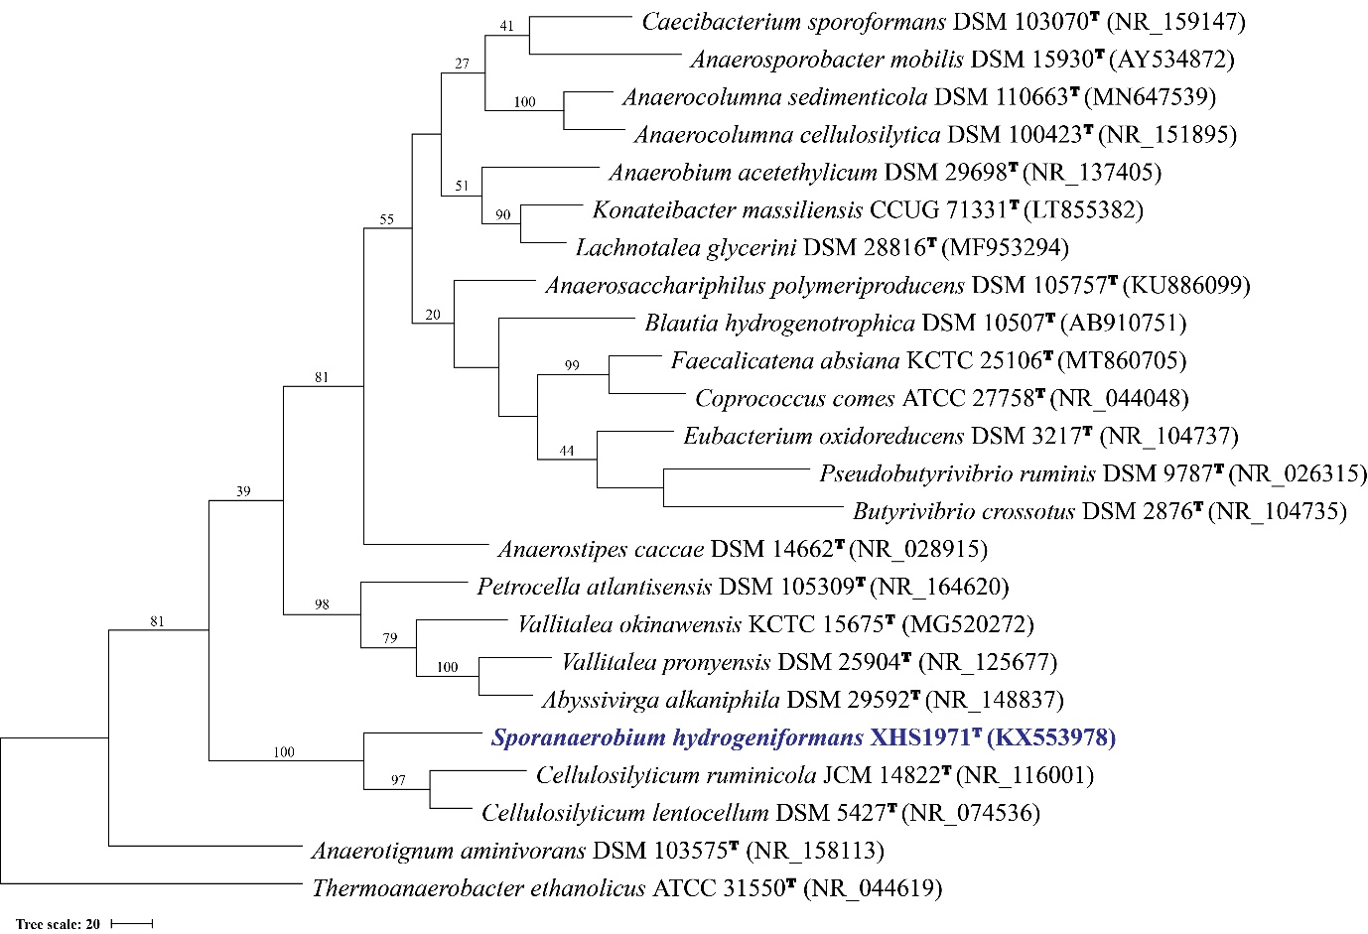

Fig. S3. BASys annotation of the Sporanaerobium hydrogeniformans XHS1971^{T} exhibiting the distribution and counts of genes in COG categories.

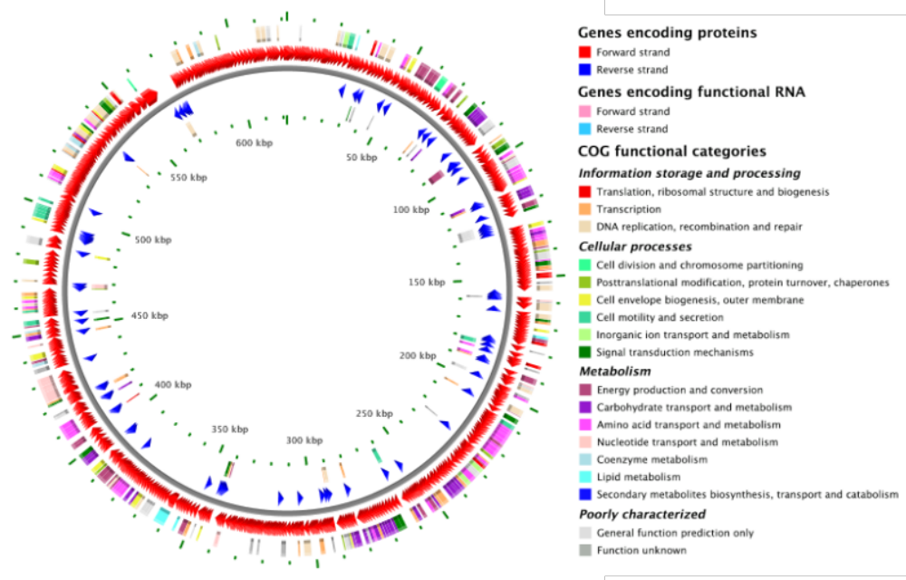

Fig. S4. Phylogenetic tree based on 16S rRNA gene sequences showing the phylogenetic positions of Sporanaerobium hydrogeniformans XHS1971^{T} (in bold) among the closest non-type sequences (sequence similarities of 92-94%) within the family Lachnospiraceae. Relatedness was inferred using the maximum-likelihood method in W-IQ-TREE and rooted with Thermoanaerobacter ethanolicus strain ATCC 31550^{T}. Numbers on the tree branches indicate bootstrap values calculated for 1000 subsets. The GenBank accession number of each strain is listed in parentheses. The habitat of the sequence is written in red. The scale bar indicates 0.1 nucleotide substitutions per site.

