Supplementary Information
Upcycling Recycled Epoxy-Based Vitrimer for Enhancing Toughness of Poly(ethylene terephthalate)

Chin-Wen Chen*, Hsu-I Mao, Hong-Kuan Lee, Jui-Yang Chou and Syang-Peng Rwei*

Department of Molecular Science and Engineering, Institute of Organic and Polymeric Materials, Research and Development Center of Smart Textile Technology, National Taipei University of Technology, No. 1, Sec. 3, Chung-Hsiao East Road., Taipei, 10608, Taiwan

Corresponding authors
Prof. C. –W. Chen cwchen@ntut.edu.tw
Prof. S. –P. Rwei f10714@ntut.edu.tw

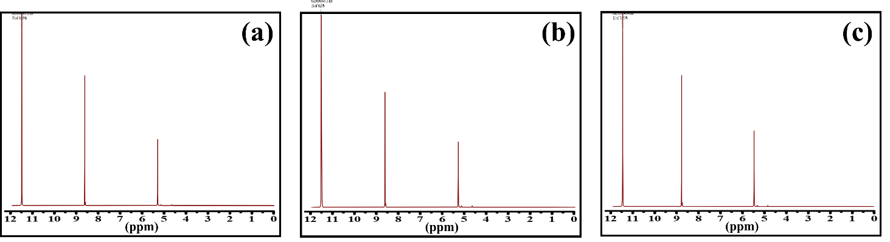
Fig. S1 ¹H-NMR spectra of the copolymers with various vitrimer content (a) PET+0.25% (b) PET+0.5%, and (c) PET+0.75%
Take PET+1% as an example, the partially enlarged image of characterization signals displays two parts of small peaks distribution, as shown in Fig. 1. In the right image, the overlapped peaks e+f at around 1.9 ppm are related to the four methylene protons in the center of the SA segments. In the left image, the peaks l and k in a range of 7.5–8 ppm are attributed to the aromatic protons of the terephthalate units of DGEBA, which illustrates no overlap with the signals of terephthalate units of PET. Therefore, the mole ratio of PET segments and vitrimer segments can be calculated by the integral areas of the signals:
 | $${\text{X}}_{vitrimer}\text{=}{ \text{X}}_{SA}\text{= }{\text{I}}_{e+f}/8$$ | (1)
 | $${\text{X}}_{\text{PET}}\text{= }{\text{I}}_{a}/4$$ | (2)
The results are collected in Table S1.
Table S1 Relative integral areas of signals in the ¹H-NMR spectrum
Sample | $${\text{I}}_{e+f}/8$$ | $${\text{I}}_{a}/4$$
PET | - | -
PET+0.25% | 0.125 | 112.40
PET+0.5% | 0.125 | 58.26
PET+0.75% | 0.125 | 45.32
PET+1% | 0.125 | 26.75
The theoretical molecular weight of the repeat unit of PET is 192 g/mole, and the vitrimer is 542 g/mole. By calculating these data, the weight ratio existence in each samples can be confirmed. The results are tabulated in Table 2.
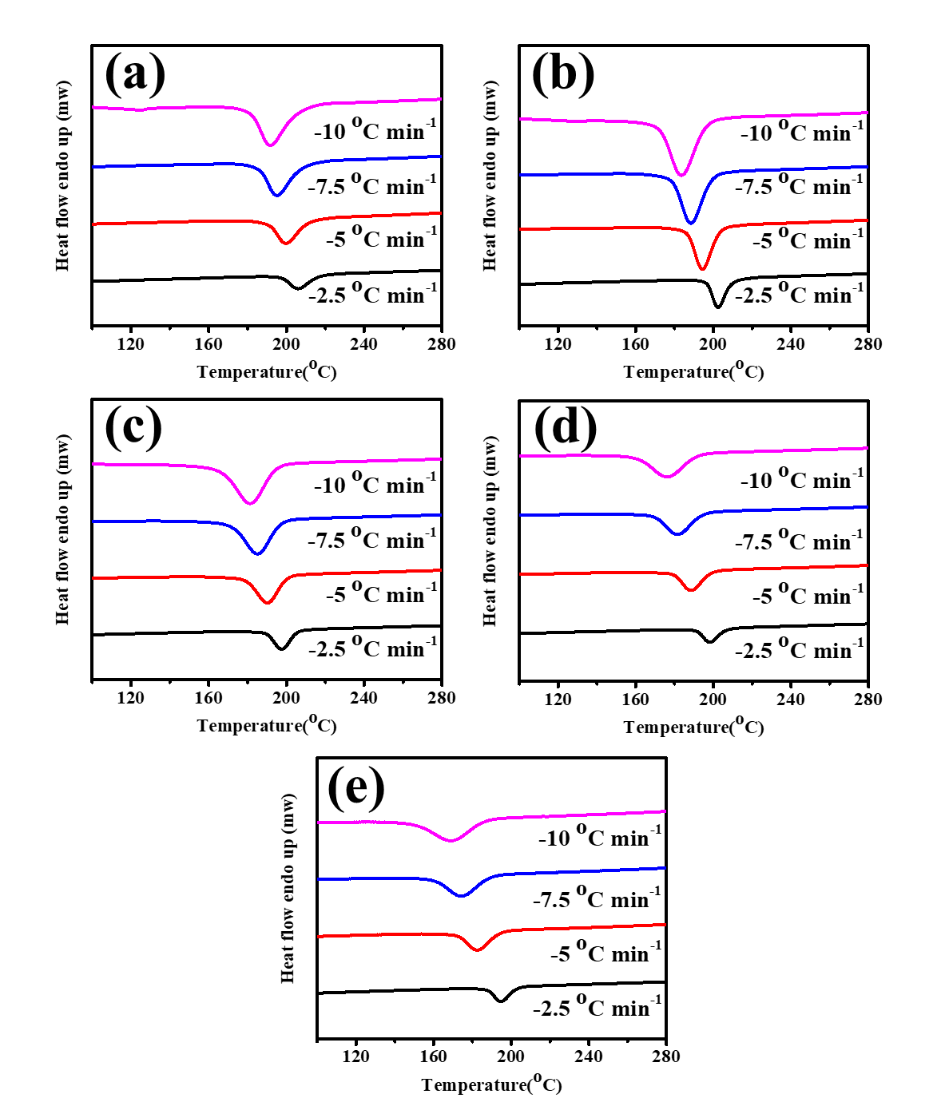
Fig. S2 DSC curve of copolymers of heating process at a rate of 10 °C min⁻¹ after the cooling process at 2.5, 5, 7.5, 10 °C min⁻¹. (a) PET, (b) PET+0.25%, (c) PET+0.5%, (d) PET+0.75%, and (e) PET+1%.
The nonisothermal DSC traces of copolymers in the cooling process under a rate of 2.5, 5, 7.5, and 10 min⁻¹ from 300 to 80 °C, as shown in Fig. S2. The following equation can calculate the relative crystallinity fraction X(t):
 | $$X\left(t\right)=\frac{X_{C}\left(t\right)}{X_{C}\left(t_{∞}\right)}=\frac{\int_{0}^{t}{\frac{ⅆH\left(t\right)}{ⅆt}ⅆt}}{\int_{0}^{∞}{\frac{ⅆH\left(t\right)}{ⅆt}ⅆt}}$$ | (S1)
Where dH(t) denotes the crystallization enthalpy at a specific temperature during the time interval dt via cooling while demonstrating that dH(t)/dt is the rate of heat flow, the relative crystallinity fraction X(t) as a function of time was analyzed as shown in Figure S3.
The exothermic heat during the crystallization process can be further analyzed, and the behavior is determined using the Avrami model as described in the following equation:
 | $$X\left(t\right)=1-\exp\left(-kt^{n}\right)$$ | (S2)
 | $$\log\left\{-\ln\left[1-x\left(t\right)\right]\right\}=-logk+n\log{t}$$ | (S3)
Where n is the Avrami exponent, and k is the constant of the crystallization rate.
The experimental data are substituted into the equations with X(t) range of 20%-80%, and the traces of log t versus log{–ln[1–X(t)]} for copolymers are exhibited in Figure S4. The slopes and intercepts of the traces obtained the Avrami equation parameters n and k. The following equations determined the half-time and growth rates:
 | 𝑡_{1/2} = (ln2/k)^{(1/𝑛)} | (S4)
 | G = 1/𝑡_{1/2} | (S5)

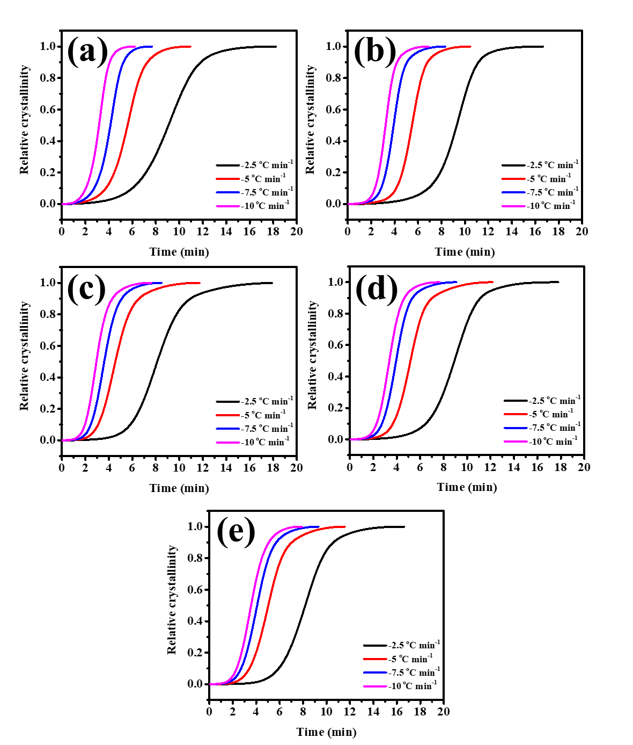
Fig. S3 Relative crystallinity (X(t)) as a function of crystallization time at various temperatures for copolymers. (a) PET, (b) PET+0.25%, (c) PET+0.5%, (d) PET+0.75%, and (e) PET+1% at various cooling rates.

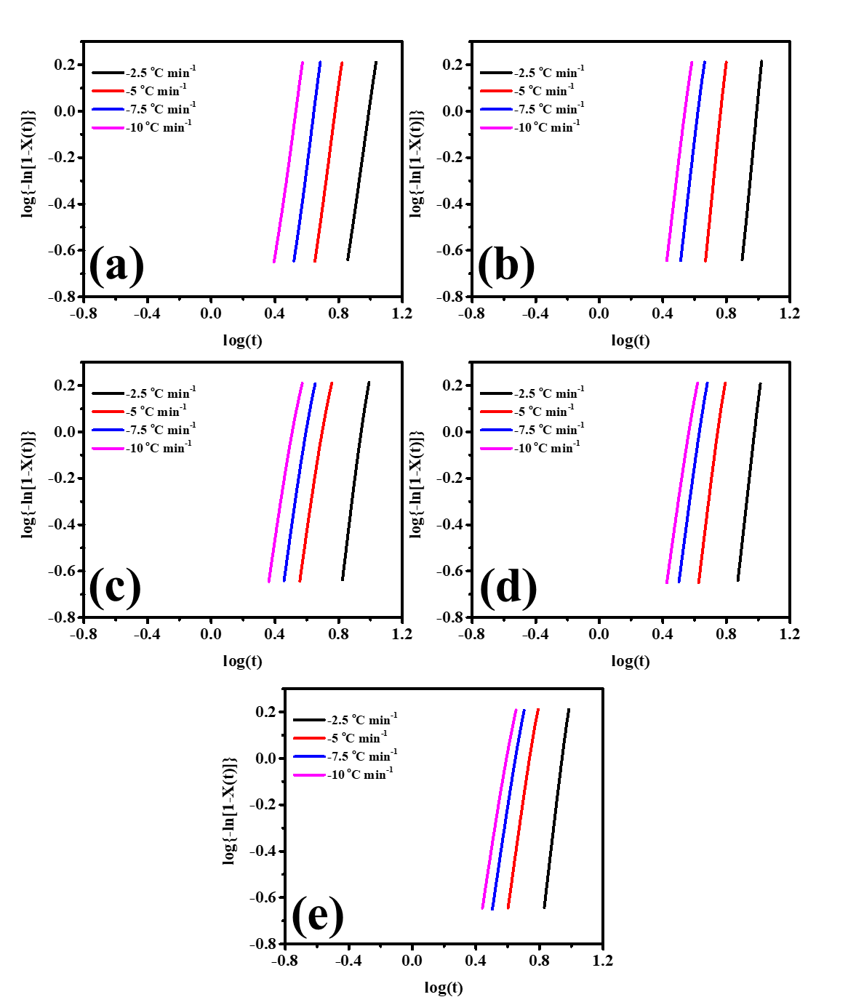
Fig. S4 Avrami plots for PBSPS copolymers (a) PET, (b) PET+0.25%, (c) PET+0.5%, (d) PET+0.75%, and (e) PET+1% at various cooling rates.

