Comparative analysis of deeply phenotyped GBM cohorts of ‘short-term’ and ‘long-term’ survivors
Archita Biswas1, Manuela Salvucci1, Kate Connor1, Heiko Düssmann1, Steven Carberry1, Michael Fichtner1, Ellen King1, Brona Murphy1, A.C O’Farrell1, Jane Cryan2, Alan Beausang2, Josephine Heffernan2, Mattia Cremona3, Bryan T. Hennessy3, James Clerkin1,4, Kieron J. Sweeney4, Steve MacNally4, F Brett4, P O’Halloran4, Orna Bacon1, Simon Furney1, Maite Verreault5, Emie Quissac5, Franck Bielle5, Mohammed Ahmed5, Ahmed Idbaih5, Sieger Leenstra6, Ioannis Ntafoulis6, Federica Fabro6, Martine Lamfers6, Anna Golebiewska7, Frank Hertel7 and 11, Simone P Niclou7 and 11, Romain Tching Chi Yen8, Andreas Kremer8, Gonca Dilcan9, Francesca Lodi9, Ingrid Arijs9, Diether
Lambrechts9, Manasa K P10, Alexander Kel10, Annette T. Byrne1, Jochen H.M. Prehn1*
1 Department of Physiology and Medical Physics and Centre for Systems Medicine, Royal College of Surgeons in Ireland, 123 St Stephen's Green, Dublin 2, D02 YN77, Ireland
2 Department of Neuropathology, Beaumont Hospital, Dublin 9, Ireland
3.Department of Medicine, Royal College of Surgeons in Ireland and Beaumont Hospital, Dublin 9, Ireland
4Department of Neurosurgery, Beaumont Hospital, Dublin 9, Ireland
5 Sorbonne Université, AP-HP, Institut du Cerveau - Paris Brain Institute - ICM, Inserm, CNRS, Hôpitaux Universitaires La Pitié Salpêtrière - Charles Foix, DMU Neurosciences, Service de Neurologie 2-Mazarin, F-75013, Paris, France
6Dept of Neurosurgery Brain Tumor Center, Erasmus University Medical Center, Wytemaweg 80, 3015 CN Rotterdam, The Netherlands
7NORLUX Neuro-Oncology laboratory, Department of Cancer Research, Luxembourg Institute of Health, 6A, Rue Nicolas- Ernest Barblé, L-1210 Luxembourg
8Information Technology for Translational Medicine, 27, Rue Henri Koch - House of BioHealth, L-4354 Esch-sur-Alzette, G.D, Luxembourg
9 VIB-KU Leuven Center for Brain & Disease Research, Onderwijs en Navorsing 5, Herestraat, 49, 3000 Leuven, Belgium
10geneXplain GmbH, Am Exer 19b, 38302 Wolfenbüttel, Germany
11Faculty of Sciences, Technology and Medicine, University of Luxembourg, L-4365 Esch-sur-Alzette, Luxembourg

*Corresponding author:
Prof Jochen H. M. Prehn
Department of Physiology and Medical Physics RCSI Centre for Systems Medicine
RCSI University of Medicine and Health Sciences 123 St. Stephen’s Green
Dublin D02 YN77, Ireland Phone: +353 1 402 2255
Email: prehn@rcsi.ie

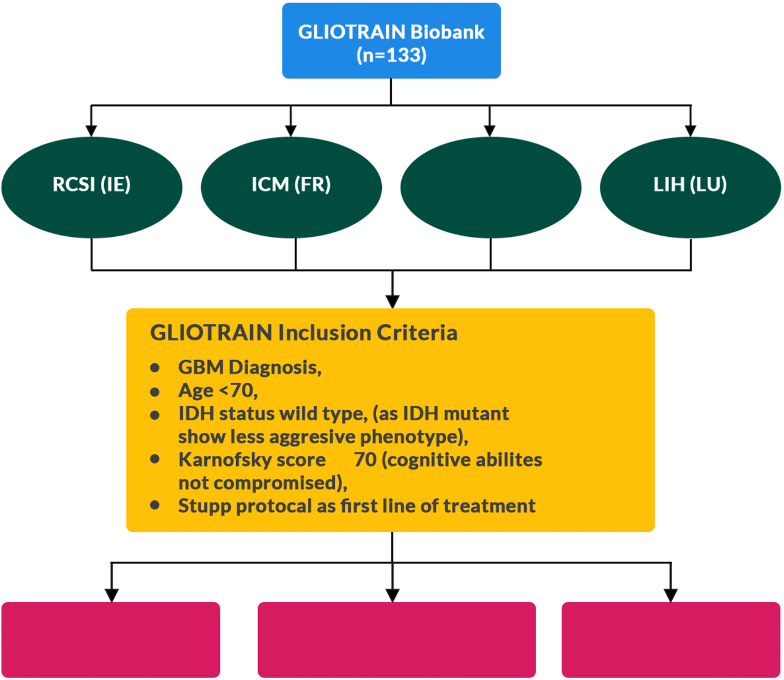

Figure S1: Sample collection criteria of expanded GT cohort samples and stratification into short, intermediate and long term survivors based on extent of survival (months)

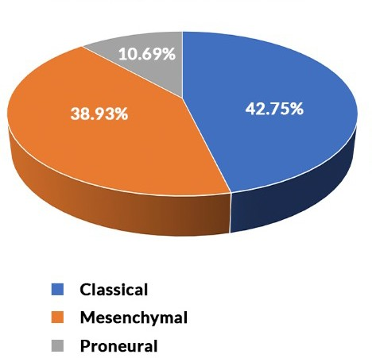

Figure S2: Pie Chart depicting the distribution of molecular subtypes for expanded-GT cohort

Overall survival

Figure S3:Overall survival analysis for expanded-GT cohort based on GBM subtypes
Strata
Subtype=Classical
Subtype=Mesenchymal
Subtype=Proneural
1.00
0.75
0.50
0.25
p = 0.4
0.00
0
Number at risk
56
51
14
20
80
39
18
5
40
Time [months]
8
12
2
60
1
1
1
1
0
0

A
7.5

5.0

2.5

0.0
1 2 3 4

0.009
1.08e-06
0.931
4.65e-07
0.024
0.002
B

6 0.002
0.000125

3
PDK1

0
1 2 3 4

0.954
0.84
0.946
0.000462

BAX

1 2 3 4 1 2 3 4
Cluster_number Cluster_number

C 1 2 3 4
0.052
15 0.002
0.015
0.008
0.001
10 0.000508
FAK

5

0

1 2 3 4
Cluster_number

Figure S4: Boxplot showing higher median expression of protein levels at cluster 1. A) BAX B) PDK1 C) FAK

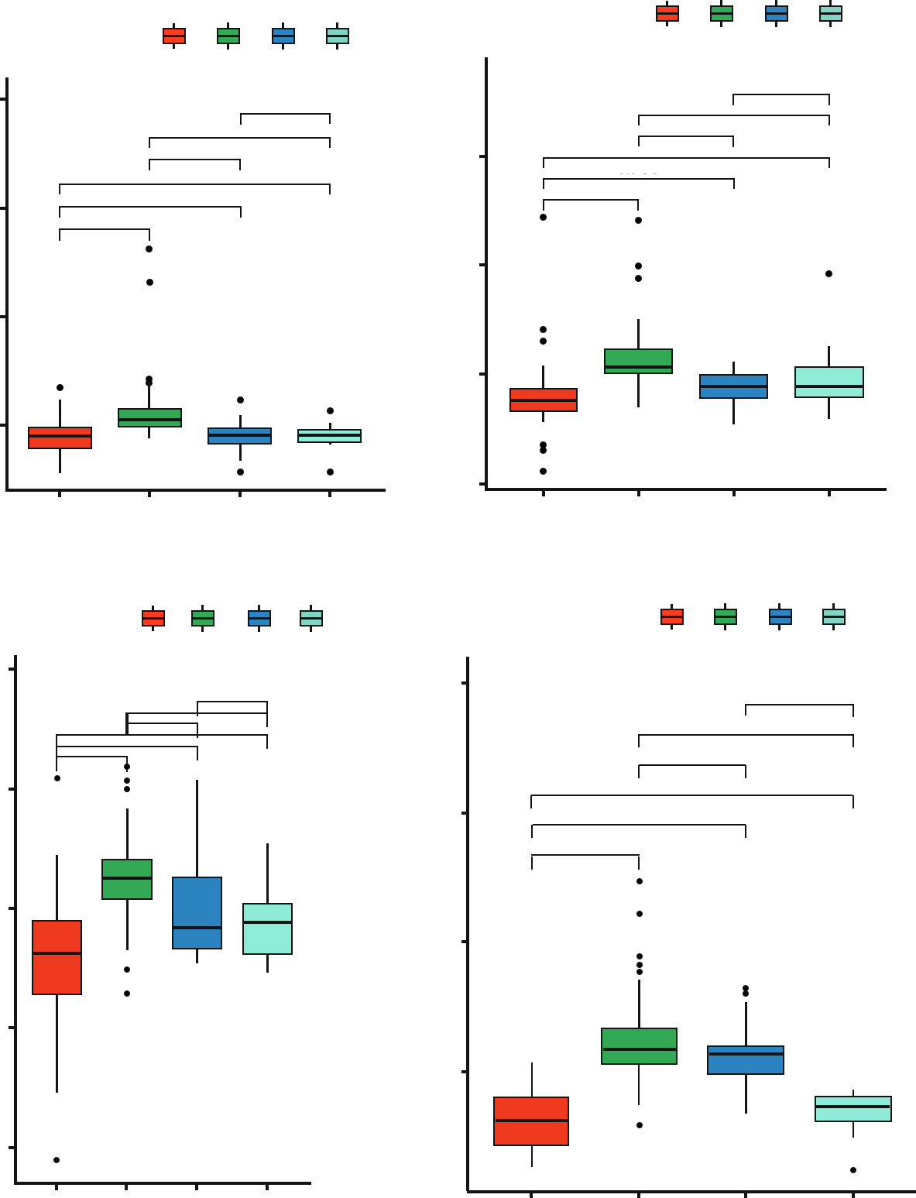A
1
2
3
4
B
1
2
3
4
0.953
0.031 0.266
3.61e-07
0.256
0.951
1.77e-05
1.75e-05
2.87e-05
0.901
6
0.738
0.000499
3
0
-3
1
Cluster_number
2
3
4
1
Cluster_number
2
3
4
1
2
3
4
D
7.5
1
2
3
4
0.02
7.91e-07
0.000583
0.421
0.012
0.004
3.2e-13
0.116
0.283
5.33e-07
5.0
3.73e-08
3.71e-15
2.5
0.0
12
CASP9(D1315)

8
CASP9(D330)

4

0

4
C

2

0
CASP9
APAF1

-2

-4

1 2 3 4

1 2 3 4

Cluster_number Cluster_number

Figure S5: Boxplot showing higher median expression of protein levels at cluster 2. A) CASP9(D1315)
B) CASP9(D330) C) CASP9 D) APAF1

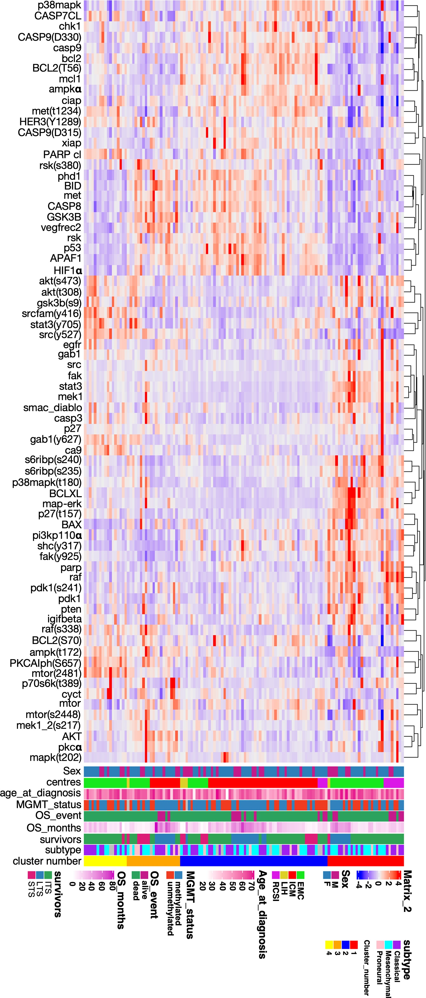

Figure S6: Complex heatmap showing normalized protein expression in x axis versus patient’s clinical parameters such as: sex, centres, age at diagnosis, MGMT status, OS event and month, survivor’s type, subtypes of GBM, and lastly the cluster numbers.in y axis.

 | Hazard ratio  (HR) | CI  (lower .95) | CI  (upper .95) | p-value
p27 | 1.79 | 1.24 | 2.58 | 0.002
Gab1 (y627) | 1.57 | 1.18 | 2.08 | 0.005
Src (y527) | 1.33 | 1.06 | 1.66 | 0.010
BCLXL | 0.78 | 0.63 | 0.97 | 0.010
BCL2 (S70) | 0.78 | 0.64 | 0.95 | 0.015
Raf (s338) | 0.78 | 0.62 | 0.99 | 0.03

Table S1: Univariate cox regression analysis identifies proteins significantly associated with overall survival.

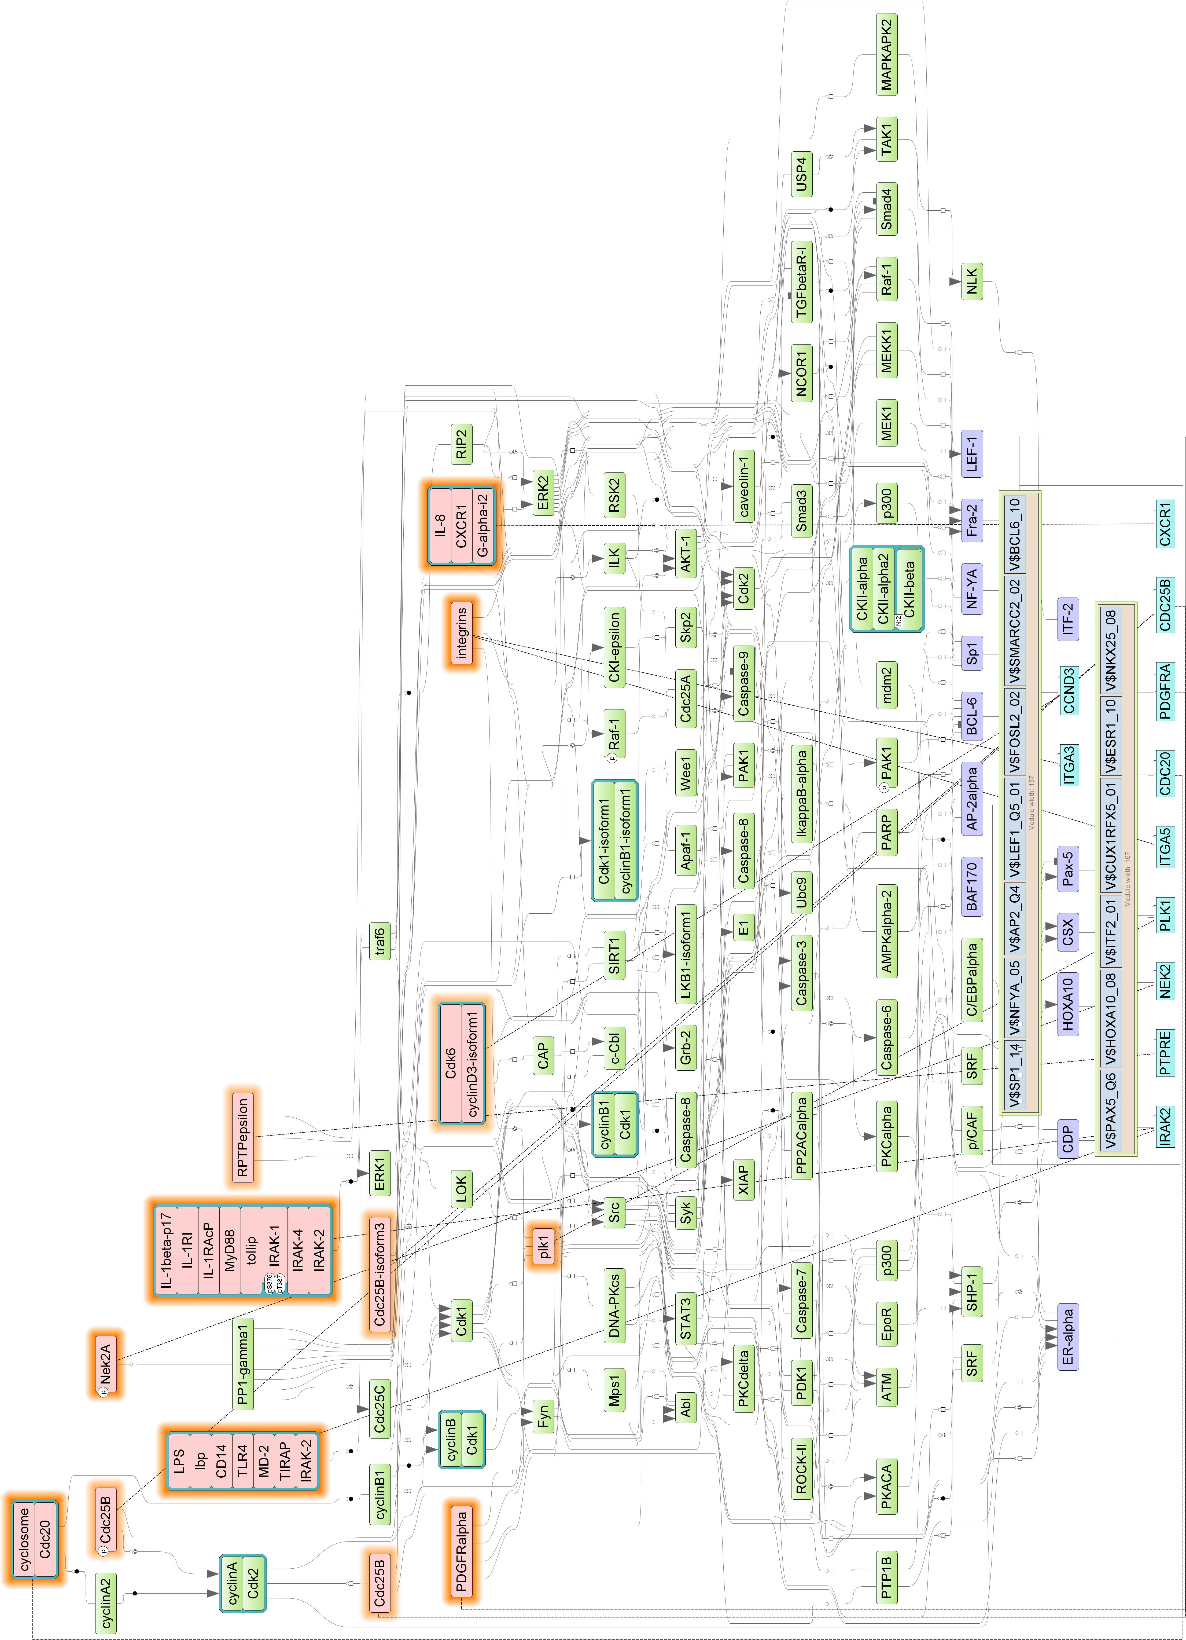

Figure S7: Master Regulator analysis for the differentially expressed up regulated genes enriched in STS samples. The gene regulatory network for upregulated genes is displayed (Log2FC > 0 and padj < 0.05). Orange outside fillings suggest master regulators that are up regulated in our dataset. Green blocks indicate intermediate molecules regulating the network. Blue blocks represent molecules which directly affect the Master regulators. Purple blocks indicate transcription factors that are present in the network.

Master regulators
Gene description Gene symbol

PDGFRalpha(h) | platelet derived growth factor receptor alpha | PDGFRA
integrins | integrin subunit alpha 1, integrin subunit alpha 2b, integrin subunit alpha 3, integrin subunit alpha 4, integrin subunit alpha 5, integrin subunit alpha 6, integrin subunit alpha 8, integrin subunit alpha 9, integrin subunit alpha L, integrin subunit alpha V, integrin subunit beta 1, integrin subunit beta 2, integrin subunit beta 3, integrin subunit beta 4, integrin subunit beta 5, integrin subunit beta 6 | ITGA1, ITGA2B, ITGA3, ITGA4, ITGA5, ITGA6, ITGA8, ITGA9, ITGAL, ITGAV, ITGB1, ITGB2, ITGB3, ITGB4, ITGB5, ITGB6
BMP2A(h) | bone morphogenetic protein 2 | BMP2
IRAK-2(h) | interleukin 1 receptor associated kinase 2 | IRAK2
IL-8(h):CXCR1(h):G-alpha-  i2(h) | C-X-C motif chemokine ligand 8, C-X-C motif chemokine receptor 1, G protein subunit alpha i2 | CXCL8, CXCR1, GNAI2
plk1(h) | polo like kinase 1 | PLK1
plk1(h)(Silke and Meier) | polo like kinase 1 | PLK1
Cdc25B(h) | cell division cycle 25B | CDC25B
Cdc25B(h)(Kalya et al.) | cell division cycle 25B | CDC25B
Cdc25B-isoform3(h) | cell division cycle 25B | CDC25B
gamma-secretase(h) | aph-1 homolog A, gamma-secretase subunit, nicastrin, presenilin 1, presenilin enhancer, gamma-secretase subunit | APH1A, NCSTN, PSEN1, PSENEN
LPS:lbp:CD14:TLR4:MD- 2:TIRAP:IRAK-2 | CD14 molecule, TIR domain containing adaptor protein, interleukin 1 receptor associated kinase 2, lipopolysaccharide binding protein, lymphocyte antigen 96, toll like receptor 4 | CD14, IRAK2, LBP, LY96, TIRAP, TLR4
IL-1beta-p17:IL-1RI:IL-  1RAcP:MyD88:tollip:IRAK- 1{pS376}{pT387}:IRAK-  4:IRAK-2 | MYD88 innate immune signal transduction adaptor, interleukin 1 beta, interleukin 1 receptor accessory protein, interleukin 1 receptor associated kinase 1, interleukin 1 receptor associated kinase 2,  interleukin 1 receptor associated kinase 4, interleukin 1 receptor type 1, toll interacting protein | IL1B, IL1R1, IL1RAP, IRAK1, IRAK2, IRAK4, MYD88, TOLLIP
Cdc20(h) | cell division cycle 20 | CDC20
cyclosome(h):Cdc20(h) | anaphase promoting complex subunit 1, anaphase promoting complex subunit 10, anaphase promoting complex subunit 11, anaphase promoting complex subunit 2, anaphase promoting complex subunit 4, anaphase promoting complex subunit 5, anaphase promoting complex subunit 7, cell division cycle 16, cell division cycle 20, cell division cycle 23, cell division cycle 26, cell division cycle 27 | ANAPC1, ANAPC10, ANAPC11, ANAPC2, ANAPC4, ANAPC5, ANAPC7, CDC16, CDC20, CDC23, CDC26, CDC27
Nek2A(h) | NIMA related kinase 2 | NEK2
Nek2A(h){p} | NIMA related kinase 2 | NEK2
plk1(h) | polo like kinase 1 | PLK1
cyclosome(h):Cdc20(h){ub} n | anaphase promoting complex subunit 1, anaphase promoting complex subunit 10, anaphase promoting complex subunit 11, anaphase promoting complex subunit 2, anaphase promoting complex subunit 4, anaphase promoting complex subunit 5, anaphase promoting complex subunit 7, cell division cycle 16, cell division cycle 20, cell division cycle 23, cell division cycle 26, cell division cycle 27 | ANAPC1, ANAPC10, ANAPC11, ANAPC2, ANAPC4, ANAPC5, ANAPC7, CDC16, CDC20, CDC23, CDC26, CDC27
Dkk-1(h) | dickkopf WNT signaling pathway inhibitor 1 | DKK1
usp13-isoform1(h) | ubiquitin specific peptidase 13 | USP13
usp13(h) | ubiquitin specific peptidase 13 | USP13
RPTPepsilon(h) | protein tyrosine phosphatase receptor type E | PTPRE
CUL4A(h):DDB1(h):DTL(h) | cullin 4A, damage specific DNA binding protein 1, denticleless E3 ubiquitin protein ligase homolog | CUL4A, DDB1, DTL
Cdk6(h):cyclinD3-  isoform1(h) | cyclin D3, cyclin dependent kinase 6 | CCND3, CDK6

Table S2: 25 Identified master regulators for STS upregulated genes.

